BEGINNING THE BEGINNING BASSIST

Electric or upright bass parts in jazz ensembles are usually fairly simple, although some will need to be rewritten for beginners. Young bassists are often faced with easy parts written in confusing ways.
For example, the may have:

or

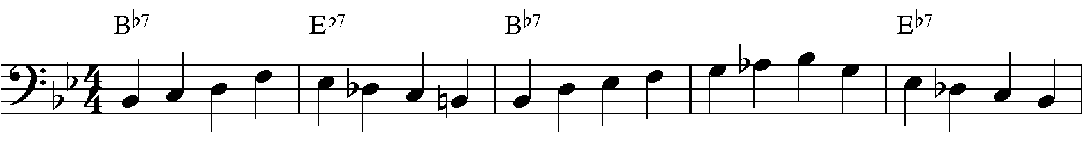
or

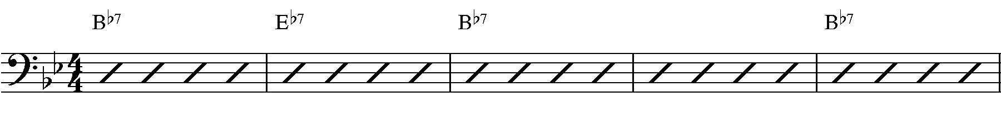

One Finger Technique

Getting beginners to read the entire line can be difficult. A good place to start is to offer empty staves with the chord changes above and concentrate on the root. The goal of the exercise on the next page is to 1) train the eye to read the chord changes, 2) learn to play roots based on the chord changes, 3) work on time and the right hand and 4) begin to hear the changes.

Hints for playing the exercise:
Use a metronome, initially set on a 4-beat pattern, then change to offbeats.
Vary the tempo, but begin at around mm=100
When possible, have the drummer and bassist play together

