CHORDS, SCALES AND FINGERING PATTERNS FOR BASS PLAYERS

In order to move beyond reading written lines, bass players need a solid knowledge of chords, and by extension, scales. The chordal approach is the key to improvising latin and rock bass lines. Chords are also used to build scales and connected walking bass lines. Finally, working through chords and scales is a good way to introduce bass players to multiple fingering patterns. Unfortunately, many students are intimidated by the thought of countless chords, scales and modes. For bass players, the following approach seems to simplify things.

The first step is to pick a chord to use as an example and concentrate only on the 3 most commonly found chords and scales.

Write out the major scale Have the student write out the major scale using both open strings and a fingering pattern. Identify the scale degrees (What is the root, 3rd, 5th, 7th?).

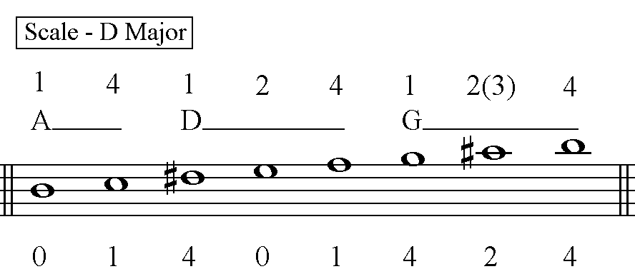

Major triad, Major 7 chord Identify the major triad (root, 3rd, 5th, octave), write it out and identify 2 fingering patterns. Write out the Major 7 chord (root, 3rd, 5th, 7th, octave), and identify 2 fingerings. Finally, write out the scale that fits those chords. Surprise, it is a major scale.

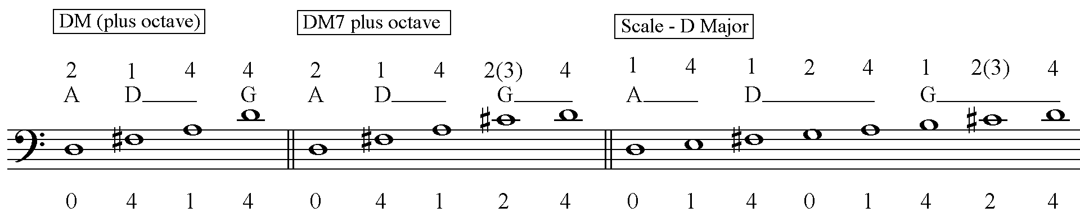

The 7th chord There is only one note different between the major 7th chord and a 7th chord; the 7th scale degree is lowered. Have the student write out Major 7 chord and then lower the 7th by ½ step. Again, identify multiple fingering patters. The next step is to identify the scale that goes with the 7th chord (hint: only 1 thing changes) and write it out with fingerings. You can call it mixolydian mode. (major scale with a lowered 7th)

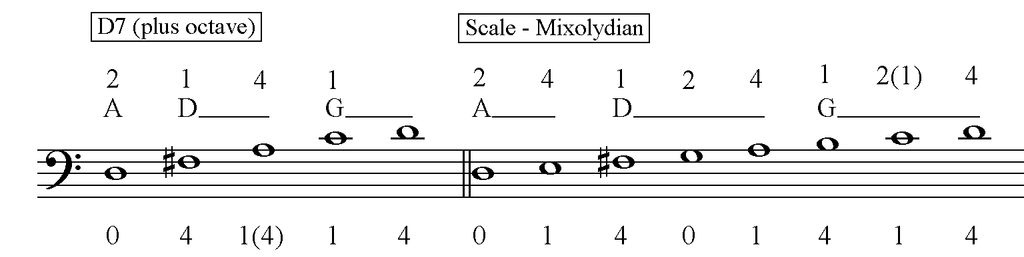

The minor 7th chord Only one thing is changed from the 7th chord to turn it into the minor 7 chord. Write out the 7th chord and lower the 3rd scale degree. There is now a minor triad and a minor 7th. Have the student identify multiple fingerings, write out the scale (again, only changing one thing) and fingerings. You can call it dorian mode. (major scale with a lowered 7th and 3rd)

