THE SECRET TO PLAYING LATINS (AND ROCK AND FUNK LINES)

Most latin tunes feature lines based on chordal root-five combinations. Young players who do not know the fingerboard well often jump all over the neck, when in reality the licks are very simple. In order to see these patterns, introduce students to a simple tune using the following process.

- Play the Root Reading only the chord symbols, have the student play the root only. The rules are simple; play only with first finger and only play on the E, A or D string. Experiment with common rhythms.

- Throw in the 5th and Octaves Sticking with the same pattern as above, add the 5th and octaves. Students may write these patterns out initially to “see” fingerings.

- Look for b5 and b9 Once the root-five is identified, it is easy to find the lowered 5th ; it is first finger (root) to second (b5).

- Rock and Funk Variations Look for the root-five-octave patterns and use different rhythms.

Easy latin, lousy key

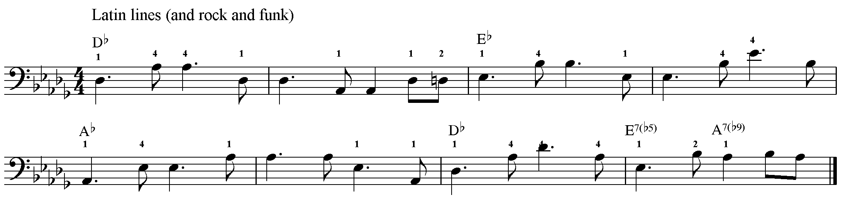

B5 and B9, good key

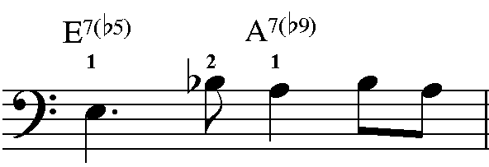

Rock, shuffle, blues pattern

