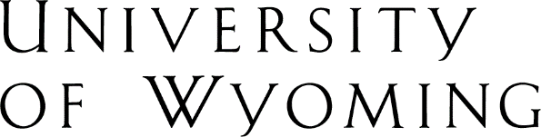
UW MPA Program
Arts & Sciences Building 208
Phone: 307-766-6484

MPA Internship Waiver Application
School of Politics, Public Affairs & International Studies
University of Wyoming

Please answer the following questions thoroughly. Attach additional sheet if necessary. Submit this typed form along with a current resume to the MPA Director. Submissions are accepted at the campus office, by fax, and by email at mpa.info@uwyo.edu.

Student Name: Enter your name. Expected Graduation Date: Choose a term.
Which positions(s) are you relying on to substitute for the internship requirement?
Students must demonstrate two or more years of recent, substantial and relevant administrative experience (higher than entry level in a governmental or non-profit organization) to be considered for a waiver of the internship requirement. Private management or administrative experience may be considered as well.

List relevant experience.

Please give a general job description of the position(s) you are submitting for the internship waiver. How did this/these position(s) give you recent, substantial and relevant public service experience? Please attach additional sheets if necessary.

Describe the experience listed above.

☐ Approved ☐ Denied

MPA Director Signature: ______________________________ Date: Enter date

