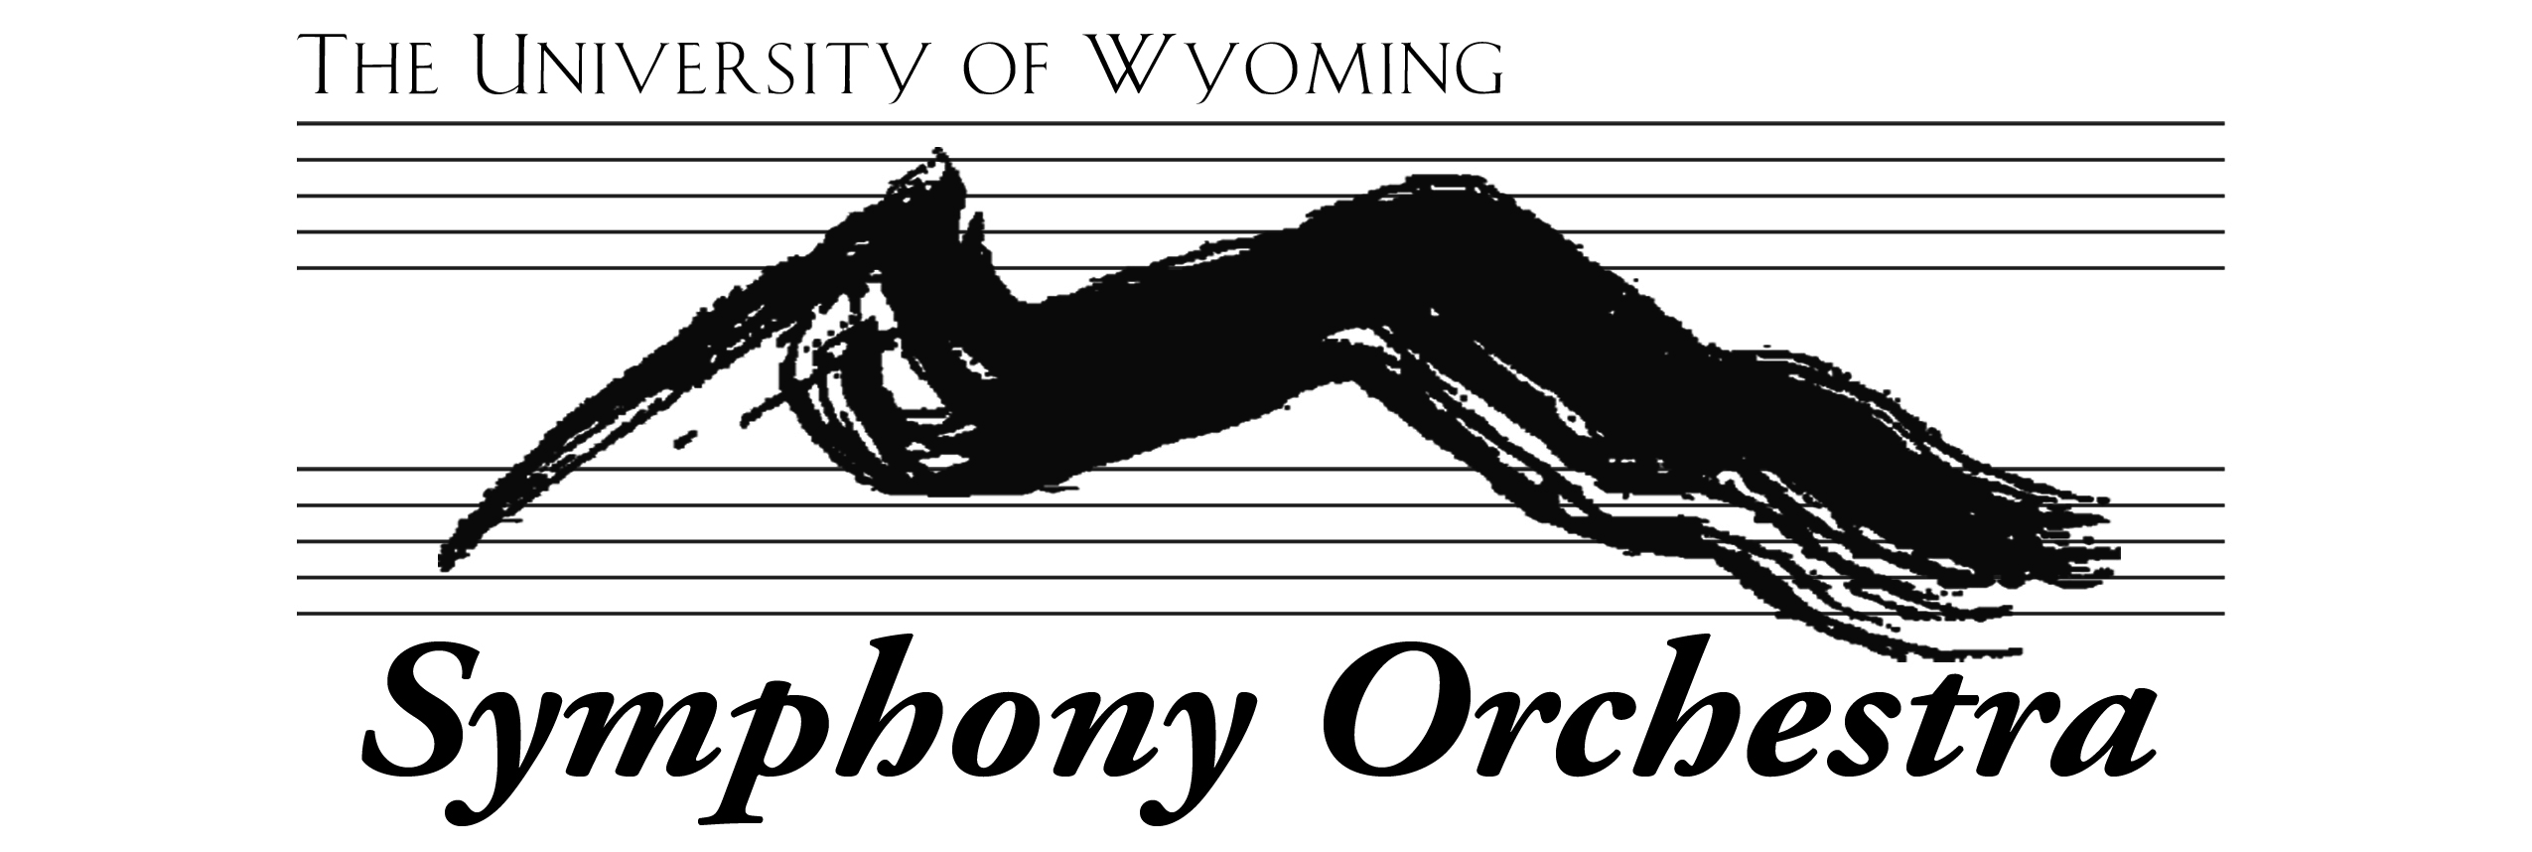
AUDITIONS 2024

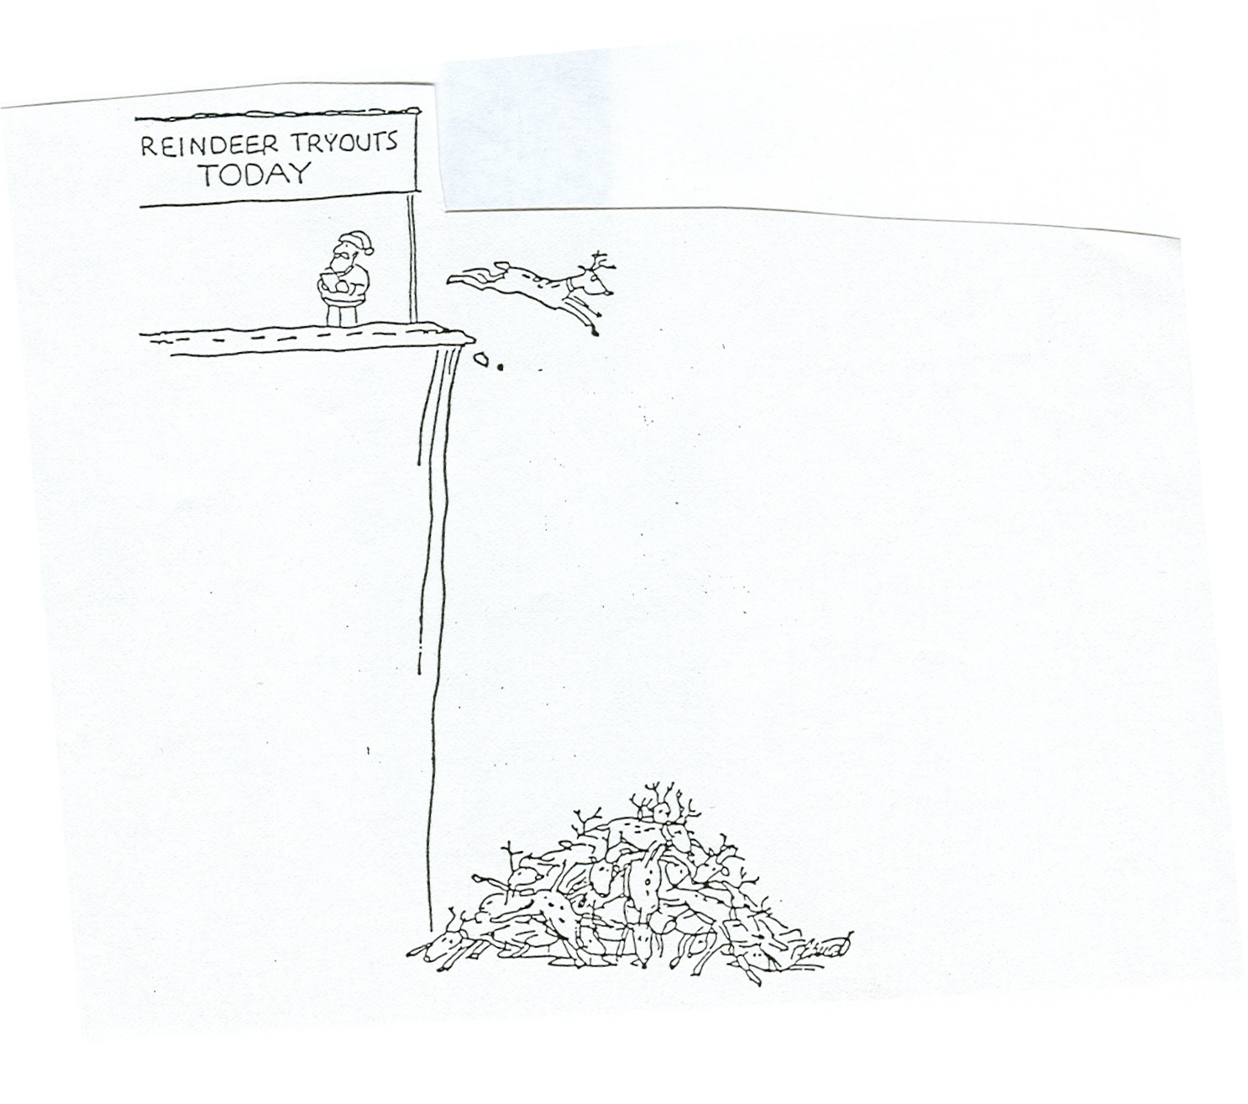

All auditions (except percussion) will be August 23, 25, 26, and 27. Sign up for a time on my office door. Winds, choose the same time for me and Dr. Schlomer. Don’t wait until the last minute! Times fill up quickly. If you can audition early, please do so.

Please prepare two selections that show your ability (except percussion, which will have repertoire assigned by Dr. Wheelock). One must be slow, so we hear your tone and musicality. The other, fast, for technique and articulation. They may be two different works, or two movements of the same piece. They don’t need to be extraordinarily long. I’d rather hear 100 well-prepared measures than an entire movement you didn’t have time to learn. For strings, something that shows your ability to shift is always informative, especially for violins who wish to be considered for first violin. Scales are not required, but I’m happy to hear one or two if you like.

NEW STRINGS – you must audition, even if you auditioned for a scholarship last spring. For most of you, this is for seating. You can audition in person or on-line. If you choose virtual, upload something to YouTube and send me the link. Chinese students may use YouKu. Deadline is 4:00 p.m. Tuesday August 27.

RETURNING STRINGS – If you’re happy with your previous seating, you’re not required to reaudition.
I will use your spring jury, or the last time I heard you, to make my decision. If you think a new audition will show improvement, you’re more than welcome to play again.

WOODWINDS AND BRASSES – Dr. Schlomer and I will do auditions together. They should be in-person.

Dr. Schlomer may also ask for sightreading. Bassoons, I sent you excerpts from Pictures earlier in the summer. Trumpets, Pictures excerpts are not required at this point. The Saxophone soloist for Pictures will be auditioned later in the semester.

PERCUSSION – auditions will be Monday evening, August 26, in the Concert Hall. Dr. Wheelock will have a sign-up sheet and repertoire list.

