Title: Identification of active ingredients in analgesic tablets using Thin Layer Chromatography (TLC)
Subject: Chemistry Grade level: 11th-12th Date: Nov 21st 2013
Learning objective: Students will learn that the different active ingredients of drug tablets can be separated using thin layer chromatography
Standards addressed: application of science
Vocabulary: capillary action, capillary tubes, thin layer chromatography, plates, stationary phase, mobile phase, spotting, develop, solvent front, retention factor (Rf), analgesics, OTC, eluent
Materials needed:
- TLC plates
- Crushed tablets of analgesics
- Capillary micropipette
- Pencils
- Methanol to dissolve the tablets
- mixture of ethylacetate,ethanol, and acetic acid (25:1:1 v/v/v)
- developing jar
- UV lamp to check the spots on the TLC plate
Background:
Chromatographic techniques are used extensively for routine analysis in chemistry.TLC can be used to determine the purity of a substance and to analyze the composition of a mixture. It is an inexpensive technique that gives the chemist a quick answer as to how many components are in a mixture. A TLC plate consists of a thin layer of silica gel particles coated on a thin sheet of aluminum. The silica is a stationary phase and an organic solvent is used as the mobile phase. The solvent moves up the plate by capillary action.
Introducing the lesson:
A review of simple paper chromatography using material like different colored-markers will be done using a video for demonstration. Thin layer chromatography will be introduced and a short video of how it works will also be shown to the students.
Instructional procedure:
How the separation works:
- Substances can move with the mobile phase (solvent)
- They can remain fixed on the stationary phase(silica)
- Substances with different properties can partition between the two phases and be separated
The spots (different substances) move at different speeds on the TLC plate
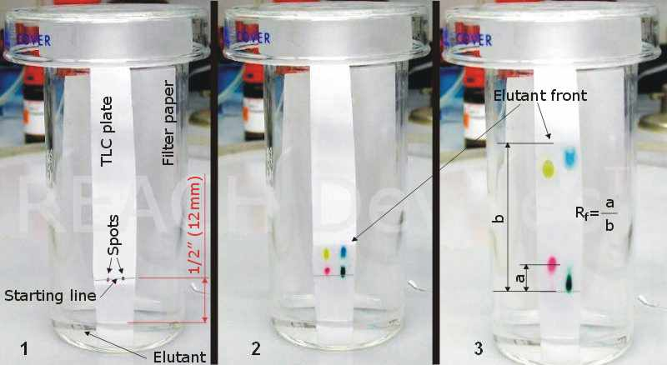
Analgesic medications:
- Analgesic is any group of drugs used to get relief from pain
- Many OTC analgesics are available such as Tylenol, Excedrin, Anacin, Midol etc
- OTC analgesic contain many compounds and only the active ingredients relieve pain
- Other components of the drugs are stabilizers and solubility enhancers
Activity outline:
- The active ingredients of the tablets will be identified by spotting authentic standards of the various components on a TLC plate
- A solution of an unknown analgesic tablet will be spotted alongside the standards
- The location of the spots from the standard and unknown will be compared
- The identification of the brand name of the tablet will be accomplished by comparing experimental results to the list below
Table: Composition of several Brand name Analgesics
Drug (Brand Name) | Ingredients
Anacin | Asprin (400 mg)  Caffeine (32 mg)
Tylenol | Acetaminophen (325 mg)
Excedrin | Asprin (250 mg)  Caffeine (60 mg)  Acetaminophen (250 mg)

Procedure:
- Obtain a TLC plate and a capillary tube.
- Practise spotting of methanol in the middle of your TLC plate with the capillary tube so as to get a small 1-2 mm diameter spot/circle.
- Prepare your TLC plate by drawing a very light pencil line about 1 cm from the bottom of the plate called the starting line.
- Three standards, asprin, caffeine and acetaminophen will be provided.
- Dip the end of the capillary tube into one of the standard solutions and spot this standard on the drawn line.
- Next check the spot under the UV lamp provided and the spot should appear as a dark circle.If the circle is faint, add more material to the same spot.
- Repeat the spotting with the other two standards and checking the spots under the UV lamp.
- Record the names of your standard and the order in which they were spotted (e.g from left to right).
- Draw a small amount of your unknown sample solution using a new capillary tube. Spot the unknown next to the standard. Check the spot under the UV light.
- Place your TLC plate with the end you spotted down into the jar of solvent provided (mobile phase). Allow the solvent to rise about ¾ length of the TLC plate.
- Remove the plate from the jar and mark the furthest point the solvent (mobile phase) has risen with a soft pencil.
- Place your TLC plate away from you and let the solvent evaporate from the plate, which takes a few mins. After the solvent has evaporated place your plate under the UV lamp and circle the spots very carefully with a pencil.
- Finally deduce the identity of your unknown from the number of spots and the location of spots on the plate
Table of Results
Compound | Location of spot(s) | Number of spots
Asprin
Acetaminophen
Caffeine
Unknown

Conclusion and Assessment:
The lesson will be concluded by letting the students do a simple measurement of the distance travelled by their unknown and the mobile phase. They will then calculate the Rf (retention factor). The take home message will be that Rf values are different for different components of a substance.
Rf = distance travelled by sample/ distance travelled by the mobile phase
Students’ understanding of the lesson will be evaluated by how well they rationalize their choice of the unknown.

