Create Your Own Head Reliquary Workshop

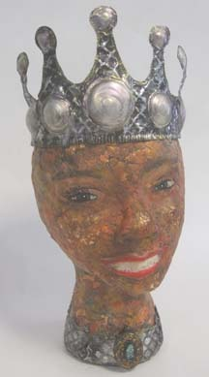

“Head Reliquary for JOY”
A reliquary is a container for a relic. The word relic comes from the Latin reliquiae, meaning "remains" or "something left behind". A relic is a material object, a memento, something left behind of personal meaning that achieves significance by being collected and honored and sequestered within a reliquary.
Taught by Deedee Hampton
Deedee was recently featured in the book “Personal Geographies: Explorations in Mixed Media” by Jill Berry; winner of the Poudre River Gallery “Recycled Art Show”, 2011; selected for the Santa Fe Recycled Art Show in 2011; Director of the Mootz Family Craft & Design Center.
I’ll teach you how to:
 Create an antique look on the head, using mosaic eggshells & paper collage.
 Use your own face or one from a magazine ad.
 Create a space for the relic in the top of the head & take the backing partially off of a mirror to see through it to the relic.
 Make a metal embossed crown & collar.
The relic, “JOY”, is behind the crown in head:
(do you see my fingers reflected in the mirror?)
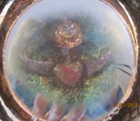
I will supply:
The head form.
The mirror & product to take off the backing. Copper foil used to finish mirror edge.
The metal & some embossing tools, crown templates.

You’ll need to bring: paint, brushes, scissors, glue- I prefer “The Ultimate”, clean egg shells (8-12 eggs worth-I’ll have some too), 2 copier printed images of your face, approx. 6.5” H by 6” W or 1 magazine ad face same size; a few sheets of paper for collage; 1 small tube of adhesive kitchen/tub caulking; object(s) for your relic, doodads for decoration (beads look nice around the mirror); heat gun & embossing tools if you have them; gold/copper leaf; sack lunch

When: Saturday May 5th, 2012
Time: 9:30-4:00ish
Place: Poudre River Arts Center; 406 North College Ave.; Fort Collins
Cost: $75.00 ($50.00 refund if you cancel 2 weeks in advance)
Register: call Deedee at 970-586-2383 or e-mail me at d2hampton@estesvalley.net I will take checks to reserve a space.


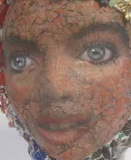
A photo of me that I used for this example reliquary-it really doesn’t look like me on the sculpture- the face shape is so different.

Magazine Ad face example:

