How to Schedule Reports In WyoCloud
Updated January 2021

Log into WyoCloud. At the home page, use the black arrow to go to the “Tools” tab. Then select “Reports and Analytics”.
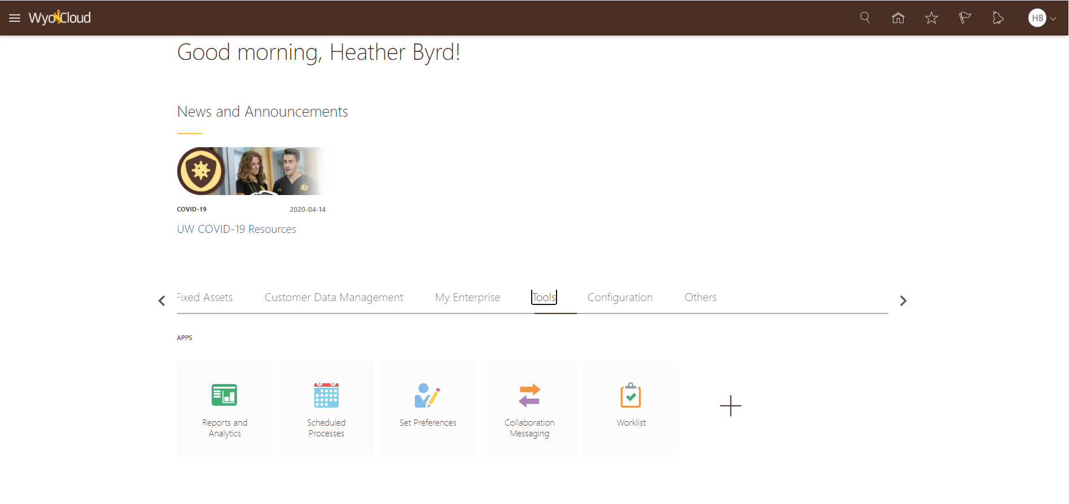
Or, log into WyoCloud. Click the three solid lines in the left hand top of the screen. Scroll down to “Tools”, then select “Reports and Analytics”.

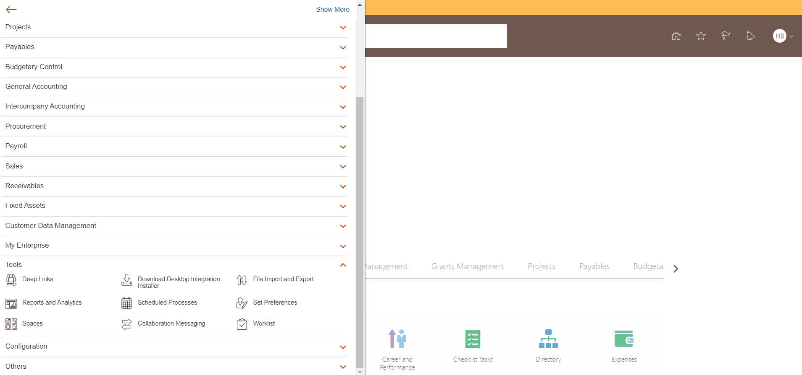

On the “Reports and Analytics” page, click browse catalog in the top right corner.
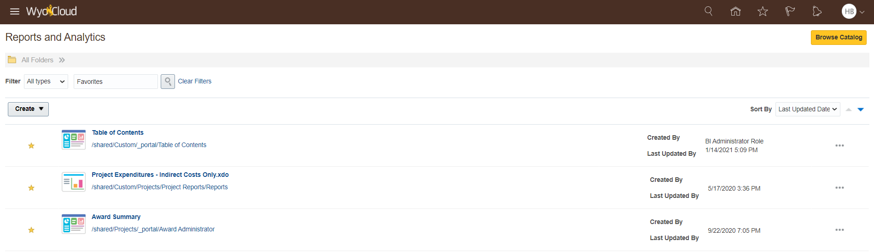
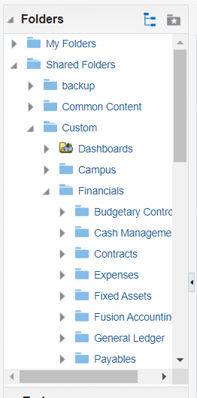
From the Catalog, you can search for a report that you need or use the folders on the left hand side, if you know where the report is located.
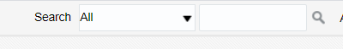

Once you select the report you want to have scheduled, on the upper right hand side, click on the gear, then Schedule.
Then the scheduling page will open. It will look like the image below.
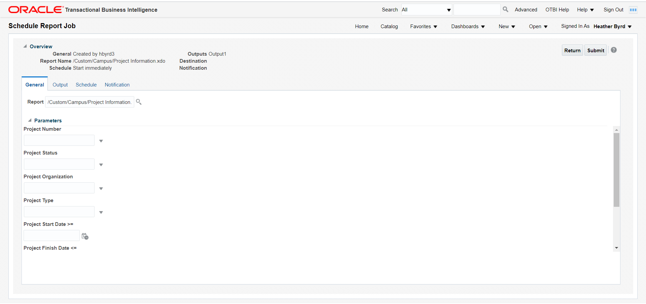

On the General tab, you can add criteria for the report. These criteria’s include which project numbers, project status, project organization, project type, project start and end date, department projects, and subdivision projects. Click in the criteria box to select which item to include. Once you have all the criteria you want, select the output tab.
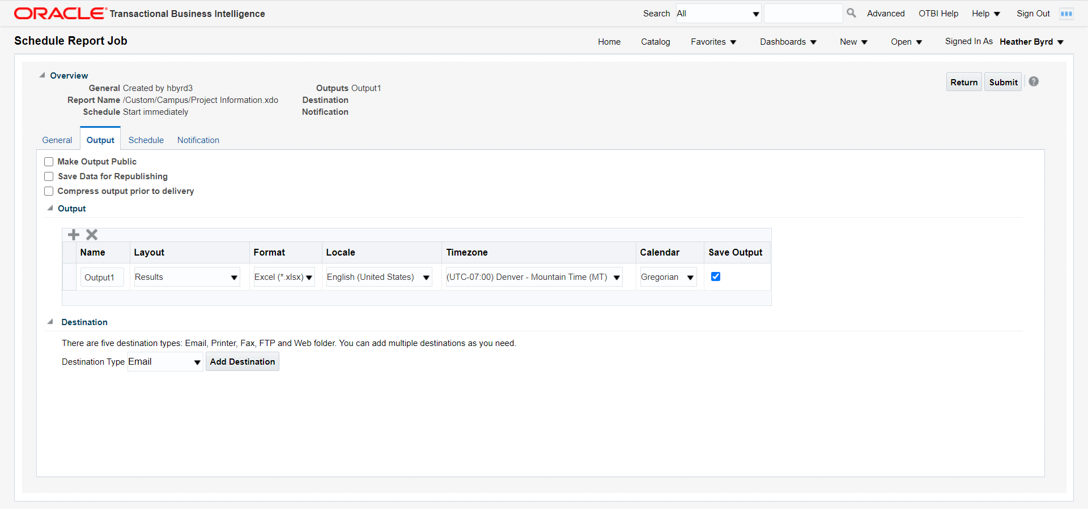
On the output tab, you can make changes about how the report is delivered to you. First, you can change the name tab and rename what you’d like the report output to be called. The Layout tab only shows results, so there is no changes to be made. The Format tab has an output of Excel only. The Locale, Timezone, and Calendar are autofilled for you.
Make sure Save Data for Republishing is checked.
The last option on the Output page is Destination. There are three destinations, email, FTP, and content server.
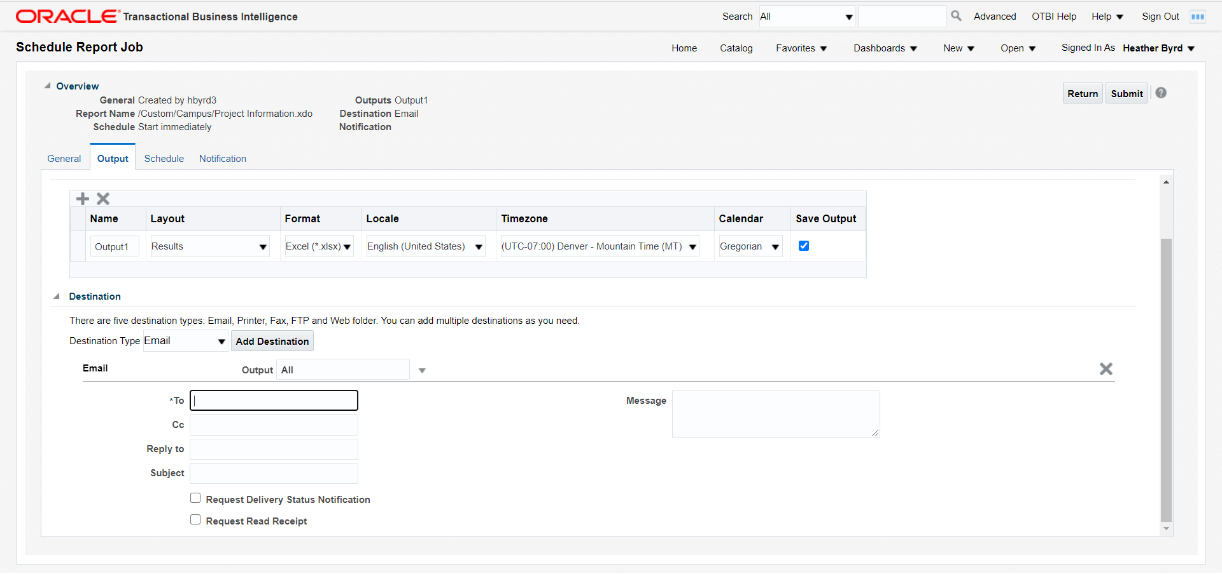
The Email destination allows you to add an email to receive the report, as well as a CC, reply to, a subject line, and a message. If adding multiple emails, separate with a comma.
The FTP Server sends the report to a file using a username and password credentials. You must enter the remote directory, which is where the report will be delivered, and the remote file name, that is the file name and it needs the file extension in the name, i.e. myreport.pdf.

The Content Server will send the report to a server. You can restrict access by adding a Security Group and Account to the report. You can add values in for account, folder path, author, title, file name, and comments.
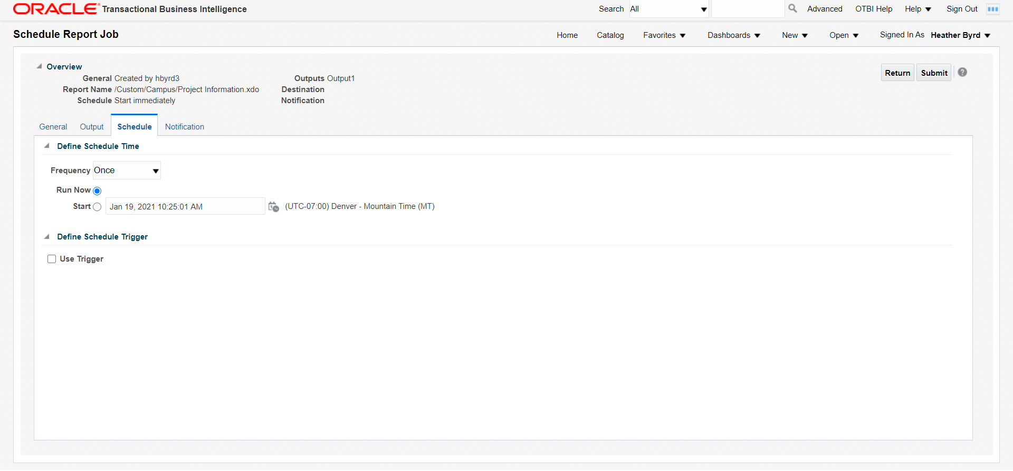

The Schedule tab allows you to schedule when to receive the report. There is an option to run the report right away or schedule it to run at an interval basis.
Reports can be ran once, hourly/minute, daily, weekly, monthly, annually, or set specific dates. Once you select an option, you will be able to select the intervals of frequency as well as the start and end date. You can adjust this report to be ran to keep your department updated on changes.

Once you select the frequency, you will get options to select the type of frequency. For example, if you chose Weekly as the Frequency, you can chose what day of the week to run the report. You can also select multiple days of the week, if needed. Just make sure to check which boxes are needed.
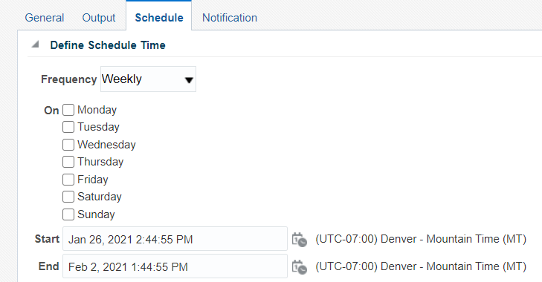

If you chose Monthly as your Frequency, you will get the option to choose what month, what day of the week or an exact date. Select the months with the check boxes, and use the On selection to select which week and day to run the report, or use the day to have it run on a certain day. 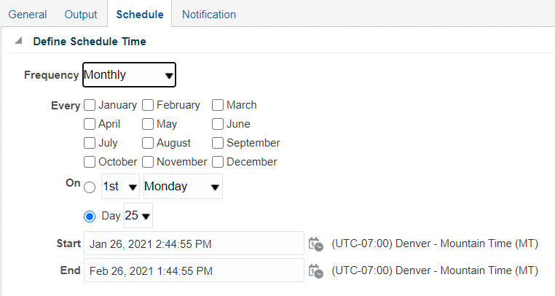
On the Schedule tab, you can use a schedule trigger. A schedule trigger is used when you place a condition and when the condition is met, the report will run.
The last tab is the Notification tab. This tab allows an email to be sent out when the report is ran. It will also send a notification if the report completed but has warnings, if the report failed, and if the report skipped.
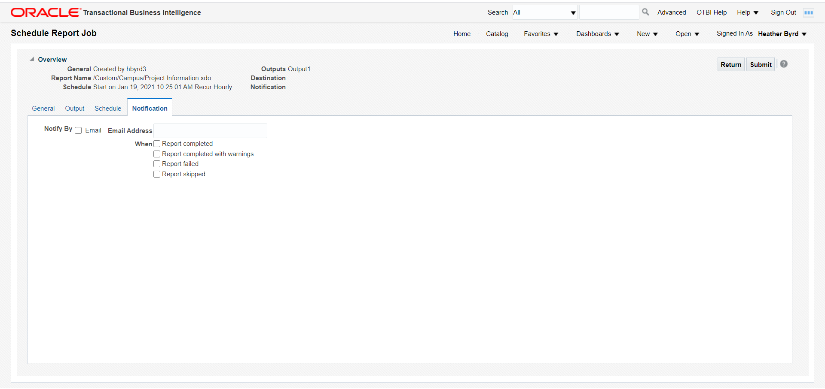
You can add your email by checking the notify by email, then type your email in the box. You can add multiple emails by separating by commas.
When the report has been set up, click submit, in the upper right hand of the screen, to save the report.

If your email was used as the email for the notification, you will receive an email that says it was successfully processed or if there were warnings.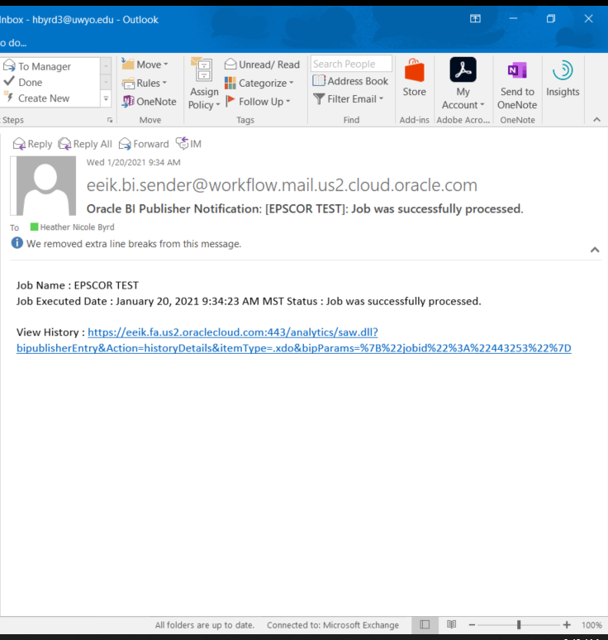
If your email was used to have the report sent to you, it will look like this. The file will be included on that email. Just download the file by using the drop down arrow by the attachment.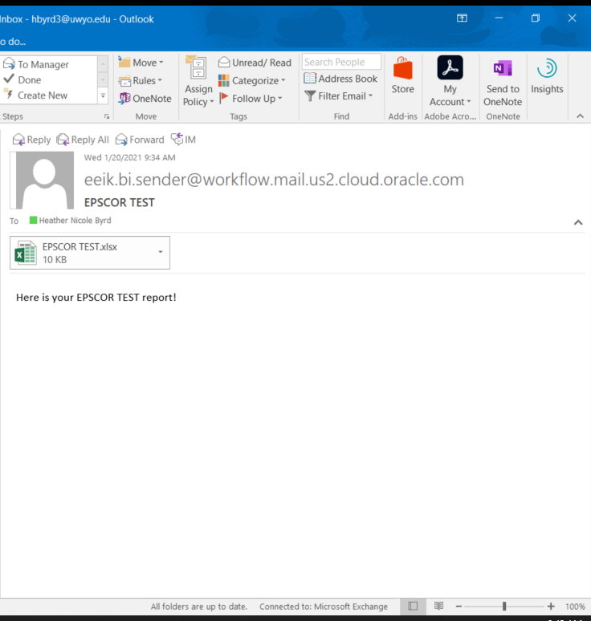

If you want to delete or edit your schedule of the job, go to the home page of Reports and Analytics.
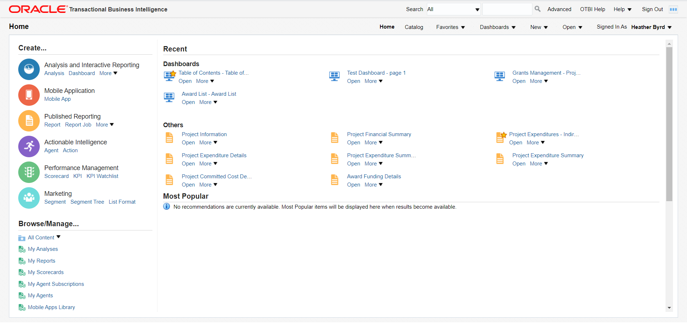

On the bottom left hand side, under Browse/Manage, click on Report Jobs.
The page will open to all of the scheduled reports you have. You are able to search for reports, if you have multiple.
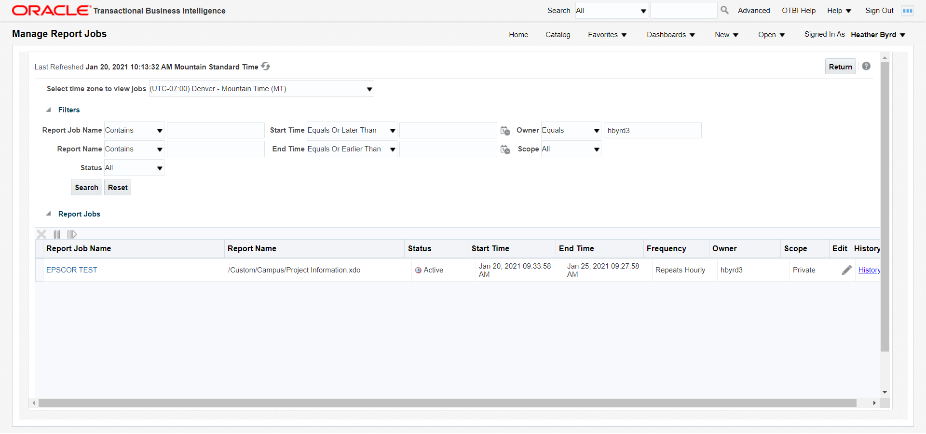
If you want to delete a report, click on the line of the repots (in the white area), it will then highlight, then hit the X above Report Job Name.
To view details on the report, click on the Report Job Name, and the details will open.
To make changes, click on the line of the report you want, then click the pencil icon under Edit. This will open Schedule Report Job and you can make changes.
*Higher level instructions can be found at https://eeik.fa.us2.oraclecloud.com/xmlpserver/help/en/htmfiles/bipoh/create_rpt_jobs.htm#gen_tab

