**USGS-WWDC Water Research Program Final Project Report**

*Project Title:* **Produced Water Treatment with Smart Materials for Reuse in Energy Exploration**

*Prepared by* Katie Dongmei Li-Oakey

Department of Chemical Engineering

University of Wyoming

Email address**:** [**dli1@uwyo.edu**](mailto:dli1@uwyo.edu)

**Phone:** (307) 766-3592

Project Time Frame**: March 1, 2016 – June 30, 2019**

**Abstract**

Hydraulic fracturing, also referred to as Hydrofracturing, has enabled the economical recovery of gas and oil from the unconventional reservoirs, such as Marcellus Shale and Niobrara. Produced water refers to the water that returns to the surface, typically 10 to 30% of the original injected amount. The produced water is composed of the original components in the fracturing fluid as well as any materials that may have entered it through its contact with the surrounding geology and groundwater, which generally results in an aqueous mixture rich in organic and inorganic substances. Produced water management has been discussed and reported by government agencies and industrial partners. The soluble organics often result in problematic re-injection of the produced water (for pressure control), such as unpredictable pore plugging of the fractures, when used to make up part of the hydraulic fracturing fluid. However, to remove the dissolved organic compounds (DOC) requires advanced water treatment that can be as costly as $8/barrel in Wyoming. One of the primary reasons for high costs results from fouling on commercial surface treatment facilities caused by DOC. The fouling issue is a concern because it results in decreased process efficiency and, consequently, increased operating and capital costs. Here we propose to develop hybrid membranes by depositing smart materials, such as TiO2 nanoparticles, onto commercial membranes (the central pieces of a commercial water/oil separation module) via a recently developed technique in the Li lab. Thanks to the photo-oxidative and hydrophilic properties of smart materials, the hybrid membrane allows decomposition of DOC, consequently breaking up aggregations of organic molecules before the formation of much larger particles. As such, the proposed technology prevents pore plugging when rejecting produced water as part of the hydraulic fracturing fluid, providing a cost-effective reuse in energy exploration loop and, alleviating environmental concerns of the citizens of Wyoming.

**Problem Statement**

***Statement of critical regional or State water problem*:** Due to the vast amount of water used in hydrofracturing process, the cost of produced water treatment and the availability of water resources have become barriers for hydrofracturing in Wyoming. The proposed research addresses these challenges by developing hybrid membranes that can self-clean their surfaces, in addition to increase clean water flux, which provides a cost-effective, energy-efficient produced water treatment approach for reuse.

***Statement of results or benefits:***  We anticipate that this project will generate the following outcomes: 1) Novel hybrid membranes that can decompose dissolved organics in produced water, consequently reducing water treatment costs in capital and operation and enabling hydrofracturing practice in acrid areas in Wyoming. 2) Generation of testing data related to water recovery for different produced water chemistries. Due to the complex nature of produced water chemistry, addressing the dissolved organics in produced has been challenging on a well-to-well base. Since the proposed TiO2 nanoparticles can decompose the organics by the radicals generated by photon, the hybrid membranes can self-clean without the need to ‘identify’ those compounds. 3) Through PI’s existing partnership with service and exploration companies, water sample from the drilling field will be tested, increasing our understanding on whether and how the treated produced water can be reused for irrigation and hydrofracturing.

**Objectives of the project and a timetable of activities:** We are proposing the construction of hybrid membranes consisting of a continuous polymer phase that contains pore structures that will be modified by TiO2 nanoparticles with well-controlled size and distribution density via both wet-chemistry and Plasma Enhanced Atomic Layer Deposition (PEALD). The unique functionalities of TiO2 nanoparticles have been well recognized, studied and applied to tailor membrane structures to mitigate fouling and enhance flux. Although there is no limitation on the starting membrane materials, we will primarily focus on use of microfiltration (MF) and reverse osmosis (RO) polymeric membrane supports since they span the range of pore sizes used in produced water treatment systems, where oftentimes MF was used as a pretreatment step for RO desalination in produced water treatment. We will modify commercial flat membrane samples and test them in bench scale module in the PI’s lab. Briefly, to fabricate a hybrid membrane material, TiO2, as small as 1-2 nm, will be deposited onto a polymer membrane substrate via solution and vapor deposition approaches. While traditional in-situ nanoparticles deposition has been problematic due to nanoparticle aggregation, the proposed approach will take advantage of cutting-edge surface chemistry by adding a short, semi-rigid polymer chain so that the nanoparticles can be deposited on the substrate surface ‘indirectly’, with a bonding agent guiding the deposition to minimize nanoparticle aggregation and a strengthened bonding between the nanoparticle and modified substrate surface as shown in Fig. 1.

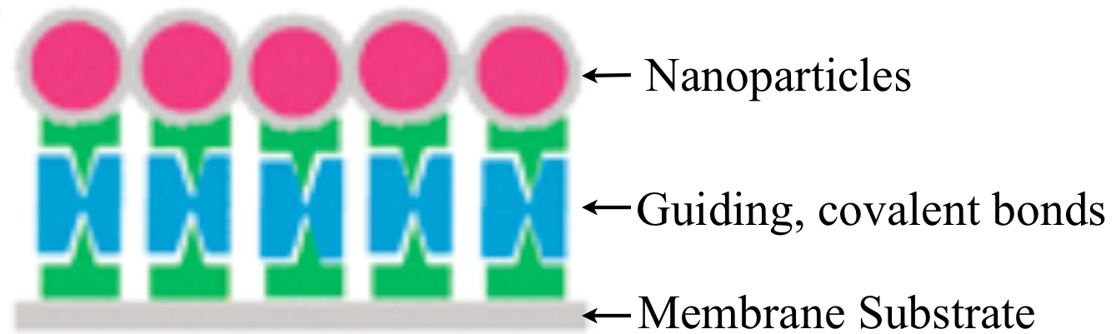

***Figure 1.*** *Guided Nanoparticle Deposition with Strengthened Bonding Between Membrane Substrate and Nanoparticles*

For comparison, Plasma enhanced atomic layer deposition (PEALD) will be employed since vapor phase deposition historically provides more accurate control in deposition density and particle size. Before the PEALD deposition, the membrane surface will go through plasma treatment to enhance adhesion between TiO2 nanoparticles and membrane surface. The nanoscale deposited particle size is achieved by the nature of atomic layer deposition (ALD), which consists of two half reactions in vapor phase, resulting in its self-limiting nature [Figure 2]. By simply controlling the number of ALD cycles, the size of deposited TiO2 nanoparticles can be accurately controlled. In addition, the density of hydroxyl groups on the membrane surface before ALD deposition is proportional to the density of the deposited TiO2, which can be adjusted by tuning both the number of ALD cycles and surface plasma treatment process parameter.

*Proposed Project Objectives*

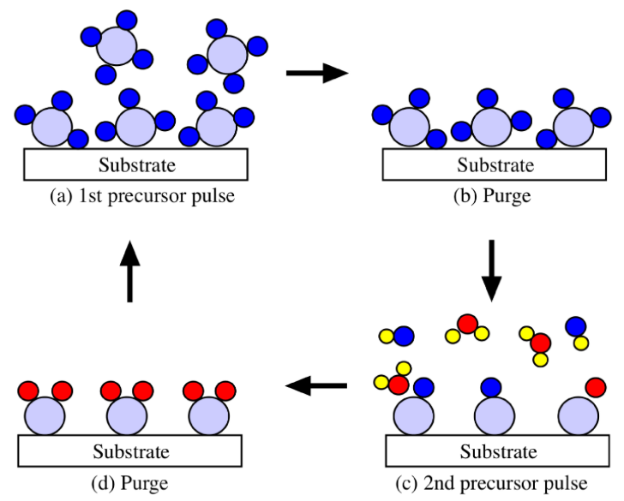

***Figure 2.*** *Schematic of ALD*

In situ photo-oxidative, hydrophilic TiO2 nanoparticles deposited via easily scalable ALD process may have the potential to heavily impact the field of cost-effective, sustainable produced water treatment by enhancing water flux and minimizing fouling caused by organic matters. To investigate the potential of this novel hybrid membrane manufacturing process, we will focus on three research goals: Research Goal #1 establishes TiO2 ALD deposition conditions using common polymer materials that have shown promise in the past or are currently being used by researchers for RO or MF applications. Research Goal #2 will explore bench scale testing of the hybrid membranes in terms of fouling resistance and permeate flux using synthetic hydrofracturing produced water sample. Naturally, we are interested in identifying the optimal deposition conditions that generates lowest fouling with enhancing permeability for long-term use, but also evaluating the short-term performance of the hybrid material will shed light on importance of how to further optimize process parameters. In addition, we will begin to evaluate the long-term membrane performance. Research Goal #3 will investigate how irradiation intensity and duration affect hybrid membrane performance in decomposing dissolved organic in produced water.

Research Goal #1: *To deposit TiO2 via ALD onto common RO/MF Polymeric Membranes.*

Research Goal #2: *To explore bench testing of the hybrid membranes in terms of fouling resistance and permeate flux using synthetic hydraulic fracturing produced water sample.*

Research Goal #3: To study the effect of irradiation

**Project Outcomes**

***Technical progress and Publications***

Throughout the funding duration, we worked on all three research goals discussed above. Specifically, detailed surface and cross-sectional characterization using x-ray photoelectron spectroscopy (XPS) and high resolution transmission electron spectroscopy (HRTEM), was carried out on polyvinylidene fluoride (PVDF) ultrafiltration membranes that were pretreated by dopamine (PDA) followed by depositing TiO2 via ALD. Part of the surface characterization results was incorporated into our manuscript that was recently resubmitted to American Chemistry Society (ACS) Omega, titled ‘*Elucidation of Titanium Dioxide Nucleation and Growth on Polydopamine Modified Nanoporous PVDF Substrate via Low Temperature Atomic Layer*’. The HRTEM and filtration data will be disseminated in two additional manuscripts that are in preparation. Our technical contribution include: 1) As shown in **Fig. 3** below, surface properties, such as contact angles, are not linearly related to the number of ALD cycles in the range of TiO2 nucleation and growth phase (<100). As a result, we find that membrane surfaces can be more finely controlled than what was reported in open literature, which consequently affect the optimum balance between water flux and fouling resistance. This finding can also be very useful in wearable sensors and smart textile fields. 2) **Fig. 4** shows that membrane pores are not significantly blocked by TiO2 nanoparticles, which we originally hypothesized.

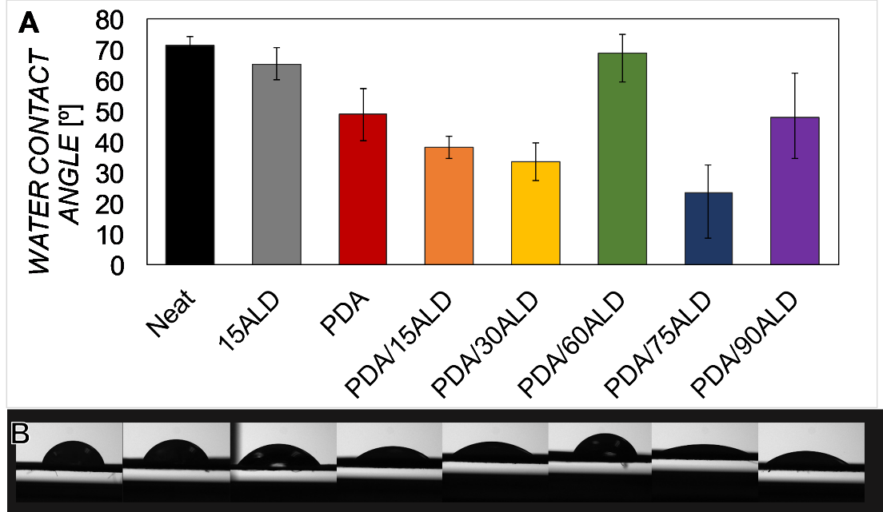

***Figure 3.*** *(a) Water contact angles for neat, 15ALD, PDA, and PDA followed by 15/30/60/75/90 ALD cycles samples and (b) corresponding water droplet images (same sample order from left to right as panel a).*

C:\Users\Andra\Documents\Research\Produced Water Research\ALD-TiO2\15PDA\SEM\SEM montage 300 dpi.tif

***Figure 4.*** *Cross-sectional SEM images of (a) neat PVDF, (b) PDA, and (c) PDA/90ALD, and (d) the top surface of PDA/90ALD.*



***Figure 5.*** *(a) DI water flux for PVDF membranes with 0-6 spray cycles on PVDF with 0, 3, 15 or 30 minutes of PDA coating, (b) effect of UV activation on DI water flux and (c) water contact angles with and without UV activation.*

We accomplished the stated research objectives of the proposal, which provide a versatile approach for fine-tuning surface properties that can be useful for various industry applications. In doing so, we identified candidate directions for produced water treatment that involves complex water chemistry, in hopes of flux enhancement that are orders of magnitude higher than existing membrane materials. One of the directions is to apply a new family of smart materials, called covalent organic framework (COF), as membrane materials. Due to the advantages of a bottom-up design approach, COF membranes can enable significant increase in both flux and rejection. In the past year, COF membranes supported on anodic aluminum oxide (AAO) were tested and showed pure water permeance of ~2260 Lm-2h-1bar-1 , which is about 20 times higher than graphene oxide membranes. COF/AAO membranes were used to treat flowback water from shale gas production using a filtration set-up (Figure 6A). The results in Figure 6 B and C show that the membrane can remove suspended and emulsified oil completely from the flowback water with a rejection rate of 100%. The total dissolved solid rejection is 25%.

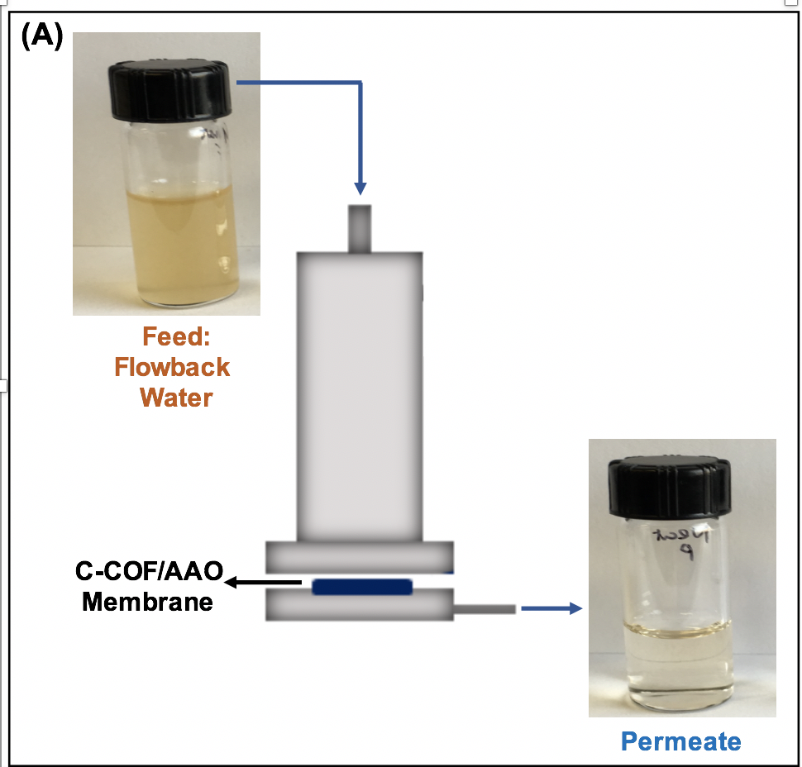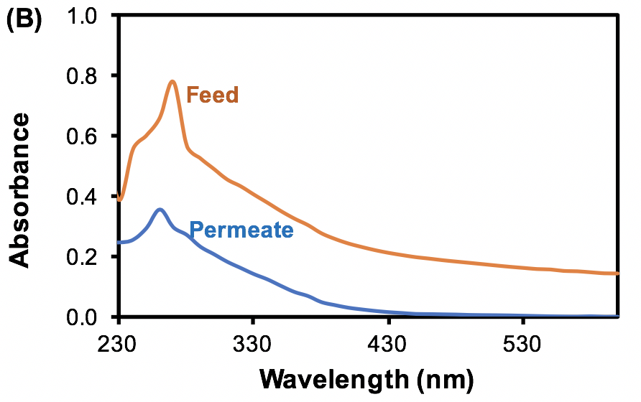

(C)

|  |  |
| --- | --- |
| **Constituent** | **Rejection (%)** |
| Oil | 100 |
| Total dissolved solid | 25 |

***Figure 6.*** *(A) Schematic of the produced water treatment process using C-COF/AAO membranes and photographs of the flowback water before treatment (feed) and the permeate after treatment, (B) UV-vis spectra of the feed and permeate, (C) the membrane removal rates towards oil and total dissolved solid presented in the flowback water.*

To test how operating pressure requirement changes for COF membranes, we used commercial PVDF as a baseline to compare COF membrane with commercial PVDF used in water treatment. Results in Figure 7 demonstrate that COF membranes (neat or dopamine modified COF) only require 3% of transmembrane operating pressure to achieve the same water flux as the commercial PVDF. Therefore, this new family of COF membranes can enable significant operating cost.



**3.5 bar**

**0.11 bar**

**0.1 bar**

***Figure 7.*** *(a) COF membrane performance. Feed: raw flowback water; transmembrane pressure: 1bar. (b) Flux decline curve comparisons. All membranes were operated at the same initial pure water flux of ~250 Lm-2h-1. Feed: raw flowback water filtered using a 0.45 µm PES membrane to minimize the effect of particulates.*

Figure 6. COF membrane performance, Feed: raw flowback water; transmembrane pressure: 1bar.

***Students who have been supported partially or fully and their achievements***

The WWDC funding has partially or fully supported Audra DeStefano (M.S. candidate), Jiashi Yin (Ph.D. candidate), Shuai Tan (Ph.D.) and Anqi Qu (Ph.D.). These highly motivated students have won national awards, passed their Ph.D. and M.S. defense and preliminary exams, as follows:

**Erik Trey Herrera, Ian Hammontree and James “Max” Weiss** **(UW undergraduates):**

Trey was partially supported as an undergraduate researcher in Spring, Summer and Fall 2016. He joinedAquahydrex, Inc. (Louisville, CO) after receiving his B.S. in Chemical Engineering in May 2017.

Both Ian and Max joined the Li-Oakey group in Summer 2017 as undergraduate researchers, working on various aspects of the separation/water treatment project. Their experience in the Li-Oakey lab sparked strong interests in pursuing graduate degress. Ian is continuing his research endeavor in the Li-Oakey group as a M.S. student starting summer 2018, while Max is a graduate student at Colorado School of Mines.

**Audra DeStefano (M.S.):**

1. Audra won the super competitive Elia Klein Travel award that is given to graduate students worldwide in 2016, which partially funded her trip to present a poster at North American Membrane Society (NAMS) annual meeting held in Bellevue, WA (May, 2016).
2. Audra was nominated as Own It! outstanding female undergraduate in Spring 2016.
3. Audra was awarded 2016-17 Mountain West Scholar-Athlete of the Year for her exceptional athletic, academic accomplishments and community services.
4. Audra’s gave an outstanding oral at 2017 International Congress on Membranes and Membrane Processes (ICOM). This conference is held every three years and known to be extremely selective for oral presentations and has over 30% rejection rate.
5. Audra successfully defended her M.S. thesis in Spirng 2018 and is accepted into multiple prestigious Chemical Engineering Ph.D. programs in the country, including Cornell University, University of Minnesota, University of California at Santa Barbara. She chose to go to UC Santa Barbara to prepare herself to be a faculty member.

**Jiashi Yin (Ph.D.)**

1. Jiashi won the super competitive Elia Klein Travel award that is given to graduate students worldwide in Spring 2017, which will partially fund her trip to present a poster at ICOM 2017 in San Francisco, CA (July, 2016).
2. Jiashi successfully passed her preliminary exam in Spring 2017.
3. Jiashi is preparing a manuscript on fabricating hybrid graphitic membranes for liquid separation including produced water treatment.

**Shuai Tan (Ph.D.)**

1. Shuai successfully defended his Ph.D. in August 2016.
2. Shuai has been a postdoc researcher in my group working on fabricating supercapacitors using carbon fibers derived from Wyoming coal.

**Anqi Qu (Ph.D.)**

1. Anqi Qu reached out to me from Columbia University (New York, US), while finishing her M.S. at Columbia University. She has learned a ton about the project and just did a great group meeting presentation about her literature survey.

**Conference Presentations**

The WWDC funding has enabled us to travel to national conferences for students to present our work and the PI to chair or co-chair sessions including:

1. For the PI, with support from WWDC (partial or full), I was able to chair/co-chair sessions for the following conferences/sessions:
   1. The PI gave two presentations (oral and poster) in 2019 NAMS.
   2. Session co-chair at International Congress of Membranes and Membrane Processes (ICOM), Nanofiltration Session, July 29-August 4, 2017.
   3. Session co-chair at AIChE 2016 Annual Conference, Micro and Nanofabricated Sensors Session, San Francisco, CA, November 2016.
   4. Session co-Chair for NAMS 2016 Annual Conference, Membrane Reactors and Contactors Session, Boston, MA, May 2016.
2. Students Presentations:

Default: oral presentation; Poster presentations will be noted in parenthesis after the title. Unless otherwise noted, all students presentations were given by the students, with student names being underscored and bolded, if they were supported either fully or partially by WWDC grant.

1. Fouling-Resistant Two-Dimensional (2D) Covalent Organic Framework Membranes for Industrial Water Reuse (poster), Phuoc H. H. Duong, Valerie A. Kuehl, Mohammad Masirul Afroz, John O. Hoberg, Bruce A. Parkinson, and **Katie D. Li-Oakey,** 28th North American Membrane Society (NAMS) Annual Meeting, May 11-15, 2019, Pittsburg, PA.
2. Two-Dimensional (2D) Covalent Organic Framework Mixed-Matrix Membranes, Phuoc H. H. Duong, Valerie A. Kuehl, Bruce Mastorovich, John O. Hoberg , Bruce A. Parkinson, and **Katie D. Li-Oakey,** 28thNorth American Membrane Society (NAMS) Annual Meeting, May 11-15, 2019, Pittsburg, PA.
3. Optimizing layer by layer approach via ultrasonic spray technique: a case study of depositing anatase titanium dioxide and polydopamine to reduce fouling while enhancing water flux, Audra DeStefano, and **Dongmei Li**, 255th ACS National Meeting, New Orleans, LA, March 18-22, 2018.
4. 2D Material-based Membranes for Ionic Liquid Recycling*, Jiashi Yin, Shuai Tan, Ian Hammontree and Dongmei Li, 255th ACS National Meeting, New Orleans, LA, March 18-22, 2018.
5. Manipulating surface properties of polymeric membranes by polydopamine guided atomic layer deposition of titanium dioxide’ (poster), **Audra DeStefano** and Dongmei Li, Annual Material Science and Engineering Symposium, Laramie, WY, March 21, 2017.
6. Optimizing layer by layer approach via ultrasonic spray technique: A case study of depositing anatase titanium dioxide and polydopamine to reduce fouling while enhancing water flux, **Audra DeStefano** and Dongmei Li American Chemistry Society (ACS), New Orleans, LA, March 17-23, 2018 (The PI had to present Audra’s work at ACS due to the time conflict with MSE symposium).
7. Nitrogen-containing graphitic membrane for ion selective separation’ (poster)*,* **Jiashi Yin**, **E. Trey Herrera**, Jordan Brophy, John Hoberg, Bruce Parkinson and Dongmei Li,ICOM 2017, San Francisco, CA, July 29 - August 4, 2017.
8. *Surface engineering of polymeric membranes: what is the impact of pre-treatment on sequential vapor phase nanoparticle deposition?*, **Audra DeStefano**, **Jiashi Yin**, T. Kraus, Bruce Parkinson and Dongmei Li, ICOM 2017, San Francisco, CA, July 29 – August 4, 2017.
9. *Experimentally Probing Ligand-Strain Effect via a Novel Catalyst Platform*’, **Shuai Tan**, Shibely Saha, Lucun Wang, Gregory Yablonsky, John Gleaves, Rebecca R Fushimi, and Dongmei Li, AIChE 2016, San Francisco, CA, November 13-18, 2016.
10. Nanoparticle Deposition with Controlled Density and Placement (poster), **Audra DeStefano** and Dongmei Li**,** North America Membrane Society (NAMS), Bullevell, WA, May 21-25, 2016.
11. Fabrication of Catalytic Micro-Membrane Reactor (CMMR) by Using Nanosize Catalysts and Atomic Layer Deposition (ALD) (poster*),* **Shuai Tan** and Dongmei Li, Consortium for Interface Reaction and Catalyst Engineering (CIRCE), Idaho National Laboratory, Idaho Falls, IA, March 21-22, 2016.

**Patent**

Two-Dimensional Nanoporous Covalent Organic Framework For Selective Separation And Filtration Membrane Formed Therefrom, Provisional Patent, 62/718,548, filed on August 14th, 2018. Katie Dongmei Li-Oakey, Phuoc Duong, Jiashi Yin, Valerie Kuehl, Bruce Parkinson and John Hoberg.

**Publications**

1. Two-dimensional Molybdenum Disulfide Based Membranes for Ionic Liquids Separation, J. Yin, P. Hoang-Hanh Duong, S. Tan, **Katie Dongmei Li-Oakey**, Separation and Purification Technology, 226 (2019), 109-116.

<https://doi.org/10.1016/j.seppur.2019.05.090>

1. A highly-ordered nanoporous, two-dimensional covalent organic framework with modifiable pores, and its application in water purification and ion sieving, V. Kuehl, J. Yin, P. H. H. Duong, B. Mastorovich, B. Newell,  **K. D. Li-Oakey**, B. A. Parkinson, and J. O. Hoberg , Journal of American Chemical Society (JACs), 140 (2018), 18200-18207.
2. <https://doi.org/10.1021/jacs.8b11482>
3. Elucidation of Titanium Dioxide Nucleation and Growth on a Polydopamine-Modified Nanoporous Polyvinylidene Fluoride Substrate via Low-Temperature Atomic Layer Deposition, Audra DeStefano, Jiashi Yin, Theodore J. Kraus, Bruce A. Parkinson, and K**atie Dongmei Li-Oakey**, ACS Omega, 3 (2018), 10493−10502.

<https://doi.org/10.1021/acsomega.8b00864>

1. Performance evaluation of platinum-molybdenum carbide nanocatalysts with ultralow platinum loading on anode and cathode catalyst layers of proton exchange membrane fuel cells*,* Shibely Saha, José Andrés Cabrera Rodas, **Shuai Tan** and Dongmei Li, J. of Power Sources, Feb., 2018.

<https://doi.org/10.1016/j.jpowsour.2017.12.062>

1. Enhancing Oxygen Storage Capability and Catalytic Activity of Lanthanum Oxysulfide (La2O2S) Nanocatalysts by Sodium- and Iron/Sodium- Doping, **Shuai Tan** and Dongmei Li, ChemCatChem, accepted, September, 2017.

[**https://doi.org/10.1002/cctc.201701117**](https://doi.org/10.1002/cctc.201701117)

1. Active Site and Electronic Structure Elucidation of Pt Nano-particles Supported on Phase-pure Molybdenum Carbide Nanotubes, **Shuai Tan**, Lucun Wang, Shibely Saha, Rebecca R Fushimi and Dongmei Li, ACS Applied Materials and Interfaces, *9* (11), p. 9815–9822, 2017. <https://doi.org/10.1021/acsami.7b01217>
2. Nano-scale Sulfur-Tolerant Lanthanide Oxysulfide/Oxysulfate Catalysts for Water-Gas-Shift Reaction in a Novel Reactor Configuration, **Shuai Tan**, Steve Paglieri and Dongmei Li, Catalysis Communications, 73, p. 16–21, 2016.

<https://doi.org/10.1016/j.catcom.2015.10.007>