Banner Course Scheduling Manual

Distance Education and
UW-Casper Courses

Office of the Registrar
University of Wyoming
October 2018

Contents
Explanation of Codes 3
Explanation of Term Codes 4
Explanation of Instructional Methods 4
Explanation of Meeting Types 4
Logging into Banner 4
Creating Course Sections 5
Adding a New Web Conferencing Only (W) Course Section 8
Adding a New Web Conferencing with Online Component (WI) Course Section 10
Adding a New On-Site Only (S) Course Section 12
Adding a New On-Site with Online Component (SI) Course Section 13
Adding a New Web Conferencing with On-Site Meetings (WS) Course Section 15
Adding a New Web Conferencing with On-Site Meetings and Online Component (WSI) Course Section 16
Adding a New Determined by Department/Contact Department (DBD) Course Section 18
Adding a New UW-Casper Course Section 19
Link Identifiers for Lectures/Labs/Discussions 21
Setting Enrollment Limits 23
Setting Meeting Times 24
Meeting Types 25
Adding an Instructor or Instructors 26
Changing an Instructor 27
Cross-Listing Courses 28
Finding a Cross List Identifier 29
Comments and Notes 31
Course Prerequisites 33
Course Section Restrictions 34
Basic Course Information 35
Cancelling a Course 37
Deleting a Course 38
Duplicating Course Sections 39

Explanation of Codes
TERM:
  - Explanation of Term Codes
- Terms are six-digit numbers and are based upon the calendar year in which an academic year ends (Academic years begin with fall and end with summer)
- Fall = 10; Spring = 20; Summer =30
- Examples:

Fall 2017 = 201810
Spring 2018 = 201820
Summer 2018 = 201830
Fall 2018 = 201910
Spring 2019 = 201920
Summer 2019 = 201930

INSTRUCTIONAL METHOD:
  - Explanation of Instructional Methods

DBD – Contact Department
I – Online/Canvas only
S – On-site meetings (when class meets in single location)
SI – On-site meetings with online/Canvas component
W – Web conferencing
WI – Web conferencing with online/Canvas component
WS – Web conferencing and on-site meetings
WSI – Web conferencing, on-site meetings, and online/Canvas component

Note: Travel may be required for onsite sessions.

MEETING TYPES:
  - Explanation of Meeting Types
These are the meeting types used for distance education courses:
F2F – Face to Face (must be used when faculty and students are in the same physical location)
NONE – No Meeting
RMTW – Remote Web/Video
TBD – To Be Determined

Logging into Banner
Go to: https://wyoinb.uwyo.edu/welcome-index.html

Click on Production Database [BNRPROD], found under Banner 9 Admin Pages
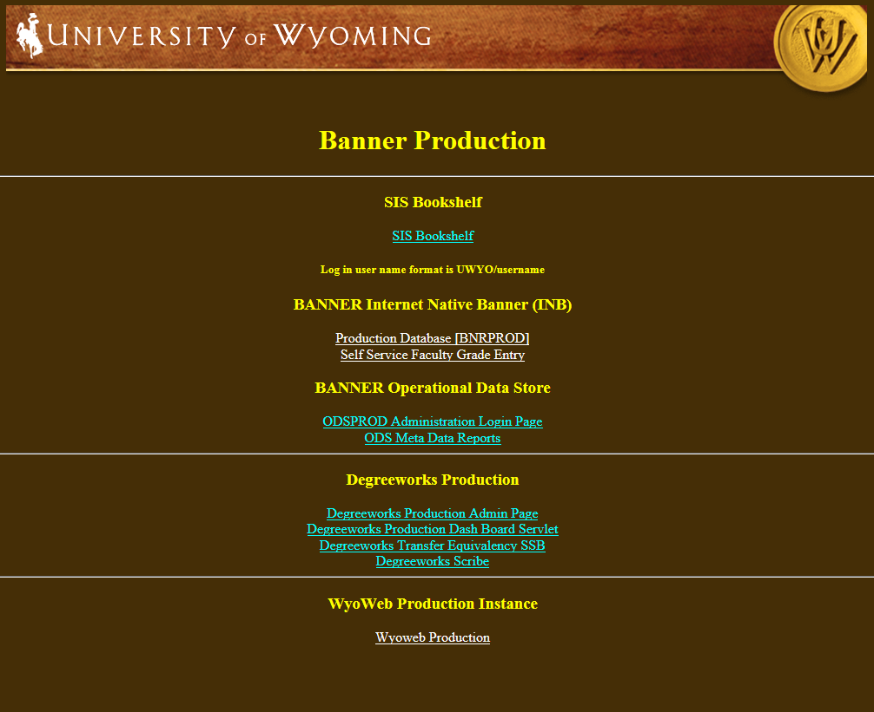
Log in with Banner user ID and password

Please note: the login process for creating and updating all types of course sections will begin with logging into Banner.

Creating Course Sections
  - Adding a New Online Only (I) Course Section
- Go To… SSASECT, press ENTER

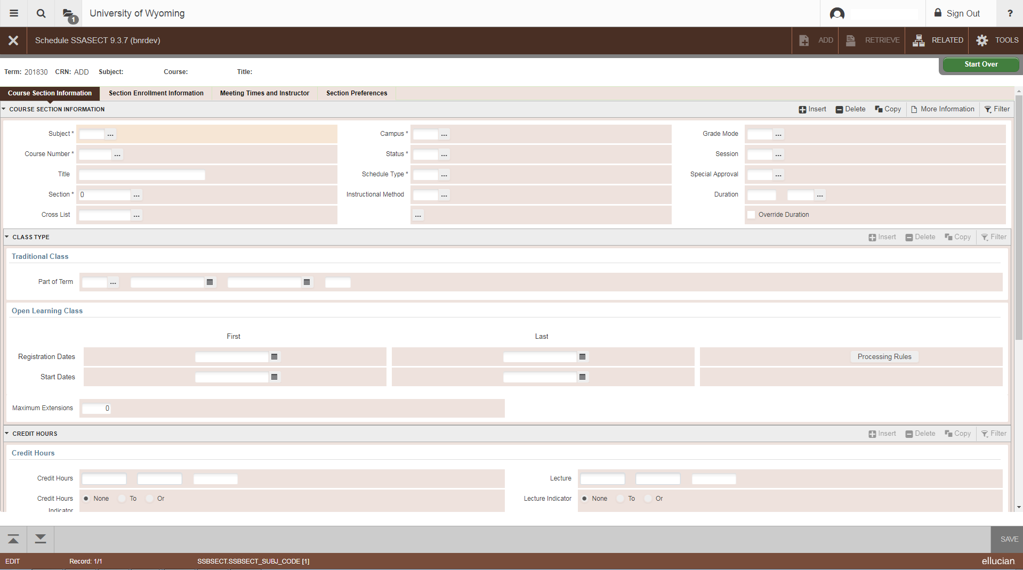
- Term: Enter the term for the course
- CRN: Type ADD in the box and then click the Create CRN button
- Subject: Fill in with appropriate course prefix
- Course Number: Fill in with appropriate course number
- Title: The course title will automatically appear as default. DO NOT CHANGE THE TITLE OF A COURSE UNLESS IT IS A TOPICS OR SEMINAR COURSE. If the course does belong to one of these categories, indicate this by adding Tp: or Sem: before the course title.
- Section: Fill in the appropriate course section number (40, 41, 42, etc.).
  - If the course section already exists, it will be highlighted in red and a popup in the upper-right corner will tell you this.
- Cross List: See Section on Cross Listing Courses in this manual
- Campus: OS = Distance Education
- Status: A = Active
- Schedule Type: LEC = Lecture; PRA = Practicum; IND = Independent Study, etc. Press the down arrow next to the field for the Schedule Type menu.
- Instructional Method: I = Online/Canvas only
- Grade Mode: Leave this field empty unless it is a laboratory, discussion, or Satisfactory/Unsatisfactory Only section. This will allow students to enroll in letter-grade courses for S/U or Audit credit. A-F courses may be offered as S/U only; S/U only courses may not be offered A-F.
  - If this section is for a laboratory or discussion, enter N for “non-graded.”
  - If this section is graded Satisfactory/Unsatisfactory only, enter S. This will automatically create a Satisfactory/Unsatisfactory Only comment on the course schedule.
- Session: Skip
- Special Approval: Y = Special Approval Required. An asterisk ( * ) will appear after the CRN in WyoRecords/the .pdf version of the schedule, indicating that students must contact the department for registration approval.
- Duration: Skip
- Part of Term: OL = Online (be sure to tab through these fields once you have entered the correct term code)
  - Summer Session parts of term are different. See the Summer Session memo for more detailed information.
- Registration Dates, Start Dates, Maximum Extensions, Prerequisite Check Method: Skip
- Credit Hours (Line 1): The first line will default to the approved credit hours for the course. This comes from SCACRSE.
  - For a fixed credit hour course, ‘None’ will be indicated, meaning that there are no variances in the hours.
  - If the course has a lecture and laboratory/discussion component, the course will appear as 0.000 Or 4.000 (or 3.000 depending on the course)
  - NOTE: Variable credit hours cannot be modified. For example, if a course is 1-8 credits, it can either be offered for fixed hours (1 or 2 or 3, etc.) or 1-8; it cannot be offered for 1-6
- Credit Hours (Line 2): If the section is the lecture part of a lecture/lab combination, enter the credit hours for the course. If the section is a laboratory or discussion, enter 0 credit hours.
  - If the has variable credit hours, but the department will be offering it for fixed hours in a specific semester, enter the fixed number of hours (e.g. 3)
- Billing Hours (Lines 1&2): See above (repeat)
- Contact hours, Lecture, Lab, and Other: This information will default; it is not necessary to enter any information
- Link Identifier: Please see section on Link Identifiers for Lectures/Labs/Discussions in this manual
- Attendance Method, Weekly Contact Hours, Daily Contact Hours: Skip
- Print: A check-mark in this box indicates that this section will print in online class schedules. Removing the check-mark will prevent the section from printing and from showing up in the Schedule_Change folder.
- Gradable: A check-mark in this box indicates that a grade will be required for this section. Remove the check-mark in this box for laboratory, discussion, and activity sections that are not graded.
- Tuition and Fee Waiver: Skip
- Voice Response and Self-Service Available: A check-mark in this box indicates that registration through WyoWeb is available. This does not override controlled enrollment. If this box is unchecked, the course will not appear on a WyoWeb class search.
- SAVE: Save your work by clicking the SAVE button or pressing F10. A CRN will appear in the CRN box.
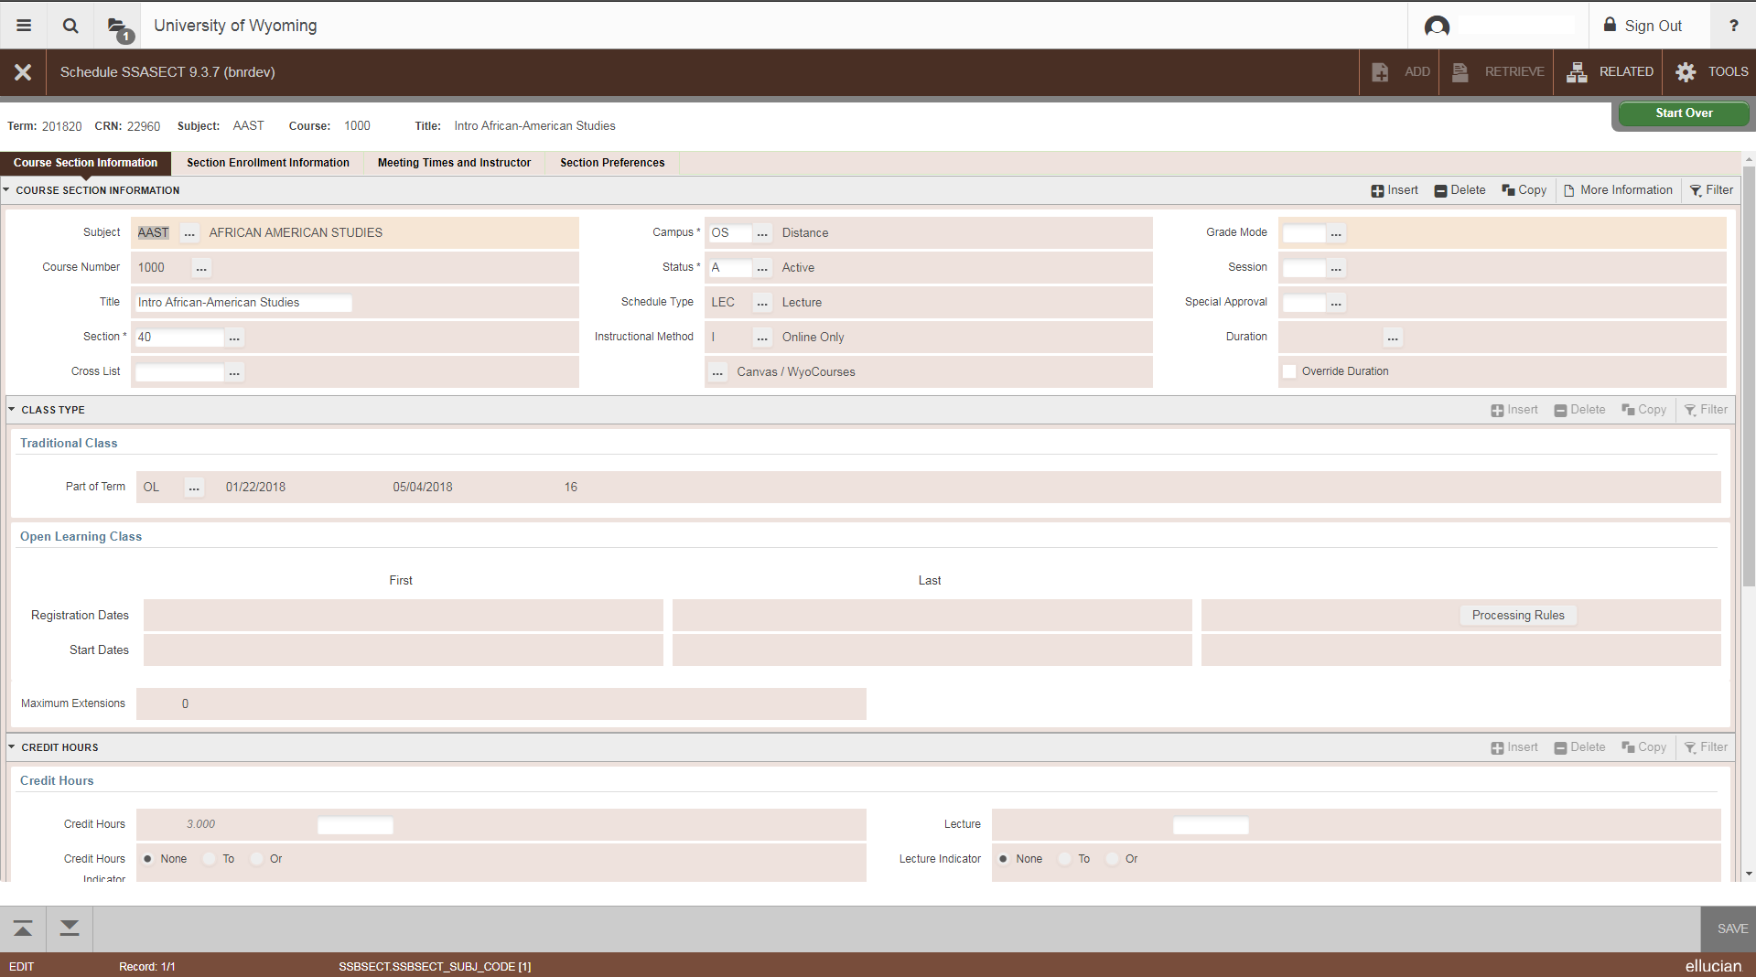
  - Adding a New Web Conferencing Only (W) Course Section
- Go To… SSASECT, press ENTER
- Term: Enter the term for the course
- Click the Create CRN button
- Subject: Fill in with appropriate course prefix
- Course Number: Fill in with appropriate course number
- Title: The course title will automatically appear as default. DO NOT CHANGE THE TITLE OF A COURSE UNLESS IT IS A TOPICS OR SEMINAR COURSE. If the course does belong to one of these categories, indicate this by adding Tp: or Sem: before the course title.
- Section: Fill in the appropriate course section number. College of Education will use section numbers 60, 61, 62, etc. Everyone else will use section numbers 80, 81, 82, etc.
  - If the course section is highlighted in blue and Banner does not let you proceed, that number already exists.
- Cross List: See Section on Cross Listing Courses in this manual
- Campus: OS = Distance Education
- Status: A = Active
- Schedule Type: LEC = Lecture; PRA = Practicum; IND = Independent Study, etc. Press the down arrow next to the field for the Schedule Type menu.
- Instructional Method: W= Web Conferencing
- Grade Mode: Leave this field empty unless it is a laboratory, discussion, or Satisfactory/Unsatisfactory Only section. This will allow students to enroll in letter-grade courses for S/U or Audit credit. A-F courses may be offered as S/U only; S/U only courses may not be offered A-F.
  - If this section is for a laboratory or discussion, enter N for “non-graded.”
  - If this section is graded Satisfactory/Unsatisfactory only, enter S. This will automatically create a Satisfactory/Unsatisfactory Only comment on the course schedule.
- Session: Skip
- Special Approval: Y = Special Approval Required. An asterisk ( * ) will appear after the CRN in WyoRecords/the .pdf version of the schedule, indicating that students must contact the department for registration approval.
- Duration: Skip
- Part of Term: O1 = Distance Education (be sure to tab through these fields once you have entered the correct term code)
  - Summer Session parts of term are different. See the Summer Session memo for more detailed information.
- Registration Dates, Start Dates, Maximum Extensions, Prerequisite Check Method: Skip
- Credit Hours (Line 1): The first line will default to the approved credit hours for the course. This comes from SCACRSE.
  - For a fixed credit hour course, ‘None’ will be indicated, meaning that there are no variances in the hours.
  - If the course has a lecture and laboratory/discussion component, the course will appear as 0.000 Or 4.000 (or 3.000 depending on the course)
  - NOTE: Variable credit hours cannot be modified. For example, if a course is 1-8 credits, it can either be offered for fixed hours (1 or 2 or 3, etc.) or 1-8; it cannot be offered for 1-6
- Credit Hours (Line 2): If the section is the lecture part of a lecture/lab combination, enter the credit hours for the course. If the section is a laboratory or discussion, enter 0 credit hours.
  - If the has variable credit hours, but the department will be offering it for fixed hours in a specific semester, enter the fixed number of hours (e.g. 3)
- Billing Hours (Lines 1&2): See above (repeat)
- Contact hours, Lecture, Lab, and Other: This information will default; it is not necessary to enter any information
- Link Identifier: Please see section on Link Identifiers for Lectures/Labs/Discussions in this manual
- Attendance Method, Weekly Contact Hours, Daily Contact Hours: Skip
- Print: A check-mark in this box indicates that this section will print in online class schedules. Removing the check-mark will prevent the section from printing and from showing up in the Schedule_Change folder.
- Voice Response and Self-Service Available: A check-mark in this box indicates that registration through WyoWeb is available. This does not override controlled enrollment. If this box is unchecked, the course will not appear on a WyoWeb class search.
- Gradable: A check-mark in this box indicates that a grade will be required for this section. Remove the check-mark in this box for laboratory, discussion, and activity sections that are not graded.
- Tuition and Fee Waiver: Skip
- SAVE: Save your work by clicking the SAVE icon or pressing F10. A CRN will appear in the CRN: box.

  - Adding a New Web Conferencing with Online Component (WI) Course Section
- Go To… SSASECT, press ENTER
- Term: Enter the term for the course
- Click the Create CRN: button
- Subject: Fill in with appropriate course prefix
- Course Number: Fill in with appropriate course number
- Title: The course title will automatically appear as default. DO NOT CHANGE THE TITLE OF A COURSE UNLESS IT IS A TOPICS OR SEMINAR COURSE. If the course does belong to one of these categories, indicate this by adding Tp: or Sem: before the course title.
- Section: Fill in the appropriate course section number. College of Education will use section numbers 60, 61, 62, etc. Everyone else will use section numbers 80, 81, 82, etc.
  - If the course section is highlighted in blue and Banner does not let you proceed, that number already exists.
- Cross List: See Section on Cross Listing Courses in this manual
- Campus: OS = Distance Education
- Status: A = Active
- Schedule Type: LEC = Lecture; PRA = Practicum; IND = Independent Study, etc. Press the down arrow next to the field for the Schedule Type menu.
- Instructional Method: WI = Online with Web Conferencing
- Grade Mode: Leave this field empty unless it is a laboratory, discussion, or Satisfactory/Unsatisfactory Only section. This will allow students to enroll in letter-grade courses for S/U or Audit credit. A-F courses may be offered as S/U only; S/U only courses may not be offered A-F.
  - If this section is for a laboratory or discussion, enter N for “non-graded.”
  - If this section is graded Satisfactory/Unsatisfactory only, enter S. This will automatically create a Satisfactory/Unsatisfactory Only comment on the course schedule.
- Session: Skip
- Special Approval: Y = Special Approval Required. An asterisk ( * ) will appear after the CRN in WyoRecords/the .pdf version of the schedule, indicating that students must contact the department for registration approval.
- Duration: Skip
- Part of Term: O1 = Distance Education (be sure to tab through these fields once you have entered the correct term code)
  - Summer Session parts of term are different. See the Summer Session memo for more detailed information.
- Registration Dates, Start Dates, Maximum Extensions, Prerequisite Check Method: Skip
- Credit Hours (Line 1): The first line will default to the approved credit hours for the course. This comes from SCACRSE.
  - For a fixed credit hour course, ‘None’ will be indicated, meaning that there are no variances in the hours.
  - If the course has a lecture and laboratory/discussion component, the course will appear as 0.000 Or 4.000 (or 3.000 depending on the course)
  - NOTE: Variable credit hours cannot be modified. For example, if a course is 1-8 credits, it can either be offered for fixed hours (1 or 2 or 3, etc.) or 1-8; it cannot be offered for 1-6
- Credit Hours (Line 2): If the section is the lecture part of a lecture/lab combination, enter the credit hours for the course. If the section is a laboratory or discussion, enter 0 credit hours.
  - If the has variable credit hours, but the department will be offering it for fixed hours in a specific semester, enter the fixed number of hours (e.g. 3)
- Billing Hours (Lines 1&2): See above (repeat)
- Contact hours, Lecture, Lab, and Other: This information will default; it is not necessary to enter any information
- Link Identifier: Please see section on Link Identifiers for Lectures/Labs/Discussions in this manual
- Attendance Method, Weekly Contact Hours, Daily Contact Hours: Skip
- Print: A check-mark in this box indicates that this section will print in online class schedules. Removing the check-mark will prevent the section from printing and from showing up in the Schedule_Change folder.
- Voice Response and Self-Service Available: A check-mark in this box indicates that registration through WyoWeb is available. This does not override controlled enrollment. If this box is unchecked, the course will not appear on a WyoWeb class search.
- Gradable: A check-mark in this box indicates that a grade will be required for this section. Remove the check-mark in this box for laboratory, discussion, and activity sections that are not graded.
- Tuition and Fee Waiver: Skip
- SAVE: Save your work by clicking the SAVE icon or pressing F10. A CRN will appear in the CRN: box.

  - Adding a New On-Site Only (S) Course Section
- Go To… SSASECT, press ENTER
- Term: Enter the term for the course
- Click the Create CRN: button
- Subject: Fill in with appropriate course prefix
- Course Number: Fill in with appropriate course number
- Title: The course title will automatically appear as default. DO NOT CHANGE THE TITLE OF A COURSE UNLESS IT IS A TOPICS OR SEMINAR COURSE. If the course does belong to one of these categories, indicate this by adding Tp: or Sem: before the course title.
- Section: Fill in the appropriate course section number. College of Education will use section numbers 60, 61, 62, etc. Everyone else will use section numbers 80, 81, 82, etc.
  - If the course section is highlighted in blue and Banner does not let you proceed, that number already exists.
- Cross List: See Section on Cross Listing Courses in this manual
- Campus: OS = Distance Education
- Status: A = Active
- Schedule Type: LEC = Lecture; PRA = Practicum; IND = Independent Study, etc. Press the down arrow next to the field for the Schedule Type menu.
- Instructional Method: S = Onsite Meetings
- Grade Mode: Leave this field empty unless it is a laboratory, discussion, or Satisfactory/Unsatisfactory Only section. This will allow students to enroll in letter-grade courses for S/U or Audit credit. A-F courses may be offered as S/U only; S/U only courses may not be offered A-F.
  - If this section is for a laboratory or discussion, enter N for “non-graded.”
  - If this section is graded Satisfactory/Unsatisfactory only, enter S. This will automatically create a Satisfactory/Unsatisfactory Only comment on the course schedule.
- Session: Skip
- Special Approval: Y = Special Approval Required. An asterisk ( * ) will appear after the CRN in WyoRecords/the .pdf version of the schedule, indicating that students must contact the department for registration approval.
- Duration: Skip
- Part of Term: Could be an O part of term (O1, O3, etc.) or could be used for J-term (J1, J2, etc.) (be sure to tab through these fields once you have entered the correct term code)
  - Summer Session parts of term are different. See the Summer Session memo for more detailed information.
- Registration Dates, Start Dates, Maximum Extensions, Prerequisite Check Method: Skip
- Credit Hours (Line 1): The first line will default to the approved credit hours for the course. This comes from SCACRSE.
  - For a fixed credit hour course, ‘None’ will be indicated, meaning that there are no variances in the hours.
  - If the course has a lecture and laboratory/discussion component, the course will appear as 0.000 Or 4.000 (or 3.000 depending on the course)
  - NOTE: Variable credit hours cannot be modified. For example, if a course is 1-8 credits, it can either be offered for fixed hours (1 or 2 or 3, etc.) or 1-8; it cannot be offered for 1-6
- Credit Hours (Line 2): If the section is the lecture part of a lecture/lab combination, enter the credit hours for the course. If the section is a laboratory or discussion, enter 0 credit hours.
  - If the has variable credit hours, but the department will be offering it for fixed hours in a specific semester, enter the fixed number of hours (e.g. 3)
- Billing Hours (Lines 1&2): See above (repeat)
- Contact hours, Lecture, Lab, and Other: This information will default; it is not necessary to enter any information
- Link Identifier: Please see section on Link Identifiers for Lectures/Labs/Discussions in this manual
- Attendance Method, Weekly Contact Hours, Daily Contact Hours: Skip
- Print: A check-mark in this box indicates that this section will print in online class schedules. Removing the check-mark will prevent the section from printing and from showing up in the Schedule_Change folder.
- Voice Response and Self-Service Available: A check-mark in this box indicates that registration through WyoWeb is available. This does not override controlled enrollment. If this box is unchecked, the course will not appear on a WyoWeb class search.
- Gradable: A check-mark in this box indicates that a grade will be required for this section. Remove the check-mark in this box for laboratory, discussion, and activity sections that are not graded.
- Tuition and Fee Waiver: Skip
- SAVE: Save your work by clicking the SAVE icon or pressing F10. A CRN will appear in the CRN: box.

  - Adding a New On-Site with Online Component (SI) Course Section
- Go To… SSASECT, press ENTER
- Term: Enter the term for the course
- Click the Create CRN: button
- Subject: Fill in with appropriate course prefix
- Course Number: Fill in with appropriate course number
- Title: The course title will automatically appear as default. DO NOT CHANGE THE TITLE OF A COURSE UNLESS IT IS A TOPICS OR SEMINAR COURSE. If the course does belong to one of these categories, indicate this by adding Tp: or Sem: before the course title.
- Section: Fill in the appropriate course section number. College of Education will use section numbers 60, 61, 62, etc. Everyone else will use section numbers 80, 81, 82, etc.
  - If the course section is highlighted in blue and Banner does not let you proceed, that number already exists.
- Cross List: See Section on Cross Listing Courses in this manual
- Campus: OS = Distance Education
- Status: A = Active
- Schedule Type: LEC = Lecture; PRA = Practicum; IND = Independent Study, etc. Press the down arrow next to the field for the Schedule Type menu.
- Instructional Method: SI = Online/Onsite Meetings
- Grade Mode: Leave this field empty unless it is a laboratory, discussion, or Satisfactory/Unsatisfactory Only section. This will allow students to enroll in letter-grade courses for S/U or Audit credit. A-F courses may be offered as S/U only; S/U only courses may not be offered A-F.
  - If this section is for a laboratory or discussion, enter N for “non-graded.”
  - If this section is graded Satisfactory/Unsatisfactory only, enter S. This will automatically create a Satisfactory/Unsatisfactory Only comment on the course schedule.
- Session: Skip
- Special Approval: Y = Special Approval Required. An asterisk ( * ) will appear after the CRN in WyoRecords/the .pdf version of the schedule, indicating that students must contact the department for registration approval.
- Duration: Skip
- Part of Term: O1 = Distance Education (be sure to tab through these fields once you have entered the correct term code)
  - Summer Session parts of term are different. See the Summer Session memo for more detailed information.
- Registration Dates, Start Dates, Maximum Extensions, Prerequisite Check Method: Skip
- Credit Hours (Line 1): The first line will default to the approved credit hours for the course. This comes from SCACRSE.
  - For a fixed credit hour course, ‘None’ will be indicated, meaning that there are no variances in the hours.
  - If the course has a lecture and laboratory/discussion component, the course will appear as 0.000 Or 4.000 (or 3.000 depending on the course)
  - NOTE: Variable credit hours cannot be modified. For example, if a course is 1-8 credits, it can either be offered for fixed hours (1 or 2 or 3, etc.) or 1-8; it cannot be offered for 1-6
- Credit Hours (Line 2): If the section is the lecture part of a lecture/lab combination, enter the credit hours for the course. If the section is a laboratory or discussion, enter 0 credit hours.
  - If the has variable credit hours, but the department will be offering it for fixed hours in a specific semester, enter the fixed number of hours (e.g. 3)
- Billing Hours (Lines 1&2): See above (repeat)
- Contact hours, Lecture, Lab, and Other: This information will default; it is not necessary to enter any information
- Link Identifier: Please see section on Link Identifiers for Lectures/Labs/Discussions in this manual
- Attendance Method, Weekly Contact Hours, Daily Contact Hours: Skip
- Print: A check-mark in this box indicates that this section will print in online class schedules. Removing the check-mark will prevent the section from printing and from showing up in the Schedule_Change folder.
- Voice Response and Self-Service Available: A check-mark in this box indicates that registration through WyoWeb is available. This does not override controlled enrollment. If this box is unchecked, the course will not appear on a WyoWeb class search.
- Gradable: A check-mark in this box indicates that a grade will be required for this section. Remove the check-mark in this box for laboratory, discussion, and activity sections that are not graded.
- Tuition and Fee Waiver: Skip
- SAVE: Save your work by clicking the SAVE icon or pressing F10. A CRN will appear in the CRN: box.

  - Adding a New Web Conferencing with On-Site Meetings (WS) Course Section
- Go To… SSASECT, press ENTER
- Term: Enter the term for the course
- Click the Create CRN: button
- Subject: Fill in with appropriate course prefix
- Course Number: Fill in with appropriate course number
- Title: The course title will automatically appear as default. DO NOT CHANGE THE TITLE OF A COURSE UNLESS IT IS A TOPICS OR SEMINAR COURSE. If the course does belong to one of these categories, indicate this by adding Tp: or Sem: before the course title.
- Section: Fill in the appropriate course section number. College of Education will use section numbers 60, 61, 62, etc. Everyone else will use section numbers 80, 81, 82, etc.
  - If the course section is highlighted in blue and Banner does not let you proceed, that number already exists.
- Cross List: See Section on Cross Listing Courses in this manual
- Campus: OS = Distance Education
- Status: A = Active
- Schedule Type: LEC = Lecture; PRA = Practicum; IND = Independent Study, etc. Press the down arrow next to the field for the Schedule Type menu.
- Instructional Method: WS = Web Conf/Onsite Meetings
- Grade Mode: Leave this field empty unless it is a laboratory, discussion, or Satisfactory/Unsatisfactory Only section. This will allow students to enroll in letter-grade courses for S/U or Audit credit. A-F courses may be offered as S/U only; S/U only courses may not be offered A-F.
  - If this section is for a laboratory or discussion, enter N for “non-graded.”
  - If this section is graded Satisfactory/Unsatisfactory only, enter S. This will automatically create a Satisfactory/Unsatisfactory Only comment on the course schedule.
- Session: Skip
- Special Approval: Y = Special Approval Required. An asterisk ( * ) will appear after the CRN in WyoRecords/the .pdf version of the schedule, indicating that students must contact the department for registration approval.
- Duration: Skip
- Part of Term: O1 = Distance Education (be sure to tab through these fields once you have entered the correct term code)
  - Summer Session parts of term are different. See the Summer Session memo for more detailed information.
- Registration Dates, Start Dates, Maximum Extensions, Prerequisite Check Method: Skip
- Credit Hours (Line 1): The first line will default to the approved credit hours for the course. This comes from SCACRSE.
  - For a fixed credit hour course, ‘None’ will be indicated, meaning that there are no variances in the hours.
  - If the course has a lecture and laboratory/discussion component, the course will appear as 0.000 Or 4.000 (or 3.000 depending on the course)
  - NOTE: Variable credit hours cannot be modified. For example, if a course is 1-8 credits, it can either be offered for fixed hours (1 or 2 or 3, etc.) or 1-8; it cannot be offered for 1-6
- Credit Hours (Line 2): If the section is the lecture part of a lecture/lab combination, enter the credit hours for the course. If the section is a laboratory or discussion, enter 0 credit hours.
  - If the has variable credit hours, but the department will be offering it for fixed hours in a specific semester, enter the fixed number of hours (e.g. 3)
- Billing Hours (Lines 1&2): See above (repeat)
- Contact hours, Lecture, Lab, and Other: This information will default; it is not necessary to enter any information
- Link Identifier: Please see section on Link Identifiers for Lectures/Labs/Discussions in this manual
- Attendance Method, Weekly Contact Hours, Daily Contact Hours: Skip
- Print: A check-mark in this box indicates that this section will print in online class schedules. Removing the check-mark will prevent the section from printing and from showing up in the Schedule_Change folder.
- Voice Response and Self-Service Available: A check-mark in this box indicates that registration through WyoWeb is available. This does not override controlled enrollment. If this box is unchecked, the course will not appear on a WyoWeb class search.
- Gradable: A check-mark in this box indicates that a grade will be required for this section. Remove the check-mark in this box for laboratory, discussion, and activity sections that are not graded.
- Tuition and Fee Waiver: Skip
- SAVE: Save your work by clicking the SAVE icon or pressing F10. A CRN will appear in the CRN: box.

  - Adding a New Web Conferencing with On-Site Meetings and Online Component (WSI) Course Section
- Go To… SSASECT, press ENTER
- Term: Enter the term for the course
- Click the Create CRN: button
- Subject: Fill in with appropriate course prefix
- Course Number: Fill in with appropriate course number
- Title: The course title will automatically appear as default. DO NOT CHANGE THE TITLE OF A COURSE UNLESS IT IS A TOPICS OR SEMINAR COURSE. If the course does belong to one of these categories, indicate this by adding Tp: or Sem: before the course title.
- Section: Fill in the appropriate course section number. College of Education will use section numbers 60, 61, 62, etc. Everyone else will use section numbers 80, 81, 82, etc.
  - If the course section is highlighted in blue and Banner does not let you proceed, that number already exists.
- Cross List: See Section on Cross Listing Courses in this manual
- Campus: OS = Distance Education
- Status: A = Active
- Schedule Type: LEC = Lecture; PRA = Practicum; IND = Independent Study, etc. Press the down arrow next to the field for the Schedule Type menu.
- Instructional Method: WSI = Online/Web Conf/Onsite
- Grade Mode: Leave this field empty unless it is a laboratory, discussion, or Satisfactory/Unsatisfactory Only section. This will allow students to enroll in letter-grade courses for S/U or Audit credit. A-F courses may be offered as S/U only; S/U only courses may not be offered A-F.
  - If this section is for a laboratory or discussion, enter N for “non-graded.”
  - If this section is graded Satisfactory/Unsatisfactory only, enter S. This will automatically create a Satisfactory/Unsatisfactory Only comment on the course schedule.
- Session: Skip
- Special Approval: Y = Special Approval Required. An asterisk ( * ) will appear after the CRN in WyoRecords/the .pdf version of the schedule, indicating that students must contact the department for registration approval.
- Duration: Skip
- Part of Term: O1 = Distance Education (be sure to tab through these fields once you have entered the correct term code)
  - Summer Session parts of term are different. See the Summer Session memo for more detailed information.
- Registration Dates, Start Dates, Maximum Extensions, Prerequisite Check Method: Skip
- Credit Hours (Line 1): The first line will default to the approved credit hours for the course. This comes from SCACRSE.
  - For a fixed credit hour course, ‘None’ will be indicated, meaning that there are no variances in the hours.
  - If the course has a lecture and laboratory/discussion component, the course will appear as 0.000 Or 4.000 (or 3.000 depending on the course)
  - NOTE: Variable credit hours cannot be modified. For example, if a course is 1-8 credits, it can either be offered for fixed hours (1 or 2 or 3, etc.) or 1-8; it cannot be offered for 1-6
- Credit Hours (Line 2): If the section is the lecture part of a lecture/lab combination, enter the credit hours for the course. If the section is a laboratory or discussion, enter 0 credit hours.
  - If the has variable credit hours, but the department will be offering it for fixed hours in a specific semester, enter the fixed number of hours (e.g. 3)
- Billing Hours (Lines 1&2): See above (repeat)
- Contact hours, Lecture, Lab, and Other: This information will default; it is not necessary to enter any information
- Link Identifier: Please see section on Link Identifiers for Lectures/Labs/Discussions in this manual
- Attendance Method, Weekly Contact Hours, Daily Contact Hours: Skip
- Print: A check-mark in this box indicates that this section will print in online class schedules. Removing the check-mark will prevent the section from printing and from showing up in the Schedule_Change folder.
- Voice Response and Self-Service Available: A check-mark in this box indicates that registration through WyoWeb is available. This does not override controlled enrollment. If this box is unchecked, the course will not appear on a WyoWeb class search.
- Gradable: A check-mark in this box indicates that a grade will be required for this section. Remove the check-mark in this box for laboratory, discussion, and activity sections that are not graded.
- Tuition and Fee Waiver: Skip
- SAVE: Save your work by clicking the SAVE icon or pressing F10. A CRN will appear in the CRN: box.

  - Adding a New Determined by Department/Contact Department (DBD) Course Section
- Go To… SSASECT, press ENTER
- Term: Enter the term for the course
- Click the Create CRN: button
- Subject: Fill in with appropriate course prefix
- Course Number: Fill in with appropriate course number
- Title: The course title will automatically appear as default. DO NOT CHANGE THE TITLE OF A COURSE UNLESS IT IS A TOPICS OR SEMINAR COURSE. If the course does belong to one of these categories, indicate this by adding Tp: or Sem: before the course title.
- Section: Fill in the appropriate course section number. College of Education will use section numbers 60, 61, 62, etc. Everyone else will use section numbers 80, 81, 82, etc.
  - If the course section is highlighted in blue and Banner does not let you proceed, that number already exists.
- Cross List: See Section on Cross Listing Courses in this manual
- Campus: OS = Distance Education
- Status: A = Active
- Schedule Type: LEC = Lecture; PRA = Practicum; IND = Independent Study, etc. Press the down arrow next to the field for the Schedule Type menu.
- Instructional Method: DBD = Contact Department
- Grade Mode: Leave this field empty unless it is a laboratory, discussion, or Satisfactory/Unsatisfactory Only section. This will allow students to enroll in letter-grade courses for S/U or Audit credit. A-F courses may be offered as S/U only; S/U only courses may not be offered A-F.
  - If this section is for a laboratory or discussion, enter N for “non-graded.”
  - If this section is graded Satisfactory/Unsatisfactory only, enter S. This will automatically create a Satisfactory/Unsatisfactory Only comment on the course schedule.
- Session: Skip
- Special Approval: Y = Special Approval Required. An asterisk ( * ) will appear after the CRN in WyoRecords/the .pdf version of the schedule, indicating that students must contact the department for registration approval.
- Duration: Skip
- Part of Term: O1 = Distance Education (be sure to tab through these fields once you have entered the correct term code)
  - Summer Session parts of term are different. See the Summer Session memo for more detailed information.
- Registration Dates, Start Dates, Maximum Extensions, Prerequisite Check Method: Skip
- Credit Hours (Line 1): The first line will default to the approved credit hours for the course. This comes from SCACRSE.
  - For a fixed credit hour course, ‘None’ will be indicated, meaning that there are no variances in the hours.
  - If the course has a lecture and laboratory/discussion component, the course will appear as 0.000 Or 4.000 (or 3.000 depending on the course)
  - NOTE: Variable credit hours cannot be modified. For example, if a course is 1-8 credits, it can either be offered for fixed hours (1 or 2 or 3, etc.) or 1-8; it cannot be offered for 1-6
- Credit Hours (Line 2): If the section is the lecture part of a lecture/lab combination, enter the credit hours for the course. If the section is a laboratory or discussion, enter 0 credit hours.
  - If the has variable credit hours, but the department will be offering it for fixed hours in a specific semester, enter the fixed number of hours (e.g. 3)
- Billing Hours (Lines 1&2): See above (repeat)
- Contact hours, Lecture, Lab, and Other: This information will default; it is not necessary to enter any information
- Link Identifier: Please see section on Link Identifiers for Lectures/Labs/Discussions in this manual
- Attendance Method, Weekly Contact Hours, Daily Contact Hours: Skip
- Print: A check-mark in this box indicates that this section will print in online class schedules. Removing the check-mark will prevent the section from printing and from showing up in the Schedule_Change folder.
- Voice Response and Self-Service Available: A check-mark in this box indicates that registration through WyoWeb is available. This does not override controlled enrollment. If this box is unchecked, the course will not appear on a WyoWeb class search.
- Gradable: A check-mark in this box indicates that a grade will be required for this section. Remove the check-mark in this box for laboratory, discussion, and activity sections that are not graded.
- Tuition and Fee Waiver: Skip
- SAVE: Save your work by clicking the SAVE icon or pressing F10. A CRN will appear in the CRN: box.

  - Adding a New UW-Casper Course Section
- Go To… SSASECT, press ENTER
- Term: Enter the term for the course
- Click the Create CRN: button
- Subject: Fill in with appropriate course prefix
- Course Number: Fill in with appropriate course number
- Title: The course title will automatically appear as default. DO NOT CHANGE THE TITLE OF A COURSE UNLESS IT IS A TOPICS OR SEMINAR COURSE. If the course does belong to one of these categories, indicate this by adding Tp: or Sem: before the course title.
- Section: Fill in the appropriate course section number. UW-Casper courses use section numbers 50, 51, 52, etc. UW-Casper online courses should use the online sections numbers (40, 41, 42, etc.).
  - If the course section is highlighted in blue and Banner does not let you proceed, that number already exists.
- Cross List: See Section on Cross Listing Courses in this manual. UW-Casper courses which are cross listed with Distance Education courses may be set to restrict enrollment based on campus. Please contact the Office of the Registrar to request such a restriction.
- Campus: UWC = UW-Casper
- Status: A = Active
- Schedule Type: LEC = Lecture; PRA = Practicum; IND = Independent Study, etc. Press the down arrow next to the field for the Schedule Type menu.
- Instructional Method: TR = Traditional and applies to most courses; NT = Non-traditional (should not be used).
- Grade Mode: Leave this field empty unless it is a laboratory, discussion, or Satisfactory/Unsatisfactory Only section. This will allow students to enroll in letter-grade courses for S/U or Audit credit. A-F courses may be offered as S/U only; S/U only courses may not be offered A-F.
  - If this section is for a laboratory or discussion, enter N for “non-graded.”
  - If this section is graded Satisfactory/Unsatisfactory only, enter S. This will automatically create a Satisfactory/Unsatisfactory Only comment on the course schedule.
- Session: Skip
- Special Approval: Y = Special Approval Required. An asterisk ( * ) will appear after the CRN in WyoRecords/the .pdf version of the schedule, indicating that students must contact the department for registration approval.
- Duration: Skip
- Part of Term: W = UW/Casper (be sure to tab through these fields once you have entered the correct term code)
  - Summer Session parts of term are different. See the Summer Session memo for more detailed information.
- Registration Dates, Start Dates, Maximum Extensions, Prerequisite Check Method: Skip
- Credit Hours (Line 1): The first line will default to the approved credit hours for the course. This comes from SCACRSE.
  - For a fixed credit hour course, ‘None’ will be indicated, meaning that there are no variances in the hours.
  - If the course has a lecture and laboratory/discussion component, the course will appear as 0.000 Or 4.000 (or 3.000 depending on the course)
  - NOTE: Variable credit hours cannot be modified. For example, if a course is 1-8 credits, it can either be offered for fixed hours (1 or 2 or 3, etc.) or 1-8; it cannot be offered for 1-6
- Credit Hours (Line 2): If the section is the lecture part of a lecture/lab combination, enter the credit hours for the course. If the section is a laboratory or discussion, enter 0 credit hours.
  - If the has variable credit hours, but the department will be offering it for fixed hours in a specific semester, enter the fixed number of hours (e.g. 3)
- Billing Hours (Lines 1&2): See above (repeat)
- Contact hours, Lecture, Lab, and Other: This information will default; it is not necessary to enter any information
- Link Identifier: Please see section on Link Identifiers for Lectures/Labs/Discussions in this manual
- Attendance Method, Weekly Contact Hours, Daily Contact Hours: Skip
- Print: A check-mark in this box indicates that this section will print in online class schedules. Removing the check-mark will prevent the section from printing and from showing up in the Schedule_Change folder.
- Voice Response and Self-Service Available: A check-mark in this box indicates that registration through WyoWeb is available. This does not override controlled enrollment. If this box is unchecked, the course will not appear on a WyoWeb class search.
- Gradable: A check-mark in this box indicates that a grade will be required for this section. Remove the check-mark in this box for laboratory, discussion, and activity sections that are not graded.
- Tuition and Fee Waiver: Skip
- SAVE: Save your work by clicking the SAVE icon or pressing F10. A CRN will appear in the CRN: box.

Please note: UW-Casper courses are now rolled. You will be able to see the UW-Casper courses which have been rolled for your department by looking at the .csv file for your department in the ‘regular’ folder at \\warehouse\deptshare$\DeptShare\Schedule_Change. If you do not have access to this folder, please contact Leslie Gallagher (leslieg@uwyo.edu).

Link Identifiers for Lectures/Labs/Discussions
The Link Identifier connects lectures with their corresponding laboratory or discussion sections. This is part 1 of a 2-part process to link sections. Departments only have access to the first part. The second part must be done in the Link Connector field on SSADETL. The designations are as follows:

- One Lecture with one laboratory/discussion//activity
  - Lecture = A1
  - Laboratory = L1
  - Discussion = D1
- Two or more Lectures with specific laboratories/discussions/activities
  - Lecture = A1/A2/A3
  - Laboratory = L1/L2/L3
  - Discussion = D1/D2/D3

- Part 1 is the identification of that particular section as a lecture, laboratory, or discussion. This is done in the Link Identifier field on SSASECT.
- Part 2 connects the lecture, lab, or discussion with its counterpart, which will force student to enroll in both a lecture and a laboratory/discussion. This is done in the Link Connector field on SSADETL.
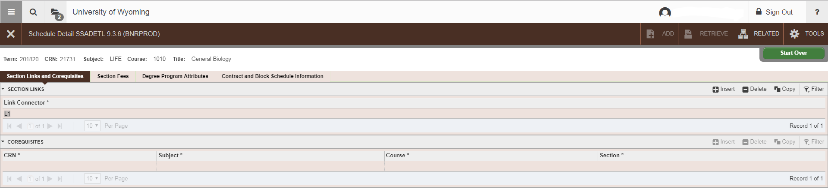

Setting Enrollment Limits
Click on the Section Enrollment Information tab
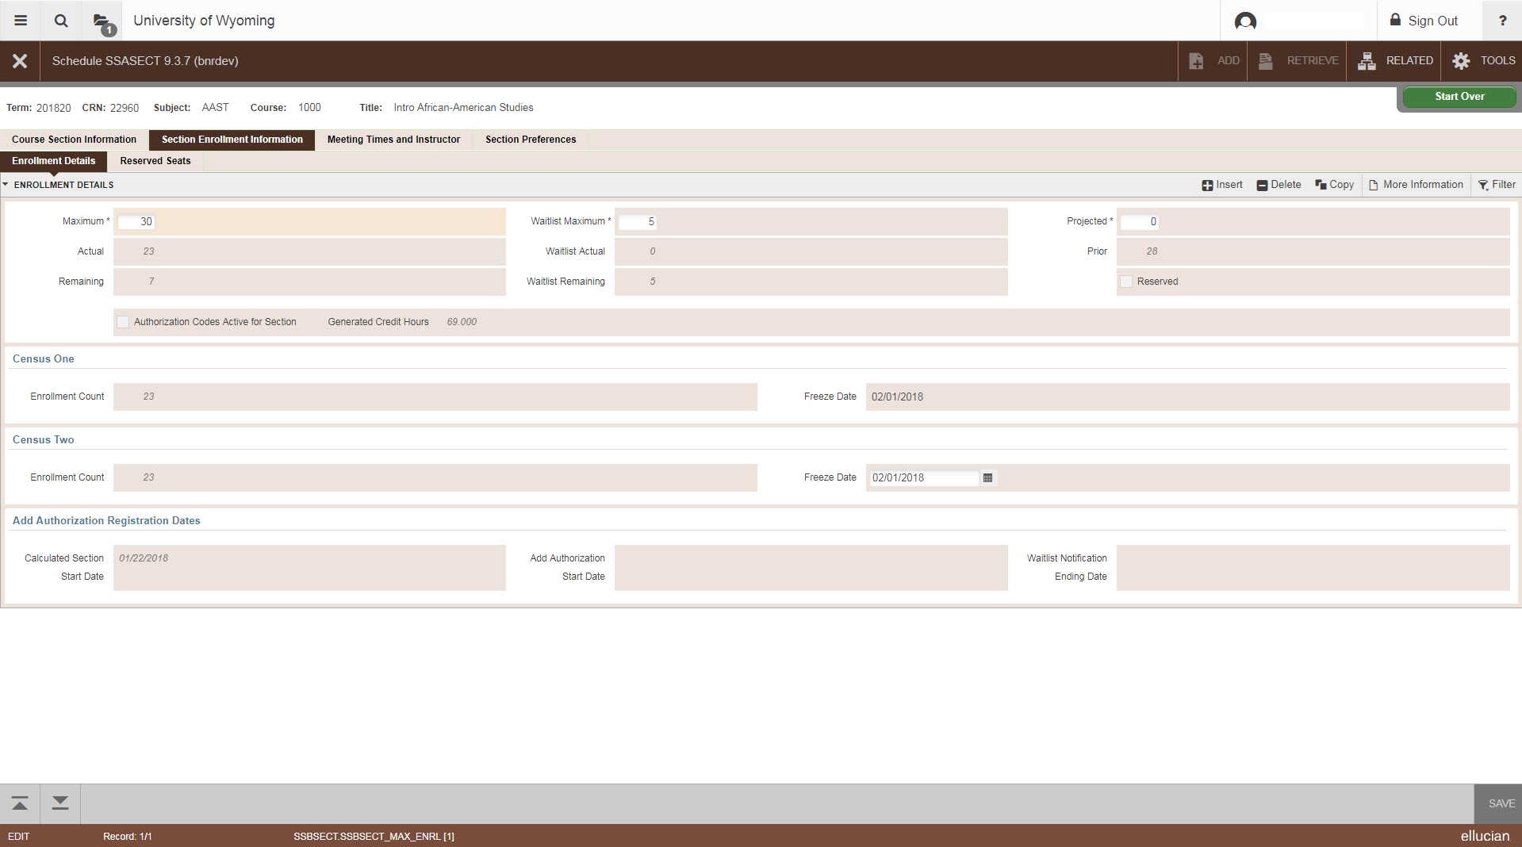
- Maximum: Enter the maximum enrollment number for this course. If the course is cross listed, this number should be the total for all combined sections. (For example, a course with 25 undergraduate seats and 5 graduate seats should be set at 30). These may need to be adjusted to match the max for all sections during room assignments and then set back or the room scheduling software may assign the smaller of the two instead of the larger.
- Waitlist Maximum: This is where waitlists are set up. Enter the number of waitlist spaces you would like to allow for this course. Please note that waitlists are automatically controlled. Please visit http://www.uwyo.edu/registrar/_files/docs/waitlistinfoadvisors.pdf for information on Automatic Waitlists.
  - Linked courses (i.e. lecture-laboratory, lecture-discussion) should have the waitlist placed on the laboratory or discussion section.
- SAVE: Save your work by clicking the SAVE icon or pressing F10.

Setting Meeting Times
From SSASECT Section Details form
Click the Meeting Times and Instructor tab
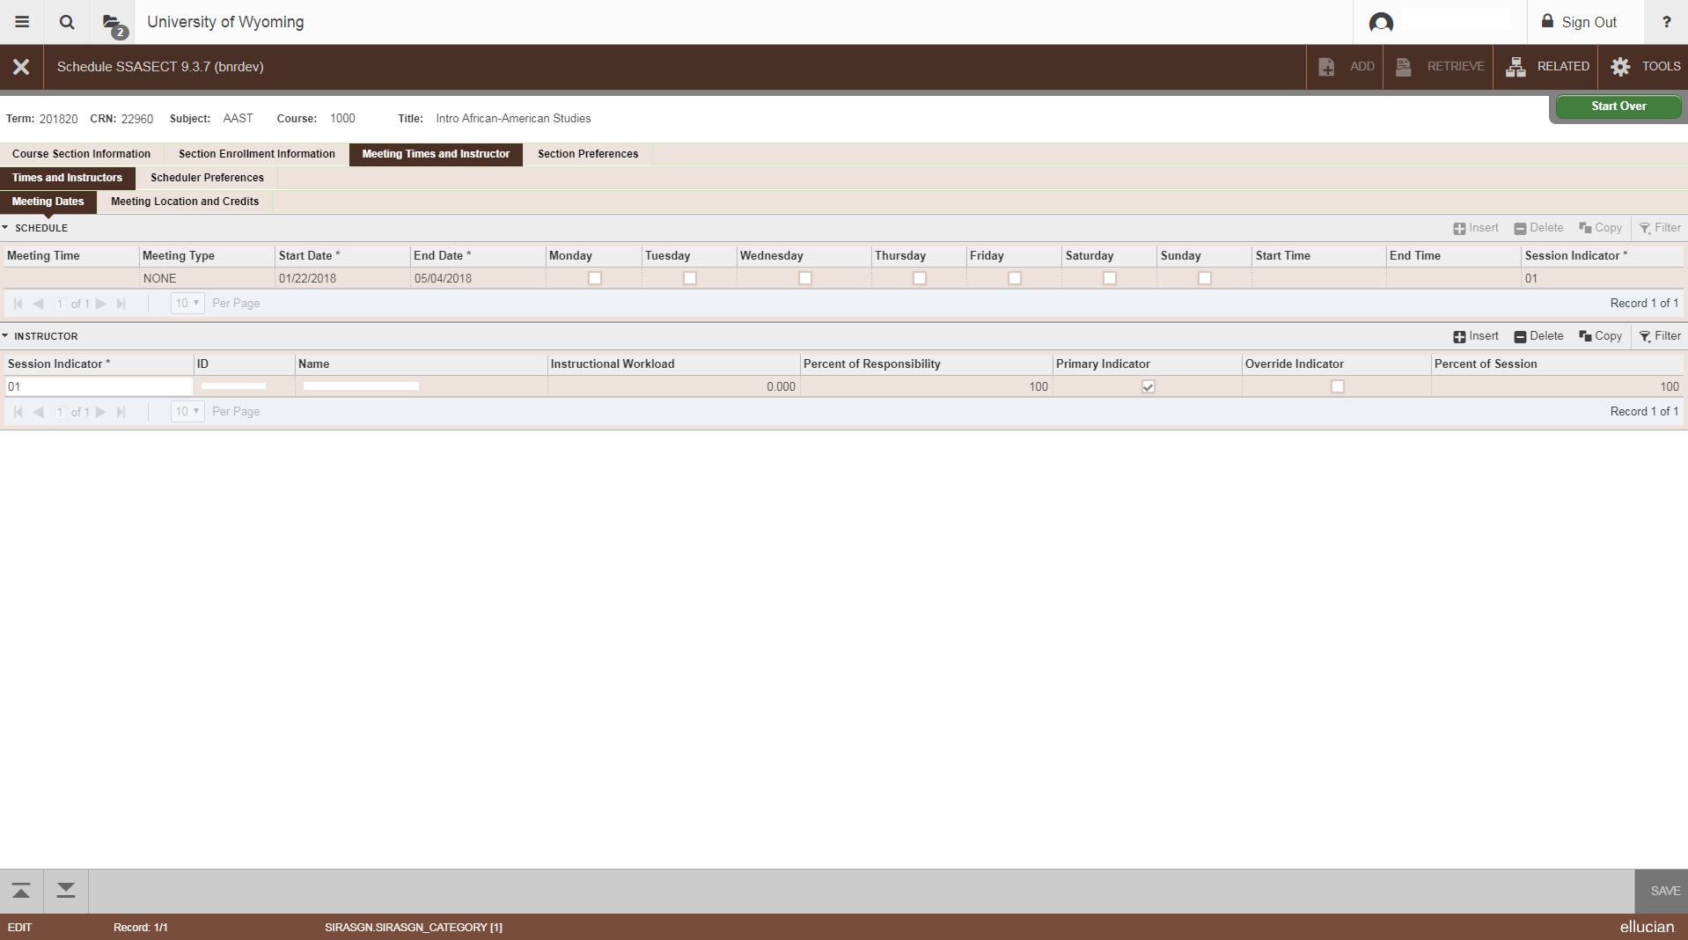

Meeting Types
Use one of the following Meeting Types based on the course you are loading:

    - Online Only (I) = NONE
    - Web Conferencing Only (W) = RMTW
    - Web Conferencing with Online Component (WI) = RMTW
    - On-Site Only (S) = F2F or RMTW if instructor is connecting via web conferencing)
    - On-Site with Online Component (SI) = NONE for the full semester listing; F2F for the on-site class meeting days/times
    - Web Conferencing with On-Site Meetings and Online Component (WSI) = RMTW for the full semester listing; F2F for on-site meetings; RMTW for the online component days/times
    - Determined by Department/Contact Department (DBD) = NONE
    - UW-Casper = CLAS

- Tab through the start date and end date fields, and the dates will self-populate based on the part of term that was selected.
- Start Time/End Time: Online only and Web Conferencing only courses will not have start times/end times. For these courses, Tab through the Start Date and End Date fields. Save. You will automatically be taken to the Hours per Week field. Enter the credit hours for the course. SAVE.
  - For courses which will require meeting times, enter the Start Time and End Time using military time (i.e. 9:00am = 0900; 12:00pm = 1200; 3:00pm = 1500)

Meeting times for most distance courses are 4:00pm-6:50pm or 7:00pm-9:50pm, Monday-Thursday. Occasionally distance courses take place during the day and follow the host community college schedule and/or a semester to semester UW-Casper schedule.

- Building and Room: If you would like to use a Distance Education room, please leave these fields blank and contact Robin Engen (rengen@uwyo.edu).
- Schedule Type: This field is populated by the Schedule Type field on the Section Details form
- Override Indicator: Skip.
- Hours Per Week: See Start Time/End Time above.
- Session Credit Hours: This field is populated by the Session Credit Hours field on the Section Details form
- Partition Details and Room Attribute Details: Skip
- SAVE: Save your work by clicking the SAVE icon or pressing F10
  - Check the notes at the bottom of the form to verify that the transaction has been processed and saved.

Adding an Instructor or Instructors
From SSASECT Section Details form
Click on the Meeting Times and Instructor tab; click on the first line of the Instructor field
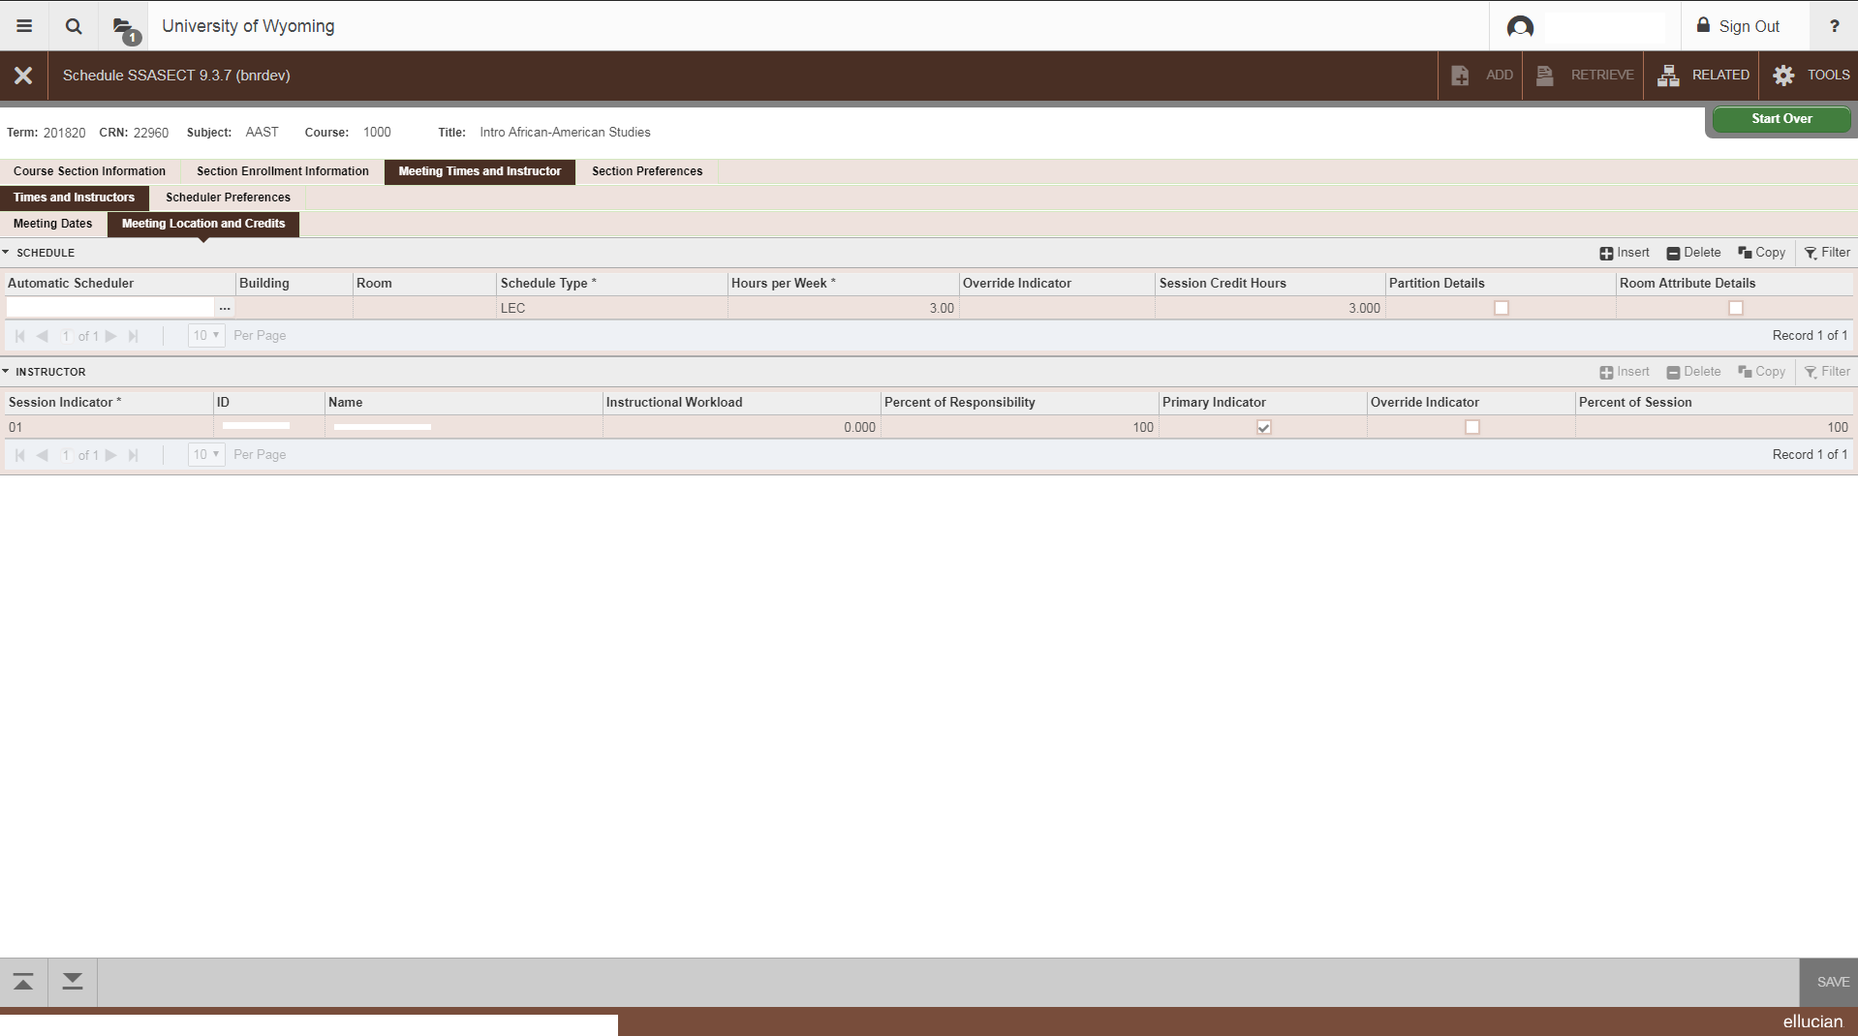
- Session Indicator: Tab through
- ID: If you know the instructor’s W ID number, enter it here. Tab.
- SAVE: Save your work by clicking the SAVE icon
  - Check the notes at the bottom of the form to verify that the transaction has been processed and saved.
  - If the course is cross listed, you may receive an ‘Instructor Schedule Conflict’ error. If this occurs, click the ‘Override Indicator’ box and save.
  - NOTE: In some cases, Banner may give an inaccurate ‘Instructor Schedule Conflict’ error for TBA courses. If this occurs, click the ‘Override Indicator’ box and save.
  - If you do not know the instructor’s W ID number, click on the drop down box for a query:
    - Faculty/Advisor Query: Next Section
    - ID: Skip; tab to next field
    - Last Name: Enter the faculty member’s last name (this field is case sensitive) or a partial last name followed by a % to search; Press Query then Execute to begin the search
      - Highlight the appropriate instructor; double-click to select. You will be returned to the previous page.
- Multiple Instructors: If multiple instructors are added, the Percent of Responsibility field may be modified to reflect the correct information.
- Percent of Responsibility: If there is just one instructor, set this at 100. If there are two, set each at 50, and so on, unless the department states otherwise.
- Primary Indicator: If multiple instructors are added, one must be chosen as the primary.
- Override Indicator: For cross listed courses, click in this box to override the instructor time conflict.
- Percent of Session: If there is just one instructor, this will default to 100. If there are two, set each at 50, and so on.
- SAVE: Save your work by clicking the SAVE icon or pressing F10
  - Check the notes at the bottom of the form to verify that the transaction has been processed and saved.
  - If the course is cross listed, you may receive an ‘Instructor Schedule Conflict’ error. If this occurs, click the ‘Override Indicator’ box and save.
  - NOTE: In some cases, Banner may give an inaccurate ‘Instructor Schedule Conflict’ error for TBA courses. If this occurs, click the ‘Override Indicator’ box and save.
- To EXIT: Click on the Course Section Information tab to return to the Section Details form

  - Changing an Instructor
- Remove the instructor by either clicking Record, then Remove, or by clicking on the Remove Record icon.
- Enter the correct instructor’s “W” ID number.
- SAVE: Save your work by clicking the SAVE icon or pressing F10.

Cross-Listing Courses
Cross listing a course in Banner indicates to the room scheduling system that only one room is needed for the cross listed courses and it adds a note in the class schedule. All course information must be added for all cross listed sections by each department. To cross list courses in Banner, from the main SSASECT page, go to:
- Related + Cross List Definitions (SSAXLST)

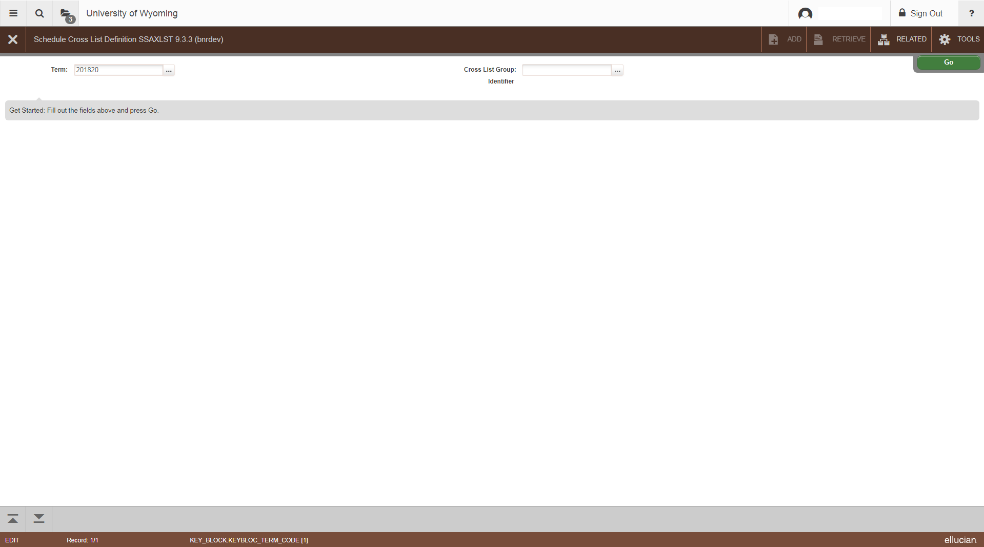

  - Finding a Cross List Identifier
  - Enter the correct term in the field.
  - Cross List Group Identifier: click the “…” box
  - With only the term field filled in, press F8 or click “Go” to execute and receive a list of identifiers already in use. Each cross listed group of courses must have a unique identifier. Always check this before creating a new group. Identifiers are two characters and should be alpha-numeric:
    - A0 to A9
    - B0 to B9
    - C0 to C9, etc.
The Cross List Section field at the bottom of the form will show which courses are combined under each identifier.
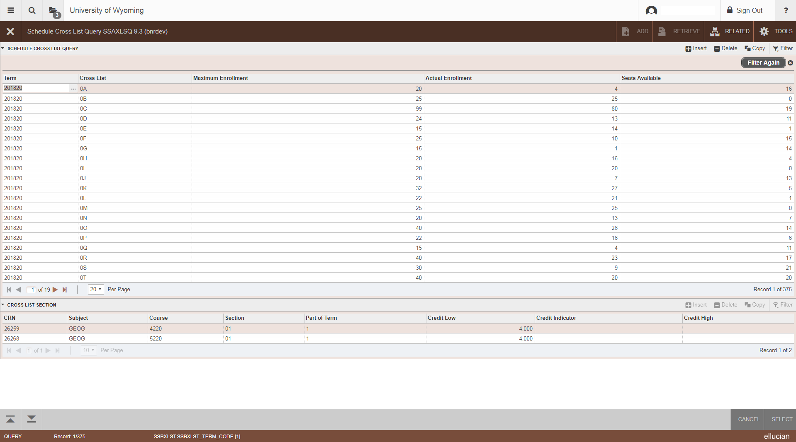
  - When searching for a cross list identifier, you should be looking for one of two options:
    - An identifier that has no courses listed beneath it;
    - A break in the pattern of identifiers. For example, in the list: A1, A2, A3, A4, C9, There is a break between A4 and C9. This means that A5, A6, A7, A8, A9, B0, B1…C8 are all available for use.
  - Once an unused identifier has been found, make a note of which identifier you would like to use, and press X to quit this query
- Enter the Cross List Group Identifier you have chosen
  - Perform a Next Section
- Set the combined maximum enrollment for the cross listed courses. This number is the end-all of enrollment limits. This means that no matter what each of the individual sections are set at, this number is the maximum enrollment limit. For example, if each section is set at 100, but this limit is set at 50, no more than 50 will be able to enroll.
  - Perform a Next Section
- CRN: Enter the CRN for each cross listed section
- SAVE: Save your work by clicking the SAVE icon or pressing F10
- EXIT: Click the X to exit or press Ctrl + Q

If a cross list group identifier has already been created for a group, a new course may be added to that group simply by entering the identifier in the Cross List field on the main SSASECT page.

When cross list groups are created, an automatic note is generated listing all courses in the group. Departments should not add a ‘Cross listed with’ note manually.

Comments and Notes
Banner has only two automatically added notes; all other notes must be manually entered.
Automatic notes (do not need to be added): Cross listed with…Satisfactory/Unsatisfactory only
- From SSASECT: Related + SSATEXT (Course Section Comments)
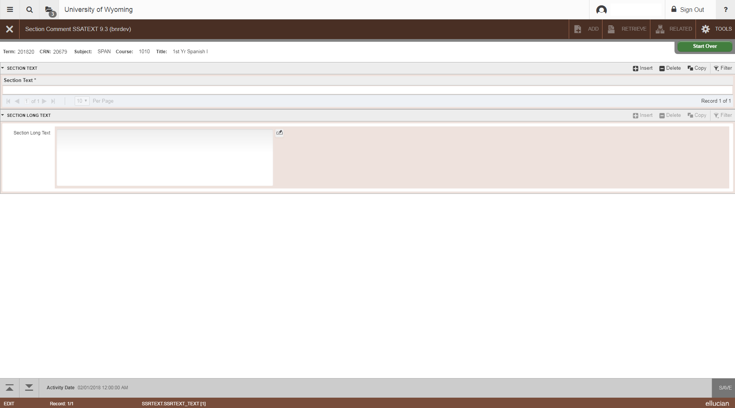
  - Click Go

- Section Text (Please note that you will not be able to view notes already loaded until you perform a Next Section).
  - Please note: Text cannot appear in both the Section Text and Section Long Text fields. If you enter text into the Section Text field, this text will override any course description information that WyoRecords pulls from the catalog section of Banner.
  - Notes may be typed in these fields. These lines do not scroll; when you reach the end of a line, you will not be able to type further. Use your arrow down key to go to the next line and continue typing. Please use proper grammar. Some standard notes should be entered as follows:

    - Meets Non-Western Certification for A&S
    - Meets A&S Core Global
    - Meets A&S Core Diversity
    - Students must enroll in a laboratory section
    - Students must enroll in a discussion section
    - Students on waitlist must attend first lecture

  - Please note that Satisfactory/Unsatisfactory Only and Cross listed with: should not be entered here. These notes will automatically print based on how the course is set up on SSASECT. Do not add notes such as Dual listed with: or Identical to:
- Section Long Text: Next Section again to see this text. Additional information, such as intensive weekend dates, that is not covered by the course description can be entered here. If this section is used, the original course catalog description must be entered here.
- SAVE: Save your work by clicking the SAVE icon or pressing F10
- EXIT: Click the X to exit

Course Prerequisites
Departments do not have access to load course prerequisites. This must be done in the Registrar’s Office. Please note that only those prerequisites which have been approved by the University Course Committee (and which appear in the University Catalog) may be loaded. To see the prerequisites set up for a course, from the main SSASECT page, go to:
- Related + Course Pre-Requisites (SSAPREQ)
- Click Go
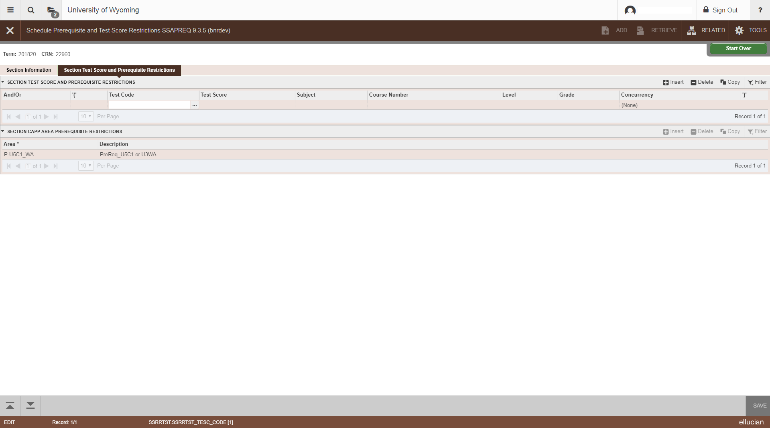
  - Course and test prerequisites are listed here.

- EXIT: Click the X

Course Section Restrictions
Departments do not have access to load course section restrictions (such as major, class standing, college restrictions). To have restrictions loaded to a course, please contact the Office of the Registrar. To see the restrictions set up for a course, from the main SSASECT page go to:
- Related + Schedule Restrictions (SSARRES)
- Click Go
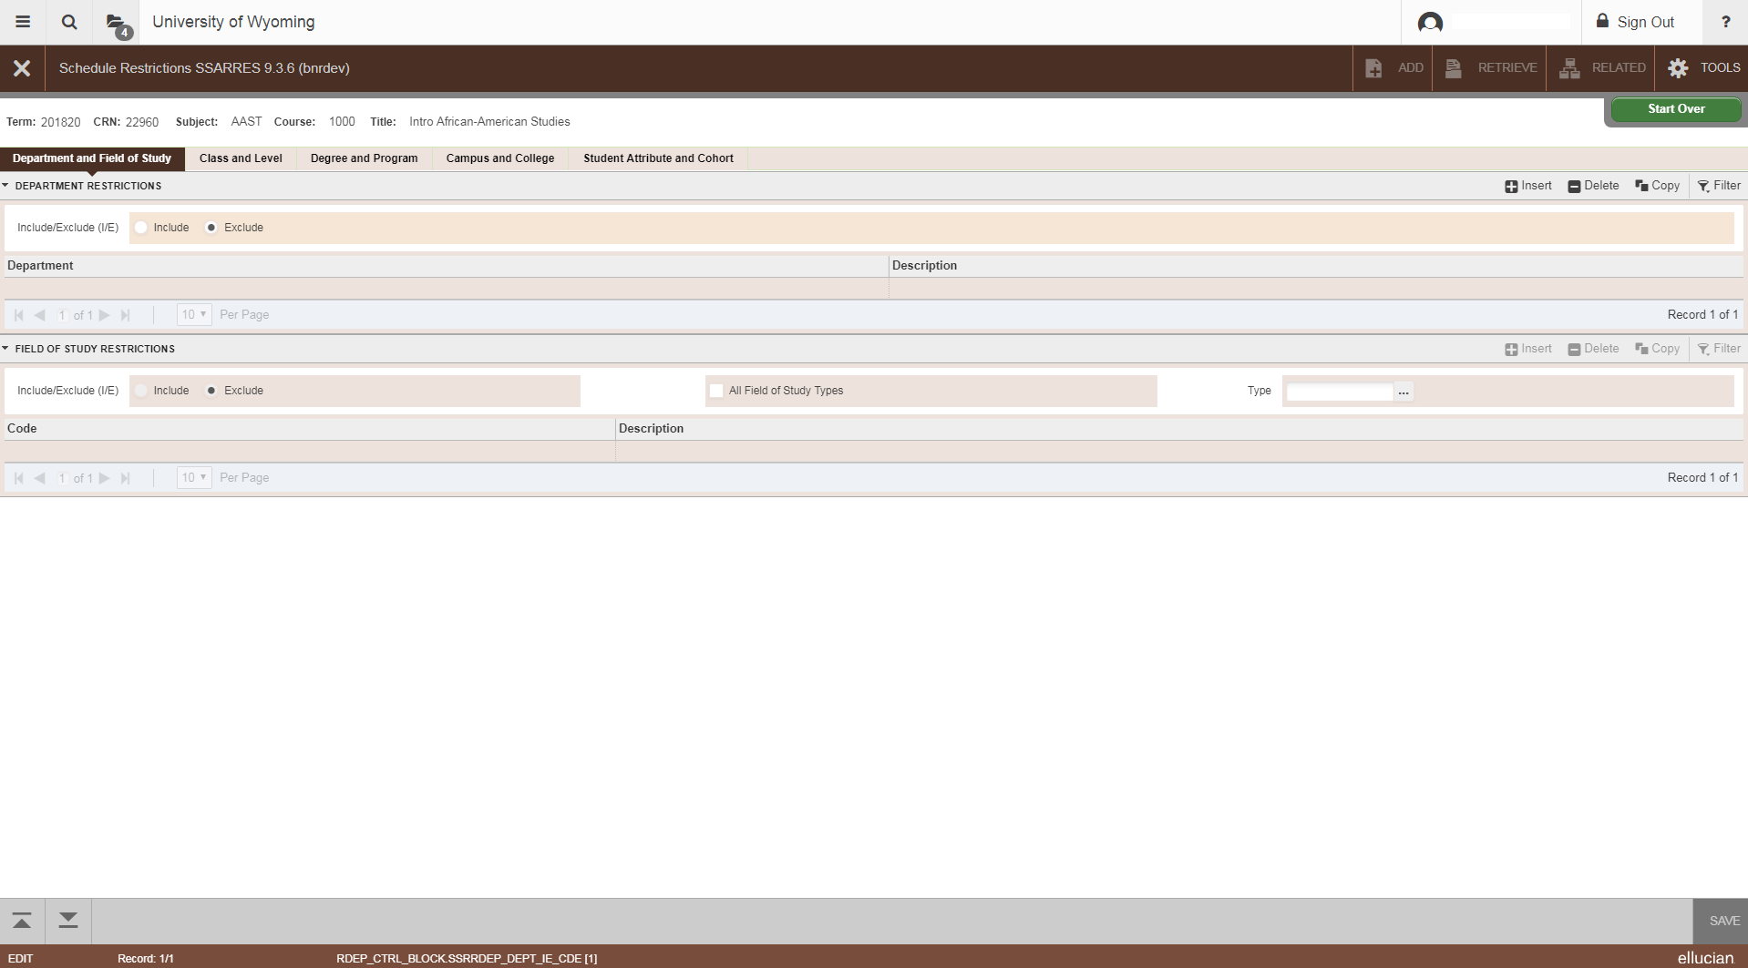
- To check all restrictions, click the tabs across the top of the page.
- EXIT: Click the X to exit

Basic Course Information
To see basic course (catalog) information:
- Related + Basic Course Information (SCACRSE)
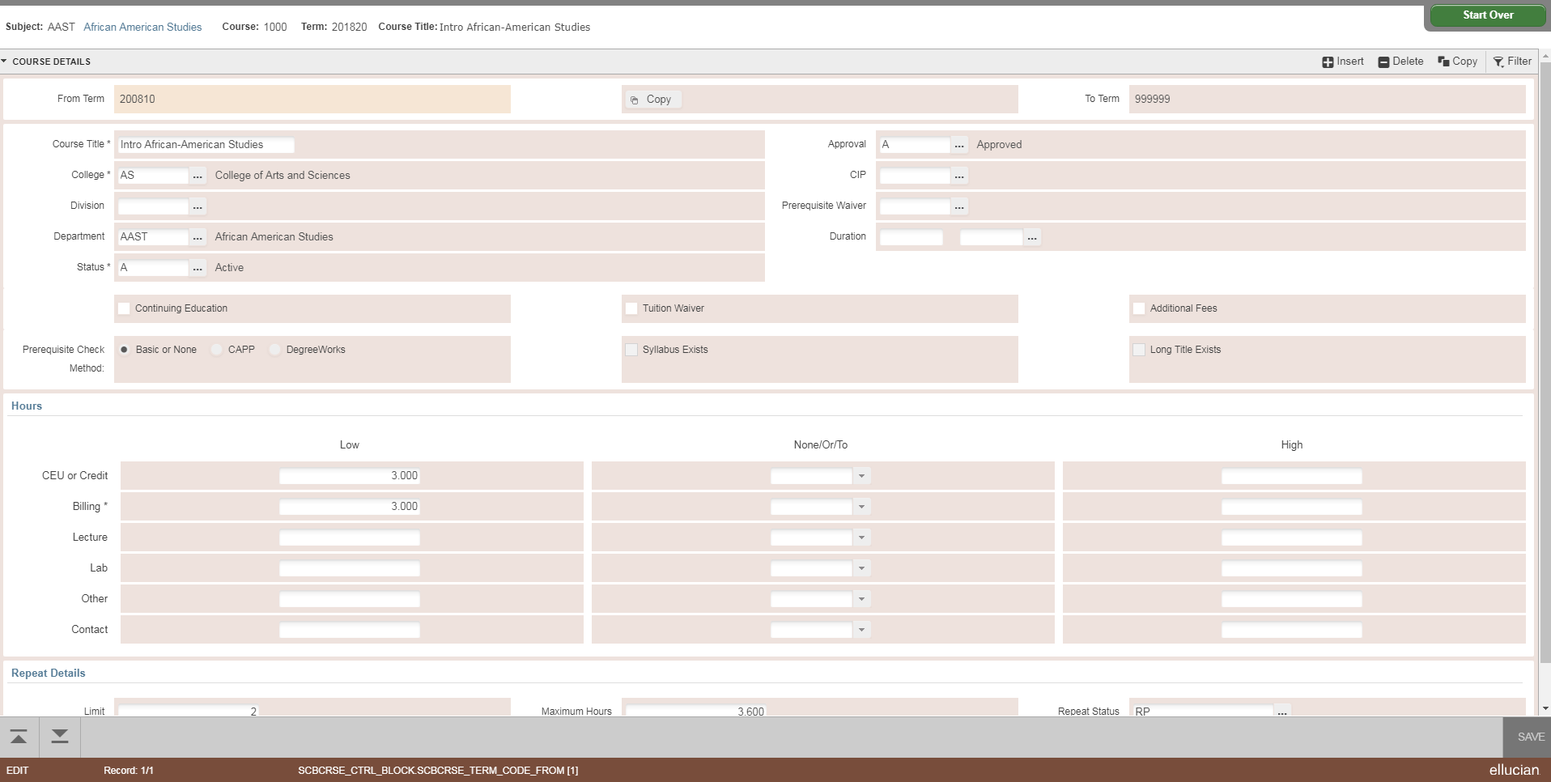
  - This will take you to SCACRSE and show catalog information such as course title and approved credit hours.

- To see the Course Description, click on Related + Course Details [SCADETL]
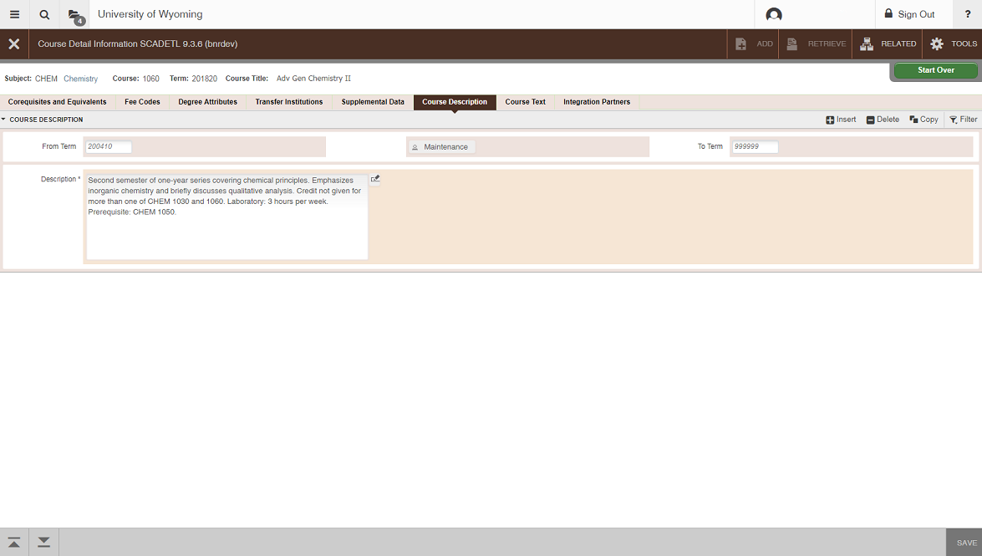
  - Click Go then click the Course Description tab

- EXIT: Click the X to exit

Cancelling a Course
Note: Enrolled students must be dropped prior to cancellation of a course. Be sure to email all students to notify them of the cancellation.

For instructions on how to drop students from a course, see the SFAMREG instruction page.

Once all students have been dropped from the course:

Go To… SSASECT, press ENTER

Enter the correct Term

Enter the correct CRN

- Click the Meeting Times and Instructor tab; click on the instructor line
  - Delete the Instructor (Record + Remove)
  - SAVE
- Click on the days/times line
  - Delete the Meeting Time information (Record + Remove)
  - SAVE
- Click on the Course Section Information tab
  - Tab to Status
  - Change from A (Active) to C (Cancelled)
- SAVE
  - Save your work by clicking the SAVE icon or pressing F10
  - Check the notes at the bottom of the form to verify that the transaction has been processed and saved.

Deleting a Course
PLEASE NOTE: Courses should ONLY be deleted in the preliminary stages of course scheduling. Once the Class Schedule has been posted online, courses should never be deleted. If they are not being offered, they should be cancelled.

Go To… SSASECT, press ENTER

Term: enter the correct term for the course

CRN: enter the correct CRN for the course
- Next Section (Alt + Page Down)
- Delete the course by clicking tools then Clear Record (Shift+F5)
- SAVE
  - Save your work by clicking the SAVE icon or pressing F10
Check the notes at the bottom of the form to verify that the transaction has been processed and saved.

Duplicating Course Sections
This process is used to create multiple sections of the same course. For example, multiple thesis or dissertation research sections, multiple laboratory or discussion sections.

Go to SSASECT and open section 01 of the course you wish to duplicate.

Section: change the section number of the course from 01 to 0

SAVE your changes by clicking the SAVE icon or pressing F10

**Be sure to make sure that this section is set up the way you want the duplicates to be. If you want the duplicates to have controlled enrollment, set it on section 0. If they should not appear in the printed schedule, uncheck the “print” box. Set the enrollment number as you would like it to be in the duplicates.

Write down the CRN for this course
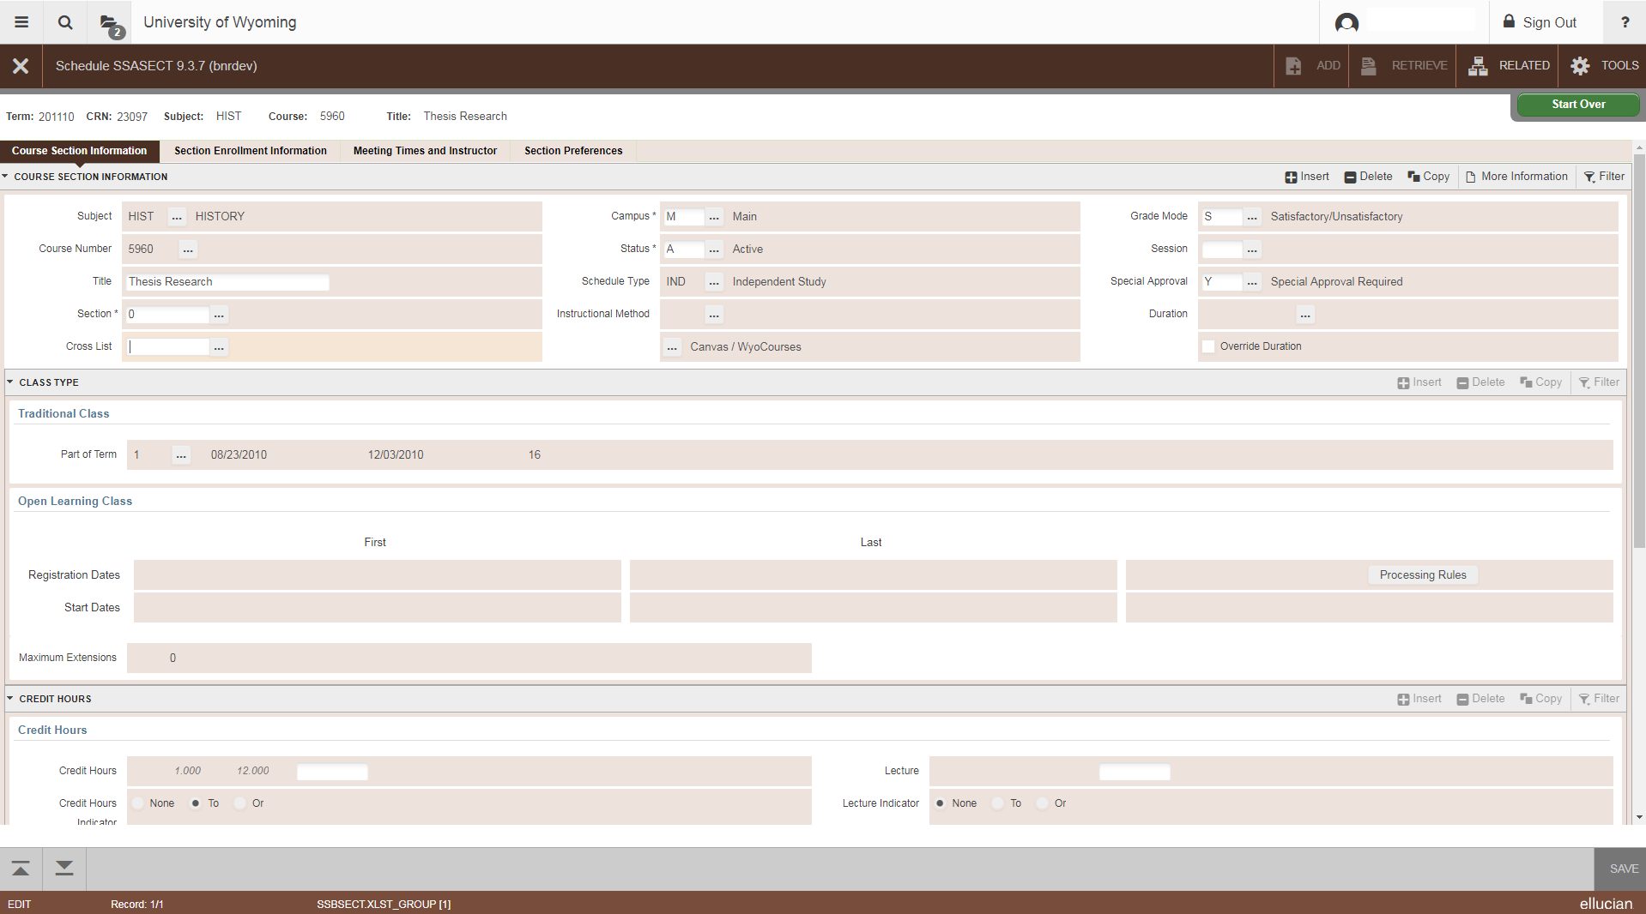

Perform a refresh (press F5 or click Start Over)

CRN: type ADD then click the Copy CRN button.

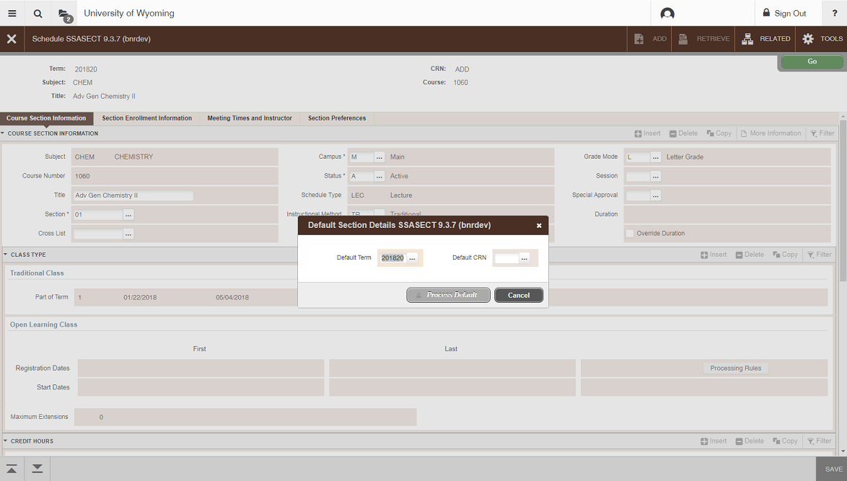
Default Term: this field should default to the term you are working on

Default CRN: enter the CRN of the section you changed to 0 (above)

Press Tab and click Process Default

Section: enter the appropriate section number, beginning with 02 (because 01 already exists)

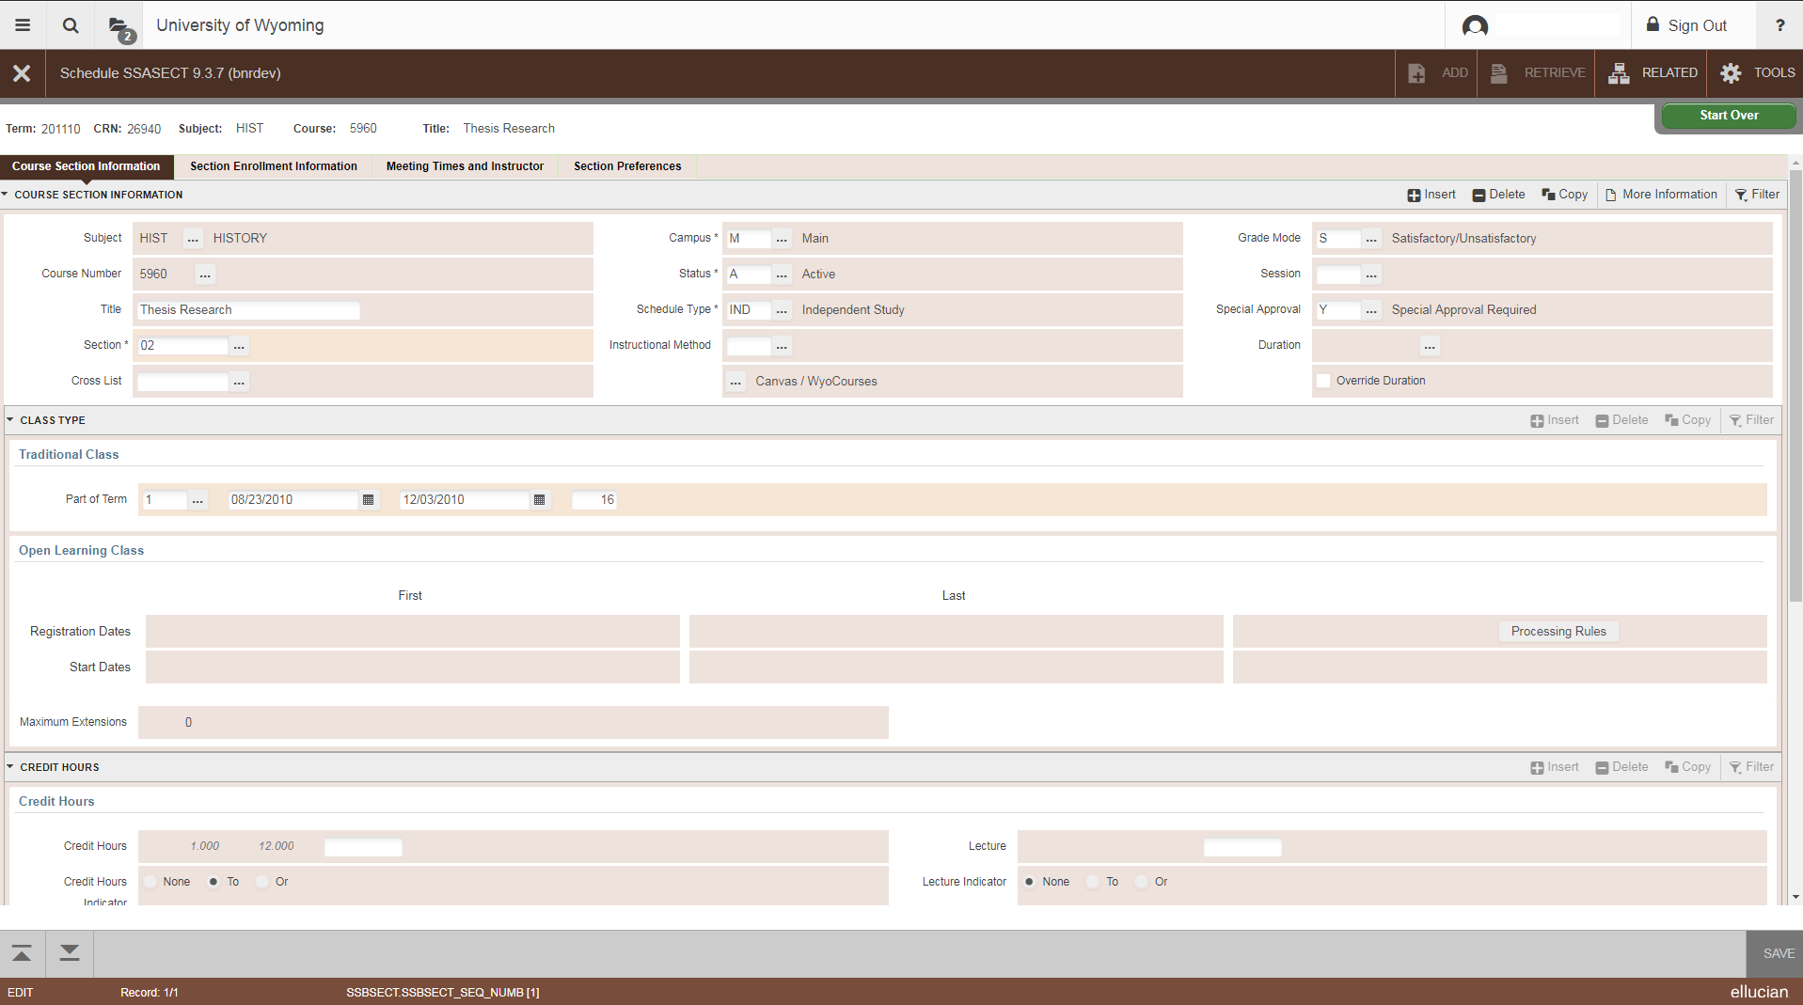

You will now have a duplicate course that looks just like section 0, but with a new CRN. Change the section number from 0 to what it should be, beginning with 02, because section 01 is your original (section numbers should be 02, 03, . . . 09, 10, etc.). You will need to enter the day/time and instructor information for these duplicated sections.

Repeat the steps to add new sections as many times as needed.
Return to the original course section on SSASECT

Section: change the section number from 0 back to 01

SAVE your changes

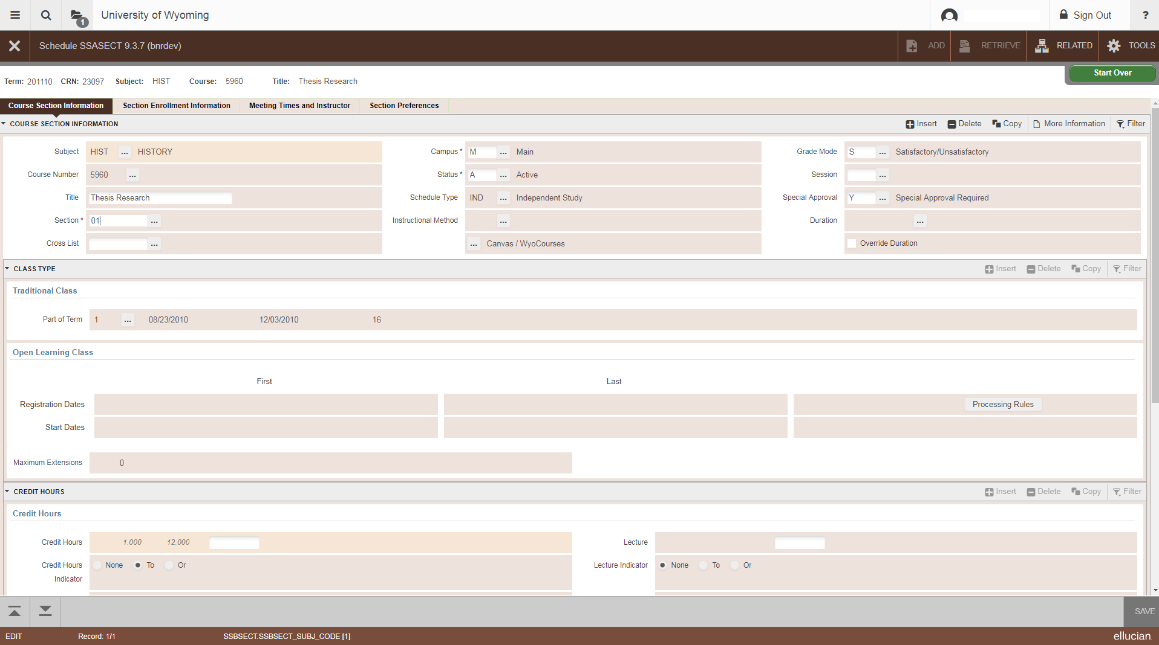

Once you have duplicated all of the sections that you need, go back to your original section (the CRN you wrote down). Change the section number from 0 back to 01 and save. If you want this course to print in the class schedule, be sure to check the “print” box.

