WHERE WAITLISTING IS SET UP IN BANNER

SSASECT is used to set up the course section with the Waitlist Option.
SSASECT will display the Course Enrollment numbers and, if the course has been set up with the Waitlist option, the Waitlist Enrollment numbers.
Each department has representatives (schedulers) that are responsible for building and maintaining course sections.
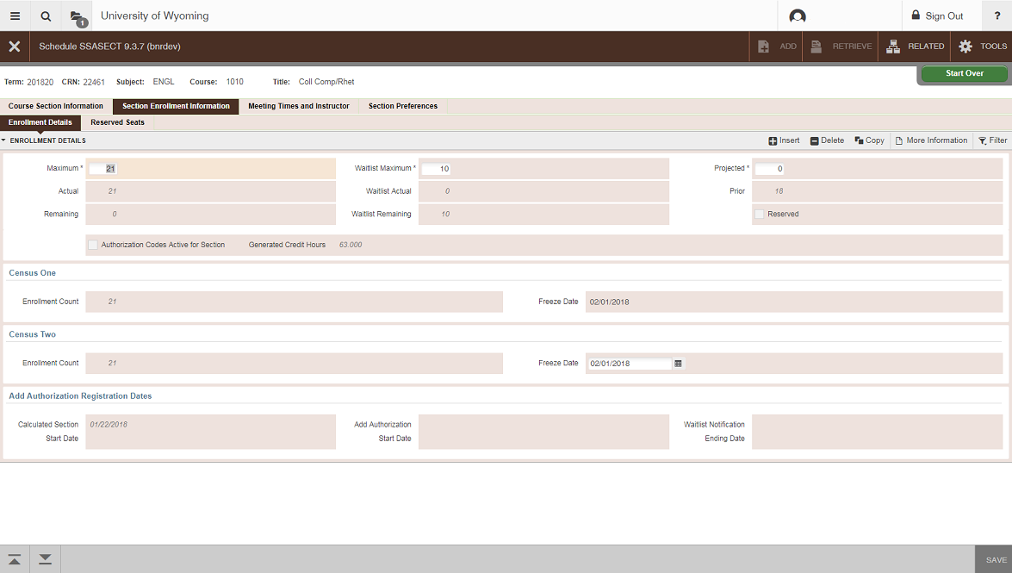
NOTE: Not all sections will have the Wait listing option.
Section has reached the Maximum enrollment meaning the class is full.
Section will allow 10 students on the Waitlist
In this example: SSASECT displays that the Maximum Enrollment has reached its limit of 21 students allowed in class, and the department will allow 10 students to add themselves to the Waitlist.
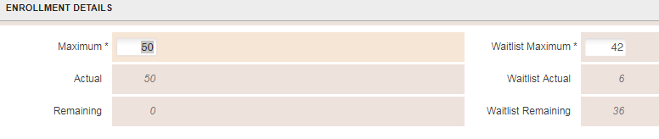
This example displays 6 students are on the waitlist and 36 more students could be added to the Waitlist. Once a seat has become available; the first student in line will be notified via email.

ADDING WAITLISTS TO COURSE SECTIONS

Departments who wish to use a waitlist on classes will need to add the waitlist option to each class section. This can be done when entering the schedule in Banner. The department will add a number for the maximum number of names allowed on the section’s waitlist. Waitlists can be used for any classes, however, when setting up a waitlist for a linked course make sure to designate the lab component as the one with the waitlist. If assistance is needed creating a course waitlist in Banner, please contact the Office of the Registrar.

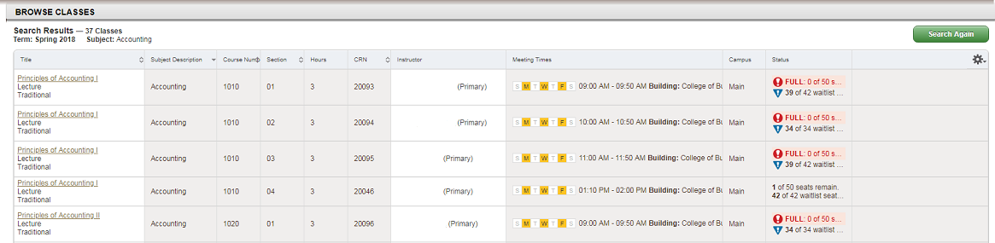
Classes that have a waitlist will indicate the cap on the schedule, in Browse Classes. In the example below, ACCT-1010-01 has an enrollment cap of 50 and 50 registered in the class. It also has a waitlist cap of 42, with 3 names already on the waitlist.

USING THE WAITLISTS DURING REGISTRATION

A class section waitlist is not available to students until the section’s enrollment is at the enrollment cap listed.

The student will need to meet any course prerequisites or restrictions, the same as if they were registering for the course, if they want to be placed on the waitlist. If they do not have the prerequisites or are restricted, they will be unable to register themselves or to place themselves on a wait list.

Once the course enrollment cap has been met, any student attempting to register will have the option to be added to the wait list. Please note that students may put themselves on more than one section’s wait list for a course, however they can only register for one section of a course.

ADDING & REMOVING STUDENTS ON THE WAIT LIST
Students can add themselves to a wait list through WyoRecords, Registration, Add or Drop classes. Information for students can be found on our website, http://www.uwyo.edu/registrar/students/registration_information.html.

A student may be on more than one course wait list, although students can only be registered for one section of a course.

CHECKING WAIT LIST STATUS THROUGH WYOWEB
Students can verify that they are on a waitlist by reviewing their Add and Drop classes screen. The class section will indicate ‘wait listed’. Students will not have the ability to verify their position on the wait list, however they will be able to see the total number of names on the wait list from the ‘Look Up Classes’ results, or when they go to add their name to a waitlist.
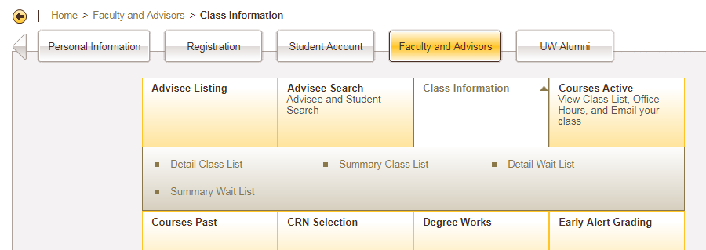
For advisors and staff, the Summary Wait list will show all the students on the wait list. You can access this list from WyoRecords, on the Faculty and Advisors tab, under Class Information.

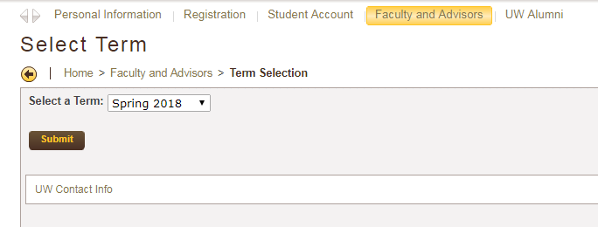
If you have a course listed for the term, Banner will show that course first. However, you can also choose to review any class wait list by clicking on ‘Enter CRN Directly’, then entering the CRN number of the course, and clicking Submit.
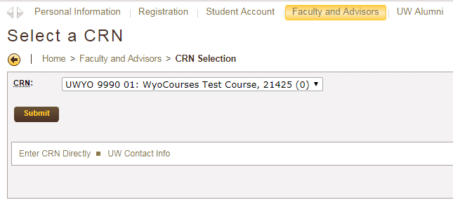

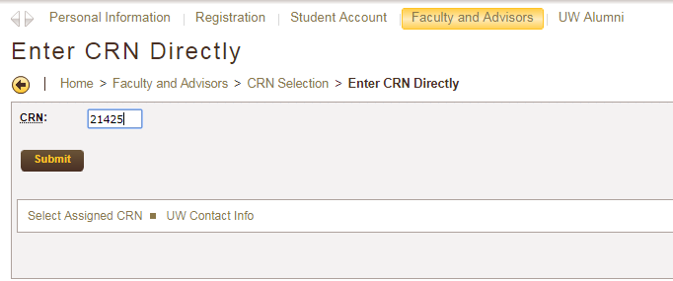

This Summary wait list tells you the total number of students who have their name on the wait list, as well as their waitlist position. The waitlist position of 0 indicates that person has been sent a notification that a seat is available. This also lists the date and time that notification will expire. The student must log into WyoRecords, and register for that seat before the notification expires. If they do not, at the point the notification expires their name will be automatically removed from the waitlist and the next person on the list (in waitlist position order) will be notified of the open seat.
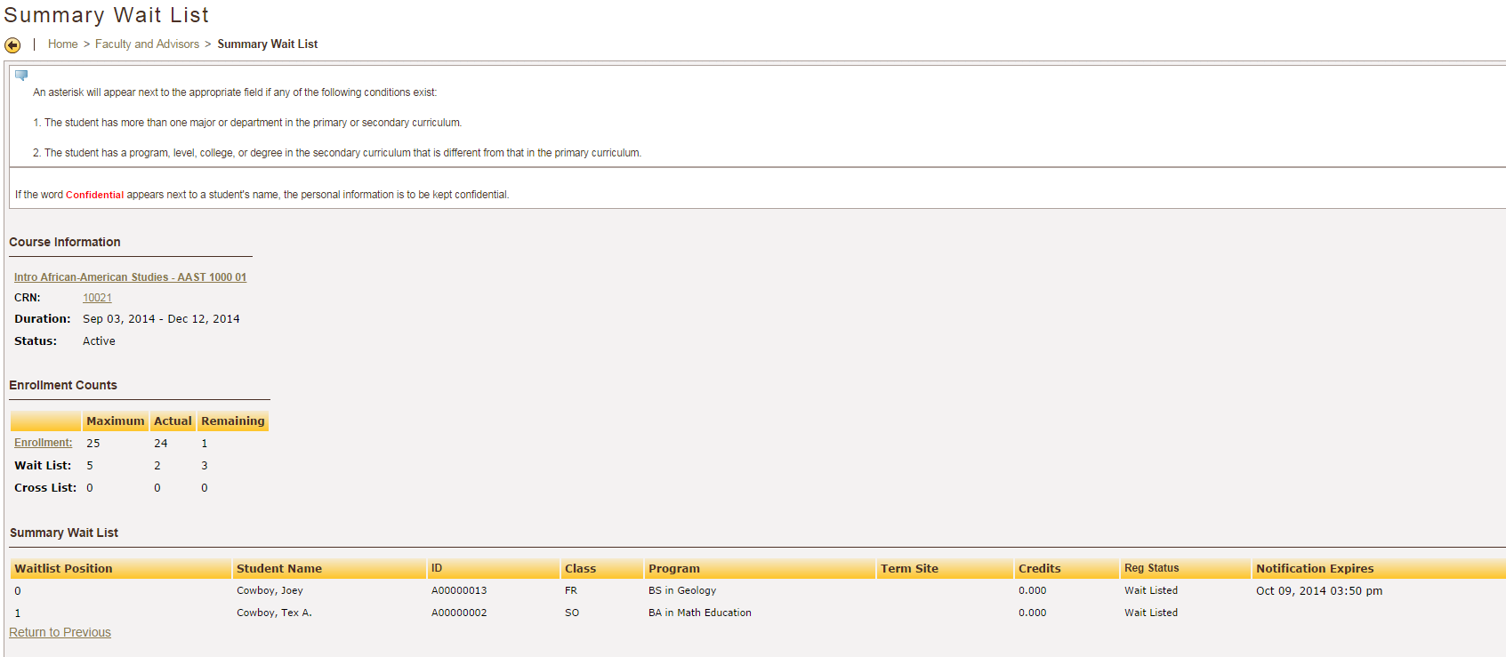

Students are able to add their name to multiple class section waitlists for a given course. When the student accepts a seat in one section, they are not automatically removed from the additional waitlisted sections.

Students should be encouraged to drop their wait list seats if they are no longer interested, to allow the next student on the list to be processed in the timeliest manner possible.

STUDENT NOTIFICATION EMAIL
As soon as the class enrollment drops below the enrollment cap, the automatic waitlist process begins.
Banner will offer the open seat to the first person listed on the waitlist (in waitlist priority order). This notification is through an email sent to the student’s uwyo.edu email address. If the student decided to opt into the text messaging notification process they would also receive a text message notification.

Example of email sent to student:
*The email will be sent from registrar@uwyo.edu, the listed sender will be University Registrar, UW.

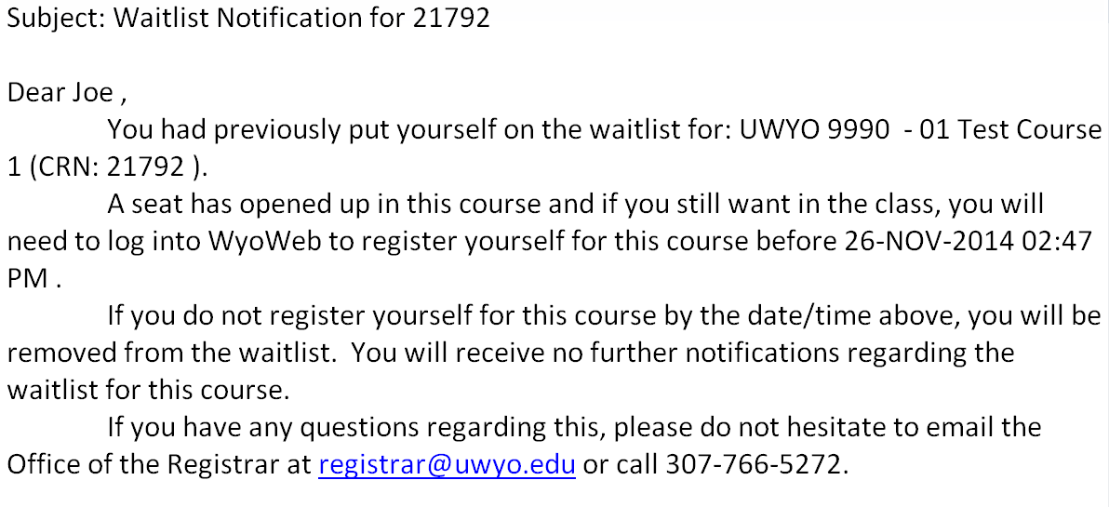

Notice that the email indicates the date and time by which a student must take action, or lose their offered seat in the class. If they do not go into WyoRecords and register for the seat by the deadline, their name will be removed from the waitlist and the next person in line will be notified of the available seat.

Students are encouraged to check their email frequently if they are on a waitlist. Students can also be reminded that their uwyo.edu email can be forwarded to another email account. Directions can be found at:

Redirect Your UW email account to another email

To accept the open seat, with the 24 hour deadline, students must go into their WyoRecords, Registration, Add and Drop Classes, and then choose ‘web registered’ as the action for their wait listed course. For more information on how the waitlist works and functions from a student perspective go to, http://www.uwyo.edu/registrar/_files/docs/automaticwaitlistsforstudents.pdf.

CONTROLLING AND MONITORING AN AUTOMATIC WAITLIST

The following Banner screens are used to control and monitor automatic waitlists:

SSAWLSC Waitlist Automation Section Control
SFAWLPR Waitlist Priority Management
SFAXWLP Cross List Waitlist Priority Management
SFIWLNT Waitlist Notification Query
SFARWLP Reserved Seats Waitlist Priority Management

SSAWLSC

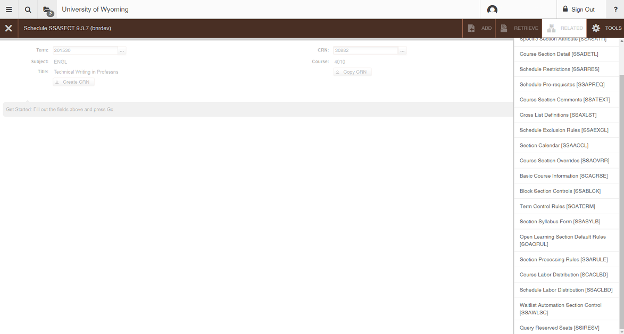
The SSAWLSC screen controls the automatic waitlist function at the section level. The default setting for Automatic Waitlist Notification is “ON”, as indicated by the check box. If you do not want to utilize automatic wait listing it needs to be manually unchecked for each section with a waitlist.
You can also access SSAWLSC through the “Related” menu of the SSASECT screen.

SFAWLPR

The SFAWLPR screen controls the priority of the students that are waitlisted. As students add themselves to the waitlist for a course they are given a priority number. Departments have the option of re-prioritizing the students on the waitlist. Notifications of open seats are sent every 30 minutes. If a waitlist needs to be prioritized it will need modified before a seat opens or that student with the first priority number will be notified of an open seat being held for them.

In the example below, Test Student3 was the first student to add themselves to the course waitlist. At this point there are no open seats. If I want Test Student2 to have priority over all others, it’s easy to change.
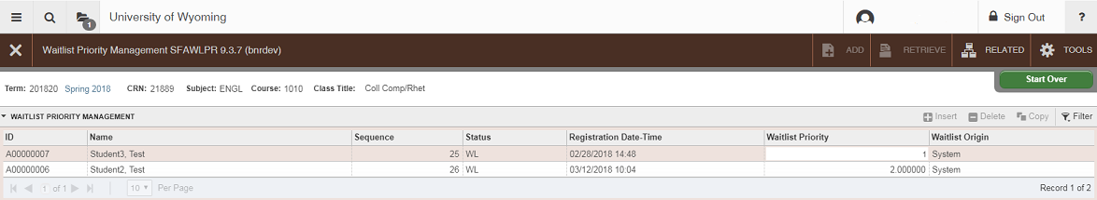

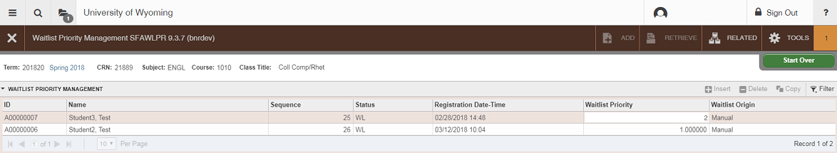
To reorder the wait list, type over the numbers in the Waitlist Priority column and save your changes. In the image below manual changes were made so that Test Student2 is 1st on the waitlist and Test Student3 is 2nd.

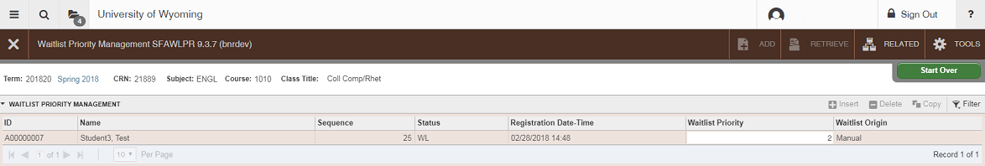
Once a seat becomes open the student is notified by email and text (if they’ve opted into that type of notification) and their name is removed from the SFAWLPR screen.

If the student does not take action within 24 hours they will be dropped from the waitlist. At that point they could choose to re-enroll themselves in the waitlist; however, they would be given the lowest priority.
SFAXWLP

The SFAXWLP is identical to the SFAWLPR screen except that it is for cross-listed courses. If automatic wait listing is not turned on it is not recommended that waitlist be created for courses that are cross-listed.
Notes on cross-listed courses and waitlists:
If a course is cross-listed each section should have its own waitlist. It’s the Office of the Registrar’s recommendation that if departments decide to cross-list and also have a waitlist, that they work together to create a wait list for each section offered under the cross-listing. It is confusing for students when a cross-listed course has a waitlist for one section and prefix, but not for the other. If 3 sections are cross-listed and there are 30 seats and each section creates a wait list with 10 seats it would be possible for 30 students to be wait listed, which may give students unrealistic expectations for registration. For this reason, it our preference that each section keep their individual section wait list maximums low.

Just like in the SFAWLPR screen departments can control the priority of students’ waitlisted for a cross-listed section. Regardless of which section the student is waitlisted for; they are given the next priority on the wait list.
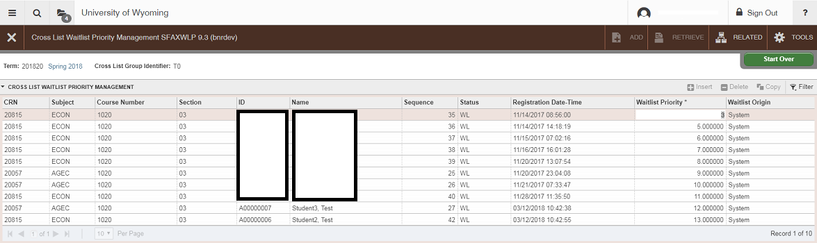
Example: Test Student2 was added to the ECON-1020-03 waitlist and Test Student3 was added to the AGEC-1020-03 waitlist. If the student had added themselves to the waitlist, then the “Waitlist Origin” field would read “Manual.” The system will automatically place students on a first come first serve priority between all the sections in the Cross-List Group Identifier.

SFIWLNT
The SFAWLPR screen displays the notifications of open seats that have been sent and when the notification expires. It’s possible for multiple students to be notified of open seats if more than one seat becomes available within a 24 hour period.
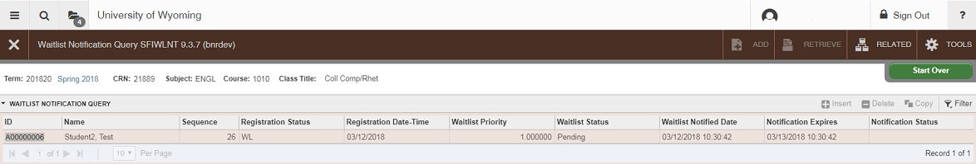
Example: Test Student2’s notification of an available seat expires 3/13/15 at 10:42 AM. If they would like to register they can log into WyoWeb and enroll themselves through the Add/Drop courses screen. If they take no action they would be dropped.

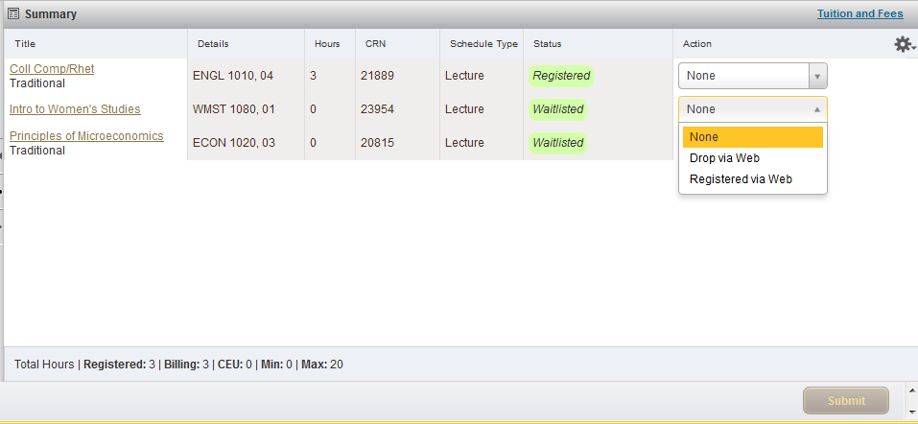
This is how that would look for the student in their Add/Drop courses screen.

Office of the Registrar – contact information

- Email – registrar@uwyo.edu
- Phone – 307-766-5272 or 307-766-3137

