Office of the Registrar
Dept. 3964 • 1000 E. University Ave • Laramie, WY 82071-2000
(307) 766-5272 • fax (307) 766-3960 • e-mail: registrar@uwyo.edu • www.uwyo.edu
TO: Summer 2022 Instructors
FROM: Kwanna King, Registrar
DATE: August 16, 2022
SUBJECT: Summer 2022 Grade Reporting – deadline: 12 pm (noon), Thursday, Aug 18, 2022
How to enter Final Grades through WyoWeb:
- Go to WyoWeb
- Click on the Faculty & Staff link in the WyoRecords column (The 2nd of 4 columns with gold headers)
- Log in
- Select Final Grades under ‘Quick Links’ on the upper left-hand side of the page
- Select course to grade
  - If you have more than 5 classes this semester, you should change the number of courses per page, then sort by Term (screen shot at bottom of this email).
- Entering grades - There are two options for entering grades in WyoWeb:
  - Spreadsheet - See “Uploading Final Grades from Excel” at http://www.uwyo.edu/registrar/faculty_and_staff/ for instructions with screenshots.
  - Manually-entering grades - You may still enter grades using the drop down menu beside each name and click Save when appropriate.
    - Note: Do not assign grades of S for courses that are not graded S/U only
    - Assign a grade of S or U for an Audit. (If in doubt whether a student is properly auditing the course, it is recommended that you assign a letter grade as you would for the rest of the class.)
- Incomplete grades ​Note: If you enter an Incomplete grade, you will need to click on the “Roster” tab above the student’s name to return to the page on which you will enter the values on whether the student attended your class and the last date of attendance. (See screen shot below.)
To continue grading the rest of your courses, click on the desired section and repeat the process outlined above.
The real-time Grading Status bars in left-hand column indicate when grading is complete for each course/section. When all of your courses have green status bars, you are finished with grading.
A visual example of when all grades have been entered follows:
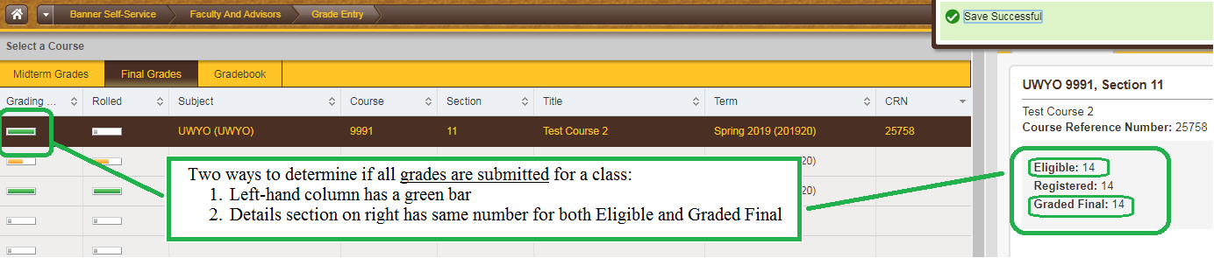
Final grades for all Summer 2022 courses should be entered by faculty members through WyoRecords by noon on Thursday, August 18, 2022.
You may save multiple times. Once you have clicked save, the final grade will be held in the system and will not show on students’ records channel until the following morning. The Office of the Registrar will roll the grades to the students’ records nightly. If you make an error and the grade is rolled to history that night, you must complete a change of grade form to correct the grade that was loaded.
Incompletes:
As defined in UW Regulation 2-106, an incomplete (mark of I) is a temporary grade assigned in those rare instances when no other grade will ensure justice to the student. It does not define the standing of the student up to that point as either passing or failing. It is not a means by which the instructor defers the report of an entire class. In cases where the student is expected to repeat the course to obtain credit, the appropriate grade is F or U. After loading a grade of “I” for a student, you will be given the opportunity to reduce the length of time the student has to complete the coursework or you may leave the default date of Dec. 18, 2022. To return to your complete class list, click on the “Roster” tab above the student’s name. Authorization of Incomplete forms are no longer required. If the student has completed no further work by the deadline and an Extension of Incomplete form has not been initiated, the grade will be reverted to a failing/unsatisfactory grade. Upon completion of missing work, the instructor will submit a Removal of Incomplete form assigning the grade for the course.
Last Date of Attendance:
As a replacement for the paper process from Financial Aid previously used to identify Last Date of Attendance, faculty members will now be required to enter a last date of attendance on the WyoWeb final grade roster for all students who receive an F or an Incomplete grade in a course. Detailed instructions for this process are available at http://www.uwyo.edu/registrar/Faculty_and_Staff/index.html under G for grades. (See screen shot below.)
Academic Dishonesty:
In instances where students have been found guilty of academic dishonesty and procedures have been followed as defined in UW Regulation 2-114, a grade of F will be pre-assigned. You will not be able to assign another grade for the student.
- Timely Reporting of Grades is Critical! Missing grades can result in students being placed on probation or suspension unnecessarily or not being notified in a timely manner that they are on probation or suspension. Missing grades can also prevent a student from being placed on the honor roll. Missing grades can also create problems with students receiving their financial aid. Please help your students by meeting the deadline.
If you need assistance with entering your grades, please do not hesitate to contact the Office of the Registrar.
W02403452.
