NO MORE Activation
E-MAIL SIGNATURE
Instructions: Please add one of these signatures to your email sign off, and show support for NO MORE with every message you send.
OPTION 1 –

Your Name/ Your Number


Option 2 –

John Doe
NO MORE
212. 555. 5555 t
251. 406. 0920 m
e-mailaddress@email.com
www.nomore.org
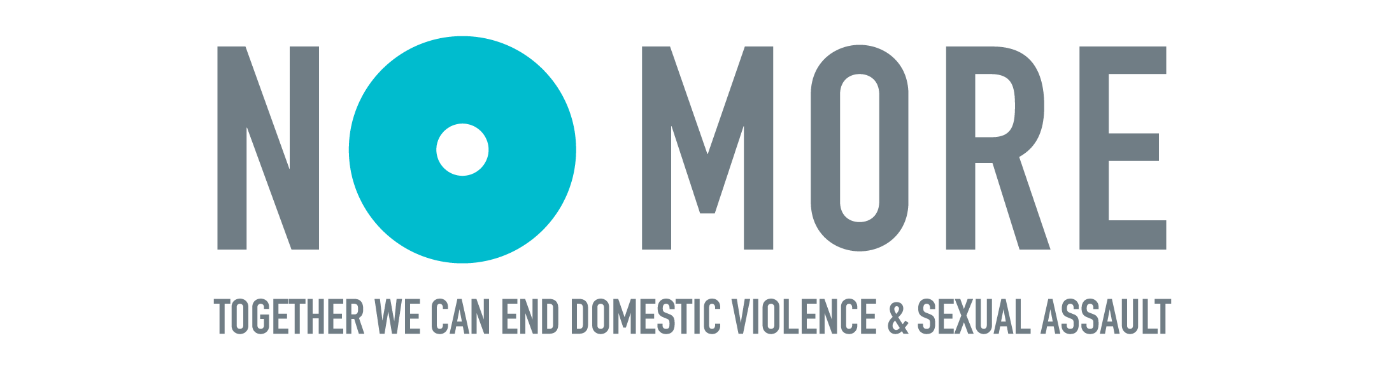

OPTION 3 –

Jane Doe
NO MORE
212. 555. 5555 t
212. 444. 4444 m
emailaddress@email.com
www.nomore.org
Together we can end domestic violence and sexual assault.

OPTION 4 –

Together we can end domestic violence and sexual assault. www.nomore.org

OPTION 4 –

Together we can end domestic violence and sexual assault. www.nomore.org

