How to register for a DEA license to DEA Diversion Control Division
https://apps.deadiversion.usdoj.gov/webforms2/spring/main?execution=e1s1
Business Category will be under Form 225
Researcher
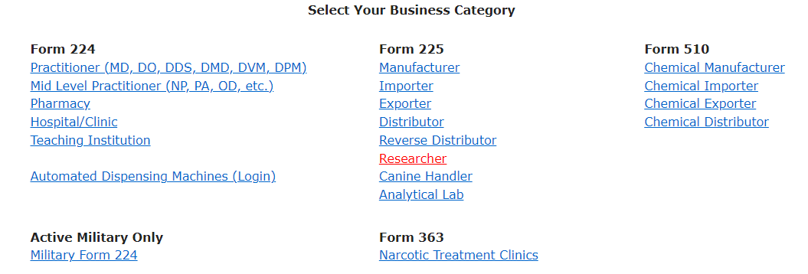

Select Business Activity
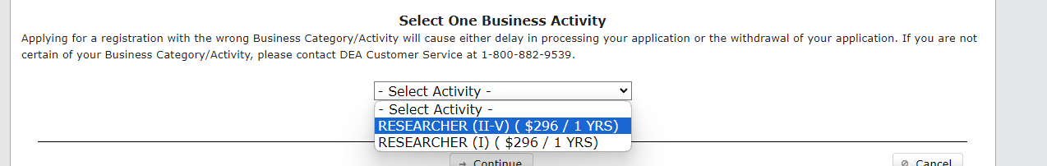
Most will need schedule II-V.
Don’t worry about the cost. It will be waived at a later point.
Continue
Next page is Power of Attorney. If you want to authorize someone else to be on your account, you need to upload a Power of Attorney. Most should not do this.
Proceed
Complete Personal Information.
The address should be where you are holding the items, most likely the lab address.
Proceed
You will need to enter your SSN AND select the Certification for Fee Exemption box

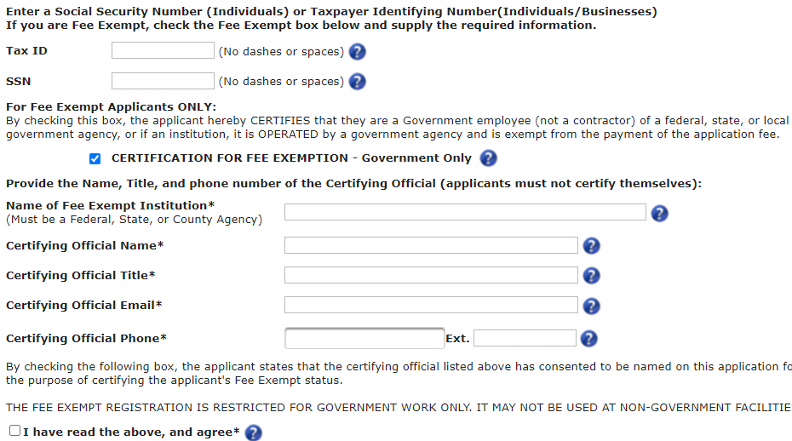
The certifying official is someone at UW who can confirm your employment. Suggest HR person. You will need to check with them and let them know you are doing this, and check the last box for them as they cannot fill this out independent of you.
Proceed
Select all top boxes
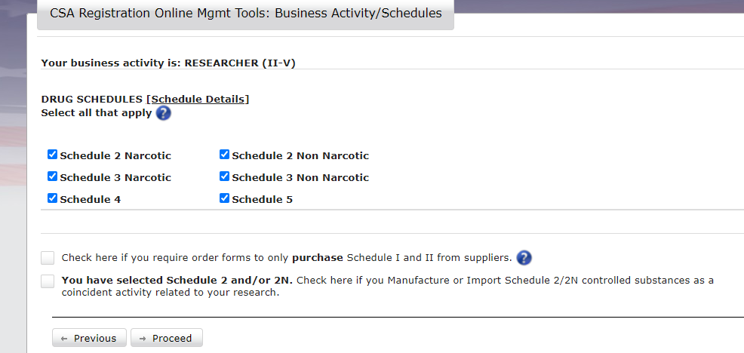
Proceed
Nothing to complete here
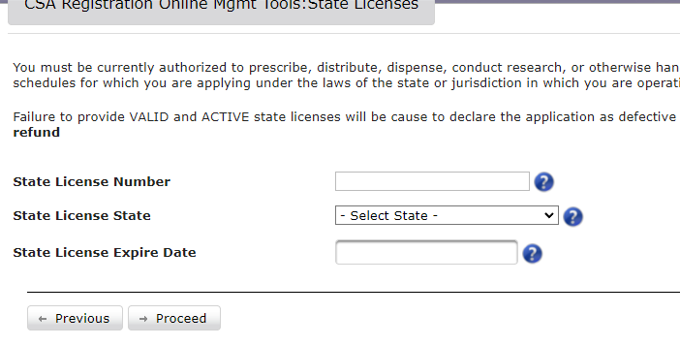
Proceed
Answer 4 questions
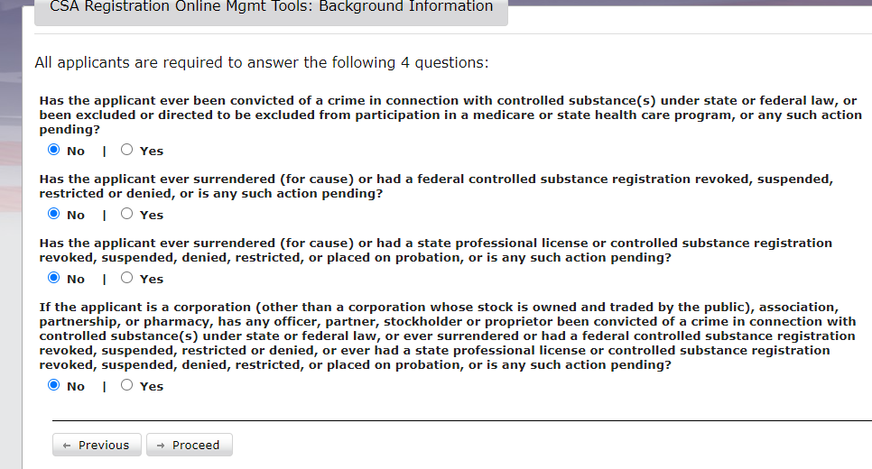
Proceed
Nothing to complete here
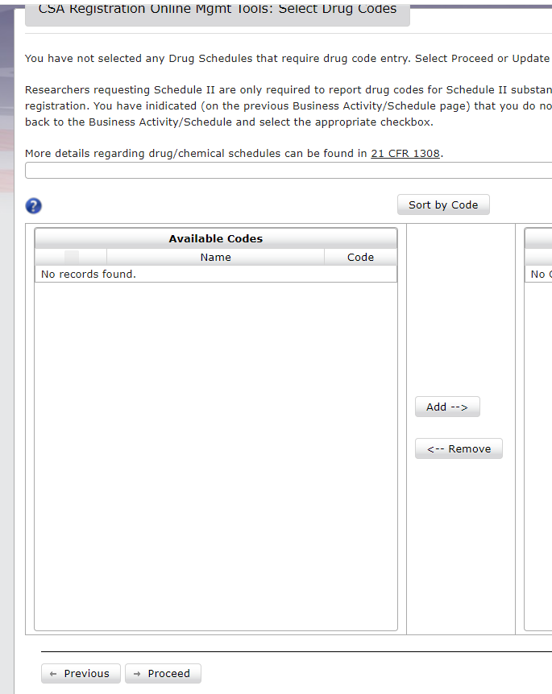
Proceed

Review application
Esign, Validate and Submit
