**Class 2M Laser In Use**

**Do not stare into beam or view directly with optical instruments.**

**Diode laser, 670nm**

**20 mW maximum power**

**CAUTION**

**!**

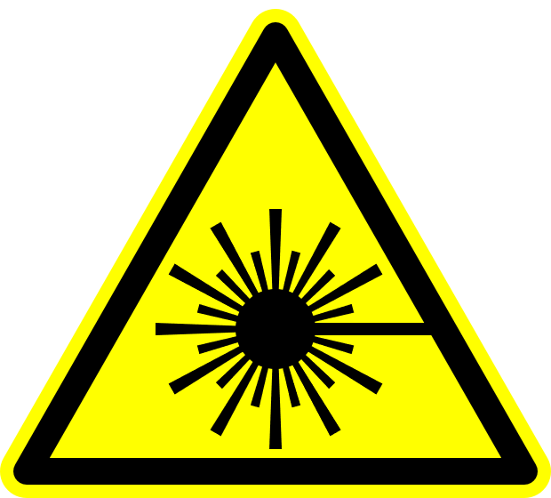

**Laser Safety Officer:** Jim F. Herrold **Phone:** 766-2638