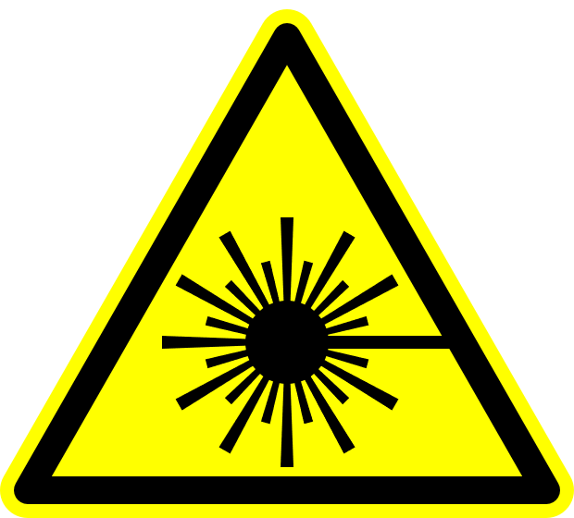

**!**

**DANGER**

**Laser Supervisor: Phone:**

**Class 4 Laser Controlled Area**

**AUTHORIZED PERSONNEL ONLY**

**Avoid eye or skin exposure to direct or scattered radiation.**

**Do not enter when light is illuminated.**

**Laser eye protection required: OD>7@1070 nm**

**Yb:Fiber Laser, 1070 nm**

**10 kW maximum average power**

**Laser Safety Officer:** Jim F. Herrold **Phone:** 766-2638