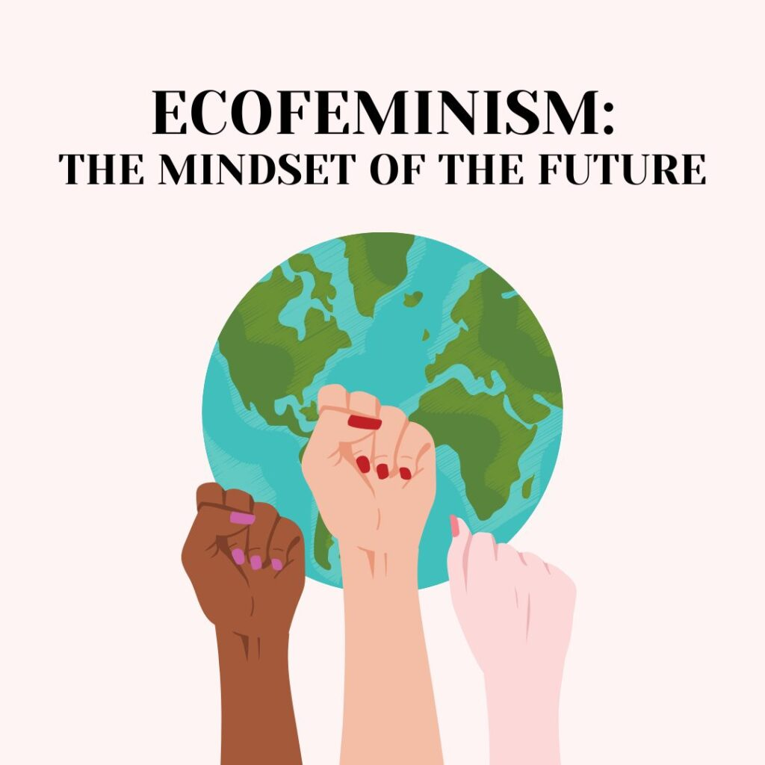**Course Announcement: Spring 2023**

**Ecofeminism**

**GWST 4450 / 5450**

**CRN: 23506 / 23521**

**Instructor: Nancy Shea**

**asynchronous / online**

**Course Description**

In this course, we will focus on issues of gender, women and ecology. Ecofeminist thinkers argue that there can be no liberation for women and no solution to the ecological crisis without a fundamental shift in relationships of domination.  Uniting the two movements will result in a radical reshaping of the ways we treat each other and the rest of nature.  This class is for those interested in understanding the environmental crisis and its dependency on improved human relations.

**Required Texts**

*Ecofeminism: Women, Culture, Nature*, Karen J. Warren, 1997

*Why Women Will Save the Planet*, Friends of the Earth, 2018

**Course Objectives**

By the end of the semester, you will be able to:

* describe at least eight connections between feminism and the environment.
* understand the history of the ecofeminist movement as a foundation for understanding contemporary environmental and globalization issues.
* describe a range of issues affecting global women’s human rights and the state of nature.
* identify ecofeminist discourse in a variety of women’s writing and discourse.
* engage in thoughtful discourse with classmates on topics of interest.
* utilize on-line learning, discussion, collaboration and research skills.