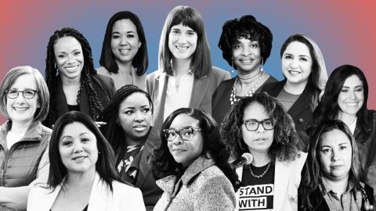

**(from https://www.cnn.com/2022/11/23/politics/election-2022-record-women-in-congress/index.html)**

**GWST 4630 / POLS 4630: Gender and Politics**

**Spring 2023**

The purpose of this course is to learn about driving theories in American politics, elitism, pluralism, and intersectionality, and apply the central concept of power to women’s participation in politics. During the class, we will discuss constructions of power and how they apply to marginalized identities: sex/gender, race and ethnicity, sexual orientation, class, and ability. Students will engage with foundational and emergent literature written from diverse perspectives, such as behavioral political science, intersectional scholarship, and multiple feminist perspectives that utilize dynamic methods.

**Driving Questions:**

* How does theory help us understand women’s political participation in elections, parties and interest groups, and social movements?
* What is the relationship between political parties and women’s reproductive rights?
* What roles do women play in social movements, such as Occupy Wall Street, Black Lives Matter, and the Disability Rights Movement?

**Upon completion of the course, students will be able to: (1)** demonstrate the ability to conduct interdisciplinary feminist analysis, (2) examine and critique ideological assumptions underlying social institutions and systems of representation, including but not limited to assumptions regarding gender, race, class, nationality, disability, age, and sexual orientation, and (3) demonstrate an understanding of women’s historical and contemporary agency, and how it has shaped women’s lives in various geographical settings.

Assignments include online discussions, section papers, and semester long research project on a topic chosen by the student.