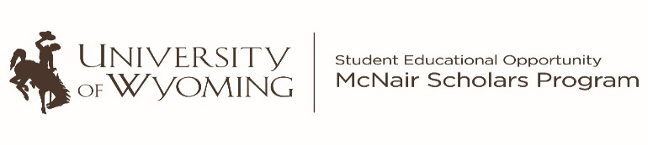
29th Annual McNair Scholars Research Symposium
Monday, July 26, 2021
Welcome 8:30 a.m.
Edward Seidel, PhD

8:40 a.m.
Tawna Herrera
Manipulation of Neuronal Pathways to Decrease Cocaine Addiction Relapse
With Ana Clara Bobadilla, Ph.D. & Carl Litif, PhD

9:00 a.m.
Cortney Borer
Effect of 30% Change in Nitrogen and Phosphorous on Microcystis and
Anabaena Cultures
With Annika Walters, Ph.D. & Ashleigh Pilkerton

9:20 a.m.
Gracen Wallen
Stratigraphic relationships surrounding the Cretaceous-Paleogene boundary in the
Northern Great Plains, USA
With Mark Clementz, Ph.D., Carl Campbell, MS
& Susannah Wright

9:40 a.m.
Jordan Eichman
Using cloud microphysics to eliminate bias in climate monitoring
With Daniel McCoy, Ph.D. & Brandon Lopez, MS

10:00 a.m. – 10:10 a.m.
Break

10:10 a.m.
Alec Wallen
Synoptic Climatology of Colorado River Low Flow Conditions at Lake Powell
With JJ Shinker, PhD and Tessa-Ray Cozzens
10:30 a.m.
Marissa LeDoux
The impact of age on the naturalness
of /r/ productions
With Breanna Krueger, PhD & Josephine Cox

10:50 a.m.
Taryn Veniegas
Investigating Public Misperceptions of False
Sexual Assault Allegations
With Matthew Gray, PhD and
Natalie Poole & Riley Hoogerwerf

11:10 a.m.
Johnathan Walker
Trauma cognition as an intervening variable in the relationship between chronic child abuse and risk factors for suicidal ideation
With Joshua Clapp, PhD and
Alexandria Sowers & Robert Kaya

11:30 a.m. – 12:30 p.m.
Lunch Break

12:30 p.m.
Anthony Sandoval
The Development of Straight Authorial Utilization of Gay Assimilation and Homosexual Visibility Narratives in Young Adult Literature
from 2010-2014
With Jason Thompson, Ph.D. & Robert Baker

12:50 p.m.

Wendy Luna Garcia
Mexico’s Golden Age of Cinema:
Reflections of Womanhood through Time
With Nicholas Crane, PhD; Trisha Martinez, PhD and Veronica Hanway

1:10 p.m.
Angela Adams
Treading Water: A Critique of
Child Protective Services
With Fredrick Dixon, PhD. & Alexandra Bitter

1:30 p.m.
Madison Davis
Who Holds the Power? An exploration of social work students’ perceptions of power in
the classroom
With Eleanor Downey, Ph.D. & Julia Cathey
______________________________________________ 1:50 p.m. – 2:00 p.m.
___________________Break_____________

2:00 p.m.
Bethany Haworth
A Study of Alienation among Fast-Food Service Industry Workers: The Self-Estranged
With Daniel Auerbach, Ph.D. &
Arianna Maikalani Garcia

2:20 p.m.
Roman Peterson
A Religious Studies Contribution to Rural Sociology with Mary Keller, Ph.D. and Jennifer Tabler, PhD

2:40 p.m.
Rebecca Lovell
Nofretete: German Appropriation of an
Egyptian Queen
With Adam Blackler, Ph.D. & Randi Spray

3:00 p.m.
Irelynn Holland
Modern perceptions of social unrest and the influence of The Beatles
With Katrina Zook, Ph.D. & Will Flagg, MA

