There should be a link on the main CCCC page for “Equipment” leading to a page showing the content below:
CCCC Equipment List (last update 4/30/2024)
SER's Center for Carbon Capture and Conversion (CCCC) may provide access to labs and equipment for students and researchers after training. If you have questions regarding our equipment or how to get access, please contact Stefan Holberg (sholber2@uwyo.edu). Please understand that we cannot always guarantee access and that we do not always have resources for instant training. At present, most usage is free. We might impose charges in the future.
The following share point folder provides general lab procedures and manuals for some of the equipment (accessible with any UW login): https://uwy.sharepoint.com/sites/SER/cccclabs/

Instruments
AFM (Atomic Force Microscope)  - MFP-3D Infinity from Oxford Instruments  - Location EIC 377 but will be moved to the EERB building.  - Scanning of surfaces with a probe, allowing nanoscale resolution  - Currently not operational | 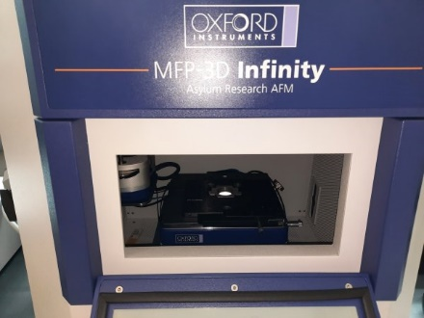
Ball mill 1  - PQ-N4 Planetary Ball mill from Across International  - Location EIC 177 A  - For dry milling of powders, runs with two or four 1 L milling jars | 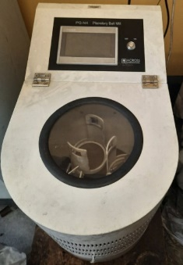
Ball mill 2  - Retzsch TM 300  - Location EIC 177 A  - For dry milling of large batches  - At present exclusively used by Kam Ng’s research group | 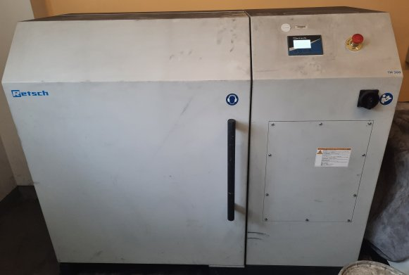
Ball mill 3  - Labmill 8000 from Gilson  - Location EIC 177 A  - For slow dry or wet milling. Uses typically 1-L bottles. | 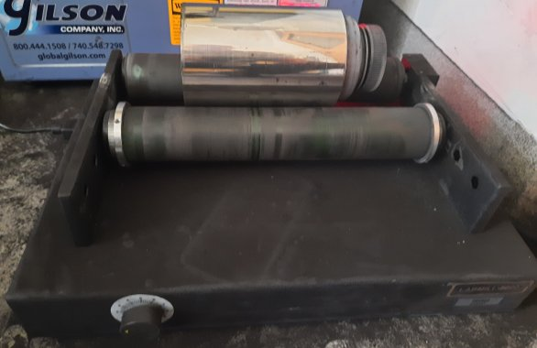
Calorimeter / DSC (Dynamic scanning calorimetry)  - Calvet Calorimeter C .80 from Setram / KEP Technologies  - Location EIC 377  - Measures temperature and heat flow of heated/cooled samples. Can be used as DSC but allows larger samples and/or higher pressure than common DSC devices. Max. temperature is 300 °C | 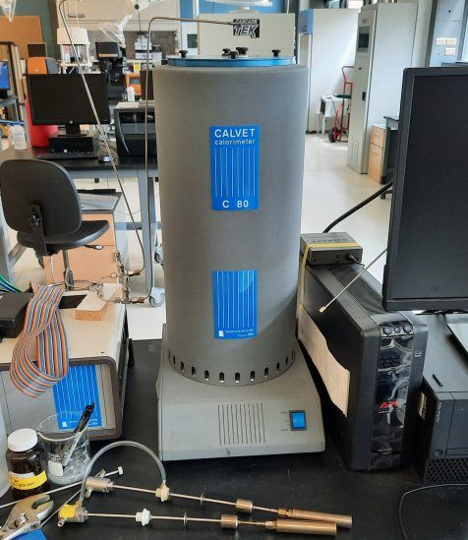
Climate chamber (Heated humidity chamber)  - HH09-DA from Darvin Chambers  - Location EIC 377  - Sample exposure to humidity and heat, mainly to investigate durability | 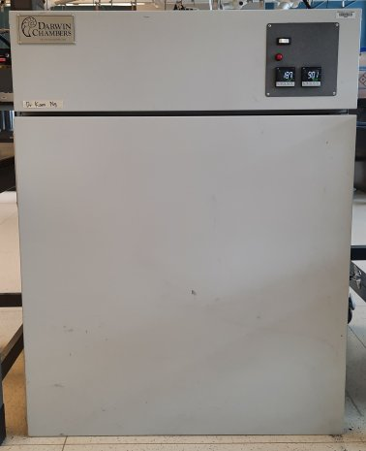
Dissolver with optional bead mill  - VMA-Getzmann, Dissolver Dispermat LC-30 with optional APS bead mills for 30 ml, 125 ml and 250 ml.  - Location EIC 177  - High speed and high shear force stirrer (up to 20,000 rpm). Can be set up as bead mill for wet milling in water, solvents, or polymer solutions. Uses typically 1-2 mm zirconia milling beads, though other beads are possible. | 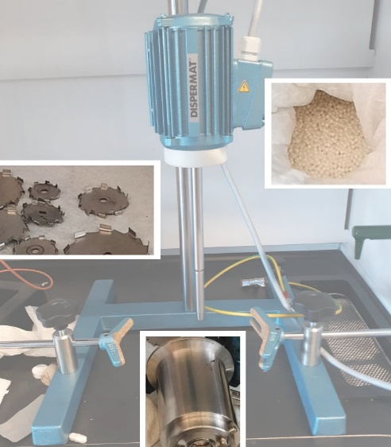
DMA (Dynamic Mechanical Analyzer)  - DMA 3200 from TA Instruments / ElectroForce  - Location EIC 377  - Various dynamic measurements. Sample grips for tension, compression and 3-point bending. Cooling possible, possibly also heating.  - Operational, but at present no trained staff. | 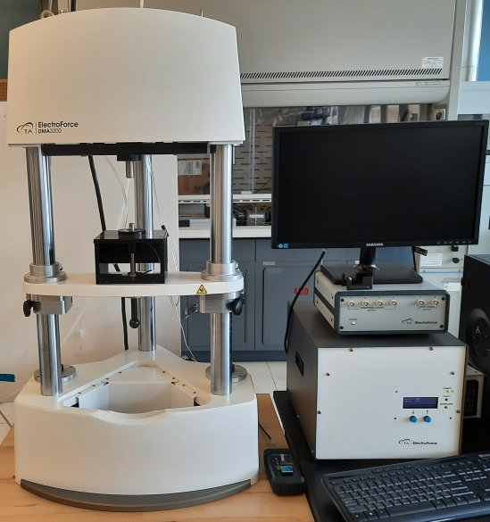
Dropping point analyzer  - DP70 from Mettler Toledo  - Location EIC 377  - Measures the dropping point / drop point / softening point of viscous materials | 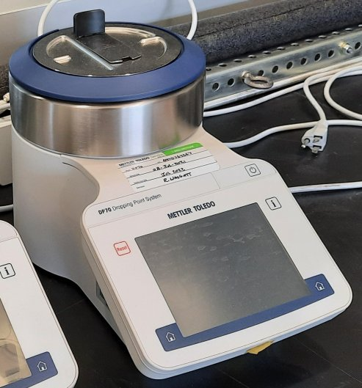
Electrospinning device with environmental control  - From IME Technologies  - Location EIC 377  - Electrospinning to create nano fiber mats.  - At present exclusively used by Katie Li-Oakey’s research group | 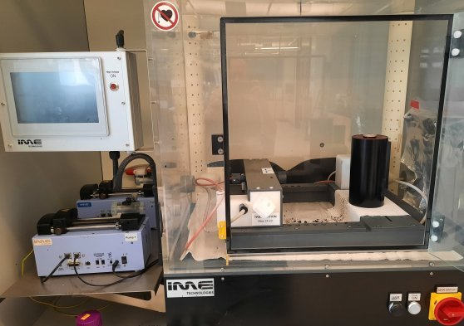
GPC (Gel Permeation Chromatography, also called SEC, Size Exclusion Chromatography)  - From Shimadzu, CBM-20A, DGU-20A, LC-20AD, CTO-20A, and RID-20A  - Location EIC 377  - Chromatography system with pump, oven, and refractive index detector (RID) to determines molecular weight distributions of soluble polymers against standards of the same polarity as the analyzed polymer. We have standards for polystyrene (PS) and the following columns from Shodex for organic solvents: LF-804 (300 – 2,000,000 g/mol), KD-802, 200 – 4000 g/mol), and KD 807 (50,000 – 200,000,000 g/mol). Other columns can be mounted. | 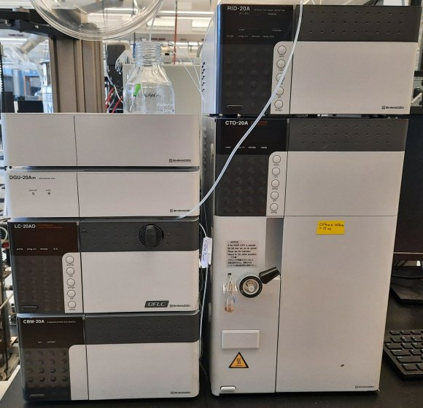
GC-MS (Gas Chromatograph with Mass Spectrometer)  - GC: Agilent 7890B, MS: Agilent 5977B  - Location EIC 377  - Analysis of gasses and volatile liquids and solids by separation (GC) and analysis (mass spectrometer) | 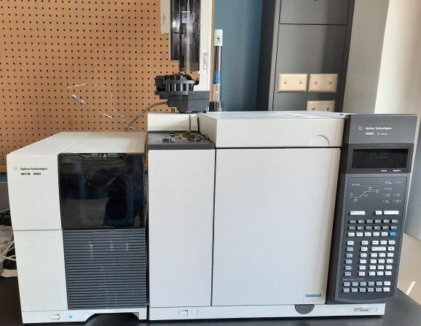
Mechanical Tester (Load Frame)  - Z 020 from Zwick/Roell  - Location EIC 377  - Mechanical tests (strength, modulus, etc.) with specimen grips for compression, tension, tension of fibers, tension of filaments, and 3-point bending. Max. force is 20 kN (20 kN load cell), with more precise load cells for 2.5 kN and 200 N (fiber testing only) | 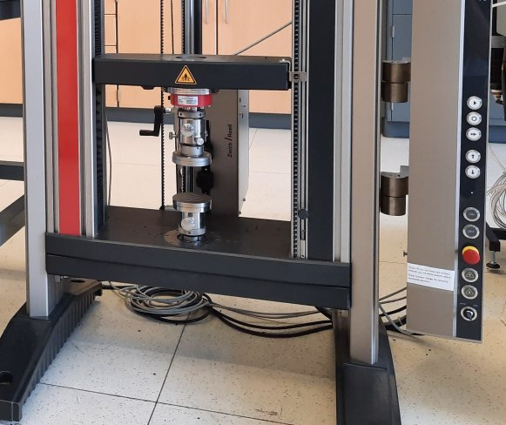
Melting point system  - MP90 from Mettler Toledo  - Location EIC 377  - Measure automatically melting points using optical sensors and a camera while heating. | 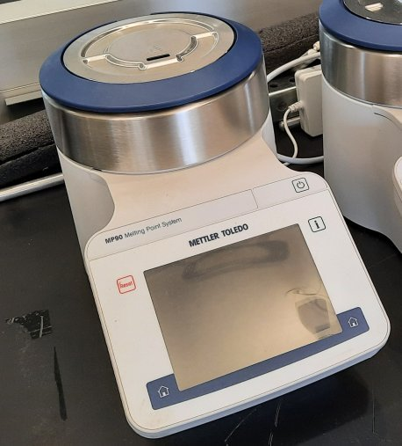
Particle sizer  - Sync from Microtrac  - Location EIC 377  - Measures particle size distributions and particle shape by combined laser diffraction and image analysis. Can analyze dry powders if they are not sticky and do not make the instrument too dirty, range 0.25 µm to 4 mm. Most common is to analyze very dilute dispersions in water with traces of surfactant, though organic solvents are also possible, range officially 10 nm to 2 mm, works best from 0.1 µm to 0.5 mm. For nanoparticles, dynamic light scattering (DLS) is better suitable, available at the College of Engineering and Physical Sciences. | 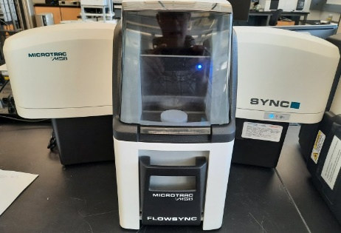
Polarizing Microscope  - DM 2700 P from Leica  - Location EIC 377  - Polarizing light microscope with camera. Only reflection (light from top). | 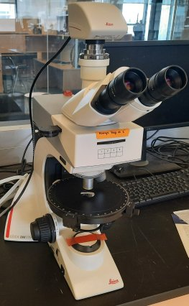
Potentiostat (Multichannel Electrochemical Analyzer)  - IVIUMnSTAT from Ivium  - Location EIC 377  - Electrochemical tests, including Impedance, Cyclic Voltammetry (CV) and Corrosion. Requires appropriate electrodes. Some reference and counter electrodes are available | 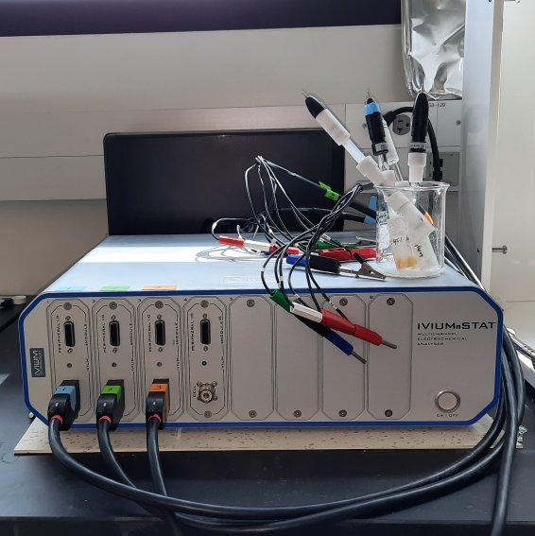
Raman Microscope  - IM-52 from Snowy Range Instruments  - Location EIC 377  - Measures Raman spectra. Allows mapping of surfaces. Can be used for powders, but other Raman spectrometer at UW work far better for this purpose | 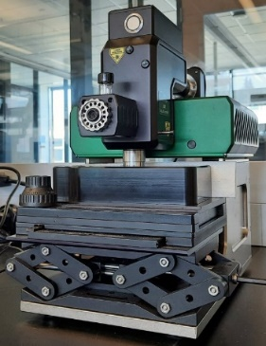
Rheometer  - Ares G2 from TA Instruments  - Location EIC 377  - Versatile instrument to measures viscosities and viscoelastic properties with different set-ups, including plate-cone, plate-plate, cylinder and torsion geometries. Environmental control (cooling/heating) possible. | 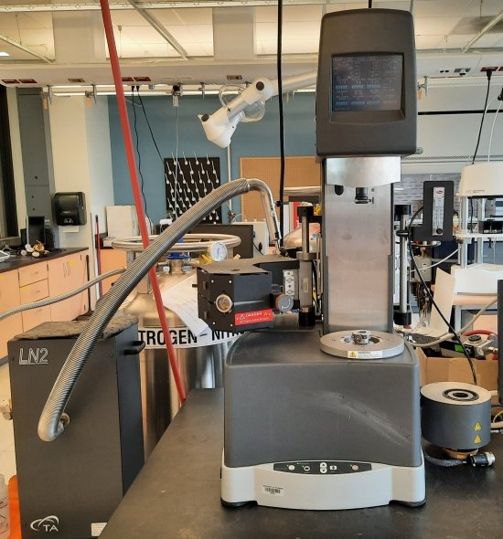
SAR-AD (Saturates, Aromatics, Resins, Asphaltenes Determinator)  - Built by Western Research Institute using Agilent chromatography components  - Location EIC 377  - Automated, combined precipitation and chromatographic analysis, mainly used to quantify components of petroleum products.  - Consists of high-performance liquid chromatography (HPLC) components such as quaternary pump, autosampler, sensitive columns, switching valves and the following detectors: ELSD (evaporative light scattering detector), VWR (variable wavelength detector, UV/Vis), and FLD (fluorescence detector) | 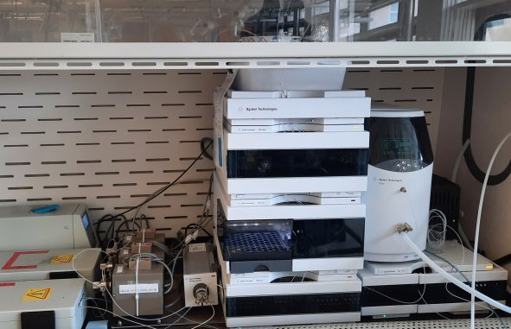
Sieve shaker  - SS-12R from Gilson  - Location EIC 177 A  - Automatic sieve shaker for 8 inch and 12 inch sieves | 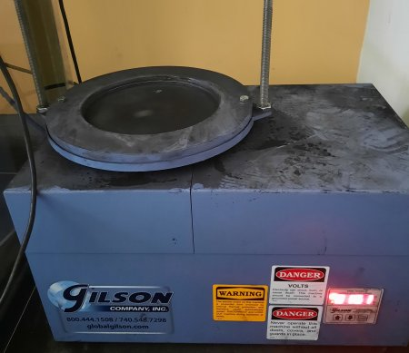
Stereo microscope with camera  - From AmScope  - Location EIC 377  - Optical stereo microscope with camera | 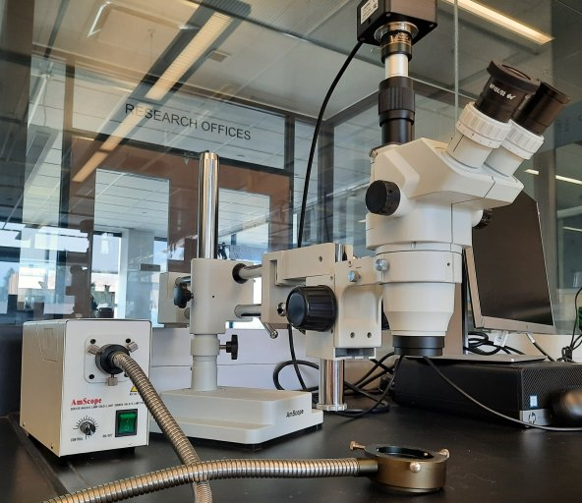
Thermal Constants Analyzer (Thermal conductivity measurement)  - TPS 1500 from Hot Disk  - Location EIC 377  - Measurement of heat conductivity, for example, of building materials | 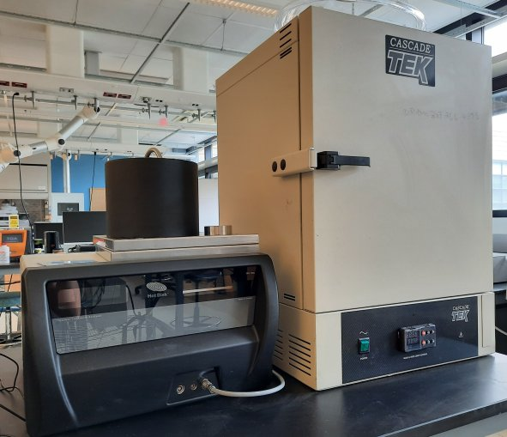
TGA 1 (Thermogravimetric analysis)  - TGA 209 F3 Tarsus from Netzsch  - Location EIC 377  - Allows to follow weight changes when heating a sample (up to ~980°C). | 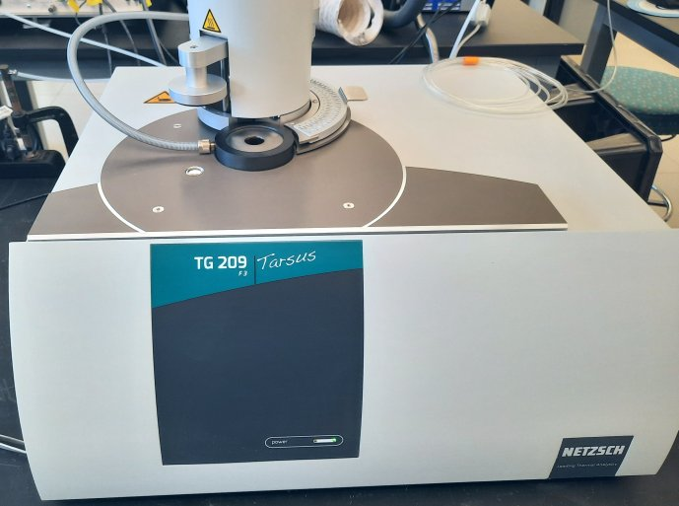
TGA 2 (Thermogravimetric analysis)  - TGA Q500 from TA Instruments  - Location EIC 377  - Allows to follow weight changes when heating a sample.  - At present exclusively used by SER-CCCC staff. | 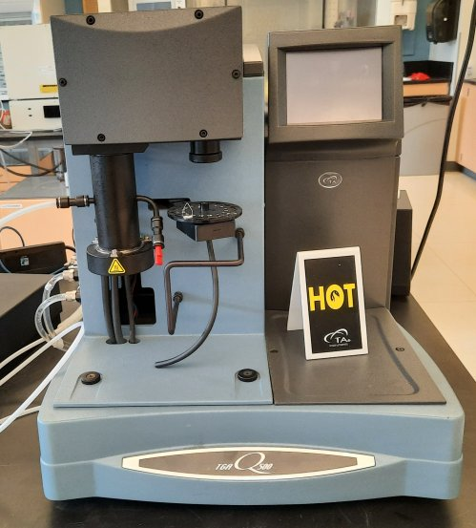

Ovens
Box Furnace  - 1210 FL W/Retort Furnace from CM Furnaces  - Location EIC 377  - Inside size roughly 20 x 20 x 30 cm. Max. T is 1000°C (or 1200°C?). Can be used with inert gas. | 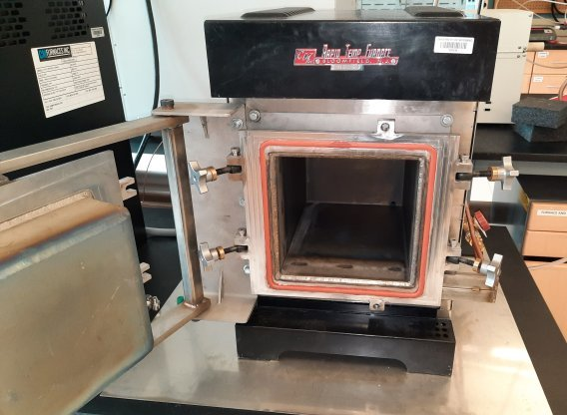
Laboratory oven  - LHT 6/120 from Carbolite Gero  - Location EIC 377  - Inside size roughly 46 x 64 x 37 cm. Max T is 600 °C. Can be used with inert gas. | 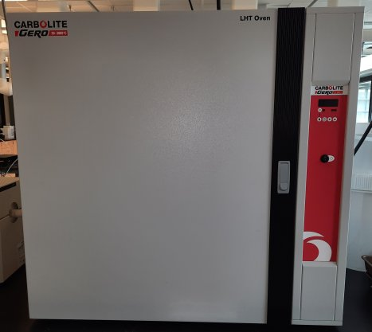
Tube furnace large  - Lindberg Blue M (STF554333PBC-1) from Thermo  - Location EIC 377  - OD 3 inches (76 mm) | 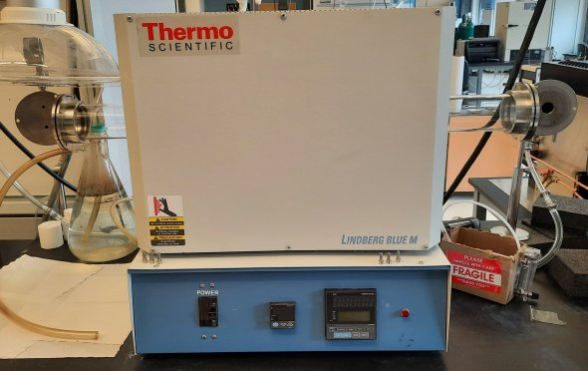
Tube furnace small  - Lindberg blue M (TF55035A-01) from Thermo  - Location EIC 377  - OD roughly 3 cm | 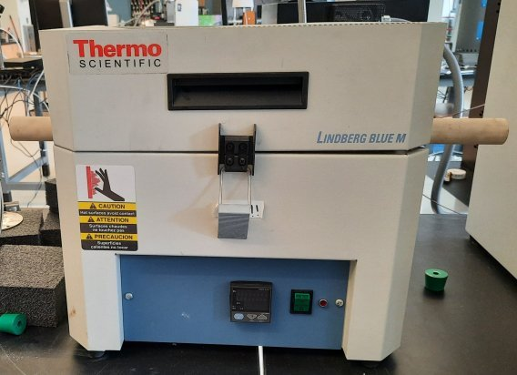
Tube Furnace middle  - STF1200 from Across International  - Location EIC 177  - OD roughly 5 cm. Max. T 1200°C. | 