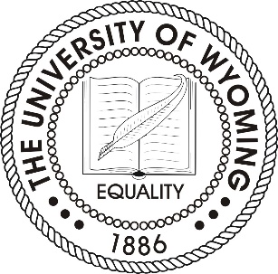

University of Wyoming
Board of Trustees
Committee on Vice President and Dean Searches
September 16, 2020
Salons A&B

AGENDA
- Update on Provost Search
- Update on Dean Searches
  - Arts & Sciences
  - Engineering & Applied Science
  - Education
- Update on UW Art Museum Director Search

