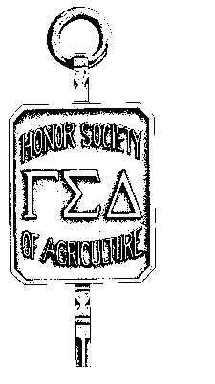

GAMMA SIGMA DELTA WYOMING CHAPTER

THE HONOR SOCIETY OF AGRICULTURE LARAMIE, WYOMING 82070

GAMMA SIGMA DELTA
UNIVERSITY OF WYOMING

FACULTY AWARD OF MERIT NOMINATION

The University of Wyoming Chapter of Gamma Sigma Delta recognizes achievements of faculty members. Up to two awards are given annually to faculty who have distinguished themselves in research, teaching, extension, or a combination thereof. At its option, the Chapter may define an award of special merit recognizing accomplishments beyond those areas mentioned.

A nominee must be a faculty member in agricultural sciences or a related field The University of Wyoming; and must have distinguished her/himself through excellence in research, teaching, and/or extension.

In presenting your nomination, enumerate reasons why you believe the nominee has earned an Award of Merit. Be specific in delineating the accomplishments of the nominee with respect to research, teaching and/or extension.

Name: ____________________________________________________________________________________

Department: _____________________________________________________________________________________

Area of Achievement (Circle): EXTENSION RESEARCH TEACHING

COMBINATION (Describe): ____________________________________________________________________

Current Rank/Position: _______________________________________ Year Attained: _________________________

Year of Initial Appointment at UW: ____________________________________________________________________

Attach a statement of support (up to two pages), a current vitae (2-3 pages), and other supporting documentation (up to 6 pages) to this form (total not to exceed 12 pages).

Nominator: ______________________________________________ Phone: _________________________________

Department: ______________________________________________ Date: __________________________________

NOTE: The Awards Committee may choose, on the basis of information provided, to make no award in a given category.

Due Date: February 17, 2012

