Cincinnati Children’s – Continuing Medical Education
Transcript Directions

To access a transcript (learning history) of your participation in Continuing Medical Education activities sponsored by Cincinnati Children’s, please use the following steps:

- Go to https://cchmc.cloud-cme.com/default.aspx
- Choose “Sign In” at the top left of the page.
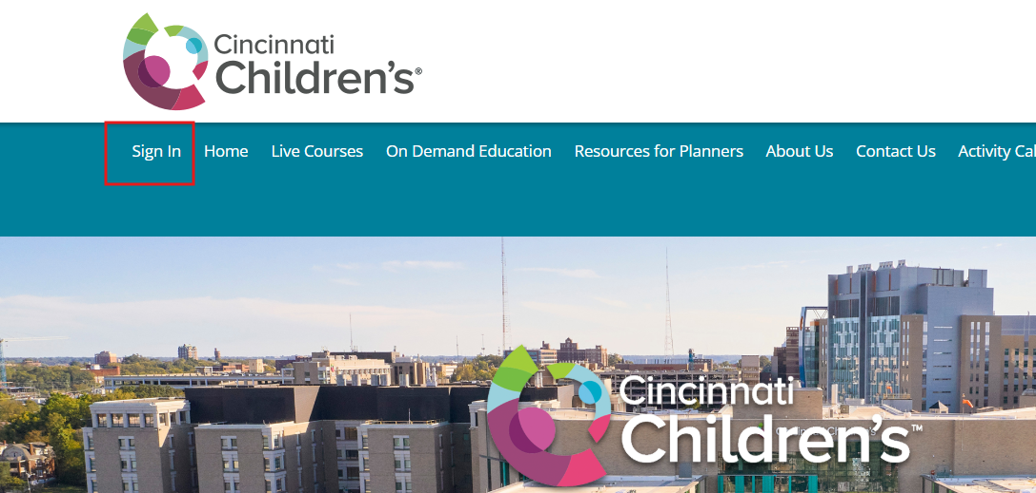

- Sign in using the e-mail and password you used when creating your profile (this is the same e-mail and password you use when registering for Cincinnati Children’s CME activities).
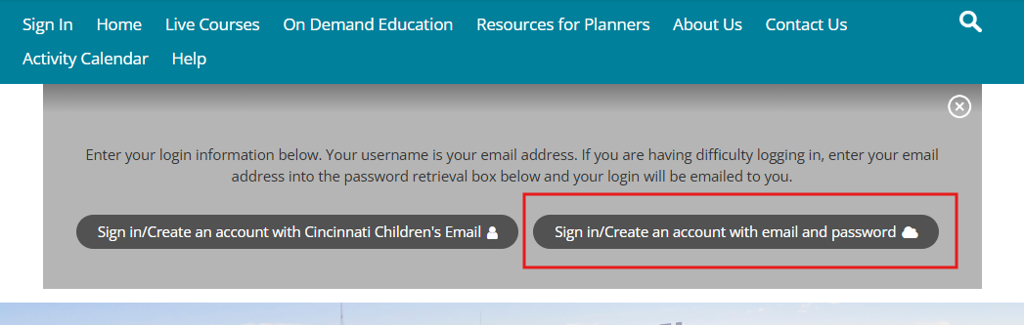

- If you forgot your password, click “Forgot Password”. A copy of your password will be sent to your e-mail address.
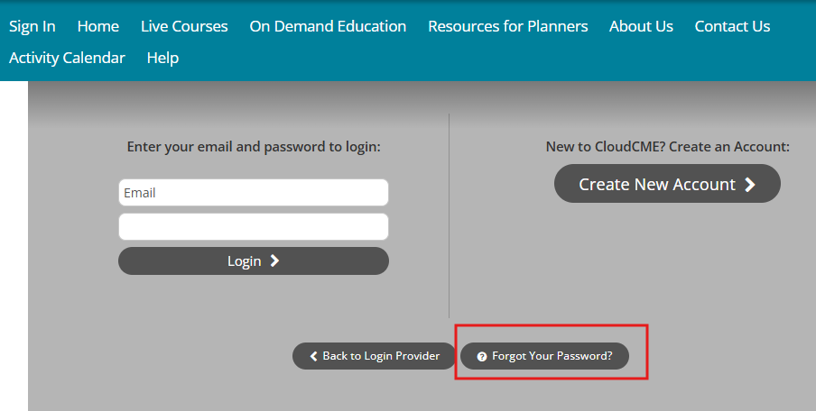

- Hover over “My Account” and select “Transcript” located in the top navigation menu.
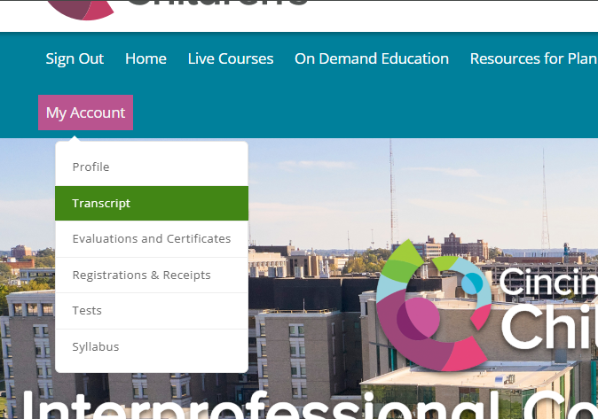

- Adjust the date range, as needed, and print or save the transcript.

Need assistance? Contact the CME office at cme@ccmc.org or call 513-636-6732.

