Enrolling in a Course
Go to wyolearn.uwyo.edu and click on the tile for the catalog you would like to browse. In this example, we will choose the Enrichment Catalog.



If the catalog seleted has subcatalogs, then click on the tile of the subcatalog you would like to search for courses.


Click on the tile for the course that you would like to enroll in.
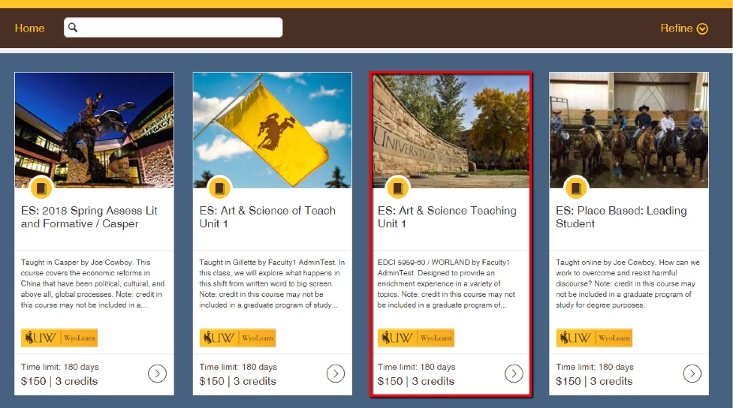
Click the “Enroll” button.


If you already have a WyoLearn account click the “Sign in now!” link and enter your login information. If you do not have a WyoLearn account, fill out the fields to create one. After you are logged in, type a promotion code if you have one and click “Apply,” then click “Proceed to Payment.”
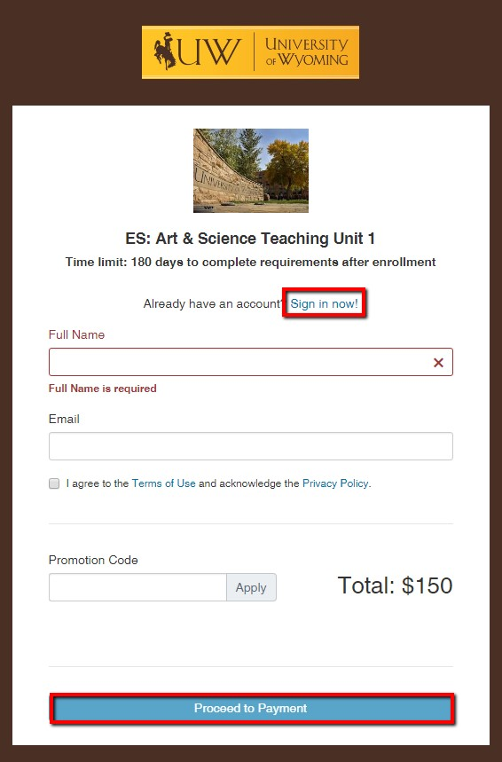

You will be redirected to TouchNet where you can input your payment information. Click “Continue” to complete your payment and then you will be directed back to the course page where you can complete your enrollment.
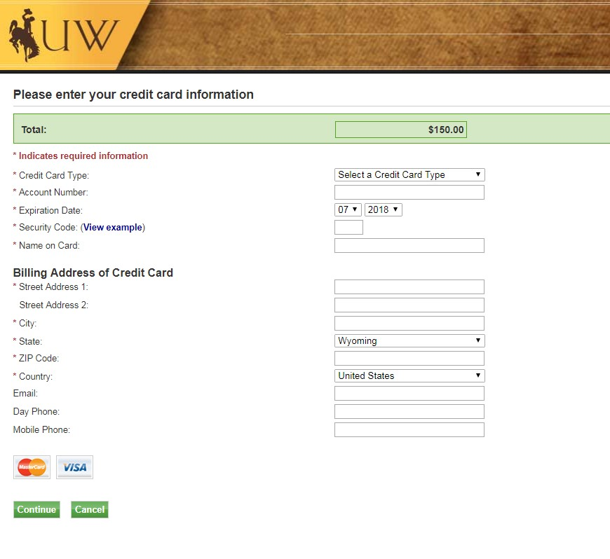

You will return to your student dashboard in WyoLearn where you can view the courses you are enrolled in. Click on “Begin Course” to go to the course in Canvas.
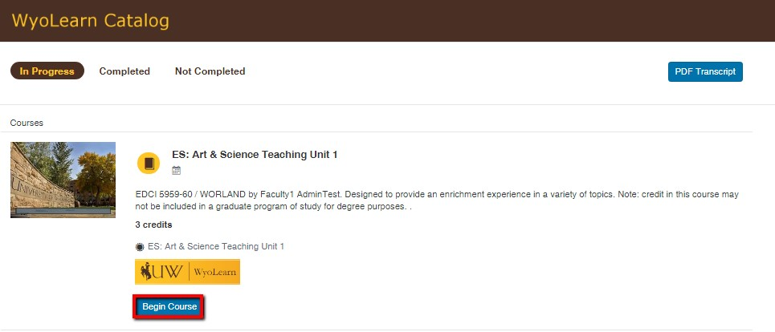

You will then be able to access the content of the course. For additional help, click on the “Help” tab to view the help options available for WyoLearn.
