Notice

This document is disseminated under the sponsorship of the U.S. Department of Transportation in the interest of information exchange. The U.S. Government assumes no liability for the use of the information contained in this document.

The contents of this report reflect the views of the author(s) who are responsible for the facts and accuracy of the data presented herein. The contents do not necessarily reflect the official views or policies of the Wyoming Department of Transportation or the Federal Highway Administration. This report does not constitute a standard, specification or regulation.

The United States Government and the State of Wyoming do not endorse products or manufacturers. Trademarks or manufacturers’ names appear in this report only because they are considered essential to the objectives of the document.

Quality Assurance Statement

The Federal Highway Administration (FHWA) provides high-quality information to serve government, industry, and the public in a manner that promotes public understanding. Standards and policies are used to ensure and maximize the quality, objectivity, utility, and integrity of its information. FHWA periodically reviews quality issues and adjusts its programs and processes to ensure continuous quality improvement.

Report No. |  | Government Accession No. |  | Recipients Catalog No.
Title and Subtitle  Evaluation of WYDOT’s Research Center and Research Program |  |  |  | Report Date  March 31, 2008  Performing Organization Code
Authors  Gary Schneider & Larry Redd, P.E. (R&S Consulting LLC)  Khaled Ksaibati, Ph.D, P.E. (University of Wyoming) |  |  |  | Performing Organization Report No.
Performing Organization Name and Address  R&S Consulting, LLC  PO Box 942  Cheyenne, WY 82001 |  |  |  | Work Unit No.  RS03(207)
Sponsoring Agency Name and Address  Wyoming Department of Transportation  5300 Bishop Blvd.  Cheyenne, WY 82009-3340  WYDOT Research Center (307) 777-4182 |  |  |  | Type of Report and Period Covered  Final Report  January 2007 – March 2008  Sponsoring Agency Code
Supplementary Notes

Abstract:

Key Words  Wyoming, Research Program, Research Advisory Committee, research performance measures, research proposals, research project selection, strategic research |  |  |  | Distribution Statement  Unlimited
Security Classif. (of this report)  Unclassified | Security Classif. (of this page)  Unclassified |  | No of Pages  124

Acknowledgements

R&S Consulting would like to acknowledge the support of the Wyoming Department of Transportation’s Research Program and the Research Advisory Committee.

R&S would like to acknowledge the contribution provided by Mr. Khaled Ksaibati, Ph.D., P.E. and Professor of Pavement Materials, University of Wyoming, Department of Civil and Architectural Engineering.

R&S Consulting would also like to thank those individuals in WYDOT and other state transportation organizations who provided data, information and opinions for this study.

Forward

This report is the result of in-depth analysis of WYDOT’s Research Program. The principal investigators, all with engineering backgrounds (including two P.E.s), have over 50 years of combined experience in performing R&D and managing research projects in universities, national laboratories and in the private sector. Each of the researchers has intimate knowledge of WYDOT’s Research program having executed numerous projects on behalf of WYDOT over the past five years. Among other related accomplishments the authors of this study hold several patents, have founded technology companies and have worked in research and product development in Fortune 500 companies.

The results of this study are intended to provide an independent review of the Research program and recommendations to increase WYDOT’s and FHWA’s return on investment for research funding. The report contains several major recommendations that WYDOT’s executive leadership may or may not wish to implement. However, it should be noted that several of these key recommendations are inextricably linked such as linking the research Program more closely to WYDOT’s strategic plan and its Balanced Scorecard Measures and the proposed lower level Research program performance measures. Interdependencies of recommendations should be carefully considered in moving from recommendations to implementation.

WYDOT has several programs (e.g. Traffic, ITS, Safety) that perform research and engineering analysis within their programs. This study did not examine these other programmatic research efforts within WYDOT.

Arguments stated, concepts presented, conclusions drawn, and recommendations made are solely those of the authors of this report and do not necessarily represent those of WYDOT, the FHWA, or the University of Wyoming.

Table of Contents

EXECUTIVE SUMMARY 1
Introduction 3
Chapter 1 – High-Level Program Review and Strategic Management of Research 7
Linking Research to WYDOT’s Balance Scorecard 9
Developing a Research Agenda to Support Departmental Strategic Goals 9
Chapter 2 – Program Review and Case Studies of Research Projects 17
High-level Review of Research Projects 25
Research Project Case Studies 37
Summary of Case Studies 62
Chapter 3 – Research Program Performance Measures 65
Source of Performance Measures 65
Selection Process 65
Selected Performance Measures and Implementation 89
Summary of Performance Measures 97
Chapter 4 – Recommended Processes, Tools and Aids for Managing Research 99
Supplemental Proposal Guidance 100
Proposal Evaluation Checklist 100
Developing an R&D Agenda and Working with Programs to Solicit Research Opportunities 100
Managing a Research Agenda 101
Researcher Feedback 101
APPENDIX A – Framework for Case Studies 103
APPENDIX B - Proposed Balanced Scorecard for WYDOT’s Research Program 110
APPENDIX C – Supplemental Proposal Guidance 114
APPENDIX D – RAC Proposal Evaluation Checklist 116
APPENDIX E – Research Feedback Form 120
REFERENCES 123

List of Figures
Figure 1: Project Work Breakdown Structure ………………………………………… 3
Figure 2: Causal Diagram Showing Linkages Between Research
and WYDOT’s Strategic Goals ………………………………………… 6
Figure 3: Research Program Execution Process ………………………………………… 7
Figure 4: Evolution of a Research Track Using a Three-step Process
for Defining Projects Traceable to Strategic Goals and BCS Measures … 11
Figure 5: Performance Curves for Two Factors in Reducing Fatalities ………………… 13
Figure 6: Two Approaches for Conceptualizing Projects ……………………………..… 14
Figure 7: The Science and Technology Continuum ……………………………………….. 25
Figures 8a and 8b: Number of Projects and Funding by Project Type ………………... 27
Figure 9a and 9b: Number of Projects and Funding by Project Category ………………… 28
Figure 10: “S” Curves Representing Competing Innovation Paths ………………………… 29
Figure 11a and 11b: Number of Projects and Funding by Strategic Intent ………………… 34
Figure 12: Concentration of Pooled Funds Projects with the Strategic
Intent of Preservation and Shared Knowledge ………………………… 35
Figure 13: Concentration of Pooled Funds Projects and WYDOT Projects
(Contract) by Project Type ………………………………………………… 35
Figure 14a and 14b: Number of Projects and Funding by WYDOT
Program Sponsorship ………………………………………………………... 36
Figure 15a: Trends in Project Funding by Strategic Intent ……………………………….... 90
Figure 15b: Trends in Number of Projects by Strategic Intent ………………………… 90
Figure 16: Trends in the Number of Proposals ………………………………………… 91
Figure 17: Trends in the Number of Needs Statements Submitted by Programs ……….. 91
Figure 18: Trends in Project Outcomes and Impacts ………………………………… 91
Figure 19: Trends in the Number of Research Reports Submitted and the
Number of Projects not Completed within Three Years ………………… 92
Figure 20: Cost-benefit Report for an Example Cost Savings Project Using RPM Tools … 94
Figure 21: Sample report for RPM Program Effectiveness Performance Measures ………… 95
Figure 22: Trend in Percentage of Administrative Costs to Total Program Funding … 96
Figure 23: Percentage of Administrative Costs to Total Program Funding ………………… 96
Figure 24: Supply and Demand for Research Funds ………………………………………… 96
Figure 25: Projects Completed on-time and within Budget for Informational
Purposes Only ………………………………………………………………… 97
Figure 26: Determining the Research Program’s Position on the Research ROI Curve … 97
Figure 27: Framework to Enhance Research Program Effectiveness
and to Increase the Probability of “Successful” Research ………………… 99

List of Tables

Table 1: WYDOT BCS Goals, Strategies and Measures …………………………….….… 17

Table 2: Projects Identified in the 2006 Research Work Program and Analysis Attributes ….. 25

Table 3: Ten Selected Highlights from the 23 Case Studies …………………………….….… 45

Table 4: Candidate Performance Measures with Measures Selected by
WYDOT Highlighted ……………………………………………………….…. 91

Table 5: Summary of Current Program Practices and Proposed Practices ……………….....109

EXECUTIVE SUMMARY

This study examined multiple aspects of the Research program. It provides numerous observations of the overall program and the research investment portfolio as well as guidance for developing a strategic research agenda which was requested by Research program management and Executive leadership. The study provides insight into various categories of research projects by analyzing data across all projects and detailed case studies for a select group of projects. This provided valuable lessons learned and recommendations for managing the research program in the future.

The overall program is very efficiently managed. The authors’ first-hand experience in performing research on behalf of WYDOT has been very positive. From proposing projects to the RAC, to executing projects with sponsors, to fulfilling administrative requirements, WYDOT’s research program has minimal decision layers, is efficient, can respond quickly and is not afraid to support research that falls “outside the box”. There are very few public sector research venues in the U.S. (in any technical field) that are as streamlined and responsive as WYDOT’s Research program.

That stated there are significant opportunities to improve program effectiveness and this report provides numerous recommendations, tools and aids to accomplish this.

The study provides a process for developing an agenda and working with programs to solicit research opportunities to execute the research agenda. If Executive leadership desires to improve the effectiveness of the Research program the study recommends that Research program management take a more active role in directing research investments – working with the interested programs to establish and execute a research agenda.

Linking research to BCS targets is not a recommendation for completely abandoning current Research program philosophy. A key strength of the program is the fact that on a quarterly basis WYDOT provides an open forum where, with program sponsorship, an idea can be proposed to the RAC and based upon merit receive significant funding within three weeks with a very few approvals and minimal process. What is recommended is that WYDOT find and maintain balance between a strategic research agenda and pursuit of real-time, high potential R&D opportunities.

The study defines performance measures for improving program effectiveness. The ten performance measures selected by WYDOT, in aggregate, comprise the proposed balanced scorecard for the Research program. These measures are comprehensive and coherent. They link research to the strategic plan through a research agenda and focus on outcomes (effectiveness) while also addressing process (efficiency). The measures provide WYDOT with a framework for continuous improvement, i.e. measure-monitor-manage-measure. The measures are quantifiable and trends in these measures should be communicated through the Annual Research Work Program report.

In addition to a performance measurement system, the study provides the Research program with other tools and aids such as a proposal evaluation checklist, supplemental guidance for researchers for proposal development and a researcher survey for gathering feedback and continuous improvement.

Although focused on WYDOT, the results of this study and the tools, aids and methods provided to improve research program effectiveness should be applicable and useful to other state transportation agencies.

Introduction

The Wyoming Department of Transportation’s Research program receives approximately one million dollars in annual funding. A research program within an engineering organization, such as WYDOT, can be a valuable tool in contributing to meeting corporate goals. In transportation, effective investment in research creates knowledge and innovations that result in more cost effective management of assets, improvements in safety and mobility, cost savings and other public benefits. Given the leverage of research dollars, improvements in research effectiveness yield high return on investment. With this understanding WYDOT’s Research Program management contracted R&S Consulting to analyze the Research Program and provide strategic and operational recommendations and implementation assistance to increase program effectiveness.

The primary project objectives were to:

- Enhance the Program by formulating more refined research management strategies, evaluation methods and performance measures.

- Develop an approach for identifying potential research needs as well as long and short term goals for research.

- Create a framework for continuous Program improvement and build upon the Program’s foundation to develop a sustainable structure that will maintain Program success and continuity independent of future changes in WYDOT staff.

The project was divided into the four tasks shown in Figure 1. Task 2 and 3 were highly interdependent.
Figure 1. Project Work Breakdown Structure

Task 1 – Background Research

The following documents were reviewed as background research:

- Wyoming Department of Transportation Research Work Program, 2007
- Wyoming Department of Transportation Annual Work Program, Accomplishment Report HPR-PL-(203)
- Wyoming Department of Transportation Project Results, Newsletter
- Research Center Proposal and Report Guidelines
- Peer Exchange, Wyoming Department of Transportation, November 6-9, 2006
- Peer Exchange, Wyoming Department of Transportation, July 8-11, 2001
- Research Peer Exchange, South Carolina Department of Transportation, October 17-19
- Lending Library Statistics, January 2006 – June 2006
- LTAP Program Assessment Report
- Technology Transfer News, New York State Department of Transportation
- Moving Forward, Ohio Department of Transportation
- Performance Measurement Tool Box and Reporting System for Research Programs and Projects, NCHRP, April 2006
- NCHRP Synthesis 300, Performance Measures for Research, Development and Technology Programs, 2001

Additional background information was collected from interviews with Research Program management and administration, WYDOT program sponsors, WYDOT Executive Staff and principal investigators.

Task 2 – Analysis of Research Projects

WYDOT’s 2006 Research Work Program report was used as the primary data source for this study. The report identified sixty-four projects executed over the past eight years representing over $5,000,000 in research funding. The review of research projects was conducted on two levels. The first level of analysis looked across all projects. Analysis across all projects quantified the distribution of research funding by programs, strategic performance measures and other project attributes. The second level of analysis involved case studies of twenty-three selected projects. In-depth analysis of these projects resulted in numerous “lessons learned” and recommendations.

Task 3 – Develop Tools and aids to Improve Program Effectiveness

Five important tools and aids were developed in Task 3. The main tool was a comprehensive and coherent set of WYDOT research program performance measures. These performance measures are intended to improve the management of research; they provide a framework to drive funding decisions based on analysis such as return on investment. These performance measures will document that the program is effective and is being well managed and administered. Seventeen candidate performance measures were evaluated by WYDOT. Through a series of workshops the 17 metrics were narrowed to ten. Task 3 included evaluating an application called the NHCRP Performance Measurement Tool Box and Reporting System for Research Program Projects -- an important tool for supporting the cost-benefit analysis performance measure. Projects analyzed in Task 2 were used to validate the selected performance measures and the framework and tools for monitoring the ten performance measures. Task 3 included developing a proposal evaluation checklist for RAC members based on lessons learned from Task 2. The checklist will help drive the performance measures. Task 3 also included recommendations for improving the effectiveness of soliciting WYDOT programs for research opportunities. Another Task 3 deliverable is supplemental guidance to help PIs improve their proposals. A final, Task 3 aid is a questionnaire to solicit feedback from program sponsors and principal investigators on the process and the project.

Task 4 – Draft Report and Disseminate Results of the Study

Although focused on WYDOT, the results of this study and the tools, aids and methods to improve research program effectiveness should be applicable and useful to other state transportation agencies. A briefing was developed as part of this project to support any requests for public presentations. Submitting a professional paper to TRB is also being considered, but no commitment has been made.

Figure 2 illustrates how the Research Program, by aligning research inputs and managing and administering the Research program, contributes to WYDOT’s strategic goals. Many factors may drive the demand for transportation research at WYDOT. New technologies, often developed in other science and engineering fields such as sensors, create new opportunities. Other DOTs can spur R&D projects when they publicize research results or request WYDOT participate in pooled funds projects. FHWA identifies problems or launches new programs that lead to R&D projects. Public concerns over safety or mobility issues can create the need for a research project. Finally, analyzing WYDOT’s strategic goals and determining if (how, when, where) research can impact these goals also creates sound rationale for research projects.

As shown in Figure 2, projects require multiple inputs including:

- Ideas, problems or opportunities which originate from the sources described above;
- Funding to execute a research project – to pay for salaries, equipment, travel, testing equipment, etc.;
- Researchers to perform the R&D;
- R&D infrastructure including facilities in which to execute the R&D project; and
- The existing knowledge/technology base upon which all new knowledge and technologies are built.

The research product created from these inputs is new knowledge, technologies and know-how. Figure 2 shows how existing knowledge/technologies is the foundation for new knowledge and new technologies and that as the knowledge/technology base grows there is more opportunity to combine more knowledge and technologies into new knowledge and innovations. This feeds the next cycle of innovation with new knowledge and technology inputs. This positive feedback creates geometric growth and is often referred to as the technology “explosion”.

In the case of WYDOT’s research program its contribution to growing the knowledge/technology base are the outcome measures shown in Figure 2 and listed below:
- Specifications revised
- New methodologies implemented
- Dollars saved/costs avoided
- Facilities with extended service life
- Fatalities and crashes reduced
- New products evaluated and implemented
- Policy and legislative impacts

Aggregation of these outcome measures are also the Research program’s contribution towards meeting the Department’s strategic goals. This is what really matters in determining WYDOT’s return on investment (ROI) from research. Enhancing the effectiveness of this contribution and increasing WYDOT’s ROI from the Research program is the intent of this project.
Figure 2. Causal Diagram Showing Linkages Between Research and WYDOT’s Strategic Goals.

Chapter 1 – High-Level Program Review and Strategic Management of Research

The first phase of this study examined program execution. As shown in Figure 2, the overall program execution process was decomposed into four sub-processes.
Figure 2. Research Program Execution Process.

The authors are familiar with the programmatic and administrative business processes. Each of the researchers has executed several projects on behalf of the Research program over the past five years. One of the authors reviewed the program’s administrative processes during recent implementation of a new financial management system (WY@ERP).

From the high-level review and first-hand experience participating in the research process six general observations were made. The first three are strategic and the next three tactical.

- While in some way all research projects link to one or more goals in the Department’s Balanced Scorecard (BCS), there is no research agenda based on strategic analysis which links projects of some percentage of research funding to specific Departmental goals.

- The program could benefit from a comprehensive and coherent set of performance measures. Currently the Research program relies primarily on anecdotal evidence to judge and communicate the impact of research funding on the Department’s overall strategic goals and measures. There is no quantifiable return on investment measures that could be used to help justify growing the program even though there may be significant return on investment in doing so.

- The Research program does not formally solicit research. A strong element of the program is the large percentage of unsolicited projects which provide an avenue for researchers to approach WYDOT with external ideas. However, primary reliance on this mode of operation does not enable WYDOT to pursue research strategically nor afford the opportunity to compare research proposals for a given need and a given project in areas such as approach, proposers’ capabilities and experience and cost estimates. In some quarterly award cycles WYDOT does not receive a sufficient number of proposals.

- The proposal and award process is relatively streamlined and efficient for both WYDOT and the principal investigator.

- Technology transfer efforts are adequate for some projects, but could be improved by better understanding of why, when and how the type of partner matters. Implementation of R&D often depends on matching the right type of partner with a project’s expected outcome measure and its location (in terms of outputs) on the continuum between science, technology and commercialization. Often overlooked in the research community is the fact that most “technology transfer” is enabled by the private sector, i.e. technology is transferred through the sale of products and services. Also technology transfer could be more consistently and deliberately addressed in proposals and at project completion.

- The program is efficiently managed and has minimum administrative staff and overhead.

Observation 1 is the most fundamental and addresses the need to re-position the Research program as a more effective strategic asset within WYDOT. Although the 2007 Wyoming Department of Transportation Research Work Program report mentions the linkage between the Department’s strategic goals and the Research program, this linkage could be strengthened. One of the first decisions points on this project posed to WYDOT’s Research program management and Executive Staff was whether the Research program should have a more strategic focus (top-down) versus its almost exclusively bottom-up approach. Currently unsolicited research topics come into the RAC from a variety of sources: the programs, WYDOT’s Executive management other states, the research community and the public. Based on a decision by WYDOT’s leadership, it was decided that the Research program should adopt a more strategic focus while maintaining some share of funding to continue to support unsolicited research opportunities. Implementing this decision will require an effort to develop a research agenda be lead by the Research program in close cooperation with selected programs.

Observation 2 addressed performance measures and was an important recommendation in a 2006 Research Program Peer Review. A good set of performance measures is necessary to monitor program effectiveness; effectiveness means that the projects are being funded that have the potential to have the greatest positive impact on the Department’s core mission and that all of the pieces are in place to enable successful execution and implementation. Performance measures must also address program efficiency; efficiency means that a high percentage of program funds are spent doing actual research and that project selection, award and administrative processes are relatively straightforward. It became apparent early in this study that if the Research program was going to measurably impact strategic goals, before developing performance measures the program needed a framework to more closely link projects (and the project selection process) to BCS targets. Due to the dependence of performance measures on strategy and policy, development and adoption of performance measures follows program re-positioning.

Observations 3-6 will be addressed in succeeding chapters as the product of re-positioning the Research program and are outcomes of the strategic issues identified in Observations 1-3. This includes changes in processes such as the proposal and selection processes and the technology transfer process. The award and administration processes, the role of the RAC work well and are not envisioned to change.

Linking Research to WYDOT’s Balance Scorecard

The first foundational decisions proposed to WYDOT’s research program management and Executive Staff was whether the program should have a more strategic focus. Currently research projects are brought before the RAC by programs, the research community and the public. The Research program also identifies research opportunities through contacts in other states, on the web and other sources across the research community and disseminates this information to programs to stimulate project proposals. However, other than the Bridge program which has a more defined research agenda and an unusual level of leadership, the process from idea generation to proposal to funding to a “successful” project to implementation resulting in high strategic impact is rare. Although all projects proposed to the RAC must have a program sponsor, the translation between these proposed projects and their potential effect on WYDOT’s BCS goals is often unclear. This approach to management of research was contrasted with a more top-down approach of working with line programs to deliberately identify and document areas where research is needed in the short and long-term. These two approaches, strategic versus opportunistic were presented to WYDOT executive leadership. Subsequently, it was decided that the Research program would transition to a partly more strategic focus. But it was important that the program retain a significant share of its funds to support unsolicited research opportunities. In order to implement this decision the Research program must develop and manage a structured research agenda.

In developing and managing this agenda, Research program staff have been given a challenging task. This task has three major components:

- Working with programs to translate measurable BCS goals into coherent research plans comprised of research tracks which flow down to prioritized projects;

- Targeting the research community with solicitations for proposals which address these priorities;

- Ensuring programs’ research tracks are progressing; and

- Assessing the impact of research outcomes on achieving the BCS targets on a continual basis and periodically re-evaluating the research tracks and priorities with the programs.

Developing a Research Agenda to Support Departmental Strategic Goals

This section will show how the Research program, working with the interested programs can facilitate developing a research agenda to more closely align research funding to support Departmental strategic goals. The intent of the following section of this chapter is not to build the research agenda but to provide the Research program with a framework leading to development of one.

A good place to start developing a research agenda to support Departmental strategic goals is with the WYDOT mission statement:
“To enhance the economic well-being and quality of life in Wyoming by working with public and private partners to produce a safe and efficient transportation system.”

This mission statement rests upon six goals specified in Excellence in Transportation, Overall BCS document (WYDOT, July 2007). Each goal has a high-level strategy, associated measures and performance targets. Four BCS goals listed in Table 1, can and should be directly supported by the Research program.

Table 1. WYDOT BCS Goals, Strategies and Measures.
Goal | Strategy | Measure | Target | Actual
Keep people safe on the State transportation system. | Through education, engineering, enforcement and other innovative methods to continuously improve the safety of the transportation system. | # Fatalities  Fatality Rate per 100 million VMT  Crashes per million VMT  Seat belt usage | TBD  TBD  TBD | 195  2.10  2.66
Serve our customers. | Gather feedback from our customers to anticipate and meet their needs. | See, Excellence in Transportation (WYDOT, July 2007)
Take care of all physical aspects of the State transportation system. | Maintain and improve the existing transportation system through:  - Training  - Resource management and prioritization  - Best practices  - Innovative solutions | See, Excellence in Transportation (WYDOT, July 2007)
Exercise good stewardship of our resources. | Wisely care for the natural and financial resources with which we have been entrusted. | See, Excellence in Transportation (WYDOT, July 2007)

The example used below relates to building one prong of a multi-pronged research agenda from one of WYDOT’s strategic goals, i.e. keeping people safe on the State transportation system. From this statement, research objectives and priorities will be developed and projects conceptualized and research projects solicited. The example is used to describe a three-step process for developing one prong of a multi-pronged research agenda. Using the safety-related performance goal, Keep people safe on the State transportation system, and focusing on engineering solutions, Figure 4 illustrates the evolution of a research track

The research track addresses a potentially significant opportunity to reduce crashes and fatalities in Wyoming which directly links to WYDOT’s strategic goals and the three BCS measures. A previously funded project examining wind-related crashes serves as subject matter in the example illustrated in Figure 4.

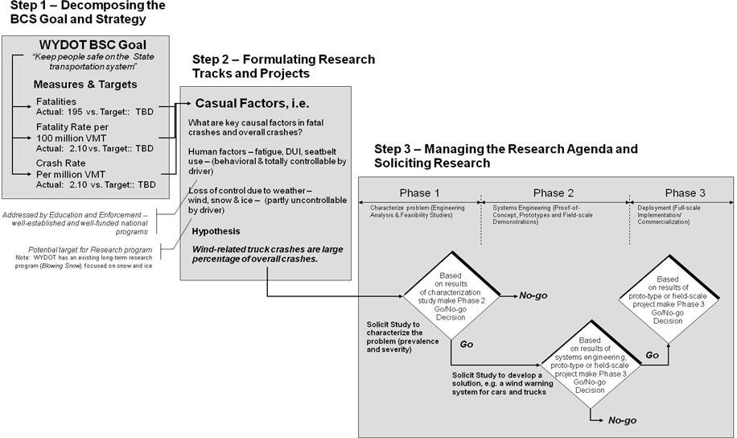
Figure 3. Evolution of a Research Track Using a Three-step Process for Defining Projects Traceable to Strategic Goals and BCS Measures
The example shown above and the process described below can be applied to all four strategic goals listed in Table 1. For example, creating a research track to reduce operating costs through energy management ties to the strategic goal and BCS measures for stewardship of resources; a research track for reducing the impact of future shortages and price increases for asphalt ties to the strategic goal and BCS measures of taking care of the system; a research track to address ways to mitigate truck traffic on the I-80 corridor ties to serving WYDOT’s customers.

Step 1 – Transforming BSC Goals and Strategies into Research Tracks

Examining the safety goal, Keep people safe on the State transportation system, the strategy can be decomposed into the following three components:
- Education
- Engineering
- Enforcement

The Engineering component has more relevance to the Research program than Education or Enforcement components. The Education component pertains to highway safety public awareness campaigns which address human factors such as driving when fatigued, driving impaired and use of seat belts. The Enforcement component focuses on safety measures such as speed enforcement, DUI enforcement and ensuring motorists are using seatbelts. While both of these components could be supported by the Research program, there are already well-established and well-funded programs to support Education and Enforcement as they relate to highway safety. Obviously, it is the Engineering component of the safety-related BCS goal is where the Research program should target its resources. In doing so, and with the appropriate performance measures in place, the Research program can more clearly demonstrate how it is contributing to the Department-wide effort to reach the targeted reduction in crashes and fatalities.

Figure 5 shows a series of performance curves that characterize two factors in reducing fatalities: seatbelt use and research program efforts to reduce crashes. WYDOT has identified increasing seatbelt use as a key BCS measure as it is a strong contributing factor to reduction in fatalities; efforts to increase seatbelt use are well-funded through educational campaigns and enforcement of secondary seatbelt laws. As shown in Figure 5, after a certain level of investment to increase seatbelt use, incremental ROI in terms of reductions in fatalities declines; this phenomenon is popularly known as the theory of constraints or the law of diminishing returns which states that at some point in complex systems returns to any one input decrease. Given this precept, the question for research management is where can research be leveraged to move the performance curve up? The answer depends on identifying prevalence of causal factors in crashes and hypothesizing whether research can affect these causal factors. Can research shift the seatbelt performance curve up (or change the shape of the curve) and what is the context for enabling a shift, i.e. under what conditions, for what type of vehicles, on what routes, etc.

The process is one of: 1) decomposing the strategy into components, 2) determining what components and what measures can be positively impacted by research, 3) understanding the degree of synergy that could be generated with other initiatives, and 4) identifying key constraints limiting or which will limit sustained positive impact from the research output. Executing this process requires not only analytical skills but synthesis, interpretation and judgment as well as an understanding of related performance curves. This characterization process should be repeated for each BCS goal in consultation with responsible program managers to identify and document areas where research is needed in the near-term, mid-term and long-term and how the research compliments existing efforts whether in safety, mobility, preservation or cost savings.
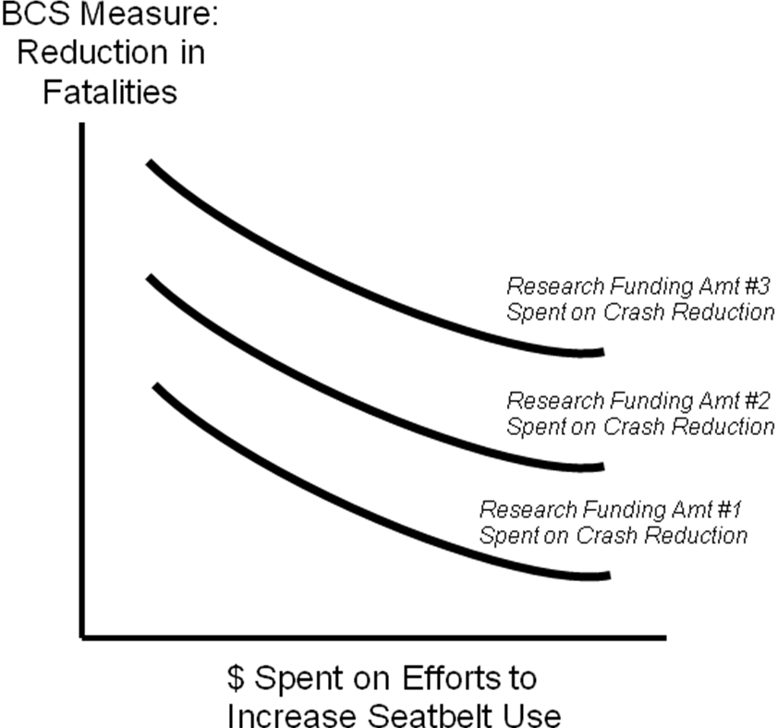

Areas of research opportunity can be identified by an analysis process described below or by simply soliciting the research community for proposals to address a specific BCS goal. For comparative purposes Figure 6 illustrates these two approaches for conceptualizing projects. One approach is analytic the other more open. Both approaches can be effective. If the Research program and program managers are confident in their assessment of the problem/ opportunity and the requirements of a solution then they should develop a hypothesis and follow the prescriptive approach. If there is uncertainty in characterizing the problem and formulating possible solutions or if an “out-of-the-box” solution is desired then follow the creative approach of publishing broad objectives and inviting the research community to respond accordingly.
Figure 5. Performance Curves for Two Factors in Reducing Fatalities.

The next step focuses on the more analytical approach and requires WYDOT to analyze causal factors and opportunities to define a line of research, i.e. a “research track”. A research track is a coherent approach to addressing a significant problem or opportunity. Research tracks normally require a series of projects to complete and may involve combinations of the following: decision gates, feasibility studies, applied research to support an engineering concept, multiple engineering or technology approaches and sometimes different sets of partners, public sector and private sector. Research tracks are established to address important problems or capitalize on large opportunities to affect BCS measures whether in safety, preservation, cost savings, etc. Establishing and pursuing research tracks often require sustained funding, focus on and investment by programs and multiple years to reach fruition.

Research tracks must be carefully managed. Ending research tracks pre-maturely often results in minimal return-on-investment while endless pursuit of one can also waste resources. Developing, publicizing and managing research tracks will provide structure needed to take the Research program to the next level of effectiveness and more closely link research to WYDOT’s strategic goals.
Figure 6. Two Approaches for Conceptualizing Projects.
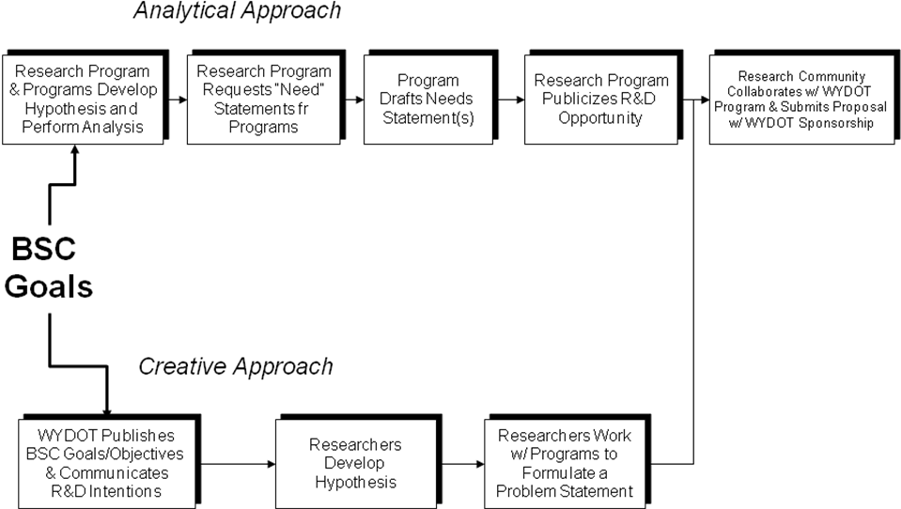

Step 2 – Formulating Research Tracks and Projects

Step 2 involves collaboratively reviewing the measures and targets for the safety-related BCS goal. This will probably be lead by the Research program and the selected programs. These measures link to causal factors affecting the number of crashes and fatalities. (In some cases, such as an operational cost savings project, the BSC goal will link to opportunities for cost savings rather than causal factors – in which case the focus would be on drivers of operational costs; in either situation the objective is to identify where is the “bang for the buck” and assessing whether this expected payoff can be realized through research.) Since human factors are addressed in the Highway Safety (education) and Highway Patrol (enforcement) programs, the Research program focuses on causal factors associated with motorists’ losing control of their vehicle due to weather conditions, specifically wind either alone or in combination with snow and ice. Since WYDOT has an existing long-term research program to address mitigating snow and ice conditions, the Research program decides to pursue a study to characterize crashes and fatalities related to high winds.

At this point the Research program does not know how prevalent or severe wind-related crashes are. There is anecdotal evidence when someone sees multiple semi-tractor trailers lying on their sides on Interstate 25 and Interstate 80 in the vicinity of Cheyenne. However, there is no single dataset from the Highway Safety or Highway Patrol programs to easily ascertain the annual number of wind-related crashes or the associated number of fatalities, injuries and monetized property loss. The Research Program and the affected program(s), in this case Traffic and Highway Safety, would develop the following hypothesis:

Wind-related truck crashes are a large percentage of overall crashes involving trucks.

This hypothesis will need to be tested to determine if reducing wind-related crashes will significantly contribute to the BCS measure of reducing crashes and fatalities. If analysis proves this to be a prevalent problem and if there are potential solutions that can be developed through research and ultimately implemented (either by WYDOT or the private sector) opportunities to reduce wind-related crashes may be a viable research track.

Step 3 – Managing the Research Agenda and Soliciting Research

Next, the Research program solicits a study to characterize the problem and test the hypothesis – Phase 1 as shown in Figure 4. The study could include a decision gate in the research contract; if the problem warrants conceptualization of engineering solutions this could be the second part of the Phase 1 research. At the end of Phase 1, the Research program, the program sponsor and the RAC make a “go/no-go” decision on whether and how to continue along the research track.

Assuming a “go” decision, the Research program would solicit a study to develop a field demonstration of a wind-warning system to be deployed in a specific location – Phase 2 in Figure 4. Phase 2 may include a proto-type system prior to a field demonstration. Phase 2 would be divided into two parts, a proto-type and field demonstration. In formulating Phase 2, the role of the public versus the private sector should be carefully considered. If the solution envisioned is complex and requires specialized maintenance or if the solution will benefit from continuous system enhancements it may be more appropriate for WYDOT to partner with the private sector who has a profit motive to sustain implementation of an R&D effort

Based on the results of this field demonstration the sponsoring program would determine where, when and how to adopt and implement the full-scale solution – Phase 3. In Phase 3 the solution moves from research to operations. The role of the private sector in Phase 3, and a determining factor in successful technology transfer, is often dependent upon the involvement of the private sector in Phase 2. If the solution is best delivered by the private sector, i.e. the private sector is needed for operations and/or maintenance, it is recommended that WYDOT involve the private sector in Phase 2 rather than academia or other not-for-profit research institutions.

The example above is characterized as a Systems Engineering and Engineering Analysis project in Chapter 2. This means an applied engineering solution to a defined problem. Not all research tracks will move directly from problem characterization to an engineering or applied materials solution. Consider a research track to prolong asphalt life driven by the BSC asset preservation goal. This research track might require advances in materials science (i.e. applied research) before a feasible engineering solution is developed. This type of applied research project (versus an engineering project) is referred to as an Engineering Standards and Information project in Chapter 2. The point is that many factors must overlay the three-step process presented above to develop a coherent research track which can result in implementation and positively impact strategic goals.

Transforming WYDOT’s Research program philosophy from mostly opportunistic to strategic is an ambitious transformation. It is not an overnight process and will take several years before some of the practices outlined above are bear fruit. It calls for greater involvement by the Research program in a facilitation and analysis role and active participation by programs to define a research agenda that will help their programs and their programs’ contribution to achieving BSC targets.

Linking research to BCS targets is not a recommendation for completely abandoning current Research program philosophy. A key strength of the program is the fact that on a quarterly basis WYDOT provides an open forum where, with program sponsorship, an idea can be proposed to the RAC and based upon merit receive significant funding within three weeks with a very few approvals and minimal process. There are very few public sector research venues in the U.S. (in any technical field) that are as streamlined and responsive as WYDOT’s Research program. It is recommended that WYDOT find and maintain balance between a strategic research agenda and pursuit of real-time, high potential R&D opportunities.

Chapter 2 – Program Review and Case Studies of Research Projects

The review of research projects was conducted on two levels. The first level of analysis looked across sixty-four projects funded between 1999 and 2007. The second level of analysis was case studies of twenty-three selected projects. Case study projects provided a representative cross-section of WYDOT programs, entities performing the research and various combinations of project attributes.

For the high-level analysis, the 2006 Research Work Program report provided basic information on the sixty-four projects in the dataset. These projects are listed in Table 2. For each project the following data elements were captured:

- Project description
- Funding (expended or obligated)
- WYDOT point of contact
- Program sponsor
- Start date
- Completion date
- Entity performing the research

In addition to capturing these data elements, each project was classified by a combination of three analysis attributes relating to the means by which the project was funded and executed, where the project was positioned on the science and technology continuum and the project’s strategic intent.

For case studies, project files were complete and well-organized and in most cases thoroughly documented the project’s lifecycle from pre-proposal to execution.

Analysis of the projects at both a high-level and selected projects as case studies provided the following:

- Key “lessons learned” and recommendations (presented below) were derived by identifying drivers behind successful project outcomes and determining root causes for less than successful outcomes;

- A basis to vet candidate performance measures (presented in Chapter 3) by viewing the measures using actual project data. This was instrumental in determining a measure’s usefulness relative to the effort required by the Research program management to: 1) collect the data required for the measure, 2) track the measure over time and 3) report against the measure on a periodic basis;

- Insights in developing tools and aids (presented in Chapter 4) to increase program effectiveness such as a RAC proposal evaluation checklist, supplemental proposal development guidance and feedback form for researchers.

Table 2. Projects Identified in the 2006 Research Work Program and Analysis Attributes.
Project ID | Description | Obligated/ Expended | Project Category | Project Type | Strategic Intent | WYDOT POC | Program Sponsor | Started | Complete | Partnering Organization
SPR-2(212) | Non-nuclear Testing of Soils and Granular Bases Using the GeoGauge | $ 24,000 | Pooled Funds | Engineering Info and Standards | Shared Knowledge | Rick Harvey | Materials | Summer 2000 | Unknown | FHWA
SRR-3(017) | Midwest States Pooled Fund Crash Test Program | $ 110,000 | Pooled Funds | Engineering Analysis | Safety | Gregg Fredrick | Bridge | Oct-06 | Oct-08 | NDOR
SPR-3(702) | Strength and Deformation of Mechanically Stabilized Earth (MSE) Walls | $ 70,000 | Pooled Funds | Engineering Info and Standards | Shared Knowledge | James Dahill | Geology | Nov-98 | Dec-08 | WA DOT
SPR-3(076) | Animal-Vehicle Crash Mitigation Using Advanced Technologies | $ 75,000 | Pooled Funds | Engineering Analysis | Safety | Kevin Powell/Bill Gribble | Planning | Apr-99 | Aug-06 | WTI
SPR-3(083) | FIXS: Fabrication Error Indexed Examples and Solutions | $ 10,000 | Pooled Funds | Engineering Info and Standards | Shared Knowledge | Gregg Fredrick | Bridge | Jul-99 | Aug-04 | KS DOT
TPF-5(001) | Soil Mixing Methods for Highway Applications | $ 30,000 | Pooled Funds | Engineering Info and Standards | Shared Knowledge | Mike Shulte | Geology | May-01 | Unknown | FHWA
TPF-5(002) | Updating "A Guide to Standardized Highway Lighting Pole Hardware | $ 40,000 | Pooled Funds | Engineering Info and Standards | Shared Knowledge | Gregg Fredrick | Bridge/Traffic | Nov-00 | Unknown | Unknown
TPF-5(005) | Study Erection Issues and Composite Systems Behavior of the Full Scale Curved Bridge Currently Under Test at the Turner-Fairbank Research Center | $ 30,000 | Pooled Funds | Engineering Info and Standards | Preservation | Gregg Fredrick | Bridge | Jan-01 | Unknown | FHWA
TPF-5(016) | Micropile Systems for Highway Bridges | $ 10,000 | Pooled Funds | Engineering Info and Standards | Preservation | Gregg Fredrick | Bridge | May-01 | Unknown | Caltrans
TPF-5(026) | Durability of Segmental Concrete Block Retaining Walls | $ 60,000 | Pooled Funds | Engineering Info and Standards | Preservation | Gregg Fredrick | Bridge | Jan-01 | Aug-05 | FHWA
TPF-5(208) | HITEC Test and Evaluation | $ 75,000 | Pooled Funds | Engineering Info and Standards | Preservation | Tim McDowell | Planning | Jul-99 | Unknown | HITEC
TPF-5(042) | Investigation of the Long-Term Effects of Magnesium Chloride and Other Concentrated Salt Solutions on Pavement and Structural Portland Cement Concrete | $ 60,000 | Pooled Funds | Engineering Info and Standards | Preservation/Safety | Andy Freeman | Materials | Apr-02 | Jun-07 | SD DOT
TPF-5(051) | Construction of Crack Free Concrete Bridge Decks | $ 10,000 | Pooled Funds | Engineering Analysis | Preservation | Gregg Fredrick | Bridge | Oct-01 | Mar-08 | KS DOT
TPF-5(054) | Development of Maintenance Decision Support | $ 150,000 | Pooled Funds | Engineering Analysis | Preservation | Kent Ketterling | Matenance | Jul-05 | Sep-07 | SD DOT
TPF-5(068) | Long-Term Maintenance of Load and Resistance Factor Design Specifications | $ 20,000 | Pooled Funds | Engineering Info and Standards | Preservation | Gregg Fredrick | Bridge | Jan-05 | Dec-06 | IA DOT
TPF-5(116) | Investigation of the Fatigue Life of Steel Base Plate to Pole Connections for Traffic Structures | $ 125,000 | Pooled Funds | Engineering Analysis | Preservation/Safety | Gregg Fredrick | Bridge/Traffic | Oct-04 | "2007" | TXDOT
TPF-5(145) | Western Maintenance Partnership | $ 3,000 | Pooled Funds | Engineering Info and Standards | Preservation | Ken Shultz | Maintenance | Unknown | "2010" | UT DOT
TPF-5(?) | Extending the Season for Concrete Construction and Repair Phase III | $ 60,000 | Pooled Funds | Engineering Info and Standards | Preservation | Tim McDowell | Programming | 2006" | "2008" | US Corps of Engineers
RS08(200) | Control and Prevention of Alkali-Silica Reaction in Recycled Portland Cement Concrete Pavement Using Lithium Nitrated | $ 27,985 | In-house | Engineering Analysis | Preservation | Bob Rothwell | Materials | Jul-00 | Unknown | WYDOT
RS01(203) | Guardrail Crash Test to NCHRP 350 Phase II: Guardrail Transition Sections | $ 163,448 | Contract | Engineering Analysis | Preservation | Bill Wilson | ??? | Dec-02 | Dec-06 | SMR2
RS04(204) | Bridge Contraction and Lateral Spillslope Scour | $ 40,000 | Contract | Engineering Analysis | Preservation | William Baily | Bridge | Feb-04 | Dec-05 | Hydrau-Tech
RS01(205) | Utilizing GPS Technology to Evaluate Moose Movements in Relation to Vegetation Structure, and Roadway Design Along U.S. Highway 287/26 in NW WY | $ 50,000 | Contract | Engineering Information | Safety | Cody Beers | Public Involvement | Feb-05 | Dec-07 | UW
RS02(205) | Fatigue Testing of WYDOT's Signal Pole Stiffened Connection Phase II | $ 192,190 | Contract | Engineering Info & Standards | Preservation | Gregg Fredrick | Bridge | Jun-04 | Apr-07 | UW
RS03(205) | Feasibility of a Next-Generation Intermodal Rail-Truck Transport System for the Western I-80 Corridor | $ 165,700 | Contract | Engineering Analysis | Preservation | Mark Wingate | Planning | Jun-05 | Dec-06 | R&S Consulting
RS04(205) | Highway Construction Related Business Impacts: Phase 3 Effort for the Town of Dubois | $ 87,972 | Contract | Public Affairs | Public Affairs | Mark Eisenhart | State Construction | Aug-05 | Jan-08 | UW
RS05(205) | Preliminary Design and USDA Forest Service NEPA Review: Snow Supporting Structures for Avalanche Hazard Reduction Milepost 151 Avalanche, Highway U.S. 89/191, Jackson, WY | $ 94,689 | Contract | Engineering Analysis | Safety Enhancement | James Montuoro | District Maintenance | Aug-05 | Feb-07 | MSI-Foothill/InterAlpine
RS01(206) | Characterization of Wyoming Hot Mix Asphalt with the Hamburg Wheel-Tracking Device | $ 120,000 | Contract | Engineering Info & Standards | Preservation | Vicki Bonds | Materials | Oct-05 | Mar-08 | WYDOT
RS02(206) | Relating Vehicle-Wildlife Crash Rates to Roadway Improvements | $ 50,478 | Contract | Engineering Analysis | Safety Enhancement | Matt Carlson | Safety | Jan-06 | Jan-07 | UW
RS03(206) | A Laboratory Investigation of Pressure Contraction Scour at Submerged Bridges | $ 171,114 | Contract | Engineering Info & Standards | Shared Knowledge | William Baily | Bridge | Jan-06 | Aug-09 | UW
RS04(206) | Evaluation of Treatment Options for ASR-Affected Concrete | $ 101,650 | Contract | Engineering Info & Standards | Preservation | Cheryl Bean | Aeronautics | Mar-06 | Aug-12 | Concrete Engineering Specialists
RS05(206) | Wyoming LTAP Center | $ 90,000 | Contract | Tech Transfer | Shared Knowledge | Tim McDowell | Programming | Apr-06 | Dec-06 | UW
RS06(206) | Practical Operational Implementation and Evaluation of Teton Pass Avalanche Monitoring Infrasound System | $ 86,853 | Contract | Engineering Analysis | Safety Enhancement | James Montuoro | District Maintenance | May-06 | Aug-08 | Inter-Mountain Laboratories
RS07(206) | Evaluation of Intelligent Transportation System Alternatives for Reducing the Risks of Truck Rollover Crashes due to High Winds | $ 88,800 | Contract | Engineering Analysis | Safety Enhancement | Mike Gostovich | State Traffic | Apr-06 | Jan-07 | R&S Consulting
RS08(206) | Peer Exchange 2006 | $ 10,000 | Contract | Tech Transfer | Shared Knowledge | Michael J. Patritch | Research Center | Feb-06 | Nov-06 | N/A
RS09(206) | Evaluating the Risk of Alkali-Silica Reaction in Wyoming Through an Inter-Laboratory Investigation of Multiple ASR Evaluation Methods | $ 228,125 | Contract | Engineering Info & Standards | Preservation | Bob Rothwell | Asst State Materials | Aug-06 | Aug-12 | UW
RS10(206) | Effectiveness of Trapper's Point Wildlife Crossing Animal Detection System | $ 76,344 | Contract | Engineering Analysis | Safety Enhancement | Matt Carlson | State HWY Safety | Aug-06 | Dec-08 | UW
Closed
SPR-3(099) | TEL-8-2000 | $ 71,700 | Pooled Fund | Tech Transfer | Shared Knowledge | David Talley | Training | Sep-00 | Jun-04 | TEL-8-2000 Board of Directors
TPF-5(003) | Extending the Season for Concrete Construction and Repair | $ 60,000 | Pooled Fund | Engineering Info & Standards | Preservation | Tim McDowell | Materials | Fall 2000 | 2003-04 | U.S. Army Corps of Engineers
SPR-2(211) | Bulk Specific Gravity Round Robin Using the Corelok Vacuum Sealing Device | $ 10,000 | Pooled Fund | Engineering Info & Standards | Shared Knowledge | Mike Farrar | Materials | Jul-01 | UNK | FHWA
TPF-5(027) | Effects of Hot Plant Fuel Characteristics and Combustion on Asphalt Concrete Quality | $ 40,000 | Pooled Fund | Engineering Info & Standards | Shared Knowledge | Bruce Morgenstern | Materials | Sep-01 | UNK | S. Dakota DOT
SPR-3(039) | Demonstration and Evaluation of ITS for Rural Highway Environment | $ 60,000 | Pooled Fund | Tech Transfer | Safety Enhancement/Mobility | Bob Rothwell | ITS | Apr-98 | "2005" | MT DOT
SPR-3(077) | Wiremesh and Cablemesh Slope Protection | $ 20,000 | Pooled Fund | Engineering Info & Standards | Preservation/Safety Enhancement | Jim Coffin | Geology | Jun-99 | Dec-05 | FOSSC Materials Laboratory
TPF-5(036) | Transportation Asset Management Research Program | $ 30,000 | Pooled Fund | Engineering Analysis | Shared Knowledge | Kevin Hibbard | Budget Officer | Apr-02 | Sep-05 | WI DOT
TPF-5(075) | Extending the Season for Concrete Construction and Repair - Phase II, Defining Engineering Parameters | $ 60,000 | Pooled Fund | Engineering Info & Standards | Preservation | Tim McDowell | Planning | Jul-03 | 18-24 mos from start | U.S. Army Corps of Engineers
RS06(203) | Determining the Feasibility of Handheld Computers to Log Geotechnical Test Holes | $ 22,404 | In-House | Engineering Info & Standards | Preservation | G. Michael Hager | Geology | Apr-03 | Apr-05 | WYDOT Geology
RS03(201) | Testing & Evaluation of Concrete Repair Materials for the Cheyenne Airport Taxiways | $ 20,000 | In-House | Engineering Info & Standards | Preservation | Tim McDowell | Materials | Aug-01 | Feb-04 | Concrete Engineering Specialists
RS03(199) | Avalanche Hazard Reduction using Wind Drift Disrupters (Snow Sails) | $ 172,581 | Contract | Engineering Analysis | Safety Enhancement | Leroy (Ted) Wells | District 3 | Feb-99 | Sep-02 | MSI-Foothill
RS03(203) | Highway Construction Related Business Impacts | $ 87,104 | Contract | Public Affairs | Public Affairs | John Lane | Systems Planning | Jan-03 | Jan-05 | UW
RS04(203) | Determine the Feasibility of Integrating Wyoming's Commercial Vehicle Information Systems Network (CVISN) | $ 105,000 | Contract | Engineering Analysis | Infrastructure Update | Richard Smith | WHP Ports of Entry | Jan-03 | Oct-04 | Meyer, Mohaddes Associates, Inc.
RS07(203) | Infrasonic Monitoring of Avalanche Activity on Teton Pass | $ 196,779 | Contract | Engineering Analysis | Safety Enhancement | L.T. Wells | District 3 Construction | Apr-03 | Jun-05 | Inter-Mountain Laboratories
RS08(203) | Avalanche Hazard Reduction Using Wind Drift Disrupters (Snow Sails) Phase 2 | $ 81,640 | Contract | Engineering Analysis | Safety Enhancement | L.T. Wells | District 3 Maintenance | Jan-03 | Dec-04 | MSI-Foothill/InterAlpine
RS01(204) | Wyoming Freight Movement and Wind Vulnerability | $ 25,682 | Contract | Engineering Info & Standards | Safety Enhancement | John Lane | Planning | Nov-03 | Oct-04 | UW
RS03(204) | Analysis of Anchor Load Tests for Stabilization of the Flying-V Landslide | $ 40,000 | Contract | Engineering Analysis | Safety Enhancement | James L. Coffin | Asst. Chief Eng. Geologist | Jan-04 | Jan-05 | UW
RS05(204) | Wyoming Department of Transportation Customer Survey, 2004 | $ 36,000 | Contract | Public Affairs | Shared Knowledge | L.T. Wells | District 3 Maintenance | Apr-04 | Oct-04 | UW
RS03(198) | Using Time Domain Reflectometry to Monitor Highway Slopes | $ 78,326 | Contract | Engineering Analysis | Safety Enhancement | G. Michael Hager | Geology | Oct-97 | Dec-05 | UW
RS01(202) | Movement and Distribution of Pronghorn Antelope in Relation to Roads in Southwestern Wyoming | $ 222,400 | Contract | Engineering Analysis | Safety Enhancement | John Eddins | District 3 | Oct-01 | Dec-05 | WY Game & Fish
RS02(204) | Three-Dimensional Roughness Elements for Snow Retention | $ 96,052 | Contract | Engineering Analysis | Safety Enhancement | Clifford Spoonemore | Construction Staff | Nov-03 | Dec-06 | Ron Tabler
RS15(197) | Traffic Signal Pole Research | $ 159,577 | Contract | Engineering Info & Standards | Preservation | Gregg Fredrick | Bridge | Aug-97 | Jun-01 | UW
RS05(199) | Update and Evaluate New Methods for Estimating the Peak Flow Characteristics of Ungaged Streams in Wyoming | $ 51,100 | Contract | Engineering Info & Standards | Shared Knowledge | Bill Bailey | Hydraulics | Jun-99 | May-02 | U.S. Geological Survey
RS05(200) | Monitoring and Performance of Permanent Ground Anchors for Stabilization of the Deer Creek Landslide | $ 33,729 | Contract | Engineering Info & Standards | Safety Enhancement | G. Michael Hager | Geology | Mar-00 | Sep-03 | UW
RS01(201) | Feasibility of Tire Chips for Roadway Drainage Applications | $ 100,000 | Contract | Engineering Analysis | Preservation | G. Michael Hager | Geology | Jan-01 | Mar-03 | UW
RS05(203) | Murphy Creek Flood and Scour Study | $ 20,000 | Contract | Engineering Info & Standards | Shared Knowledge | William Bailey | Bridge | Apr-03 | Oct-03 | Hydrau-Tech
RS01(200) | Enhancement of WYDOT's BRASS-PIER for the New AASHTO LRFD Bridge Design Specification | $ 280,104 | Contract | Engineering Info & Standards | Shared Knowledge | Gregg Fredrick | Bridge | Jul-99 | Dec-02 | BridgeTech
RS04(202) | Avalanche Hazard Reduction using the Doppelmayr "Avalanche Blaster" Cache' and Mortar Technology | $ 140,000 | Contract | Engineering Analysis | Safety Enhancement | L.T. Wells | District 3 Maintenance | Apr-02 | Aug-04 | Doppelmayr CTEC

To provide context to the analysis of research projects a continuum of science and technology is illustrated in Figure 7. The base level shows the progression of the knowledge creation to innovation and finally new products, systems and processes. Although this is a complex process with circuitous routes and feedback, for simplicity the science and technology continuum is shown as a linear process which relates foundational knowledge developed in basic sciences to applied sciences which in turn support engineering principals which are manifested in applied materials, systems, products or processes. The middle tier shows the evolution of research products in relation to the continuum. The top tier shows an attribute created for this analysis called Project Type. Project Type is used to classify research projects. This science and technology continuum will be referenced many times in this report to provide context for analysis of the research program in general and projects in particular. It will be referenced along with recommendations for policies and guidelines to improve research program efficiency and effectiveness.
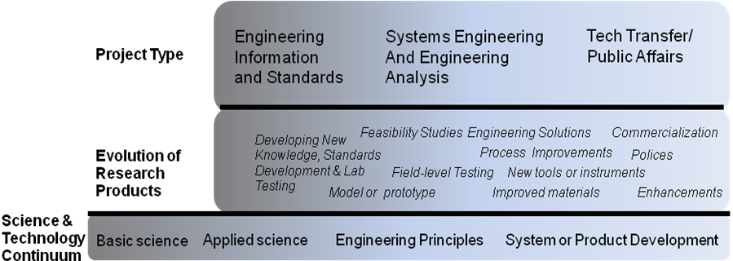
Figure 7. The Science and Technology Continuum.
.

High-level Review of Research Projects

The high-level review of WYDOT research projects funded over the past eight years categorized sixty-four research projects using four key attributes. These attributes are described and used as the basis for case study analyses.

- Project Type is the attribute describing the project’s position along the science and technology continuum as described above and illustrated in Figure 7. Four project types were defined for this analysis: 1) engineering standards and data and new knowledge, 2) systems engineering and engineering analysis and 3) technology transfer and public affairs.

- Project Category is the attribute describing the means to execute the project. This includes how the project was funded and who received the funding. Three project categories were defined for this analysis: contract research, pooled funds and in-house.

- Strategic Intent is the attribute describing the linkage between a research project and the strategic objectives of WYDOT. Five strategic areas were defined for this analysis: safety, preservation, infrastructure, shared knowledge and public affairs.

- WYDOT Program Sponsorship is the attribute identifying the program sponsoring the research project. Sixteen programs sponsored the 64 projects funded over the past eight years.

Project Type

Project Type is the attribute describing the project’s position along the science and technology continuum. (While several projects in areas of technology transfer and public affairs do not fit into the accepted classification of science and technology projects, these were included in analysis of the project type attribute for consistency in order to include all 64 projects across the other three project attributes.) Four project types defined this analysis:

- Engineering standards, data and new knowledge projects are in the realm of applied science and engineering principles. These projects result in new knowledge, know-how and standards. These projects are normally executed in the lab but may also include field testing and are not normally location-specific.

- Systems engineering and engineering analysis projects span the continuum from application of engineering principles to system and product development. These projects result in application of new engineering solutions, process improvements, new tools or instrumentation, improved materials and new policies or strategic initiatives. These projects are normally applicable to one or more locations or situations.

- Technology transfer projects are present all along the continuum from publications of research results to commercial products. However, for the purpose of this study technology transfer projects are defined as those projects that enable the diffusion and subsequent adoption of safety practices, new products, new and enhanced systems or process innovations.

- Public affairs projects focus on public policy and socio-economic issues and often result in policy recommendations or address a public request or concern and are not directly related to furthering science, technology or engineering.

As illustrated in Figures 8a and 8b, analysis of data by project type shows balance between the two project types. Thirty-two (32) projects and forty percent (40%) of research funds were spent on Engineering Information and Standards projects. Twenty-five (25) projects and fifty-one percent (51%) of research funds were spent on Systems Engineering and Engineering Analysis projects. Technology Transfer and Public Affairs project types accounted for a combined seven projects and less than ten percent (10%), of research funds.

On the surface this appears to be a good balance between fiscal support of applied science and basic engineering principals and applied engineering solutions. Absent a research agenda defining the engineering solutions needed to address important problems and opportunities in safety, preservation, mobility and cost-savings (and the projects in applied science and engineering principal needed to underpin the engineering solutions) it is indeterminate whether this is the optimal mix of funding across project types. A more rationale and structured research portfolio would justify the investment by project type.
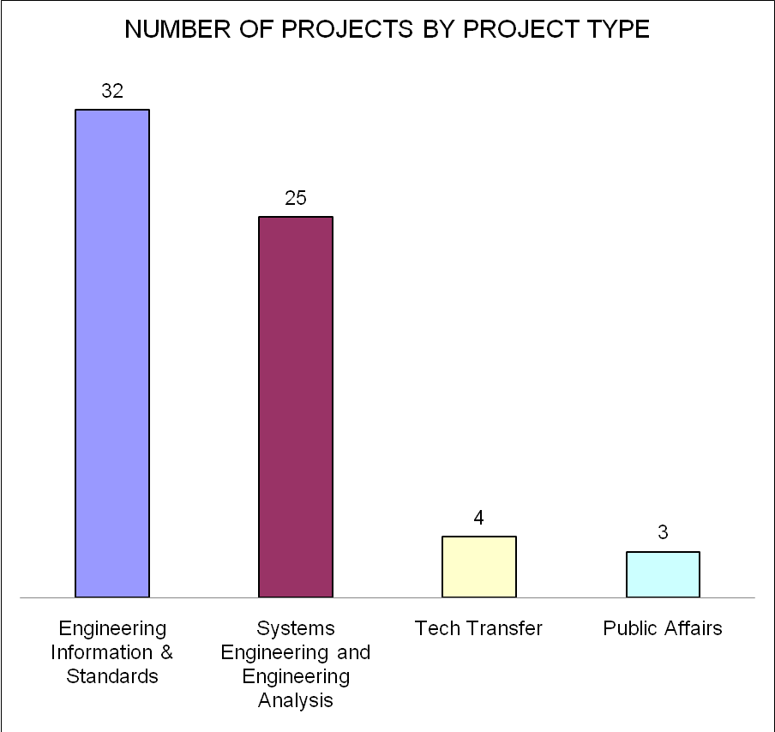
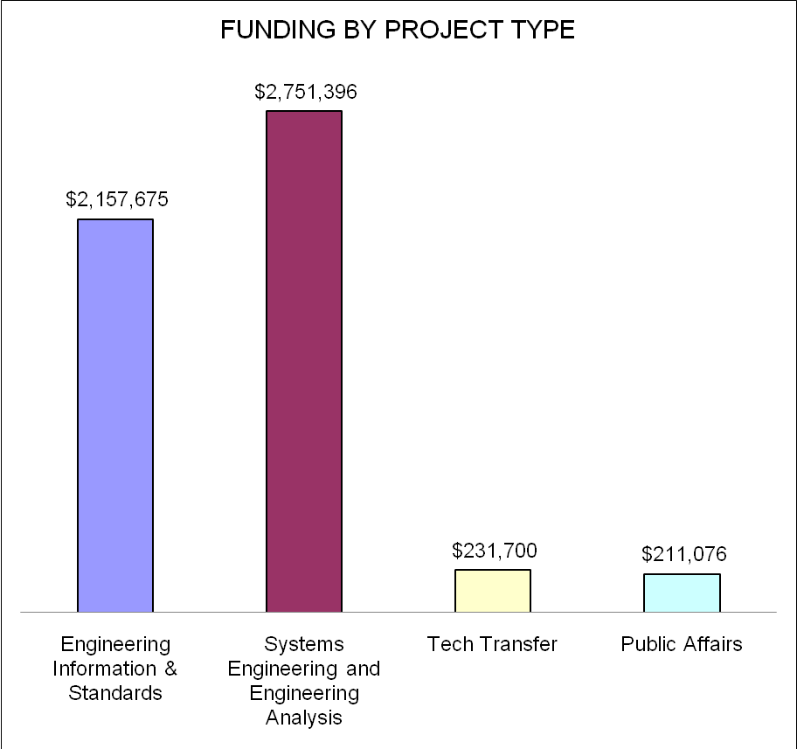

Figures 8a and 8b. Number of Projects and Funding by Project Type.

Project Category

Project Category is the attribute describing the means to execute the project; this includes how the project was funded and who received the funding. Three project categories were defined for this analysis:

- Contract projects are projects wholly funded by WYDOT and executed by for-profit or a not-for-profit entities.

- Pooled funds projects are collaborative projects funded by multiple states and managed by a state DOT. The research partner may be a for-profit entity or a not-for-profit entity such as a research institute or an educational institution.

- In-house projects are projects wholly funded by WYDOT and executed by WYDOT personnel.

As illustrated in Figures 9a and 9b, data for the Project Category attribute shows that nearly all research projects funded by WYDOT are contract research and pooled funds projects. Contract research accounted for 35 of the 64 projects (55%) and seventy-four percent of project funding. Pooled funds accounted for 26 projects (40%) in the study group and twenty-four percent (24%) of project funding. As shown by the data, WYDOT has performed a small fraction of in-house research during the past eight years. In-hours research accounted for less than five percent (5%) of research projects and less than two percent (2%) of the funding. More detailed analysis of project categories is provided below.
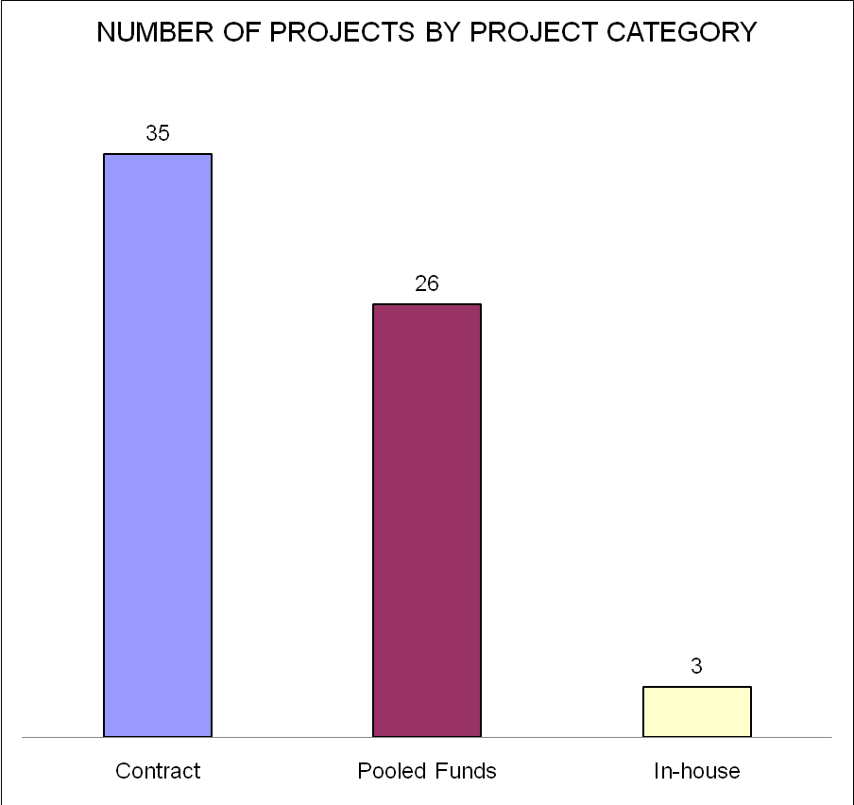
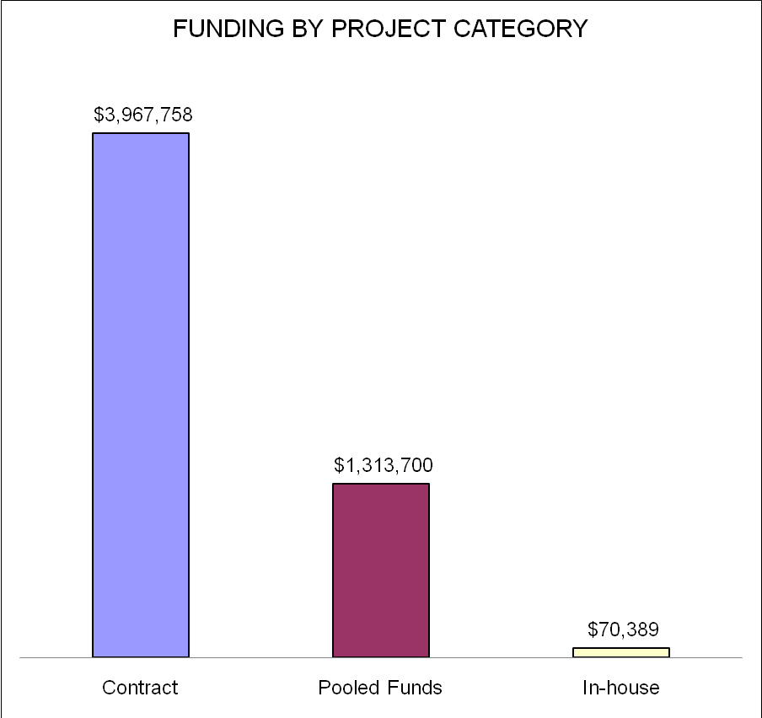

Figure 9a and 9b. Number of Projects and Funding by Project Category.

Contract Research Projects

Contract research targets specific WYDOT problems and opportunities, and well executed contract research is an effective means to support Programs as will be shown in many of the case studies. The fact that almost three-quarters of WYDOT research funds are spent on contract research, whether deliberately or coincidentally, is good allocation across that dimension of the research portfolio. As will be shown later in this chapter, based on eleven contract research category of projects analyzed as case studies, contract research projects have given WYDOT a relatively high ROI. However since these projects are wholly funded by WYDOT, the total amount required per project averages approximately $110,000 (versus less than half that amount for Pooled funds projects). The extent to which WYDOT can, at its current level of funding, use contract research to execute a meaningful strategic agenda may be questionable. As a general guideline, WYDOT does not encourage contract research proposals significantly in excess of $100,000 (which generally span two to three budget years). It is difficult for WYDOT to fund contract research projects much beyond this amount without a single project consuming a disproportionate percentage of the annual research budget. Projects requiring significantly more funding may be candidates for a pooled funds study but the time and effort go get one started and the staff time to manage one of these projects can be limiting. An effective approach in pursuing a research track is to develop multi- phase and execute these phases using contract research with decision gates. Additional insight into when to use universities and research institutions and when to use the private/ commercial sector to perform contract research to increase the probability of implementation are discussed later in this chapter under the topic of Strategic Intent.

Pooled Funds Projects

Pooled funds projects are funded by a coalition of states to meet a common need. They provide a good opportunity for WYDOT to leverage its research dollars for projects that are too expensive for WYDOT to fund and manage alone. Individual state transportation agencies often cannot justify funding projects that are more science-oriented and may have no direct near-term impact. However, advances in the areas of applied science and engineering principals are often key to creating “breakthroughs” be it in cost savings for preservation or improvements in safety and mobility. Some of the highest value pooled funds projects should be characterized by advancements beyond incrementalism. In order to reach a new level of performance, i.e. to “breakthrough” a constraint or limitation, a technological leap is necessary such as a new material, a new practice, a new sensor, a new communication technology etc. These leaps were characterized by Foster (1986) and are illustrated in Figure 10 as pairs of “S” curves representing competing innovation paths. Moving up an “S” curve represents incremental innovation, and depending on the current state of the technology (i.e. position on the “S” curve) incremental innovation can result in strong performance gains. However, as a technology (or process) matures increased investment results in smaller performance gains. Recognition of this situation should spur the research community to define a new innovation path. These “leaps” to a new innovation path enable radical improvements in performance and should be acknowledged in research proposals. Many of these leaps are dependent upon advances in applied sciences and engineering principals which may make ideal pooled funds projects.
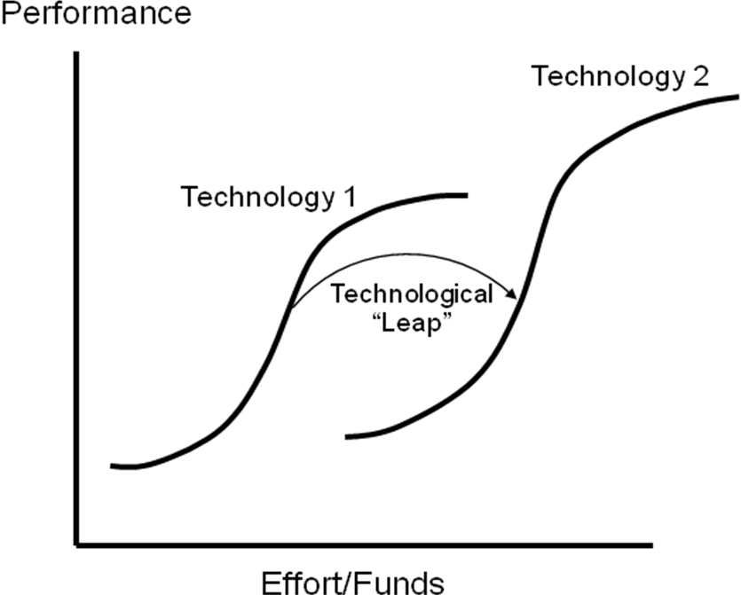

Figure 10. “S” Curves Representing Competing Innovation Paths.

Pooled funds projects, which accounted for forty-percent (40%) of the projects and twenty-four percent (24%) of the funding, can be an important component of WYDOT’s research program, As shown in Figures 9a and 9b, there were 26 pooled funds projects with aggregate WYDOT funding of approximately $1.3 million. Under an assumption that WYDOT’s contribution is ten percent of total funding, WYDOT leveraged its investment in research dollars to $13 million in research activity. When pooled funds projects adequately meet a common need across states and can be rationalized by filling a gap in a research track they can be a sound investment.

However WYDOT’s return on investment in pooled funds projects, as measured by several of the performance measures provided in Chapter 3, can vary greatly depending on several factors. These factors include:

- Dependence on location for relevance to WYDOT;
- Number of participating states;
- Capabilities of the lead state to manage the project;
- Level of involvement and commitment of the WYDOT program and the WYDOT representative on the Technical Advisory Committee (TAC).

When evaluating pooled funds proposals or pre-proposals it is recommended that the following decision factors be collectively addressed by the program proposing the project and discussed by the RAC.

Pooled Funds Decision Factor #1 – Dependence on location for relevance to WYDOT

If the applicability and usefulness of a project to WYDOT is dependent on location (i.e. the climate, physical conditions, level of congestion, etc.) careful consideration should be given towards whether to participate in the project.

Pooled Funds Decision Factor #2 – Number of participating states

Applicability can be positively or adversely influenced by the number of participating states. Unless the project is location-neutral, as the number of states funding the project and actively participating in the project increases, the usefulness of the project to WYDOT and the ROI may decrease. Projects with a high numbers of active participants (e.g. eight or more states) can increase the coordination due to personnel turnover and overall logistics and administrative costs (travel, communication) significantly such that the efficiency of the research is lessened. As the duration of the project increases, the probability of the project being adversely impacted by turnover increases. Despite these drawbacks, in the right circumstances there are advantages, besides additional funding, in having a large number of states involved in a project. A large number of participants are important for:

- Developing and modifying standards;
- Developing instruments and tools;
- Establishing unified policy positions;
- Creating a somewhat unified industry for interaction with the private sector;
- Addressing corridor issues that cross multiple state boundaries; and most importantly of all,
- Working on projects in areas of applied science and engineering principals, i.e. the left side of the science and technology continuum.

During the proposal and pre-proposal process the RAC should consider the number of participating states in relation to the project’s position of the project on the science and technology continuum. In some cases it may make sense for the interested program to simply wait for and read the final report and for WYDOT to use its funding on another research opportunity.

Pooled Funds Decision Factor #3 – Capabilities of the lead state to manage the project

Since pooled funds projects often range from $500,000 to $1,000,000 and involve numerous states, much of the success of pooled funds projects is dependent on the ability of the lead state to manage a large and complex research project. The ability to align all states’ interests, maintain alignment, manage execution of the project and ensure that the knowledge or technology created is transferrable to participating states requires strong leadership. Success of a pooled funds project can come down to the talents of the individual managing the project for the lead state and continuity in the position. Many factors driving success on pooled funds projects are outside of the control of WYDOT. Therefore, reliance on the capabilities and competence of the lead state’s project manager is critical to ensuring WYDOT’s ROI for the project. Reviewing the resume of the lead state research manager, and perhaps interviewing the research manager, should be considered by the RAC during the proposal or pre-proposal process.

Pooled Funds Decision Factor #4 – Level of involvement and commitment of the WYDOT program and the project liaison.

When the RAC makes a commitment to invest in a pooled funds project at the request of a WYDOT program it should be with the explicit understanding that the program will provide the (human) resources to ensure WYDOT’s ROI is maximized. Turnover of an employee assigned to a pooled funds project can have a significant negative impact on continuity and should be avoided. Contingencies should be developed (such as dual participation or a designated backup) if employee mobility is a high probability during the expected life of a project. Representation on the project TAC should be considered as important as an employee’s day-to-day job responsibilities requiring active engagement in reviewing project documents, providing input on research direction and participating in meetings to adequately represent WYDOT. This level of involvement should not be underestimated by the program’s management as, particularly if a program is already understaffed, it will put an undue burden on an individual employee (or their colleagues) and adversely affect the employee’s willingness and ability to participate and hence WYDOT’s ROI on the project. The program’s commitment to the project should extend to developing a plan during the proposal process to address how the results of the project, i.e. new knowledge or technology, will be utilized or furthered by the program once the project concludes. This plan should be developed to address several possible project outcomes which, of course, are “known unknowns” at the outset of the study. The track record of the program in previous pooled funds projects (assuming the personnel are the same), the program’s resources with respect to its core responsibilities and the intensity of activities during the project lifecycle should all be considered by the RAC during the proposal and pre-proposal process.

In summary, pooled funds projects are a vital component of WYDOT’s research portfolio. As a rule of thumb, devoting approximately twenty-five percent (25%) of research funding to these projects appears to be a good split, but the ultimate test should be where does the project fit within a research track – rather than simply positioning the proposal as a “good opportunity.” In the right scenarios, pooled funds projects can be both efficient and effective use of limited WYDOT research funds. These projects can provide high ROI when these factors align, i.e. when targeted towards the proper place on the science and technology continuum with the right type of partner; when location of the project does not adversely impact applicability within Wyoming; when comprised of an optimum number of states with aggregate funding balanced against project focus; when well-managed by the lead state; and when properly supported (strategically and operationally) by the WYDOT program. Later in this chapter, the results of seven case studies involving pooled funds projects are presented as well lessons learned from these projects. The RAC Proposal Evaluation Checklist is provided in Appendix C and should be referenced when considering funding pooled funds projects.

In-house Projects

Of the 64 projects reviewed, projects executed by WYDOT staff accounted for less than five percent (5%) of projects and less than two percent (2%) of project funding. This low level of activity does not necessarily reflect WYDOT programs’ disinterest in pursuing research. WYDOT has a lean workforce often with only one or two staff in critical program positions performing work activities supporting WYDOT’s core, operational mission of system preservation, mobility and safety. This can leave program managers and staff little time to pursue research opportunities – even with available funding. In-house projects can be severely disrupted due to turnover unless there is some provision for redundancy in the principal investigator role. Once research projects lose momentum it can be difficult to regain. Projects with durations more than two years and ambitiousness scope, increase the probability that there will be discontinuity in the principal investigator’s role. This can be particularly true when the WYDOT researcher and the position occupied fits a certain profile correlating with employee mobility and turnover. For some individuals working full-time in an operational or managerial role, the incentive structure (monetarily or professionally) may not align with, or trade-off well against, the additional effort and responsibilities associated with a research project.

Individuals’ personal initiative and leadership with respect to their employer, their profession and their career is a combination of personal choices and is beyond the scope of this study. It will not be addressed any further other than to state that behavior is driven by incentives and expectations. If in-house research was important to WYDOT 's executive leadership it could be increased. However, this would probably entail increasing WYDOT’s fixed costs and probably does not make sense from a cost-benefit standpoint.

With respect to the limited number of research projects performed internally, actually the University of Wyoming provides a convenient and effective way for WYDOT to “outsource” research. Several projects initiated by WYDOT and contracted to UW, bear this out. Twenty-five percent (25%) of the projects funded over the past eight years and sixty-four (64%) percent of contract projects have been performed by UW. During this period, UW has received thirty-one percent (31%) of research program funding. In states with more program staff resources devoted to research, some of these projects might be performed more efficiently in-house given the standard “multiplier” fee for UW research. But besides convenience, this close relationship between WYDOT and UW has other benefits as it and enables WYDOT to support the state university, its research programs, its faculty and its students.

Of course, convenience and loyalty should not be the primary driver of whether a project is appropriate for contracting with UW. Projects positioned towards the right-side of the science and technology continuum, i.e. towards field-scale deployment and when the private sector is ultimately needed to deliver, maintain and enhance a solution, the private sector is probably a more appropriate partner to execute the project. In these situations it is in WYDOT’s best interest to establish a long-term relationship with a private sector entity that has a profit motive, emerging market presence, local representation and staying power to improve the product or process over time – perhaps leading to commercialization (which is one of the most efficient modes of technology transfer). University researchers are not as strongly motivated or experienced in implementation and commercialization, rather, researchers’ interests lie in research and its product – publishing – not necessarily in product R&D or in deploying, operating and maintaining systems. Also projects with significant subcontracting are more appropriately lead by the private sector; this saves WYDOT the “indirect” tax (approximately 60%) for work performed by UW. In summary, WYDOT is fortunate to have a research institution in close proximity with facilities, talented researchers and access to graduate engineering students focused on relevant aspects of transportation research. Supplementing WYDOT’s limited internal research capabilities should continue to be an execution strategy of the Research program, but it is important to understand when to engage UW in particular and the public or not-for-profit research community in general, in terms of Project Type fit and understand what is the expected private sector role, if any in implementation.

Strategic Intent

Strategic Intent is the attribute describing the direct and indirect linkage between a research project and WYDOT’s strategic goals as defined in WYDOT’s strategic plan. Four strategic areas are defined for this analysis:

- Safety enhancement projects are intended to reduce the number of crashes on Wyoming roads.

- Preservation projects are aimed at increasing the life of facilities and other assets.

- Shared knowledge projects are expected to generate knowledge capital such as new data or information, new testing techniques which have broad applicability both within and beyond WYDOT.

- Communications infrastructure upgrade projects are funded to enable improved communications and diffusion of knowledge.

- Public affairs projects are geared towards engendering good will and/or political capital from the general public or a particular stakeholder constituency.

Surprisingly, there were no projects identified that could be classified with a strategic intent of cost savings.

As illustrated in Figures 11a and 11b, data for the strategic intent attribute shows that safety enhancements and preservation projects accounted for seventy percent (70%) of projects funded over the past eight years, i.e. thirty percent (30%) and forty percent (40%), respectively. The percentage of overall funding is nearly proportional for safety enhancement and preservation projects – approximately thirty-five percent (35%) and forty-two percent (42%), respectively. Shared knowledge projects comprised twenty-five percent (25%) of the projects and eighteen percent (18%) of research funding. One project was funded for a communications infrastructure upgrade and two projects were funded for public affairs. Combined funding for these projects was approximately five percent (5%).

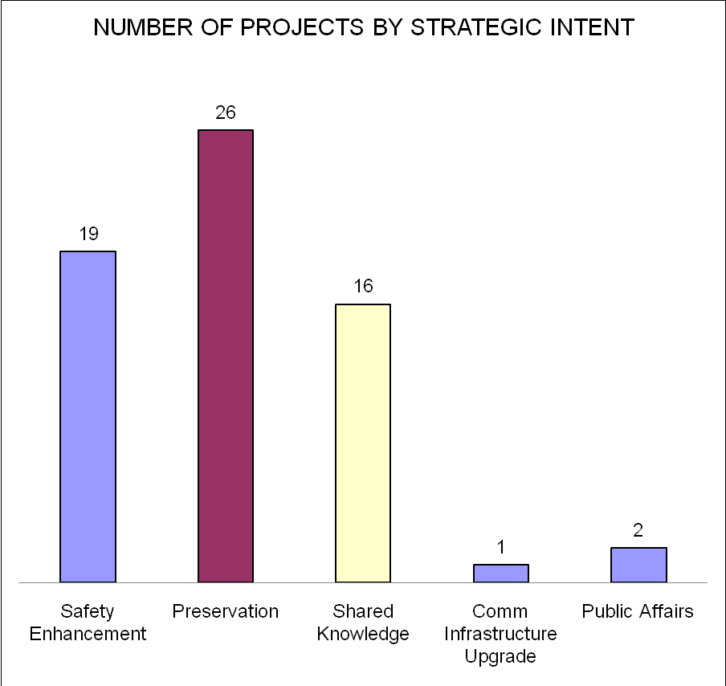
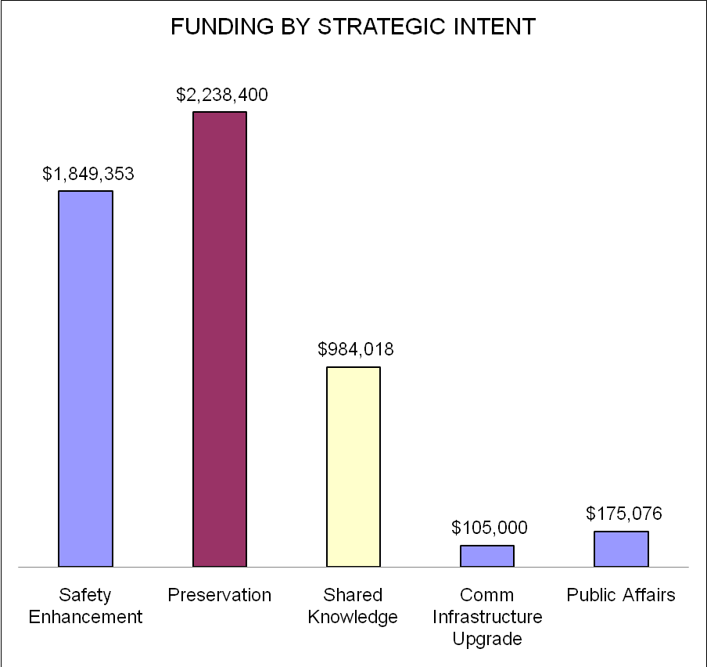

Figure 11a and 11b. Number of Projects and Funding by Strategic Intent.

It is evident from the data that WYDOT’s Research program has a well-balanced portfolio with ninety-five percent (95%) of funding distributed between safety enhancements, preservation and shared knowledge. Investments in safety enhancements and preservation support key elements of WYDOT’s strategic plan. Investments in shared knowledge, like the Project Type attribute Engineering Information and Standards previously discussed, may or may not be immediately applicable. However, in either case the strategic intent of shared knowledge projects is to support the science and engineering enablers which underpin advancements primarily in WYDOT’s Materials, Geology and Bridge programs. Through technology transfer these projects enrich the body of science and engineering knowledge upon which new solutions and innovations are developed as described at the beginning of this report. In order to engender good-will inside of WYDOT and with the public, on rare occasions the Research program provides funds to address a tactical need such as providing funding to support a communication infrastructure project for the Highway Patrol and two public affairs projects assessing construction impacts on rural communities. Only a small percentage of funding is spent outside the realm of safety enhancements, preservation and shared knowledge demonstrates discipline by research program management, the RAC and program sponsors in avoiding the urge or pressure to fund research opportunities only marginally related to WYDOT’s strategic goals.
Figure 12 illustrates the concentration of Pooled funds projects with a strategic intent of preservation and shared knowledge. This is reasonable since preservation projects are often grounded in the applied sciences and engineering principals which have wide applicability, i.e. improvements related to materials, structural designs and geo-sciences. As discussed above, projects whose intent is to generate shared knowledge, standards and tools represent wise use of Pooled funds.
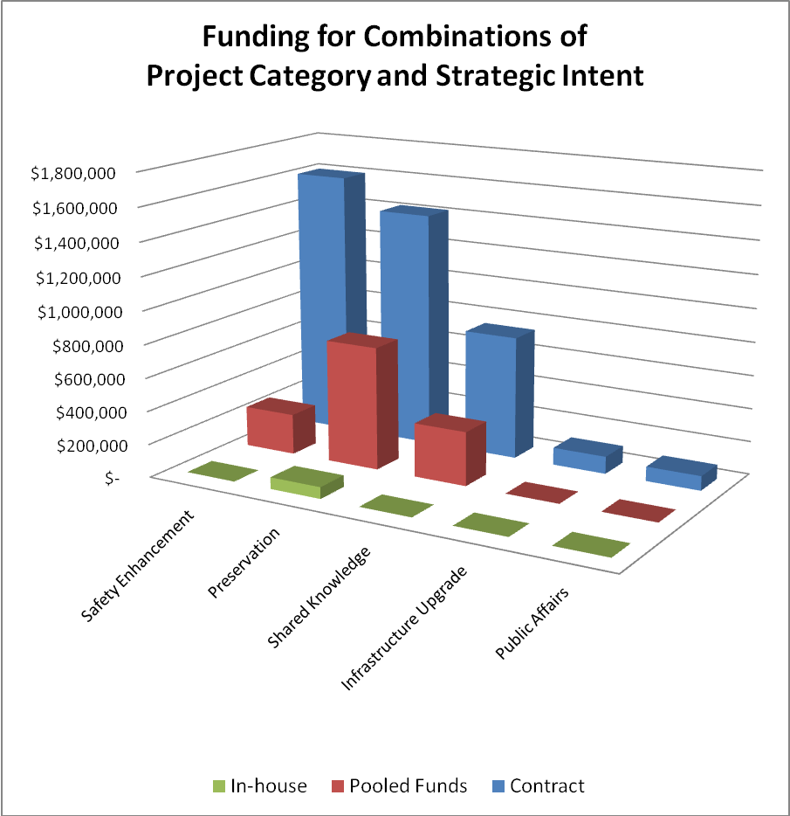

Figure 13 shows the high concentration of pooled funds projects for the Project Type Engineering Information and Standards. This is as expected since pooled funds projects are skewed more towards the applied science and engineering concepts of the science and technology continuum and are characterized by common interest across multiple states. Pooled funds funding is much less for more applied solutions, i.e. Project Type Systems Engineering and Engineering Analysis in which location factors have a greater impact on applicability. As expected Figure 13 shows a high concentration of WYDOT funded (contract) research in the Systems Engineering and Engineering Analysis Project Type and considerably less funding for the Project Type Engineering Information and Standards which are more appropriately funded as pooled funds projects – assuming broad applicability and interest beyond WYDOT.
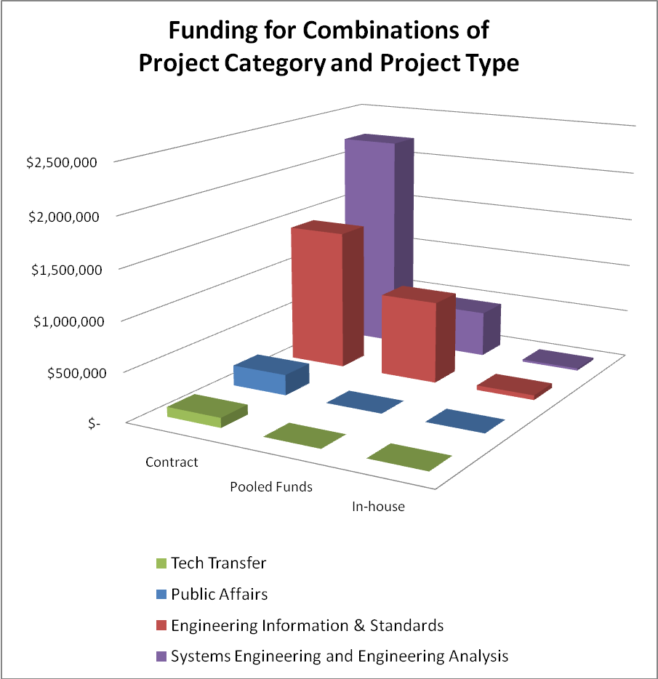
Figure 13. Concentration of Pooled Funds Projects and WYDOT Projects (Contract) by Project Type.
Figure 12. Concentration of Pooled Funds Projects with the Strategic Intent of Preservation and Shared Knowledge.

WYDOT Program Sponsorship

Program sponsorship is the attribute identifying the program sponsoring the research project. Sixteen programs sponsored 64 projects funded over the past eight years.

  - Bridge (16)
  - Materials (9)
  - Planning (9)
  - Geology (8)
  - District 3 (8)
  - Construction (2)
  - Maintenance (2)
  - Highway Safety (2)
  - Aeronautics (1)
  - Budget (1)
  - Environmental Services (1)
  - Highway Patrol Ports of Entry (1)
  - Public Affairs (1)
  - ITS (1)
  - Traffic (1)
  - Training (1)

The number of projects sponsored by each program and the funding for these projects is illustrated in Figures 14a and 14b.
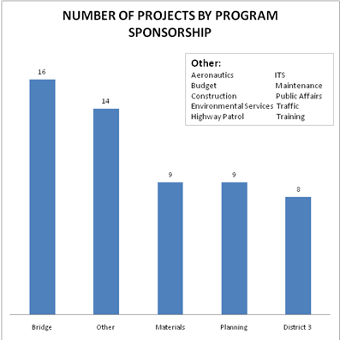
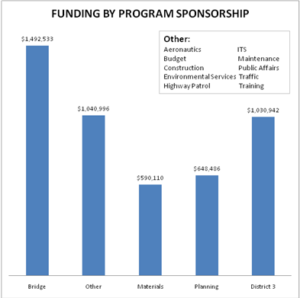

Figure 14a and 14b. Number of Projects and Funding by WYDOT Program Sponsorship.

As shown by the data, WYDOT’s Bridge program is the most active participant in the Research program both in the number of projects and funding. This affinity for research is primarily driven by the Program Manager, Mr. Gregg Fredrick, who is active in numerous AASHTO committees. Through his leadership and mentoring, other Bridge Program personnel have become involved in supporting the Bridge Program’s research projects. Other programs with a significant number of projects include Geology, Planning, Materials and surprisingly, District 3. Based on the data District 3 is the only District Office that has sponsored research projects over the past eight years. This may be due to several factors, i.e. location of facilities in relation to geography and topography, wildlife populations, public interest, as well as a District Engineer support for research. There was no evidence of the Project Development program sponsoring a research project in the past eight years.

Research Project Case Studies

Twenty-three Research projects were selected for detailed analysis in order to gain an in-depth understanding of the proposal process, project execution and research outputs. Projects were analyzed individually and specific lessons learned and recommendations documented. Case study projects were selected to reflect diversity across specific project attributes. These attributes included:

- Projects started and completed within last 3 years;

- Projects sponsored by various programs (Bridge, Geology, Materials, Traffic, Planning);

- Project Type (engineering information and standards and systems engineering an engineering analysis);

- Project Categories (Pooled funds, contract research and in-house);

- Strategic Intent (safety, preservation and shared knowledge).

A balance between closed and open projects was necessary for selecting case study projects. The dataset included eight projects currently in progress at the time of selection and analysis and 15 completed projects. Open projects were selected because these represented the most recent funding decisions of the RAC and reflected the current state of program execution.

Case studies were conducted by reviewing project proposals, correspondence, progress reports, final reports and other outputs such as design guides and standards. A comprehensive assessment framework was developed to document numerous aspects of these projects. This framework is presented in Appendix A. In addition, WYDOT sponsors were interviewed and in some cases representatives from participating DOTs and Principal Investigators were contacted. Areas of analysis included:

- Review of the project’s planned versus actual budget and schedule.

- Evaluation of the quality of the proposal – baseline scope, objectives, soundness of approach, cost/benefit analysis, expected outcomes, technology transfer, background of research team.

- Examination of the execution of the project relative to the proposal, issues encountered and how these issues were addressed.

- Assessment of project outcomes in terms of implementation, continuing research and technology transfer.

Findings from the 23 case studies, organized by Project Type, are presented below. Each case study contributed to a better understanding of the overall program and in aggregate provided a basis to validate the performance measures developed later in the study and presented in Chapter 3. Lessons learned from case studies were synthesized and are presented at the conclusion of this chapter. Table 3 provides ten selected highlights from the 23 case studies. However, since eight of the projects selected for case studies had not yet been completed some of these areas highlighted are only applicable to a subset of the 15 completed projects.

Table 3. Ten Selected Highlights from the 23 Case Studies.
Case Study Highlight and Commentary | Aggregate Measure*
Percentage of case study projects were initiated by WYDOT program personnel:  This would be expected to be somewhat higher with a research agenda to ensure closer linkage between the Research program and Department’s strategic goals. | 45%
Percentage of completed projects that had high-quality final reports:  Expectations for high-quality final products is being well communicated to researchers; strong and consistent effort by Research program staff to insure research reports produced for WYDOT (and for dissemination to the wider research community) are professional and well-written. | 100%
Percentage of completed projects that produced final reports within three years:  In nearly all cases projects that will require more than 2-3 years should be broken into separate projects even if multiple phases are initially planned. Decision gates can be used to contractually implement this strategy without having to re-contract (unless desirable to WYDOT). Projects where weather is a consideration and certain types of testing are some of the few exceptions, and in these situations the dependency of additional time to additional funding should be addressed in the proposal and so that the RAC is adequately informed. | 65%
Number of completed projects that were implemented:  A - one-time, but no longer  B - currently implemented  This is shows a balance between research and engineering. Tracking and monitoring the “outcome” – based performance measures defined in Chapter 3 will provide a framework for quantifying and documenting the impact of Research projects. | 5 projects  6 projects
Percentage of completed projects resulting in a new or enhanced product:  This is a relatively high percentage and speaks highly of relevance, i.e. implementation, given that only about 50% of projects are intended to result in a new or enhanced product. | 33%
Number of completed non-pooled funds projects where identified results are in use by other entities:  This is surprisingly small involve one or many of numerous factors such as the location-specific nature (or other reasons for narrow applicability) of WYDOT projects; limited Research program staff time; ineffective technology transfer strategies; or the researcher not placing a priority of technology transfer. | 3
Percentage of completed projects presented in professional forums (journals, conferences):  This was somewhat lower than expected, but would require more analysis o re the type of partner involved (private sector partners are less likely to publish especially if commercialization opportunities (i.e. product development) are part of the project; also the situation regarding available funding to compensate for the time involved in technology transfer activities and funding for travel can be barriers. Barriers to technology transfer will be addressed in Chapter 4. | 53%
Percentage of project proposals or final reports containing cost-benefit analysis:  Use of cost-benefit analysis, when appropriate, should be encouraged. Performance measures and tools for cost-benefit analysis are provided in Chapter 3. Chapter 4 provides research proposers guidance on what type of projects for which to perform cost benefit analysis. | 14%
Percentage of completed projects that were completed within originally proposed time:  It should be expected that research projects will often require additional time due to uncertainties. Researchers tend to be overly optimistic and often, research projects are not a full-time effort for researchers but must be balanced against other competing professional responsibilities. These factors should be taken into account when reviewing research proposals. Supplemental guidance for proposers provided in Chapter 4 addresses providing adequate estimates for research projects. | 50%
Percentage of completed projects that were completed on or under original budget:  Due to the nature of research and the “unknowns unknowns” and a “known unknown” it is not unexpected that 25% of the projects examined required additional funding. Although WYDOT does not use contingency funding in its contracts, contingency should be addressed in the proposal and justified if included in the budget depending on the number of “known unknowns”. | 72%
* Note: 15 of 23 projects in dataset completed; therefore some projects whose final budget, completion date, outcomes, etc., are unknown are not included in the aggregate measure.

Summaries of each case study presented below includes funding information, highlights regarding project execution, participants, project outcomes and lessons learned.
Pooled Funds Projects

Pooled Funds Research Project | SPR-3(076)
Pooled Funds Research Project | Animal-Vehicle Crash Mitigation Using Advanced Technologies
Background Information
Project Type | Systems Engineering and Engineering Analysis
Funds Obligated/Expended | $75,000
WYDOT Program | Planning
WYDOT Sponsor | Kevin Powell/Bill Gribble
Started | April 1999
Completed | August 200 – Phase 1
Participants | Western Transportation Institute , AK, CA, IN, IA, KS, MD, MT, NV, NH, NY, ND, OR, PA, WI, WY
Objectives
- Design and implement a warning system for mitigating animal vehicle crashes; use two sites and two different technology approaches and evaluate their effectiveness.
- The study had intrinsic PR benefits.
Execution and Performance
Problems with system reliability, especially at the PA site showed that the technology was perhaps pre-mature for a field-scale implementation. Perhaps a lab-scale pilot would have been useful for testing sensor technologies and software. The project cancelled further research on the PA site due to poor system performance and unresponsiveness by the system vendor. Due to the large number of participants there were different expectations and a diverse experience base. There was not sufficient funding to perform the monitoring after the system was installed.
Project Outcomes
- The project produced a good report of the knowledge acquired during the project.
- Research is continuing on Phase 2 which began on August 2008.
- Given the continuing O&M costs there should have been a plan for on-going Research funding.
- Project is proceeding into Phase 2 with fewer states.
- WTI developed a testbed in MT with a reasonable amount of area and animals to permit vendors to test and refine their systems; there have been over five vendors using this facility.
Lessons Learned and Recommendations
- The willingness of the host DOT states to fund O&M of the system should have been considered. Given the continuing O&M costs which are perhaps higher than anticipated there should have been a plan for on-going Research funding or other programs assuming the cost for maintaining the system.

- The project had significant technological risk and organizational risk given the large number of organizations participating. Better attention to identifying and managing these risks should have been included in the proposal which would have helped when they were encountered during execution. Regarding the technical risk a smaller (lab-scale) pilot would have been useful in sensor and software testing prior to field-scale deployment; sensors and software (and the integration of the two) usually pose the greatest technical risk to a project. These risks (organizational, on-going funding for O&M and technical) should be scrutinized by the WYDOT project sponsor and the RAC in future pooled funds proposals and projects.

Pooled Funds Research Project | RS02(205)
Pooled Funds Research Project | Fatigue Testing of WYDOT’s Signal Pole Stiffened Connection Phase II
Background Information
Project Type | Engineering Information and Standards
Funds Obligated/Expended | $192,190
WYDOT Program | Bridge
WYDOT Sponsor | Gregg Fredrick
Started | June 2004
Completed | April 2007
Participants | University of Wyoming, WYDOT
Objectives
- Characterize the fatigue performance of the stiffened connection in signal poles. Two typical WYDOT designs were tested. The goal was to validate the strength of the connections and possibly provide information enabling extension of mast-arm lengths with smaller, more economical and aesthetic connections.
Execution and Performance
- Project went according to plan. Due to the nature of testing, there was additional time required, i.e. once it was determined the design would meet the design life criteria, efforts were made to determine the failure point of the new design.
- Continuation of a good strong partnership between WYDOT and UW engineering program.
Project Outcomes
- New design is being tested at two other locations and is available to public and private entities through WYDOT’s website.
- Successful implementation of design will increase safety and result in cost savings by addressing potential failure of over 250 signal poles state-wide.
- Supported UW student’s Master’s Thesis.
- Will be adopted as AASHTO standard.
Lessons Learned and Recommendations
- Example of professional leadership by WYDOT Bridge Program Manager and strong support by the Research program to address a serious, immediate, prevalent problem.

Pooled Funds Research Project | SPR-3(077)
Pooled Funds Research Project | Wiremesh and Cablemesh Slope Protection
Background Information
Project Type | Systems Engineering and Engineering Analysis
Funds Obligated/Expended | $20,000
WYDOT Program | Geology
WYDOT Sponsor | Jim Coffin
Started | June 1999
Completed | December 2005
Participants | WYDOT, FOSSC Materials Laboratory, ID, AZ, AK, PA, NH, NY, CA, NC, OR, WA
Objectives
- Develop new design guidelines. Perform structural, dyanamic, anchor design, and snow load analysis of wiremesh and cablemesh systems for slopes exceeding 75 feet in height. Goal was to reduce construction costs and improve safety by improving/validating the engineering underlying current design and construction practices.
Execution and Performance
- Costs increased by approximately 200%.
- Only one progress report was available in the file.
Project Outcomes
- The study produced design guidelines; however, WYDOT did not adopt the entire methodology.
Lessons Learned and Recommendations
- WYDOT needed the anchors tested in field conditions similar to WY, but these conditions did not exist at the test locations. WYDOT had experimented with new designs prior to the pooled funds project. If WYDOT has a specific need and unique conditions it should use its funds to directly contract for the research. This will probably result in a greater return on investment in a shorter timeframe.

Pooled Funds Research Project | TPF-5(036)
Pooled Funds Research Project | Transportation Asset Management Research Program
Background Information
Project Type | Other
Funds Obligated/Expended | $30,000
WYDOT Program | Budget
WYDOT Sponsor | Kevin Hibbard
Started | April 2002
Completed | Unknown
Participants | WYDOT, WI, MI, MO, OH
Objectives
- Investigate how functional areas create barriers to efficient decision making and identify practices to overcome these barriers.
Execution and Performance
- Contractor organization was not able to adequately staff the project.
- Progress reports are very brief so it is difficult to determine project performance.
Project Outcomes
- The study produced design guidelines; however, WYDOT did not adopt the entire methodology.
- WYDOT ceased participation in this project in January 2007 since the focus became urban versus rural areas.
Lessons Learned and Recommendations
- WYDOT did not oversee this project as actively as was needed. WYDOT would have been a good organization to participate in this study given the organizational issues encountered in implementing a new state-of-the-art asset management system and investment decision making process.

Pooled Funds Research Project | TPF-5(027)
Pooled Funds Research Project | Effects of Hot Plant Fuel Characteristics and Combustion on Asphalt Concrete Quality
Background Information
Project Type | Engineering Information and Standards
Funds Obligated/Expended | $40,000
WYDOT Program | Materials
WYDOT Sponsor | Bruce Morgenstern
Started | September 2001
Completed | Unknown
Participants | WYDOT, SD DOT
Objectives
- The lead state in the study wanted the researcher to prove that the fuel characteristics influence the characteristics of the asphalt mix.
Execution and Performance
- There was no official proposal on file to review.
- RAC Committee has not received any progress reports but the Materials Program has received a draft progress report which shows that there are no conclusive findings at that time.
- Several WYDOT engineers have worked on this study. Some have left WYDOT.
Project Outcomes
- Marginal if any benefit to WYDOT since the findings were not implemented.
Lessons Learned and Recommendations
- The WYDOT representative on the advisory committee has expertise in a different area than the research study. It is important that WYDOT representatives has expertise in a similar area to effectively participate in a pooled funds study.

Pooled Funds Research Project | TPF-5(042)
Pooled Funds Research Project | Investigation of the Long-Term Effects of Magnesium Chloride and Other Concentrated Salt Solutions on Pavement and Structural Portland Cement Concrete
Background Information
Project Type | Engineering Information and Standards
Funds Obligated/Expended | $60,000
WYDOT Program | Materials
WYDOT Sponsor | Andy Freeman
Started | April 2002
Completed | June 2007
Participants | WYDOT, SD DOT
Objectives
- Investigate the long-term effects of Magnesium Chloride and other salt solutions on pavement and concrete. Also investigate alternate solutions.
Execution and Performance
- This project was originally planned for two years; however, this was extended to five years due to the number of potential solutions and the number of project participants.
- Nine states participated.
- Research results well-respected within WYDOT
Project Outcomes
- The results should be very useful.
Lessons Learned and Recommendations
- Projects involving materials studies and multiple participants normally take longer than projected.

Pooled Funds Research Project | TPF-5(054)
Pooled Funds Research Project | Maintenance Decision Support System
Background Information
Project Type | Systems Engineering and Engineering Analysis
Funds Obligated/Expended | $150,000
WYDOT Program | Maintenance
WYDOT Sponsor | Kent Ketterling
Started | July 2005
Completed | September 2007
Participants | FHWA, WYDOT, SD (lead), IA, IN, MN, ND, KS, NE, CA, NH, NY, VA, Aurora, CO
Objectives
- Improve Maintenance Decision Support Systems predictive models for blowing snow.
Execution and Performance
- A high-quality proposal was built in contingencies regarding mid-course adjustments based on unknowns.
- A cost-benefit analysis is being performed and will be available within the year.
Project Outcomes
- The product is a “concept of operations” for the system and the software.
- The results are being implemented to varying degrees by participating states.
Lessons Learned and Recommendations
- WYDOT could have participated more in the study by funding WYDOT-related activities in the state. WYDOT does not appear to have a vision regarding how to get the maximum use from this research.

In-house Research Projects

In-house Research Project | RS02(205)
In-house Research Project | Control and Prevention of Alkali-Silica Reaction in Recycled Portland Cement Concrete Pavement Using Lithium Nitrate
Background Information
Project Type | Engineering Information and Standards
Funds Obligated/Expended | $27,985
WYDOT Program | Materials
WYDOT Sponsor | Rob Rothwell
Started | June 2000
Completed | Unknown
Participants | WYDOT
Objectives
- Evaluate the effectiveness of using Lithium Nitrate to accelerate concrete hardening in warm weather.
Execution and Performance
- There was no official proposal on file to review.
- RAC Committee has not received any progress reports but the Materials Program has received a draft progress report which shows that there are no conclusive findings at that time.
- Several WYDOT engineers have worked on this study. Some have left WYDOT.
Project Outcomes
- The performance of the treatment is still being evaluated so no final report has been submitted.
Lessons Learned and Recommendations
- It is recommended that benchmarks and deadlines be established for long-term performance studies.

In-house Research Project | RS203(201)
In-house Research Project | Testing and Evaluation of Concrete Repair Materials for the Cheyenne Airport Taxiways
Background Information
Project Type | Engineering Information and Standards
Funds Obligated/Expended | $20,000
WYDOT Program | Materials
WYDOT Sponsor | Tim McDowell
Started | August 2001
Completed | February 2004
Participants | WYDOT, Concrete Engineering Specialists
Objectives
- Test a new treatment to extend the life of the runway pavement.
Execution and Performance
- This was a low-cost project with a successful outcome.
Project Outcomes
- The result of the project was a new treatment to extend the life of runways.
- This project was an example of how the research program is responsive to a diverse set of WYDOT needs.
Lessons Learned and Recommendations
- An implementation/technology transfer plan should have been requested in the proposal. There should have been a more deliberate effort to share the knowledge created with the transportation community across the state.

In-house Research Project | RS06(203)
In-house Research Project | Determining the Feasibility of Handheld Computers to Log Geotechnical Test Holes
Background Information
Project Type | Engineering Information and Standards
Funds Obligated/Expended | $22,404
WYDOT Program | Geology
WYDOT Sponsor | Mike Hager
Started | April 2003
Completed | April 2005
Participants | WYDOT
Objectives
- Evaluate use of PDA hardware and software for use by WYDOT’s drill teams. Device would permit WYDOT personnel to record information electronically then automate the upload process into Microstation for generation of drawings.
Execution and Performance
- A delay in software development delayed completion of the project one year.
Project Outcomes
- The device has not yet been deployed. (update)’
- The project generated key learnings and useful recommendations WYDOT in use of mobile devices.
Lessons Learned and Recommendations
- The Principal Investigator left WYDOT; no one in Geology picked the project up for approximately six months. Having more than one person in a program involved in a Research project, even at a high-level, should be a requirement as it maintains continuity in the event that something happens to the sponsor.
- The original version of the software did not log point data; delays in software development are not uncommon and should always be considered as a significant project risk when reviewing proposals or monitoring research progress.

Contract Research Projects

Contract Research Project | RS03(205)
Contract Research Project | Feasibility of a Next-Generation Intermodal Rail-Truck Transport System for the Western I-80 Corridor
Background Information
Project Type | Systems Engineering and Engineering Analysis
Funds Obligated/Expended | $165,700
WYDOT Program | Planning
WYDOT Sponsor | Mark Wingate
Started | June 2005
Completed | December 2006
Participants | WYDOT
Objectives
- Determine the impact of increasing truck traffic on Wyoming I-80 and examine an innovative alternative to diverting trucks from I-80 to rail.
Execution and Performance
- The project had a fifty percent increase in funding an additional six months to develop a multi-media product for use with the legislature and the public.
Project Outcomes
- The study provided good information to justify higher levels of expenditures on Wyoming highways and helped WYDOT obtain additional annual state funds for highways.
- A simulation model was developed that can be used by WYDOT (and other DOTs) to determine the long-term costs for highway maintenance and re-construction costs given various combinations of truck traffic, construction and O&M costs, inflation, material and capacity changes, etc.
Lessons Learned and Recommendations
- There should be an effort to determine the needs to continue this research as the preliminary results were favorable and the potential impact on WYDOT could be significant.

Contract Research Project | RS07(206)
Contract Research Project | Evaluation of Intelligent Transportation System Alternatives for Reducing the Risks of Truck Rollover Crashes due to High Winds
Background Information
Project Type | Systems Engineering and Engineering Analysis
Funds Obligated/Expended | $88,000
WYDOT Program | Highway Safety
WYDOT Sponsor | Mike Gostovich
Started | April 2006
Completed | January 2007
Participants | WYDOT
Objectives
- Analyze truck crashes caused by high winds and develop a conceptual design for a system to reduce these crashes.
Execution and Performance
- Well executed in quantifying prevalence of wind-related crashes and characterizing the problem.
- Multiple stakeholders consulted during study.
Project Outcomes
- The study identified technologies that would help reduce wind-related crashes.
- Study findings were presented to interested parties within and outside of WYDOT.
- The researchers proposed implementation of the system in a second phase which was funded by WYDOT validating the merits of the findings.
Lessons Learned and Recommendations
- Good cost-benefit analysis in the final report showed the effectiveness of implementing the proposed system and provided a sound basis for WYDOT to continue with this line of research.

Contract Research Project | SRP-3(199)
Contract Research Project | Avalanche Hazard Reduction using Wind Drift Disrupters (Snow Sails)
Background Information
Project Type | Systems Engineering and Engineering Analysis
Funds Obligated/Expended | $254,321
WYDOT Program | District 3
WYDOT Sponsor | Ted Wells
Started | February 1999
Completed | September 2002
Participants | WYDOT, MSI-Foothill
Objectives
- Deploy a system to prevent snow from collecting and periodically releasing an avalanche across State Highway xxx which would result in fewer planned and unplanned road closures.
Execution and Performance
- Unexpected NEPA requirements for implementing a project on national forest lands delayed project 12 months.
- Project was re-scoped into two phases to accommodate small-scale deployment prior to full-scale design, production and installation.
Project Outcomes
- Due to continuing dangers to WYDOT and contractor workers deploying the sails it was determined that a different type of technology, e.g. snow rakes, should be pursued.
- A research project studying snow rake technology is underway.
Lessons Learned and Recommendations
- This is a good example of research evolution where an original approach did not pay off but by maintaining continuity of research to solve an important problem eventually an acceptable engineering solution for will be developed for this unique location.

Contract Research Project | RS15(197)
Contract Research Project | Traffic Signal Pole Research
Background Information
Project Type | Engineering Knowledge and Standards
Funds Obligated/Expended | $159,577
WYDOT Program | Bridge
WYDOT Sponsor | Gregg Fredrick
Started | August 1997
Completed | June 2001
Participants | WYDOT, University of Wyoming (UW)
Objectives
- Perform testing and analysis for wind and pole monitoring, fatigue testing, non-destructive evaluation and testing and finite element analysis.
Execution and Performance
- Well executed and successful project; however, it took five years to complete rather than the three years as originally planned.
Project Outcomes
- Project created new knowledge and design analysis capabilities, i.e. models and techniques that should create long-term benefit.
- Published in several professional publications; presented at an AASHTO Subcommittee; presentations made at several tech transfer forums to state DOTs and the design community.
- Study spurred a follow-up study with UW to determine fatigue performance of WYDOT’s ring stiffened box connection.
Lessons Learned and Recommendations
- Although not always quantified, in general investment in models, tools and techniques that improve design productivity and products have high ROI and should be a consideration in project solicitation and selection.

Contract Research Project | RS05(199)
Contract Research Project | Update and Evaluate New Methods for Estimating the Peak Flow Characteristics of Un-gauged Streams in Wyoming
Background Information
Project Type | Engineering Knowledge and Standards
Funds Obligated/Expended | $51,100
WYDOT Program | Bridge
WYDOT Sponsor | Bill Bailey
Started | June 1999
Completed | May 2002
Participants | WYDOT, USGS
Objectives
- Review methods for estimating stream flows for designing structures.
Execution and Performance
- It was difficult dealing with USGS. The final report was approximately two years late.
Project Outcomes
- Findings from studying are being used by the WYDOT Bridge program and the results should be useful for years to come.
Lessons Learned and Recommendations
- This project was initiated by WYDOT personnel to address a need for updating and improving collection of data that impacts a design process and ultimately the design of structures.

Contract Research Project | RS01(201)
Contract Research Project | Feasibility of Tire Chips for Roadway Drainage Applications
Background Information
Project Type | Systems Engineering and Engineering Analysis
Funds Obligated/Expended | $254,321
WYDOT Program | Geology
WYDOT Sponsor | Mike Hager
Started | January 2001
Completed | March 2003
Participants | WYDOT, University of Wyoming
Objectives
- Assess the feasibility of using tire chips in highway drainage applications. Conduct laboratory and field studies representative of tire chips used to construct highway edge drains and slope under drains while monitoring constructability and performance characteristics.
- The project had some public relations benefits.
Execution and Performance
- Only one progress report was found in the file.
- The project achieved its objectives.
- Actual project costs were 150% higher than originally estimated.
Project Outcomes
- The cost of tire chips for fill or drainage material was competitive with sourcing and hauling conventional material.
- In terms of performance, tires were acceptable fill material but ability to implement this solution is dependent on volume of tires available in proximity to need.
Lessons Learned and Recommendations
- The proposal should have addressed the scalability/applicability of this research by performing a high-level assessment of the potential volume of tires that could be used in this fashion if tire were deemed feasible for drainage material.
- Research gates could have been used for the lab-scale model prior to moving into the field; this would ensure water quality assumptions, and permeability were correct prior to the contractor expending 80 percent of project funds on the field-scale project.

Contract Research Project | RS01(200)
Contract Research Project | Enhancement of WYDOT’s BRASS-PIER for the New AASHTO LRFD Bridge Design Specification
Background Information
Project Type | Engineering Information and Standards
Funds Obligated/Expended | $280,104
WYDOT Program | Bridge
WYDOT Sponsor | Gregg Fredrick
Started | July 1999
Completed | December 2002
Participants | WYDOT, Bridge Tech
Objectives
- Develop an analysis capability for bridge design specifications for the new AASHTO LRFD Bridge Design Specification.
Execution and Performance
- Successful project although it required 20 percent additional funding and several additional months to complete testing.
Project Outcomes
- Software is in use by 14 state DOTs, 12 FHWA offices, 17 consulting firms, the US Army Corp or Engineers and is licensed to five other government entities in the US and Canada.
Lessons Learned and Recommendations
- Users pay for maintenance and updates and drive enhancements and pay for these enhancements.
- This is a good success story and a good model of a public-private partnership.

Contract Research Project | RS04(202)
Contract Research Project | Avalanche Hazard Reduction using the Doppelmayr “Avalanche Blaster” Cache and Mortar Technology
Background Information
Project Type | Systems Engineering and Engineering Analysis
Funds Obligated/Expended | $140,000
WYDOT Program | District 3
WYDOT Sponsor | Ted Wells
Started | April 2002
Completed | August 2004
Participants | WYDOT, Doppelmayr CTEC
Objectives
- Demonstrate, test and evaluate an avalanche control system.
Execution and Performance
- Project was performed on schedule and at estimated cost.
Project Outcomes
- The product is an improvement over the current system. It is less of a hazard than the howitzer system which was being used on Teton Pass and has more issues and restrictions.
Lessons Learned and Recommendations
- The proposal for project was unsolicited; maintaining a balance between solicited and unsolicited research should remain a cornerstone of WYDOT’s research program.

Contract Research Project | RS04(203)
Contract Research Project | Determine the Feasibility of Integrating Wyoming’s Commercial Vehicle Information Systems Network (CVISN)
Background Information
Project Type | Systems Engineering and Engineering Analysis
Funds Obligated/Expended | $105,000 of a $275,000 project
WYDOT Program | Wyoming Highway Patrol – Ports of Entry
WYDOT Sponsor | Richard Smith
Started | January 2003
Completed | October 2004
Participants | WYDOT, Meyer, Mohaddes Associates
Objectives
- Identify the most beneficial and cost-effective ways to use electronic information exchange for commercial vehicle operations to ensure the safety of the general public and trucking efficiency.
Execution and Performance
- Well structured and comprehensive analysis of technologies and priorities.
Project Outcomes
- The project resulted in enhanced CVISN strategies and a prototype website and security protocol.
Lessons Learned and Recommendations
- This is the type of project that could benefit from a technology roadmap; this would enable the RAC to better understand how the research program’s contribution fits in to a coherent plan.

Contract Research Project | RS01(202)
Contract Research Project | Movement and Distribution of Pronghorn Antelope in Relation to Roads in Southwestern Wyoming
Background Information
Project Type | Systems Engineering and Engineering Analysis
Funds Obligated/Expended | $222,400
WYDOT Program | District 3
WYDOT Sponsor | John Eddins
Started | October 2001
Completed | December 2005
Participants | WYDOT, WY Game & Fish
Objectives
- Identify the migration routes of antelope in southwestern Wyoming.
Execution and Performance
- The project was executed as per the proposal.
Project Outcomes
- WYDOT (District 3) is using the maps developed from the study when installing fences.
Lessons Learned and Recommendations
- The District Engineer supported the study which resulted in a useful product.

Contract Research Project | RS02(204)
Contract Research Project | Three-Dimensional Roughness Elements for Snow Retention
Background Information
Project Type | Systems Engineering and Engineering Analysis
Funds Obligated/Expended | $96,052
WYDOT Program | Construction
WYDOT Sponsor | Clifford Spoonemore
Started | November 2003
Completed | December 2006
Participants | WYDOT, Tabler and Associates
Objectives
- Evaluate 3-D roughness elements for blowing snow control.
Execution and Performance
- The project took 3 years rather than the two years originally estimated due to weather.
Project Outcomes
- A new research project has been initiated.
- The project resulted in gaining data on a potentially useful product to reduce the hazard of blowing snow across highways.
Lessons Learned and Recommendations
- A change in the snow snake concept was needed after field tests of performance of the original design. Knowing when to provide researchers the flexibility to make design changes is key to well-managed research.

Summary of Case Studies

Presented below is a summary of lessons learned from in-depth analysis of these projects which are segregated by Project Category.

Contract Research Projects

- Sometimes after field tests an original design needs to be changed; knowing when to provide researchers the flexibility to make design changes is a key to well-managed research.

- A District Engineer’s support is important in getting a useful project outcome and output.

- Complex technology projects can benefit from a technology roadmap. This would enable the RAC to better understand how the research program’s contribution fits in to a coherent plan.

- WYDOT has created a model strategic partnership with a private sector firm by developing a successful software product where users pay for maintenance and enhancements.

- Proposals should address the scalability of the results by performing a high-level assessment of the potential volume of available materials if that can be a constraint, otherwise, even though the research is successful the results will not be implemented.

- Research gates can be used for a lab-scale model prior to moving into the field; this would ensure key assumptions are correct prior to expending a large percentage of project funds on a field-scale project.

- Research projects initiated by WYDOT personnel to address a need for updating and improving collection of data that impacts a design process and ultimately the integrity of the design of structures is good use of research funds.

- Working with non-transportation federal agencies adds time to a project and often WYDOT has little leverage with a federal agency.

- Projects whose outcome results in models, tools and techniques that improve design and operational productivity often have high ROI.

- WYDOT has several examples of research evolution where an original approach did not pay off but by maintaining continuity of research to solve an important problem eventually results in an acceptable engineering solution developed for a unique location.

- Good cost-benefit analysis in a final report can show the effectiveness of implementing a proposed system and provide a sound basis to continue with an important research track.

- There is a need to deliberately decide whether to continue down a research path when preliminary results are favorable and the potential positive impact on WYDOT could be significant.

In-house Projects

- When a principal investigator leaves a project and especially an organization not having more than one person in a program involved in research project, even at a high-level, is needed to maintain continuity in the event that something happens to the sponsor.

- Any projects involving even moderately complex software should expect delays due to the nature of software development. This should normally be considered a significant project risk and addressed when reviewing proposals or monitoring research progress.

- An implementation/technology transfer plan should be requested in the proposal. For certain projects there should be a deliberate effort to share the applicable results with the transportation community across the state.

- It is recommended that benchmarks and deadlines be established for long-term performance studies.

Pooled Funds Projects

- Programs do not always invest adequate resources in a project and hence do not get the maximum payoff from the research investment.

- Projects involving materials studies and multiple participants normally take longer than projected.

- It is important that WYDOT TAC representative has expertise in a similar area to effectively participate in a pooled funds study.

- The WYDOT TAC representative needs to be active to ensure WYDOT gets what was intended from the project.

- A project’s applicability to WYDOT may be based similar testing conditions. If these are not similar at the test locations the results of the research for use by WYDOT may be suspect. If WYDOT has a specific need and unique conditions it should use its funds to directly contract for the research. This will probably result in a greater return on investment and a shorter project timeline.

- Systems that become operational require operations and maintenance (O&M) funding and this should be addressed in the proposal. There needs to be a plan for another program to assume O&M costs for maintaining the system or it may cease to operate.

- Some projects have significant combinations of risk, i.e. technological risk and organizational risk (when a large number of organizations participate). Better attention to identifying and managing these risks should be included in the proposal which will help if encountered during execution. Regarding the technical risk a smaller (lab-scale) pilot would have been useful to test sensors and software prior to field-scale deployment; sensors and software (and the integration of the two) usually pose the greatest technical risk to a project. These risks (organizational, on-going funding for O&M and technical) should be scrutinized by the WYDOT project sponsor and the RAC in future pooled funds proposals and projects.

Grouping lessons learned from these case studies by other project attributes besides Project Category (i.e. Strategic Intent, Project Type and Program Sponsorship) was not included in this study. This analysis may have revealed other common factors of success or barriers to success which correlate to particular project attributes or combinations of project attributes. Even if the results of this analysis are anecdotal it might still be useful to Research program management. This analysis was not pursued in this study due to the limited sample set. Perhaps twice as many case study projects would need to be reviewed in order to define meaningful and useful correlations. It is suggested that the framework developed for case studies provided in Appendix A be used in conjunction with the performance measures presented in Chapter 3 on an on-going basis to document projects as they are executed. This will facilitate future analysis without the need for the analyst to review project files.

Chapter 3 – Research Program Performance Measures

The 2007 Wyoming Department of Transportation Research Work Program report mentions the linkage between the Department’s strategic goals and the Research program but there are no measures supporting this linkage. The performance measures developed in this study and presented in this chapter are intended to improve the management of research by providing a framework to drive funding decisions based on analysis such linkage with WYDOT’s strategic plan and return on investment. These performance measures will quantify program management and administration. Seventeen candidate performance measures were evaluated by WYDOT. Through a series of workshops the 17 measures were narrowed down to ten. The software application developed in conjunction with the NHCRP Performance Measurement Tool Box and Reporting System for Research Program Projects was recommended to support the cost-benefit analysis performance measure. Selected performance measures were validated using case study projects presented in Chapter 2. An implementation framework is included in this chapter for monitoring and assessing trends in the ten performance measures that make up the proposed balance scorecard for the Research program. However, collecting data to measure post-project implementation and actual ROI to support analysis and reporting requirements may be beyond current staffing capabilities.

Source of Performance Measures

A 2001 NCHRP study Performance Measures for Research and Technology Programs and an accompanying companion product Performance Measurement Tool Box and Reporting System for Research Programs and Projects were used as a starting point in developing candidate performance measures. This study included a compilation of surveys taken of state departments of transportation to determine the extent of use of performance measures in these agencies. Other sources of R&D performance measures and the authors’ experience in managing R&D were drawn upon in developing the following candidate measures.

Selection Process

Seventeen (17) candidate measures were divided among three categories. The measurement categories are described below:

- Strategic Portfolio Measures – these measures reflect WYDOT policies which should define the portfolio that comprises WYDOT’s Research Program, e.g. mix of strategic vs. opportunistic projects, the balance of projects supporting different BSC goals, the distribution of funding across pooled funds vs. contracted vs. in-house projects.

- Project Output Measures – these measures reflect the “success” or outputs given the resources expended on R&D, e.g. estimation of dollars saved, number of products “on the road”

- Program Efficiency and Management Measures – these measures reflect the overall value of the program in terms of cost-benefit and how well it is managed in terms of administrative costs and adequacy of resources.

These 17 candidate measures were reviewed individually and then collectively as a set of measures. Some measures are dependent on other measures. Several guiding principles for selecting candidate performance measures were:

- Use only a few measures;
- Focus measures on outputs;
- Measures should be understandable to upper management;
- Some measures are for reporting while some may be for informational/internal purposes;
- Measures should be measurable;
- For each measure consider the cost/benefit of developing, recording and monitoring it;

Each performance measure was evaluated using the following context:

- Brief description of the candidate measure;

- Policy issues associated with the candidate measure. In several cases answers to the policy questions posed were needed to determine whether to adopt the measure. Consultation at the proper level within WYDOT was recommended to address these policy questions;

- Comparison of the candidate measure with results of analysis of: 1) the overall Research program, 2) the 64 projects in the data set and the 23 case studies;

- Comments and recommendations on the applicability and other considerations of the candidate measure;

- The proposed method to measure the candidate measure;

- The suggested frequency of measuring and recording the candidate measure.

Following presentation of the evaluation of each measure, Table 4 presents a condensed view of all measures. Measures selected by WYDOT for implementation are highlighted.

PERFORMANCE MEASUREMENT CATEGORY: Strategic Portfolio Measures

PM #1 - Portfolio balance percentage of projects (number and dollar amounts) categorized as:
- Safety
- System preservation/asset management
- Customer service/mobility
- Stewardship of resources/ cost savings/environmental

Policy Questions/Implications/WYDOT Response
Does WYDOT want to have a research program that is balanced across BSC measures? – Yes.

Is a category of environmental needed? – Yes.

Is WYDOT sensitive to (pro or con) basic research, i.e. “knowledge” creation projects, in the portfolio? – No.

Results of Analysis of the Research Program & Projects

Note: Safety projects includes mobility elements in two projects.
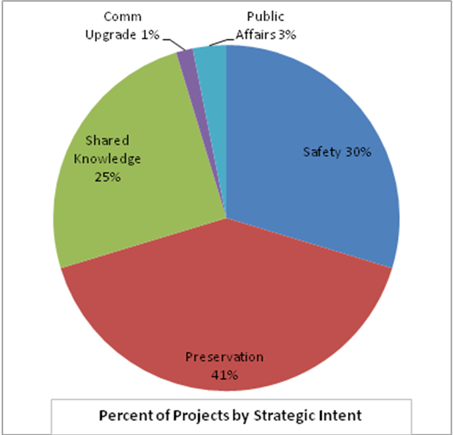
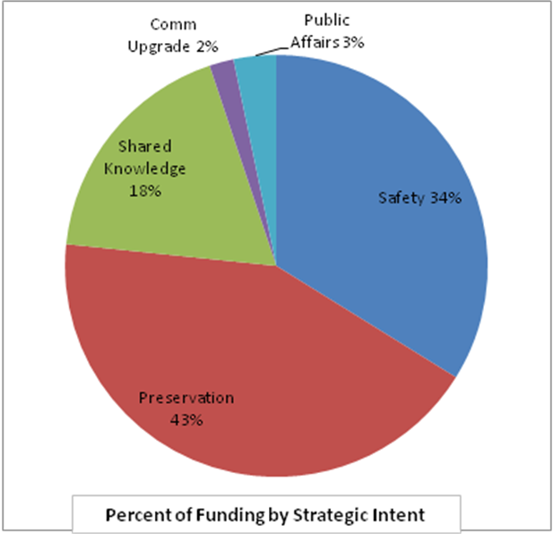

For number of projects and funding by Strategic Intent see Chapter 2.

Comments & Recommendations
Make determination whether hard linkage to WYDOT’s strategic goals is important and what percentage of the Research budget should be targeted towards supporting projects within a strategic research agenda.

If yes, set targets take actions to drive towards target in solicitation and selection process and monitor.

Method to Measure
- Percentage of projects by number of projects and of funding by Strategic Intent.
- Total number of projects and funding by Strategic Intent.

Frequency of Measure
Should be reviewed prior to RAC meetings and used for developing (quarterly or annual) solicitations for target areas.

Publication of Measure
Report on an annual basis as accomplishments and show trends in annual Research Work Plan.

PERFORMANCE MEASUREMENT CATEGORY: Strategic Portfolio Measures

PM #2 - Number of proposals responding to WYDOT solicitation requesting research
in focused areas

Policy Questions/Implications
Does WYDOT want to develop a more strategic research agenda? – Yes.

Results of Analysis of the Research Program & Projects
Not a current practice @ WYDOT. However, Programs initiate a significant number of projects. Forty-five percent (45%) of case studies were initiated by WYDOT Program personnel.

Comments & Recommendations
Make determination whether this is important.

If yes, Research Program should work within WYDOT to develop a process to create a more deliberate and strategic research agenda. The Research program must have the ability to work with line programs and the capability to develop a set of research opportunities/priorities that positively impact top-level BSC measures. The success to which this is done will be reflected in responses from the research community to WYDOT solicitations for research.

Method to Measure
Record and report # of projects responding to WYDOT solicitation. (However, too many may not be good.)

Frequency of Measure
Record and report quarterly to determine if solicitation process is working.

Publication of Measure
Report on an annual basis as accomplishments and show trends in annual Research Work Plan.

PERFORMANCE MEASUREMENT CATEGORY: Strategic Portfolio Measures

PM #3 - Number of project needs statements submitted by Programs

Policy Questions/Implications

Related to strategic research agenda above, as well as internal awareness of Research Program and its mission.

Results of Analysis of the Research Program & Projects
Not currently a formal practice @ WYDOT.

Comments & Recommendations
If Research Program develops strategic research agenda, submittal of needs statements by Programs will be part of the process.

Method to Measure
Record and report # of Program needs statements submitted each year.

Frequency of Measure
Record and report quarterly to determine if execution of strategic agenda is working.

Publication of Measure
Report on an annual basis as accomplishments and show trends in annual Research Work Plan.

PERFORMANCE MEASUREMENT CATEGORY: Strategic Portfolio Measures

PM #4 – Percentage (# and $) projects split between Project Categories, i.e. pooled funds, contract and in-house projects

Policy Questions/Implications

When it comes to WYDOT funds and the type of R&D, what is right balance, if any, between who sponsors, manages and executes the research? – No.

How can WYDOT get more bang-for-the buck on pooled funds project?
What type of project is most appropriate for universities and non-profits?
What is the role of the private sector in performing and then implementing?

Results of Analysis of the Research Program & Projects

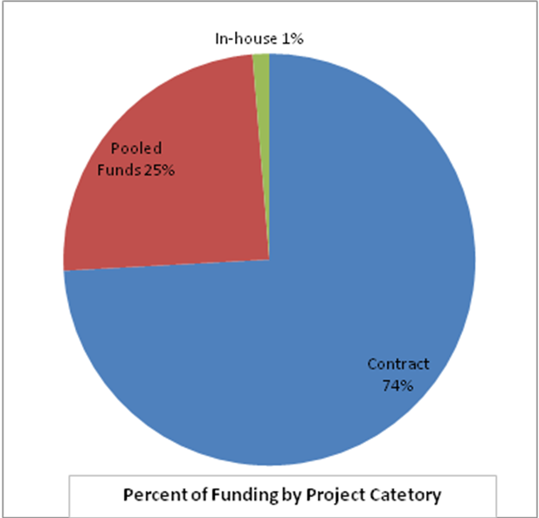
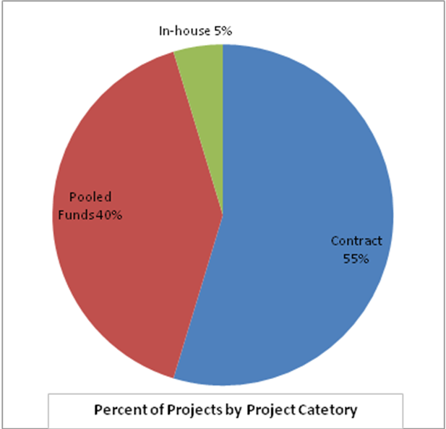

For number of projects and funding by Project Category see Chapter 2.

Comments & Recommendations
If mix between Project Categories is important, set targets take actions to drive towards target in solicitation and selection process and monitor.

More importantly and in any event WYDOT needs to improve understanding of:
- When pooled funds projects make sense?
- What conditions are key to success for in-house projects?
- What stage of the science and technology continuum is it more appropriate to partner with a university vs. the private sector?

Method to Measure
- Percentage of projects by number of projects and of funding by Project Category.
- Total number of projects and funding by Project Category.

Frequency of Measure
Should be reviewed prior to RAC meetings and used for developing (quarterly or annual) solicitations for target areas.

Publication of Measure
Document trend in annual Research Work Plan report.

PERFORMANCE MEASUREMENT CATEGORY: Strategic Portfolio Measures

PM #5 – Research projects executed in-house

Policy Questions/Implications

Does WYDOT want to encourage research to be performed internally and if so what type and, how much? – No.

Results of Analysis of the Research Program & Projects

Of 64 projects in study population less than 5% are performed within WYDOT.

Comments & Recommendations
Make determination whether this is important.

If yes, set target, take actions to drive towards target (publicize w/i WYDOT) and monitor.

Method to Measure
- Percentage of projects by number of projects and of funding for In-house projects.
- Total number of projects and funding for in-house projects.

Frequency of Measure
Since projects are continually starting and ending this measure should be taken and reported on an annual basis and compared to previous years for movement to or away from goal.

PERFORMANCE MEASUREMENT CATEGORY: Strategic Portfolio Measures

PM #6 – Funding research and technology transfer activities that are relevant to local governments in the state.

Policy Questions/Implications

What role does WYDOT want to assume in providing funding for research that is relevant not only to WYDOT but also to local governments in the state? – Minimal.

How can the limited research dollars benefits motorists using roads managed not only by WYDOT but also by counties and cities?

Results of Analysis of the Research Program & Projects
LTAP measures as defined and required by FHWA and managed for WYDOT by the University of Wyoming are adequate.

Method to Measure
Summarization of standard LTAP measures provided in annual reports to FHWA to measure the effectiveness of the research and technology transfer efforts geared toward local governments, e.g. number of workshops, number of participants, etc.

Frequency of Measure
Report on an annual basis as accomplishments and show trends in annual Research Work Plan.

PERFORMANCE MEASUREMENT CATEGORY: Project Execution Output Measures

PM #7 – Number of reports produced

Policy Questions/Implications

N/A

Results of Analysis of the Research Program & Projects
100% of case studies of completed research projects had high-quality final reports.

Comments & Recommendations
Required. Basic measure of research program outputs.
Supports measure of portfolio balance between products and reports (above).

Method to Measure
Record and report the number of reports produced each year.

Frequency of Measure
Report on an annual basis as accomplishments and show trends in annual Research Work Plan.

PERFORMANCE MEASUREMENT CATEGORY: Project Execution Output Measures

PM #8 – Percentage of projects completed that produced reports and/or products w/i 3-year timeframe

Policy Questions/Implications

N/A

Results of Analysis of the Research Program & Projects

TBD: 65% of completed case study projects produced final reports within 3 years.

Comments & Recommendations
Recommended. Recorded by Research program but not measured. Except in some cases, best management R&D practices would be to break projects extending over 3 years into separate projects. This measure helps ensure best practices are maintained.

Method to Measure
Record and report.

Frequency of Measure
Review on an periodic or annual basis. Internal measure.

PERFORMANCE MEASUREMENT CATEGORY: Project Execution Output Measures

PM #9 – Number of innovations implemented.

Policy Questions/Implications

Does WYDOT want to differentiate innovations (as a research project) from reports (PM #7)? – No.

Results of Analysis of the Research Program & Projects

11 of 15 case studies of completed projects were implemented at least once and/or temporally. Five projects were implemented once and are no longer in implementation and six projects are currently implemented.

Comments & Recommendations
Powerful and simple to measure. Basic measures of research program outputs that focus on business impacts. Driven by project selection and successful project execution.

Method to Measure
Record and report:
- Specifications revised
- New methodologies implemented
- Dollars saved/costs avoided
- Facilities with extended service life
- Fatalities and crashes reduced
- New products evaluated and implemented
- Policy and legislative impacts

Frequency of Measure
Report on an annual basis as accomplishments and show trends in annual Research Work Plan.

PERFORMANCE MEASUREMENT CATEGORY: Project Execution Output Measures

PM #10 – Effectiveness of technology transfer.

Policy Questions/Implications

Does WYDOT want to improve the dissemination of its research results?

Does WYDOT want to know if a commercial product was created or a company started from the research?

Does WYDOT want to know if the result of the research was deployed elsewhere?

Results of Analysis of the Research Program & Projects

- Thirty-three percent (33%) case studies of research projects resulted in a new or enhanced product.
- Three case study projects were identified whose results are in use by other entities.
- Just over 50% of case study projects were presented in professional forums (journals, conferences).
- Review of final report for Nov ’06 WYDOT Peer Exchange recommended increased efforts to communicate research results (web page w/ access to reports, brochures, events, etc.)

Comments & Recommendations
- Makes good anecdotal evidence of value of R&D.
- Product commercialization can take a long time, i.e. latent results.
- May be difficult and time-consuming to track.

Method to Measure
Record anecdotes but rarely report.
At conclusion of project, identify likely candidates for commercialization or adoption by other entities and follow-up w/ PI 1-2 years, e.g. contact and ask questions re status/evolution of R&D results.

Frequency of Measure
N/A.

PERFORMANCE MEASUREMENT CATEGORY: Project Execution Output Measures

PM #11 – Number of University (UW or other students) participating in project.
.

Policy Questions/Implications

Does WYDOT want to leverage research projects to assist in recruitment of engineers? – No.

Does WYDOT want to provide/support educational opportunities? – Not explicitly.

Results of Analysis of the Research Program & Projects
Was not addressed in study.

Comments & Recommendations
Make determination whether this is important and if so is it important enough to be actively pursued and measured.

Encourage in proposal preparation guide as appropriate. Could be leveraged with in-house projects in order to build closer relationship with student and WYDOT Program personnel (i.e. recruitment tactic).

Method to Measure
Ask PI.
Record if student participated in project and if student went to work for WYDOT.

Frequency of Measure
Report on an annual basis as accomplishments and show trends in annual Research Work Plan.

PERFORMANCE MEASUREMENT CATEGORY: Program Efficiency and
Management Measure

PM #12 – Program and Project Benefit-Cost ratios.
.

Policy Questions/Implications

Does WYDOT want to attempt to quantify/maintain and monitor this? – Yes.

Results of Analysis of the Research Program & Projects
Fourteen percent (14%) of case study projects included cost-benefit analysis.

Comments & Recommendations
Apply cost-benefit measure to cost savings type projects and safety projects.

Do not recommend trying to do this for the overall program even though a tool is provided in the NHCRP Performance Measurement Toolbox and Reporting System for Research Programs and Projects. The compilation of the selected performance measures, i.e. the Research program’s proposed BCS will provide a much better reporting system and product.

Method to Measure
The software application developed in conjunction with the NHCRP Performance Measurement Tool Box and Reporting System for Research Program Projects is recommended as the tool to support this measure. However, even with this tool cost-benefit will be difficult measure to monitor and to maintain.

For proposals, a template could be provided to research proposers and a cost-benefit analysis could be performed and attached to the proposal for consideration by the RAC for project selection.

Original NPV estimate (total present value dollar savings of project vs. total present value cost of project or total R&D program + related implementation costs) can be converted into “actual” ROI and updated over project lifecycle.

Frequency of Measure
Report on an annual basis as accomplishments and show trends in annual Research Work Plan.

PERFORMANCE MEASUREMENT CATEGORY: Program Efficiency and
Management Measure

PM #13 – Percentage of Administrative costs.
.

Policy Questions/Implications

Does WYDOT want to measure and monitor this? – Yes.

If Admin costs increase could be a sign of inefficiency. If Admin costs decrease could be a sign that the program is growing but the resources (staff) to administer it are not.

Results of Analysis of the Research Program & Projects
Reported in 2007 Research Work Program. Less than ten percent of Program budget is spent on admin costs.

Comments & Recommendations
Make determination whether this is important.
If yes, collect data and monitor.

Method to Measure
Record and report ratio of admin costs to Program budget.

Frequency of Measure
Report on annual basis and show trends in annual Research Work Plan.

PERFORMANCE MEASUREMENT CATEGORY: Program Efficiency and
Management Measure

PM #14 – Percentage/amount of funds requested vs. available/awarded.
.

Policy Questions/Implications

Does WYDOT want to know if (and how much) requests for research funding exceed supply perhaps as evidence to Executive management and the Legislature that more funding is needed. – Yes.

Results of Analysis of the Research Program & Projects
Was not addressed in study. The number of proposals not funded or the reasons projects were not funded was outside the scope of the study.

Comments & Recommendations
Make determination whether this is important.
If yes, collect data and monitor.

Method to Measure
Record and report number of projects that were not funded and dollar amounts requested (for projects not funded) vs. annual funding.

Frequency of Measure
Report on annual basis and show trends in annual Research Work Plan.
.

PERFORMANCE MEASUREMENT CATEGORY: Program Efficiency and
Management Measure

PM #15a – Percentage of projects completed on-time.

PM #15b – Percentage of projects completed on or under budget.

Policy Questions/Implications

Does WYDOT want to know these?- Yes.

Results of Analysis of the Research Program & Projects
Fifty percent (50%) of completed case study projects were completed on-time.

Seventy-two (72%) of completed case study projects were completed on or under original budget.

Comments & Recommendations
- Easy to measure but can be mis-read. Research projects often have legitimate need or additional time and/or budget.

- Too much emphasis on these measures can negatively impact a research project.

- Recommend measuring/monitoring these but for information purposes as oppose to a performance measure of Research program administration.

Method to Measure
Record but do not report.

Frequency of Measure
N/A.

Table 4. Candidate Performance Measures with Measures Selected by WYDOT Highlighted.

[Type a quote from the document or the summary of an interesting point. You can position the text box anywhere in the document. Use the Text Box Tools tab to change the formatting of the pull quote text box.]

Selected Performance Measures and Implementation

Of the 17 candidate performance measures, ten were selected for a proposed Research program balanced scorecard. The measures are divided into the three measurement categories previously discussed and are as follows:

Group 1 – Strategic Portfolio Measures
1.a. Funding by Strategic Intent.
1.b. Number of Projects by Strategic Intent.
2. Number of proposals responding to WYDOT solicitation (based on research agenda).
3. Number of needs statements submitted by Programs.

Group 2 – Project Output Measures
1. Outcome of a project and its impact:
  - Specifications revised;
  - New methodologies implemented;
  - Dollars saved/costs avoided;
  - Facilities with extended life;
  - Crashes reduced;
  - Fatalities reduced;
  - New products evaluated and implemented;
  - Policy and legislative impacts;
2. Number of research reports completed each year and number of research reports not completed within three years.

Group 3 – Program Efficiency and Management Measures
1. Cost-benefit analysis for individual projects;
2. Cost-benefit analysis for overall program;
3. Percentage of Administrative costs to overall program funding;
4. Funds requested by research community versus funds available;
5. Percentage of projects completed on-time and within budget (internal tracking only).

Suggested implementation of the selected performance measures can be accomplished using Excel except for the cost-benefit analysis of individual projects and the overall program. Examples provided are for illustrative purposes only and do not contain historic Research program data. It would be useful if Excel macros could be developed which would facilitate data input and would generate the formatted reports with minimal effort. For each selected measure suggested reporting formats are provided. Each measure can be presented tabular and graphically and should show be trended over time.

Group 1 – Strategic Portfolio Measures

Figures 15a and 15b show Strategic Portfolio Measures 1.a. Funding by Strategic Intent and 1b. Number of Projects by Strategic Intent, respectively.
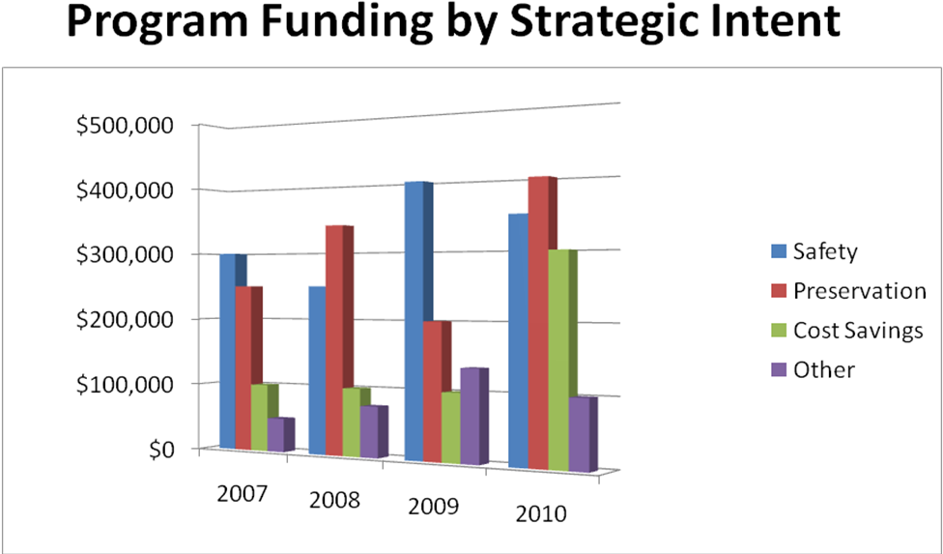

Figure 15a. Trends in Project Funding by Strategic Intent.

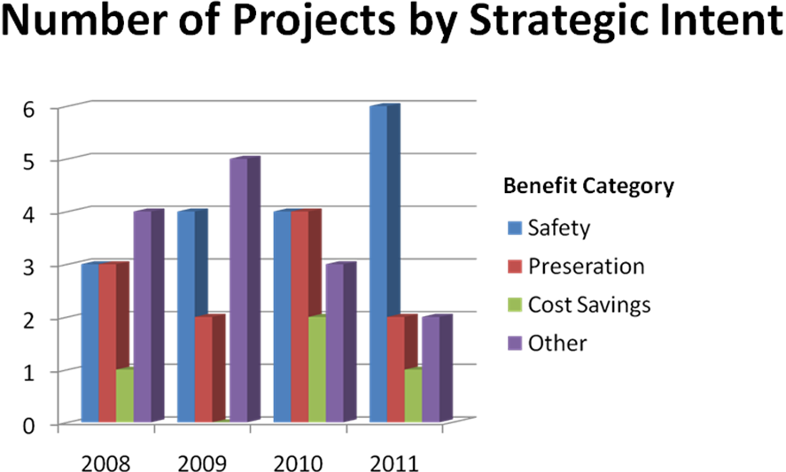
Figure 15b. Trends in Number of Projects by Strategic Intent.

Figures 16 and 17 show Strategic Portfolio Measures 2 and 3 which track (over time) the number of proposals responding to WYDOT solicitation and the number of needs statements submitted by programs – based on executing a defined research agenda. These measures are linked and are perhaps two of the most important measures for Research program management and the RAC. The examples below use tables but graphs could also be developed.

# ProposalsQtr 1Qtr 2Qtr 3Qtr 4Annual Total2008 2009 2010 2111
Figure 16. Trends in the Number of Proposals Responding to WYDOT Research Program Solicitation.

# of Needs Statements | Qtr 1 | Qtr 2 | Qtr 3 | Qtr 4 | Annual Total
2008
2009
2010
2111

Figure 17. Trends in the Number of Needs Statements Submitted by Programs.

Group 2 – Project Output Measures

Figure 18 depicts Project Output Measure 1 which documents the outcome of a project and its actual and projected impact.

Output Measure | 2008 | 2009 | 2010 | 2011
Specifications Revised
New Methodologies Implemented
Dollars Saved/Costs Avoided
Facilities with Extended Service Life
Fatalities Reduced
Crashes Reduced
New Products Evaluated and Implemented
Policy and Legislative Impacts

Figure 18. Trends in Project Outcomes and Impact.

Figure 19 shows Project Output Measure 2 which documents the number of research products, i.e. reports completed each year and projects with elapsed time greater than three years. Again, many of these measures can be reported in graphical and/or tabular formats.

 | Start | Report Complete | Elapsed Time
Project 1 | 10/1/2005 | 9/1/2006 | 11 months
Project 2 | 12/1/2005 | 1/1/2007 | 23 months
Project 3 | 1/1/2006 | 10/1/2006 | 9 months
Project 4 | 9/1/2004 | - | 36 months
Project 5 | 5/1/2005 | 8/1/2007 | 27 months
 | 2008 | 2009 | 2010
# Projects w/ Elapsed Time > 3 Years | 1 | 2 | 0
Active Projects | 5 | 6 | 5
 | 0.20 | 0.33 | 0.00

Figure 19. Trends in the Number of Research Reports Submitted and the Number of Projects not Completed within Three Years.

Group 3 – Program Efficiency and Management Measures

It is recommended that cost-benefit analysis for individual projects be performed only for selected types of projects. Projects that should be evaluated using cost-benefit analysis are projects whose intent is to generate cost savings or result in cost avoidance or projects whose intent is to reduce the number of crashes and fatalities.

The tool recommended to support this analysis is the RPM Tools (NCHRP 20-63, 2006). The tool is targeted to transportation research, is relatively easy to use, is stable (beta version was tested), well documented and free. (How well the tool will be supported remains to be seen). The tool also includes program effectiveness measures available on the RPM website. Although use of this tool is not recommended, for comprehensiveness the RPM report for program effectiveness is included as part of the RPM Toobox.

Program Efficiency and Management Measure 1, shown as sample output from the RPM
software is illustrated in Figure 20. Sample output from the program for a cost savings
project. Under a proposed implementation scenario the proposed measure would be used
during proposal evaluation. The process would work something like this:

- The proposer would complete a worksheet/template similar to the RPM application’s input screens.

- Research program staff, a contractor or a UW intern would enter the data from the worksheet into the RPM application and run the cost-benefit analysis
- Output from the cost-benefit analysis would be shared with the proposer and the RAC as part of the proposal evaluation process.

- After project execution, the RPM Tool might be used to track actual benefits. However, the practicality of this and the resources required should be considered on a case-by-case basis before committing to this type of on-going measurement. For example, deployment of the innovative wind warning system described in Chapter 1 is intended to reduce wind-related crashes involving trucks statewide and at specific locations; the cost-benefit of this project can easily be measured if the Research program communicates with Highway Patrol and Highway Safety its need for wind-related crash data involving truckers be captured and properly labeled.

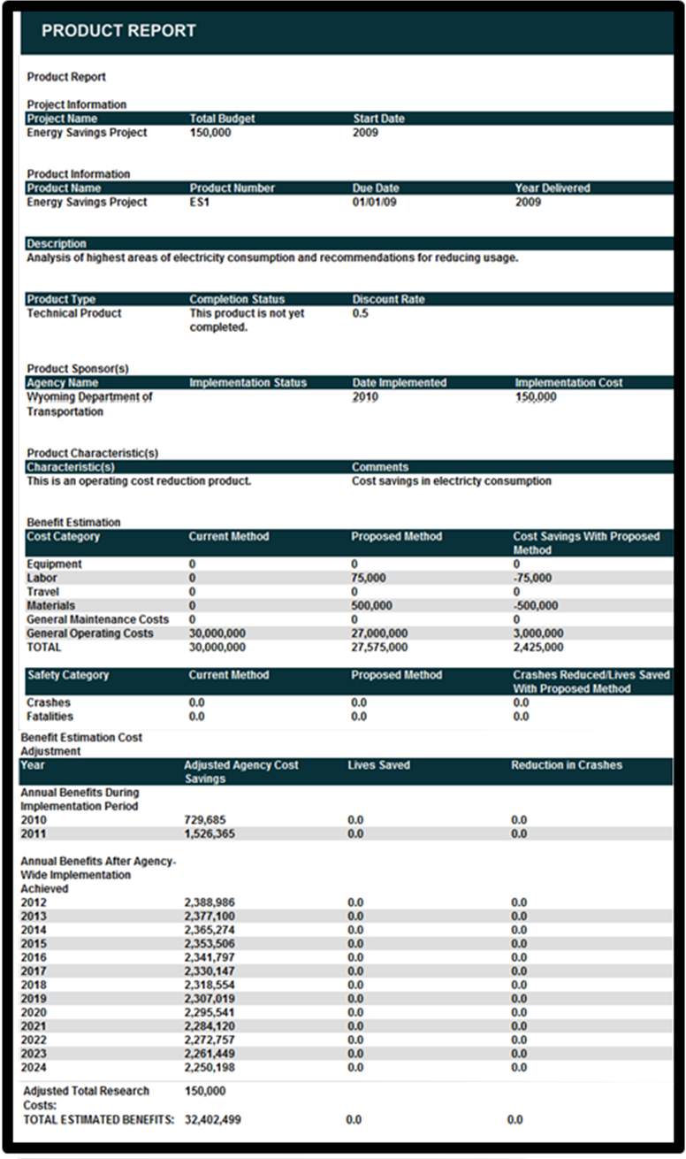
Figure 20. Cost-benefit Report for an Example Cost Savings Project Using RPM Tools.

For illustrative purposes the second Program Efficiency and Management Measure 2 Figure 21 provides a sample of the RPM cost-benefit analysis for an overall research program. This data collection, analysis and reporting tool is available on the RPM website. This tool could not be fully evaluated during this study as the website was being revised and the program measurement tool was unavailable. Although the tool will aggregate cost-benefit data for projects, other measures will be somewhat redundant to the proposed Research program BSC measures and not as tailored to WYDOT. It is recommended that WYDOT take a more customized approach to reporting overall Program effectiveness using the suite of performance measures developed in this chapter.

Figure 21. Sample report for RPM Program Effectiveness Performance Measures.

Figures 22 and 23 illustrate the Program Efficiency and Management Measure 2 which addresses the percentage of administrative costs to total program funding in graphical and tabular formats. These measures address whether administrative costs are proportional and sufficient to manage the program or if administrative costs relative to overall program funding are increasing which would indicate decreases in efficiency. Research program management will have to decide whether to include program “take-offs”, i.e. funds that are not managed by WYDOT but are taken off the top of annual Research program funding. Another consideration is whether to use the number of projects under contract as an input to measure program efficiency.

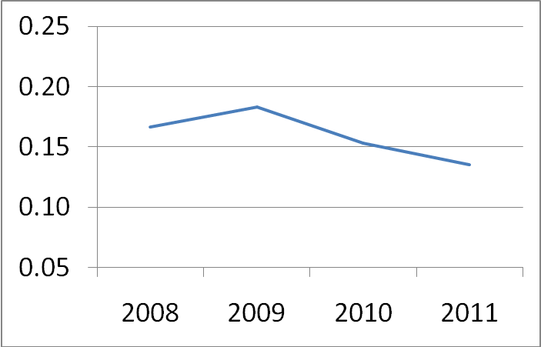
Figure 22. Trend in Percentage of Administrative Costs to Total Program Funding.

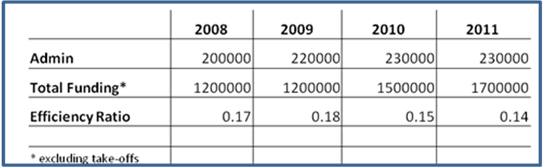

Figure 23. Percentage of Administrative Costs to Total Program Funding.

Figure 24 shows the Program Efficiency and Management Measure 4 which tracks the supply and demand of research funds requested by programs and the research community versus funds available. This measure can help the Research program monitor whether funding is sufficient to address the research opportunities. This measure combined with the cost-benefit measure can help Research program management determine when and why to request additional funding from Executive management and can provide Executive management the business case to request additional State funding from the Legislature.

 | 2008 |  |  |  |  | 2009
 | Qtr 1 | Qtr 2 | Qtr 3 | Qtr 4 | Total | Qtr 1 | Qtr 2 | Qtr 3 | Qtr 4 | Total
Funds Available |  |  |  |  | 890000 |  |  |  |  | 920000
Funds Requested* | 225000 | 250000 | 200000 | 250000 | 925000 | 250000 | 400000 | 260000 | 125000 | 1035000
* only qualified projects |  |  |  |  | -35000 |  |  |  |  | -115000

Figure 24. Supply and Demand for Research Funds.

Program Efficiency and Management Measure 5 tracks the number and percentage of projects completed on-time and within budget. These measures, shown in Figure 25, are not intended to be reported in the annual Research Program Work Plan but rather provide program management and administration information.

 | 2008 | 2009 | 2010 | 2011
Total Projects Completed | 4 | 5 | 3 | 6
On-time | 4 | 4 | 2 | 6
% On-time | 100% | 80% | 67% | 100%
Within Budget | 4 | 5 | 2 | 6
% Within Budget | 100% | 100% | 67% | 100%

Figure 25. Projects Completed on-time and within Budget for Informational Purposes Only.

Summary of Performance Measures

The ten performance measures selected, in aggregate comprise the proposed balanced scorecard for the Research program. These measures are comprehensive and coherent. They link research to the strategic plan through a research agenda and focus on outcomes (effectiveness) while also addressing process (efficiency). The measures provide WYDOT with a framework for continuous improvement, i.e. measure-monitor-manage-measure. The measures are quantifiable and trends in these measures should be communicated through the Annual Research Work Program report.

The condensed version of WYDOT’s proposed Balanced Scorecard is show in Appendix B.
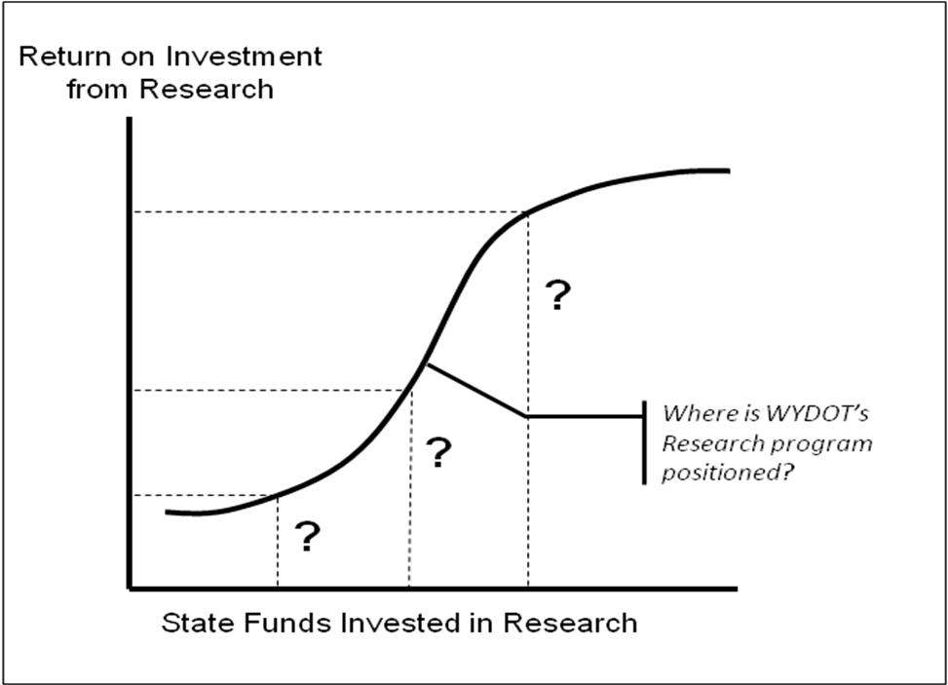
Figure 24. Determining the Research Program’s Position on the Research ROI Curve.

Capturing, tracking, monitoring and analyzing these performance measures will require resources. Current Research program staffing may be inadequate to manage this performance measurement system and administer the program. If so, it is recommended that WYDOT consider using UW resources or solicit external (contract) support if necessary to implement and maintain these measures over the next three years to establish a performance baseline. After three years, each measure should be re-assessed.

As shown in Figure 26 over time the performance measures may reveal the Research program’s position regarding increasing or decreasing return on investment from R&D. Increasingly effective use of research funding will shift the curve to the left and may even alter the shape of the curve – enabling WYDOT to have a demonstrable, leading program in terms of results using a fraction of the budget that other state transportation departments devote to research.

Chapter 4 – Recommended Processes, Tools and Aids for Managing Research

This study examined multiple aspects of the Research program. Chapter 1 provided numerous observations of the overall program and the research investment portfolio as well as guidance for developing a strategic research agenda. Chapter 2 provided insight into various categories of research projects by analyzing data across all projects and detailed case studies for a select group of projects all of which provided lessons learned and recommendations for managing the research program in the future. Chapter 3 defined and evaluated candidate performance measures for improving program effectiveness and identified a core set of performance measures selected by WYDOT Executive leadership and program management Chapter 3 included the development of a proposed balanced scorecard for the Research program based upon the selected measures. This chapter concludes this study by emphasizing implementation key elements from the previous chapters and providing several additional tools and aids for the Research program.

These include:
- Supplemental guidance to help PIs improve their proposals;
- A checklist for use by RAC members when evaluating proposals;
- Suggestions on how the Research program can work with interested programs to develop a research agenda and to solicit research opportunities; and
- A survey for researchers to provide structured feedback to the Research program and program sponsors.

Using the framework introduced at the beginning of this study, Figure 26 shows where the performance measures and other tools and aids developed during this study fit into each facet of program execution.

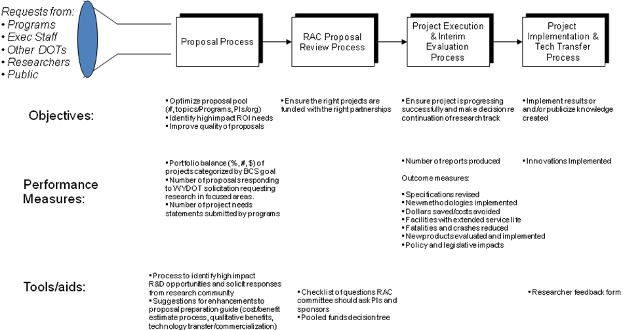
Figure 27. Framework to Enhance Research Program Effectiveness and to Increase the Probability of “Successful” Research

Supplemental Proposal Guidance

The Research program has developed and published a good set of proposal guidelines. These are accessible to program sponsors and researchers through the WYDOT website. Nearly all proposals for projects reviewed as case studies had high-quality proposals. However, there were many lessons learned from this project that can strengthen research proposals. Improving proposals can have a large payoff by improving project execution and research outcomes. Additional paragraphs, questions and suggestions for the proposer to consider are provided in Appendix C. Suggested modifications have been made to the following sections of the Research Report Writing Guidelines:

- Problem Statement;
- Study Objectives;
- Study Benefits;
- Work Plan/Scope; and
- Technology Transfer.

Proposal Evaluation Checklist

To assist the RAC in evaluating proposals a proposal checklist was developed and is presented in Appendix D. This checklist is the product of analysis of the overall program, the project portfolio and the case studies of individual projects. The checklist is a tool for RAC members to complete while reviewing proposals and to stimulate critical questions of the researcher during review and presentation of their proposals. The checklist is tightly integrated with several of the performance measures proposed for adoption by WYDOT. For consistency, some elements of this checklist are included in the supplemental sections of the Research Report Writing Guidelines.

Developing an R&D Agenda and Working with Programs to Solicit Research Opportunities

If WYDOT intends to develop a more strategic direction with its Research program the organizational leadership role fits within the Research program. The Research program will need to work closer with interested programs to facilitate development of an R&D agenda, and the programs must want to participate. This is not to say that some percentage of research funding should not be available to pursue immediate needs or unsolicited opportunities, the question is what is the optimal balance?

This agenda would be comprised of four research tracks since four of six WYDOT goals are candidates to be positively affected by research. Each research track would be aligned to one strategic goal so that a coherent set of successive and sometimes interdependent projects was focused on each BCS target. These research tracks can be developed using the 1st level analysis process described in Chapter 1.

However, going further down the path in defining a research track requires problem or opportunity analysis. This may or may not be a desirable role for Research program management and staff. Alternatively, brief analyses of problems and opportunities can be performed with external resources to qualify potential projects to be pursued within a given research track.

The analytical approach described above to defining projects is one of two distinct research management strategies WYDOT should consider. The other is to more broadly solicit the research community for proposals to address a specific BCS goal.

As stated in Chapter 1, both approaches can be effective. If the Research program and program managers are confident in their assessment of the problem/opportunity and the requirements of a solution then they should develop a hypothesis and follow the more structured approach. This approach usually works best when the project calls for systems engineering or engineering analysis. Contracting with the private sector often makes the most sense the further along a project is positioned on the science and technology continuum. If what WYDOT ultimately needs is a product or service, this will be better provided by the private sector and private sector partners this should be considered apriori for the project. If there is uncertainty in characterizing the problem and formulating possible solutions or if an “out-of-the-box” solution is desired then follow the open approach of publishing broad objectives and inviting the research community to respond accordingly. If the solution lies in the areas of applied sciences or engineering principals it should perhaps more appropriately be pursued as a pooled funds project with the costs shared across numerous states and the research performed in the academic research community.

Managing a Research Agenda

The performance measures and the framework detailed in Chapter 3 are based upon WYDOT’s decision to move research into a more strategic direction and key learning from analysis of research projects. With these performance measures the Research program has the blueprints to enable greater program effectiveness. Managing to these ten performance measures will drive the proposal and selection process which results in outputs that are valuable and implementable. The measures will help maintain administrative efficiency. Implementation of these measures will address perhaps the most insightful observation in the November 2006 Peer Exchange, “WYDOT is progressive enough to realize the need to develop useful performance measurements.”

Researcher Feedback

The authors’ first-hand experience in performing research on behalf of WYDOT has been very positive. From proposing projects to the RAC, to executing projects with sponsors, to fulfilling administrative requirements, WYDOT’s research program has minimal decision layers, is efficient, can respond quickly and is not afraid to support research that falls “outside the box”.

In order to create a more structured communication channel, use of a post-project survey such as the one provided in Appendix E is highly recommended. The survey attempts to solicit comments and suggestions regarding the proposal process, interaction with Research staff and program sponsors, transferrable lessons and opportunities for follow-on research. It is proposed that this survey be completed by the researcher after submittal of their final report. This will create a feedback loop for the Research program to receive and document constructive comments from the research community.

Table 5. Summary of Current Program Practices and Proposed Practices.
 | Current Practice | Practices Proposed in Study
Linkage to Strategic Goals | - No analysis of potential impact on strategic goals  - No formal solicitation of research community for projects or project ideas  - Portfolio comprised almost exclusively of opportunistic projects | - Investment portfolio includes pursuit of research tracks that will have the greatest impact on strategic goals  - Solicitation of projects to execute research tracks  - Balance between strategic and opportunistic projects
Performance Measures | - No formal performance measures | - Ten measures proposed for monitoring and managing program effectiveness and program efficiency
RAC Committee and Evaluation Process | - No structure for review of proposals | - Evaluation checklist to help RAC members review proposals and ask the tough questions of researchers and program sponsors
Proposal Guidance | - Good proposal guidance for researchers and program sponsors provided on website | - Supplemental guidance to enhance existing guidance and help generate better proposals to affect project execution, implementation and diffusion
Role of Research Program Management | - Focus on administrative side of the program with more passive research management | - Active research management at overall program level working with programs to formulate, execute and manage research agendas
Pooled Funds Projects | - Discipline in proposing projects to RAC  - Outcomes from pooled funds project mixed | - Type of projects and other project characteristics that leads to successful pooled funds projects identified for consideration by RAC and sponsors
Types of Partnerships  (What, Why, When, How) | - In some cases not enough consideration given to whether a research partnership should be with the private sector or a public entity | - Recommendations provided regarding when WYDOT should partner with universities versus the private sector to increase the probability of successful implementation and transfer of technology

APPENDIX A – Framework for Case Studies

This page intentionally left blank.

RAC Case Study Analysis
___Pooled ___In-house ___Contract
WYDOT POC: ___________________
PI: _____________________________

Review Phase | Lines of Inquiry | Observations
Overall Planned vs. Actual | Start date  End date  Proposal estimated cost  Project actual/current cost
Proposal Review  Proposal Review  Proposal Review | What was the project’s baseline scope?
Proposal Review  Proposal Review  Proposal Review | How was the opportunity identified?
Proposal Review  Proposal Review  Proposal Review | If pooled funds, what States participated?
Proposal Review  Proposal Review  Proposal Review | Was knowledge and awareness of background research and characteristics of the problem adequate?
Proposal Review  Proposal Review  Proposal Review | Was the objective(s) clearly stated?
Proposal Review  Proposal Review  Proposal Review | Was proposed plan (engineering concepts, data collection methods, planned activities, equipment) to support the stated objectives sound?
Proposal Review  Proposal Review  Proposal Review | Was there any discussion of how to address unknowns and uncontrollable factors (e.g. lack of knowledge base, cooperation from other entities, weather, unproven devices/technologies)?  - Were there decision points  - Were there contingencies  - Were there any “stop the project conditions”
Proposal Review  Proposal Review  Proposal Review | Was a cost/benefit analysis included in the proposal? [1 - 5}  - Was the method sound  - What was the ROI  - What are the links to KPI/BSC  - Who would be the beneficiaries (WY DOT, other DOTs, Local Govts)
Proposal Review  Proposal Review  Proposal Review | What were the expected outcomes?  - New knowledge, i.e. engineering standards  - Next phase of study  - Results on the road (safety, preservation)  - Policy recommendation  - Public relations
Proposal Review  Proposal Review  Proposal Review | How would you rate the quality of the proposal?  - Professional  - Clear  - Concise  - Complete
Proposal Review  Proposal Review  Proposal Review | If research is “successful” would the research results be implementable, e.g. is commercialization required, does a standard need to be changed, do complimentary assets need to be in place?  - How  - When  - By whom  - Potential barriers
Proposal Review  Proposal Review  Proposal Review | Was a technology transfer “plan” included?  - Was it relevant  - Was there sufficient detail  - What were the major elements/strategies  - Would it be effective
Proposal Review  Proposal Review  Proposal Review | Was a technology “roadmap” included?
Proposal Review  Proposal Review  Proposal Review | Was the background of the PI and team presented?
Proposal Review  Proposal Review  Proposal Review | Did they appear competent?
Proposal Review  Proposal Review  Proposal Review | If pooled funds project, did WYDOT have a representative on the project advisory board?
Proposal Review  Proposal Review  Proposal Review | If pooled funds project, did the WYDOT representative have input on the research proposal?  If yes, what was the nature of the input?
Project Implementation & Technology Transfer  Project Implementation & Technology Transfer  Project Implementation & Technology Transfer | Did/is the project proceeding according to the proposal?  - Scope (does the progress report indicate self-scrutiny)
 | Was an interim briefing provided to the RAC (notes, comments)?
 | If pooled funds project, did the WYDOT representative have input on the project during the course the research?
 | What was the outcome relative to the proposal’s expected results, i.e. were the proposed objectives achieved?
 | Was a final report developed/delivered? (if not, why not)
 | If pooled funds project, did the WYDOT representative review the final report and provide input?
How would you rate the quality of the final report?
- Professional
- Clear
- Concise
- Complete

 | Were the results presented in a professional forum? (what forum, e.g. conference, journal article)
 | Did the research spawn additional research or product development?
Were the results of the project deployed within WYDOT/ Wyoming?
- How
- Where
- When
- By whom

If not deployed, why?

Were the results of the project deployed elsewhere?
- How
- Where
- When
- By whom

If not deployed, why?

Was the technology commercialized?
- Product or service
- Name and Location of company
- Type of company (start-up, small, mid-size, large)

Will benefits identified in the proposal realized?
- If not, why not

Were additional phases proposed
- Were additional phase(s) executed under the RAC or other R&D program

 | If decision gates were built-in to the contract was the structure used?

APPENDIX B - Proposed Balanced Scorecard for WYDOT’s Research Program

GROUP 1 - STRATEGIC PORTFOLIO MEASURES

# ProposalsQtr 1Qtr 2Qtr 3Qtr 4Annual Total2008 2009 2010 2111
Trends in the Number of Proposals Responding to WYDOT Research Program Solicitation
# of Needs StatementsQtr 1Qtr 2Qtr 3Qtr 4Annual Total2008 2009 2010 2111
Trends in the Number of Needs Statements Submitted by Programs
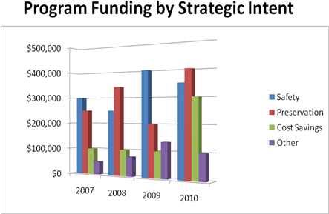
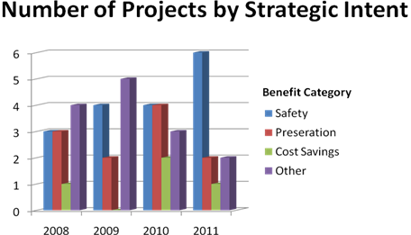
GROUP 2 - PROJECT OUTPUT MEASURES

Output Measure | 2008 | 2009 | 2010 | 2011
Specifications Revised
New Methodologies Implemented
Dollars Saved/Costs Avoided
Facilities with Extended Service Life
Fatalities Reduced
Crashes Reduced
New Products Evaluated and Implemented
Policy and Legislative Impacts

Trends in Project Outcomes and Impacts

 | Start | Report Complete | Elapsed Time
Project 1 | 10/1/2005 | 9/1/2006 | 11 months
Project 2 | 12/1/2005 | 1/1/2007 | 23 months
Project 3 | 1/1/2006 | 10/1/2006 | 9 months
Project 4 | 9/1/2004 | - | 36 months
Project 5 | 5/1/2005 | 8/1/2007 | 27 months
 | 2008 | 2009 | 2010
# Projects w/ Elapsed Time > 3 Years | 1 | 2 | 0
Active Projects | 5 | 6 | 5
 | 0.20 | 0.33 | 0.00

Trends in the Number of Research Reports Submitted and the Number of Projects not Completed within Three Years
GROUP 3 - PROGRAM EFFICIENCIY AND OUTPUT MEASURES
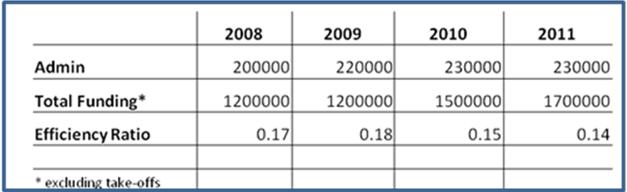
Cost-benefit Report for an Example Cost Savings Project Using RPM Tools
Trend in Percentage of Administrative Costs to Total Program Funding
Percentage of Administrative Costs to Total Program Funding.

2008
2009 Qtr 1Qtr 2Qtr 3Qtr 4TotalQtr 1Qtr 2Qtr 3Qtr 4TotalFunds Available 890000 920000Funds Requested*2250002500002000002500009250002500004000002600001250001035000* only qualified projects -35000 -115000
Supply and Demand for Research Funds

2008200920102011Total Projects Completed4536On-time4426% On-time100%80%67%100%Within Budget4526% Within Budget100%100%67%100%
Projects Completed on-time and within Budget for Informational Purposes Only.

APPENDIX C – Supplemental Proposal Guidance

Problem Statement
When stating the problem, a sponsor is expected to give an explanation of the existing problem and the situation that could exist if conditions were different. All circumstances surrounding the problem should be explained, including its effects on the operations of the DOT. Often a problem is known only to a few people, so it is important that as much detail as possible be included in the problem statement. An explanation of the inadequacy of a technique, material, or specification can help define the extent of the problem. The project should link to one or more balanced scorecard measure(s) below:
- Reduction in number of crashes
- Reduction in number of deaths
- Service to customers (e.g. mobility in winter road conditions)
- Stewardship of the State transportation system (e.g. conditions of roads/bridges)
- Cost savings in planning, design, construction or operations
- Positive impact on environment (e.g. wildlife mitigation)
If the project is successful, it should have a meaningful, positive impact on one or more of these measures.

Study Objectives
The objectives define the conditions that are expected to exist at the completion of the work. These conditions are described by goals that give the optimum technique, material, or specification from a financial, operational, environmental, or social viewpoint. In other words, what is the expected output from this project?

- Specification revised
- New engineering knowledge
- New methodology implemented
- New product evaluated and implemented
- Facilities with extended service life
- Dollars saved/costs avoided
- Impacts on policy or legislation
- Improved public relations

For any of these outcome measures there should be an acknowledgement whether an objective of a study is to move into a subsequent phase, as applicable.

Study Benefits
To the extent possible, qualitative benefits of successful research should be stated. These might include: estimated monetary savings; how operational methods will be improved; how safety will be enhanced; estimated increase in public user support; expected reduction in energy consumed, and how practices will be improved or simplified.

If the intent of the project is cost savings or cost avoidance then the proposal should include a cost-benefit analysis. Similarly, if the intent of the project is to reduce crashes and fatalities, the proposal should include quantitative analysis of the cost-benefit of potential reduction in crashes and fatalities. The Research Program has prepared templates to collect data and assumptions and to perform cost-benefit analyses as part of the research evaluation process.

Work Plan/Scope
From a clear list of objectives, an approach detailing their attainment must be done, that is, a work plan. The work plan demonstrates an understanding of: the techniques and methods to be used to resolve the problem, and contains all components necessary for the successful completion of the research, including updating the state of the art; design of the research experiment; lab, testing, and computer facilities; data collection elements and procedures, analytical procedures; notation of key decision points; schedules of meeting; and reporting details. The work plan allows the reviewers the opportunity to more accurately judge the potential success and cost of the research.

Sponsors and researchers should address the following applicable questions in their proposals:
- Are there any potential barriers to implementation (e.g. material, technology, vendors, legal/regulatory, public perception)?
- For each potential barrier, are strategies to mitigate potential barriers identified and presented?
- What is the expected timeframe for implementation?
- Does the project involve action on federal lands or other condition that will require NEPA documentation (e.g. Categorical Exclusion or Environmental Assessment)?
- What are the major uncontrollable factors and/or unknowns in the project such as weather, wildlife, material properties, traffic, etc.?
- Are there contingencies to address these uncontrollable factors and unknowns in the proposal and are there additional costs if there are delays due to uncontrollable variables such as weather?
- Should the project be segmented into phases with go-no/go decision points based on known unknowns (e.g. technology, partnerships, regulatory)?
- If the project involves evolution of one or more technologies, is a technology roadmap provided showing how these technologies fit together?

Technology Transfer
The main goal of conducting research is to improve or enhance transportation practice. In order for research results to be used, transfer of knowledge from the researcher to the new or potential user must be made. This transfer can be seen as a process encompassing the dissemination of the research results and knowledge regarding any new processes, methods, and products which increases the technical quality and ability of the Department to better provide transportation services to its citizens. Like the implementation process, a sound strategy, with sufficient detail (who, how, when, where) should be developed. The proposal should address, in sufficient detail, how the research results will be adopted by or transferred into WYDOT and/or other targeted entities. The proposal should identify who are expected direct and indirect beneficiaries of this research.

APPENDIX D – RAC Proposal Evaluation Checklist

This page intentionally left blank.

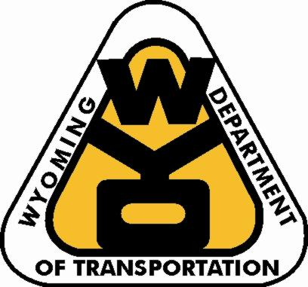
Proposal: ________________________
________________________

RAC Member: ____________
___________________________ ______

Proposal Checklist for RAC Members

Category | Question | Response/ Observation
General | Is the proposed problem adequately understood and defined? | ⁯ Yes ⁯ No
General | Which balanced scorecard measure(s) does this project support?  ⁯ Reduction in number of crashes  ⁯ Reduction in number of deaths  ⁯ Service to customers (e.g. mobility in winter road conditions)  ⁯ Stewardship of the State transportation system (e.g. conditions of roads/bridges)  ⁯ Cost savings in planning, design, construction or operations  ⁯ Positive impact on environment (e.g. wildlife mitigation)  ⁯ Other ___________________________________________________________
General | If the project is successful, could it have a meaningful impact on the balanced scorecard measure(s)? | ⁯ Yes ⁯ No  ⁯Unsure
General | Does the proposal reflect an open mind and is not focused on proving a specific outcome? | ⁯ Yes ⁯ No  ⁯Unsure
General | Is the proposal a response to a Program request? | ⁯ Yes ⁯ No
Project Outcomes  Project Outcomes | What is the expected output from this project?  ⁯ Specification revised ⁯ New engineering knowledge  ⁯ Dollars saved/costs avoided ⁯ New methodology implemented  ⁯ Impacts on policy or legislation ⁯ Facilities with extended service life  ⁯ New product evaluated and implemented ⁯ Improved public relations  ⁯ Determination on whether to move into next phase/follow-up study
Project Outcomes  Project Outcomes | Is the intent of this project cost savings or cost avoidance?  Is the intent of this project to reduce crashes and fatalities?  If yes, to either of previous two questions, a cost-benefit analysis should be included with proposal. Was a cost-benefit analysis included?  Note: Cost savings projects should always have at least a rough cost benefit analysis. | ⁯ Yes ⁯ No  ⁯ Yes ⁯ No  ⁯  Yes ⁯ No
Project Outcomes  Project Outcomes | Are there any potential barriers to implementation (e.g. material, WYDOT personnel, technology, vendors, legal/regulatory, public perception)?  For each potential barrier, are strategies to mitigate potential barriers identified and presented?  What is the expected timeframe for implementation? | ⁯ Yes ⁯ No  ⁯ Yes ⁯ No  ⁯ 0-1 yr ⁯ 1-3 yrs  ⁯ 3-5 yrs ⁯ > 5 yrs
In-house Projects | What is the track record of the WYDOT Program/Principal Investigator in executing in-house research projects? | ⁯ Successful  ⁯ Unsuccessful  ⁯ Mixed Results  ⁯ N/A
In-house Projects | Has the Program Manager clearly committed that the Program/ Principal Investigator have the available man-hours to execute the project in the expected timeframe? | ⁯ Yes ⁯ No  ⁯ Unsure
In-house Projects | If the project will be performed by WYDOT personnel, is there a backup person? | ⁯ Yes ⁯ No
Contract Projects | Does the research institution or private sector firm have the expertise to execute the project? | ⁯ Yes ⁯ No  ⁯ Unsure
Contract Projects | What is the track record of the institution or private sector firm in executing research projects for WYDOT or other DOTs? | ⁯ Successful  ⁯ Unsuccessful  ⁯ Mixed Results  ⁯ Not Applicable
Pooled Funds Projects | Will the results of the project be applicable to WYDOT? | ⁯ Yes ⁯ No  ⁯ Unsure
Pooled Funds Projects | Are there elements of the project that would make the results of the research less applicable to WYDOT, (e.g. rural traffic, weather conditions, geology, and cultural issues)? | ⁯ Yes ⁯ No  ⁯ Unsure
Pooled Funds Projects | Is the proposed project timeframe realistic given the scope and the required coordination across multiple DOTs? | ⁯ Yes ⁯ No  ⁯ Unsure
Pooled Funds Projects | If WYDOT is managing the pooled funds project does the WYDOT sponsor have adequate experience managing a pooled funds research project? | ⁯ Yes ⁯ No  ⁯ Unsure
Pooled Funds Projects | Does WYDOT have a representative on the technical advisory board?  Does the WYDOT representative have adequate time to participate?  Does the WYDDOT Program representative have adequate technical expertise? | ⁯ Yes ⁯ No  ⁯ Yes ⁯ No  ⁯ Yes ⁯ No
Pooled Funds Projects | Is the track record of the lead state in managing a pooled funds project adequate? | ⁯ Yes ⁯ No  ⁯ Unsure
Pooled Funds Projects | Does the WYDOT Program have the management commitment and the resources necessary to support an appropriate level of involvement? | ⁯ Yes ⁯ No  ⁯ Unsure
Pooled Funds Projects | For the amount of funding being requested, would it be more cost-effective for WYDOT to contract directly for the research? | ⁯ Yes ⁯ No  ⁯ Unsure
Project Unknowns &  Uncontrollable Factors | Does the project involve action on federal lands or other condition that will require NEPA documentation (e.g. Categorical Exclusion or Environmental Assessment)? | ⁯ Yes ⁯ No  ⁯Unsure
Project Unknowns &  Uncontrollable Factors | What are the major uncontrollable factors and/or unknowns in the project such as weather, wildlife, material properties, traffic, etc.?  _____________________ ____________________  _____________________ ____________________
Project Unknowns &  Uncontrollable Factors | Were these identified in the proposal? | ⁯ Yes ⁯ No
Project Unknowns &  Uncontrollable Factors | Are there contingencies to address these uncontrollable factors and unknowns in the proposal and is there additional costs if there are delays due to uncontrollable variables such as weather? | ⁯ Yes ⁯ No
Project Unknowns &  Uncontrollable Factors | Should the project be segmented into phases with go-no/go decision points based on known unknowns (e.g. technology, partnerships, regulatory)? | ⁯ Yes ⁯ No  ⁯Unsure
Project Unknowns &  Uncontrollable Factors | Are there other entities that will be required to participate in order for the project to be “successful”? | ⁯ Yes ⁯ No
Project Unknowns &  Uncontrollable Factors | If the project involves evolution of one or more technologies, is a technology roadmap provided showing how these technologies fit together? | ⁯ Yes ⁯ No
Technology Transfer and Breadth of Applicability | Does the proposal present a sound strategy for how the research results will be adopted by or transferred into WYDOT and/or other targeted entities?  Does the technology transfer section contain sufficient detail? | ⁯ Yes ⁯ No  ⁯ Yes ⁯ No
Technology Transfer and Breadth of Applicability | Who are the expected beneficiaries of this research (e.g. blowing snow mitigation or bridge analysis software could be used by a multitude of organizations)? | ⁯ WYDOT  ⁯ Other State DOTs  ⁯ WY Local Gov’ts  ⁯ Others
Overall Proposal Ranking

Insufficient Excellent

1 2 3 4 5 6 7 8 9 10
Recommendation
⁯Fund proposal as-is
⁯ Fund proposal with modifications
⁯ Present at future RAC meeting
⁯ Decline

Justification for recommendation:
_______________________________________________________________________________________________________________________________________________________________________________________

APPENDIX E – Research Feedback Form

This page intentionally left blank.
Researcher Feedback Form

Researcher: _______________________________________
Organization: _______________________________________
Project Title: _________________________________________
___________________________________ ______
WYDOT Sponsor: _______________________________
Survey Date: ____________________________________

Proposal Process | Rate your satisfaction with the proposal process: |  | ◻ Very Satisfied  ◻ Satisfied  ◻ Dissatisfied
Proposal Process | What did you like about the proposal process?
Proposal Process | What did you dislike about the proposal process?
Research Program Staff | Rate your satisfaction with the Research program staff: | ◻ Very Satisfied  ◻ Satisfied  ◻ Dissatisfied
Research Program Staff | As a researcher, what suggestions can you provide to improve the management and administration of the program?
Project Sponsor | Rate your satisfaction with the Research program staff: | ◻ Very Satisfied  ◻ Satisfied  ◻ Dissatisfied
Project Sponsor | What suggestions can you provide to improve the interaction with the program sponsor?
Lessons Learned | Briefly, what are the three most important and transferrable lessons learned from this project?  1.  2.  3.
Follow-up Research | Is follow-up research warranted? |  |  | ◻ Yes ◻ No
Follow-up Research | If yes, please explain why:
Continuous Improvement | Please provide other suggestions to improve the Research program.

REFERENCES

Foster. The Attackers Advantage. 1986.

NCHRP. Performance Measurement Tool Box and Reporting System for Research Programs and Projects. April 2006.

NCHRP. Synthesis 300, Performance Measures for Research, Development and Technology Programs. 2001.

New York State Department of Transportation. Technology Transfer News.

Ohio Department of Transportation. Moving Forward.

South Carolina Department of Transportation. Research Peer Exchange. October 17-19.

University of Wyoming. LTAP Program Assessment Report. January 2005 – December 2005

WYDOT (Wyoming Department of Transportation). Research Work Program 2007.

WYDOT (Wyoming Department of Transportation). Annual Work Program Accomplishment Report HPR-PL-(203).

WYDOT (Wyoming Department of Transportation). Project Results Newsletter. Report Number: FHWA–WY–07/01F

WYDOT (Wyoming Department of Transportation). Research Center Proposal and Report Guidelines.

WYDOT (Wyoming Department of Transportation). Peer Exchange. November 6-9, 2006.

WYDOT (Wyoming Department of Transportation). Lending Library Statistics, January 2006 – June 2006.

WYDOT (Wyoming Department of Transportation). Peer Exchange. July 8-11, 2001.

