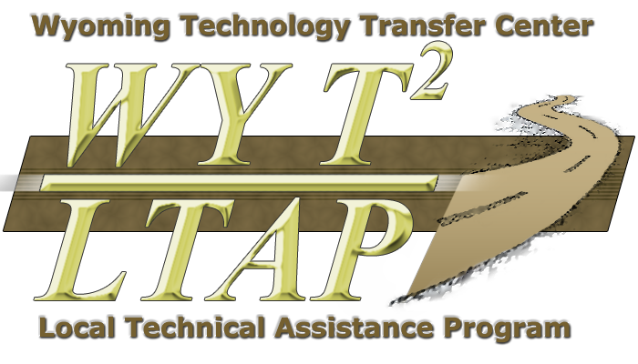
Wyoming Technology
Transfer Center
Sign Retroreflectometer
Loan Program Policies

The Federal Highway Administration is in the process of finalizing new standards and regulations regarding minimum levels of sign retroreflectivity. As a result, agencies will be responsible for maintaining their signs to a minimum level of service. A retroreflectometer plays a key role to ensure quality and accuracy when implementing an effective sign management program. To help local agencies who are unable to afford or don’t warrant enough need to purchase their own meters, the Wyoming Technology Transfer Center purchased two retroreflectometers and implemented a loan program. These devices were purchased with 402 Funds from the Wyoming Department of Transportation’s Highway Safety Office and the Safety Management System Committee.

The retroreflectometers are DELTA RetroSign® 4500 Retroreflectometers with GPS capability. Each comes with an extension pole kit to extend the operator’s reach an additional nine feet and includes a remote trigger with digital display allowing the operator to take multiple readings without having to retract the pole each time.

Features of the RetroSign® 4500 include:
- High tech filters that accurately measure the retroreflectivity of any color or type of sign sheeting;
- A calibration reflection standard traceable to an accredited national standards laboratory through an ISO 17025 certified testing and calibration laboratory. The instrument is also supplied with a field calibration standard;
- Ability to measure all colors of sheeting accurately after a single initial calibration, recalibration is not necessary for each individual color or type;
- A lens reducer which allows the accurate measurement of smaller letters (15 mm) such as the white letters on a 30” x 18” “Wrong Way” sign;
- A built-in Global Positioning System (GPS) for increased accuracy, and displays specific coordinates where the sign is located, which can then be downloaded into the agency’s sign inventory programs;
- Ability to store 1000 measurements which can be downloaded to a spreadsheet or integrated into a sign management program.

The Center will take requests from agencies via phone (800-231-2815), fax (307-766-6784), mail or e-mail (mharman@uwyo.edu), and loan the equipment on a first-come first-served basis. Agencies will be required to provide an estimated length of use (a maximum of two weeks) and schedule a return of the equipment. A waitlist will be maintained and the equipment will be delivered to the next agency on the list upon its return. The Center will host three workshops statewide to provide training for the use of these devices. If an agency was unable to attend one of these workshops, training will be available at the Center. The Center will charge a fee of $75 to ship or deliver the retroreflectometer unless the device is picked by your agency from the Center. Each agency is responsible for returning the device to the Center; a late fee of $25 per day will be assessed if the device is not returned on time. These fees will be used for future maintenance and repair.

The University of Wyoming Property Office will tag the equipment so that it is in their inventory of insured items. In order to be covered by the University’s insurance, agencies will be required to maintain the equipment in a secure and locked location during transportation or storage, i.e. locker, trunk or lock box. Because each retroreflectometer is worth approximately $15,000, if one is reported lost or stolen, the agency will be required to reimburse the Center a $2500 fee. The Center will also expect agencies to cover expenses related to obvious physical damage to the equipment.

A copy of the Center’s Sign Retroreflectometer Loan Program Policies will be provided to all borrowing agencies. A signature will be required from the borrowing agency at time of delivery recognizing the Center’s expectations for proper use and handling.

