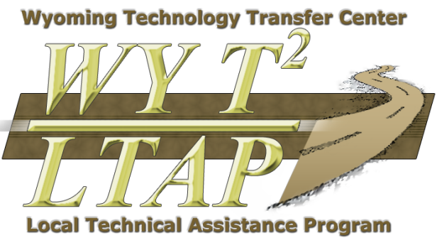
WYT²/LTAP SIGN PROGRAM
ROAD SIGN PROGRAM (RSP) ROUND 3

The deadline for submitting signs request was extended to August 31, 2017
The WYT²/LTAP Center, WYDOT, and FHWA have been working with counties around the state to help improve the safety on rural roads. In an effort to continue safety improvements that help reduce fatal and incapacitating injury crashes, a third round of a statewide sign program is proposed.
This statewide sign program will provide advance warning signs for high risk rural roads where signs have not previously existed or where enhancement would be beneficial. A report showing the list of eligible roads for this program was sent to you in June. Eligible roads are those that have 2 or more crashes between 1-1-2007 to 1-1-2017 in at least one mile section. In order for this program to work, counties would identify number of signs and posts needed on eligible roads and submit their requests to the WYT²/LTAP Center. The center will then compile all the requests and pass them to WYDOT. WYDOT will purchase and deliver all signs and posts to the counties. The counties are responsible for the installation of the signs within one year of delivery. The deadline to submit request forms to the WYT²/LTAP Center is August 31, 2017.
The RSP request form can be used to submit counties requests for signs. This form is available electronically on our web site under the Safety Program Tab wwweng.uwyo.edu/wyt2/. We prefer the Excel spread sheet form be used and a separate Excel Spread Sheet for each road e-mailed to Bart Evans at the address below. Please feel free to contact us at the center if you need any additional information or if you have any questions about this program.
Khaled Ksaibati, PhD., P.E. Bart Evans
Director Safety Analyst
Wyoming Technology Transfer Center Wyoming Technology Transfer Center
(307) 766-6230 (307) 321-1705
Khaled @uwyo.edu mevans2@uwyo.edu

