Date

First Last
Address
City, ST Zip
Dear First,
Congratulations! I am pleased to inform you that you have been provisionally admitted for graduate studies at the University of Wyoming for the Fall 2010 semester. Your final admission to the university will be determined upon receipt of the following information. Note that this information should be sent directly to the Admissions Office. If you have supplied this documentation directly to your graduate program, please request that it be forwarded to the Admissions Office:
XXXX
XXXX
In addition to the information above, you will also be required to provide proof of your measles, mumps, and rubella vaccination prior to registration. A copy of your vaccination records may be faxed to the Student Health Office at 307-766-2711 or call their office for questions at 307-766-2130. Previous UW students do not need to supply immunization records again.
Soon you will be receiving information on how to access your WyoWeb account. WyoWeb will provide you with access to your university account, UW news, class updates, and class registration.
Please contact your graduate program for your assigned advisor. Your advisor will work with you to ensure that you select the most appropriate courses for your program and complete departmental requirements. Your advisor will also provide your PERC number which is needed to register for classes.
Welcome to the University of Wyoming!
Sincerely,
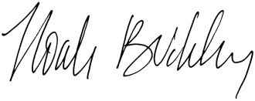
Noah Buckley
Director of Admissions
UW Student Number: W
CC: Imaging

