Crystal Cleavage and Nanocrystals

General description
Students are introduced to cleavage patterns of basic 2-dimensional lattices. This is used to demonstrate angle relationships students learn in geometry, including vertical angles, straight angles, and the angles formed by parallel lines and a transversal. This, then, is used in a discussion of crystal shapes, regardless of size, including nanocrystals.

Age group
High School Geometry

Estimated time
30 minutes

Background
Crystals are compounds in which their base atoms or molecules are arranged in an orderly, repeating pattern, forming a three dimensional lattice. Because of this, they tend to break along unique planes according to the pattern. This breaking is called cleavage. This phenomena can be extended to a two dimensional lattice.
When cleavage occurs, the breaks always occur in the same orientations as determined by the geometry of the crystal, regardless of their distance from one another. Because of this, angle relationships are constant for a given crystal pattern, and some properties of the crystals remain regardless of the size of the crystals. One such example is the interaction of electromagnetic radiation with the crystals, as in X-ray diffraction (XRD), a technique used to characterize crystal lattices and by extension the identification of unknown crystals.

Concepts
The principle concepts introduced in this lesson are geometric angle relationships, including vertical angles, straight angles, and the angles formed by parallel lines and a transversal, as they apply to crystal lattices.

Materials
Attached two dimensional lattices

Wyoming science standard

Crystal Cleavage Worksheet Instructions
- Choose any circle in the lattice.
- Imagine pushing it in any direction.
- All circles behind it remain stationary, but all circles in front of it must move with it.
- Where the two groups of circles (those remaining stationary and those being moved by the pushing action) would separate is the line of cleavage.
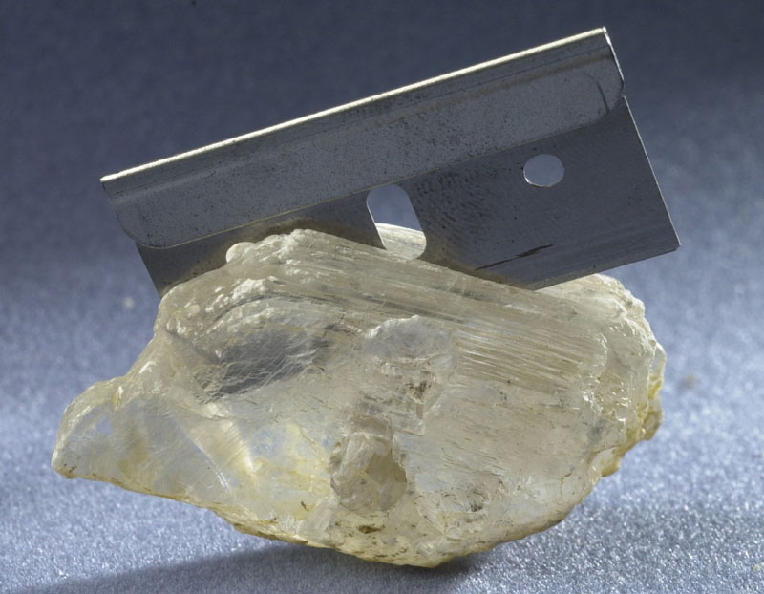
Gypsum.

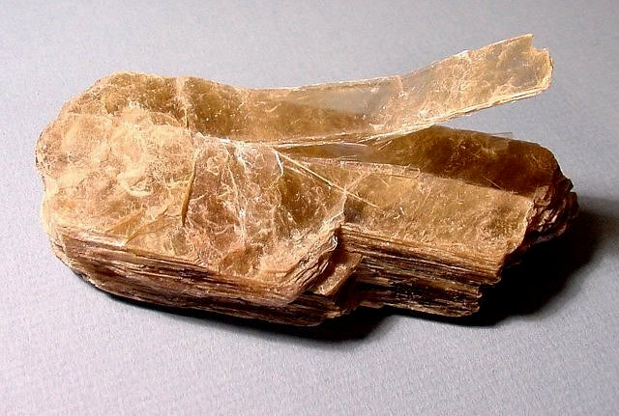
Muscovite (mica)
Crystal Cleavage Answer Key

Natural Cleavage
Unnatural Cut

Many lines exist in this pattern
Crystal Cleavage Worksheet

