Thermite reaction and activation energy

General description
The thermite reaction is a reaction between iron oxide and aluminum powder. It creates large amounts of heat and energy with iron and aluminum oxide as the products. The reaction can help demonstrate exothermic reactions and activation energy.

Age group
High school chemistry

Estimated time
50 minutes

Background
Reactions that require energy are called endothermic reactions and reactions that produce energy are called exothermic. When reactants are mixed they do not necessarily react immediately. Often times energy input is needed in the system. This can be in the form of kinetic energy (stirring or mixing), sound energy (not usually used but possible), light, heat, etc. The main energy input is heat because it is easy to apply and control and large amounts of energy can be transferred to the system.
Each reaction needs energy to proceed. Some get enough energy from the temperature of the room but others must have what is called activation energy. Activation energy is the energy required to get over the initial energy barrier. As seen in fig. 1, it can be thought of as pushing a ball over a hill, the higher the hill, the higher the amount of energy required to begin a reaction.
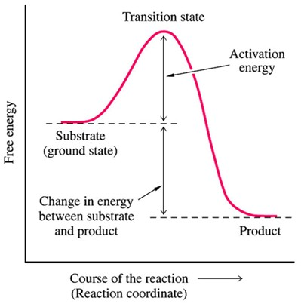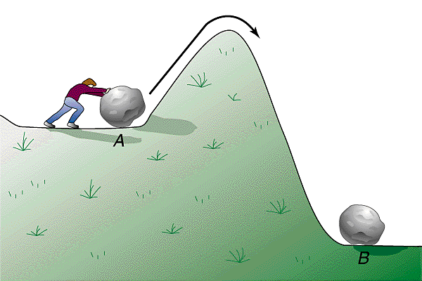
Figure 1: A comparison between activation energy (left) and pushing a boulder over a hill (right).

The activation energy is the height between the substrate/reactant and the transition state. This is the height between the beginning and the highest point in the reaction energy diagram. The energy change between the reactants and products is the heat of reaction or change in enthalpy (∆H). On the Diagram, this is the height change between reactants and products. Figure 2 shows the activation energy and enthalpy change more clearly.
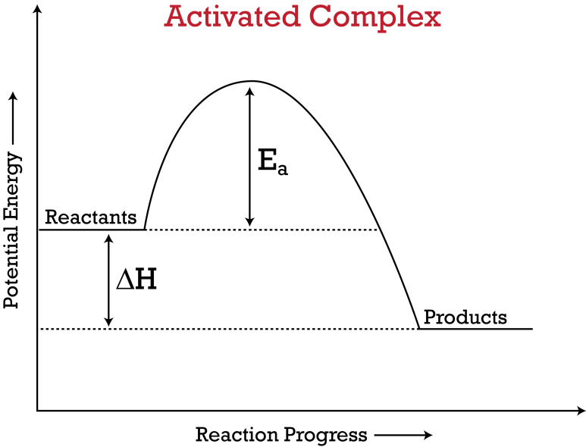
Figure 2: Showing the energy of activation Ea and the heat of reaction ∆H.
Exothermic and endothermic reactions differ in the sign of the energy of reaction (∆H). Exothermic reactions produce heat, giving -∆H meaning the system is losing or giving off energy. Endothermic reactions have a positive ∆H meaning they require energy or the system gains energy. The difference between exothermic and endothermic reactions can be seen in figure 3.
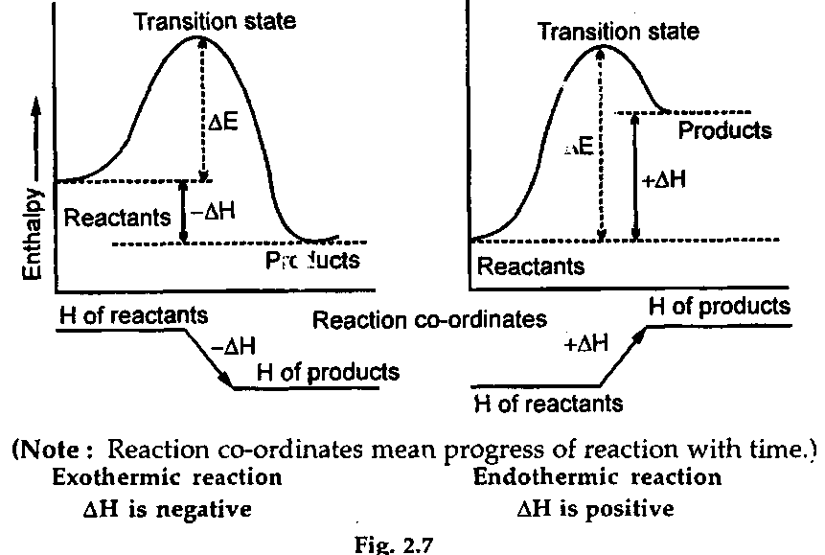
Figure 3: On the left is an exothermic reaction, the right shows an endothermic reaction.
There can be many different activation energies and heats of reaction; it depends on the reaction. In figure 4 it can be seen that there can be reactions with very large activation energies or very small activation energies, this concept will be explored in this lesson.
Energy
Reaction Coordinate
Reactants
Products

Figure 4: Showing different activation energies for the same ∆H between reactants and products.
The thermite reaction is a mixture of iron oxide and aluminum powder. When it reacts it gives of large amounts of heat and light, creating iron and aluminum oxide. The iron will be so hot that initially it will be molten. The reaction was used to weld railroad rails together because it became so hot it could melt iron. The reaction is as follows:
Fe₂O₃ + 2 Al → 2 Fe + Al₂O₃

Safety
Iron oxide and aluminum can irritate skin and eyes so the use of rubber gloves and eye protection is required. Aluminum powder is flammable; keep away from open flames or heat sources. During and immediately following reaction large amounts of heat are given off and molten iron is produced. During the reaction molten iron can be thrown into the air so safety glasses and distance from reaction are also required. Do not look directly at burning magnesium, it can damage retinas.

Concepts
The concepts that are explained are activation energy, heat of reaction and the difference between exothermic and endothermic reactions.

Vocabulary
Reactants and Products
Transition state/Intermediate/Activated Complex
Activation energy
Heat of reaction (∆H)
Enthalpy
Exothermic
Endothermic
Oxide

Materials
- Iron oxide (rust)
- Aluminum powder
- Clay pots
- Empty aluminum can/steel sheet/other metal scrap
- Matches
- Lighter
- Propane blowtorch
- Magnesium ribbon
- Sand in a large tray or on the ground

Instructions
- Measure out desired iron oxide and aluminum in a 2:1 Iron: Aluminum ratio by weight. For example, if you wanted to make 150 grams of thermite, measure out 100 grams of iron oxide and 50 grams of aluminum.
- Mix the reactants together well. This can be done in plastic bottles with screw tops so that the container can be closed and the reactants shaken together. Well mixed reactants will react better.
- Go outside and place sand in a large tray or over the ground you will react the thermite. This is to ensure that you do not ruin concrete or start a fire since the sand will absorb the heat.
- Place the thermite in a clay pot or aluminum can, if desired you can place it over a piece of sheet metal to see if the thermite will melt through it. If you are using an aluminum can, it might be easier to cut the top off of it, but do it carefully so you do not cut your hand on the sharp edges of the can.
- Start with a match and attempt to light the thermite.
- If match does not work move to lighter.
- If lighter does not work move to blowtorch.
- If none of the above work, cut a strip of magnesium ribbon, place it in the thermite like a candle and light it with the blowtorch.
- Enjoy the reaction carefully and from a safe distance.

Questions
- What type of reaction (exo or endo) is thermite?
  - Ans. Exothermic
- What temperature does a match, lighter, propane torch, and magnesium burn at?
  - Ans. Match: 1100-1500 ºF, Lighter: 850-1500 ºF, propane torch 3623 ºF, Magnesium 5610 ºF
- What temperatures do iron and aluminum melt at?
  - Ans. Iron 2800 ºF, Aluminum can 1220 ºF
- What do you think the reaction energy diagram might look like?
  - Ans. Use judgement, large activation energy (needs high temp) and large ∆H (due to large amount of heat given off)

Follow Up
There are many videos on YouTube that shows thermite on larger scales. Specifically one with Mythbusters that shows them trying to melt a car in half http://www.youtube.com/watch?v=PPAYZMzGMwQ , and another showing them lighting thermite on ice blocks http://www.youtube.com/watch?v=w6cMmk8LZgQ . Other videos can be found if desired.

