FIELD SAFETY PLAN
BOTANY DEI COMMITTEE | UNIVERSITY OF WYOMING

To be filled out every field season by faculty and team:

Site Info & Contacts

Field Site Location: | e.g. Happy Jack Recreation Area, Medicine-Bow Routt National Forest
Activity Description: | Type, length, and purpose of activity (e.g. hiking 8 miles round trip for species comp surveys)
Plan Created for: | Name of Research Group / Trip Leader | Date created: | Mo-Day-Yr
Date(s) of Travel: | Start date, duration, expected return e.g. Tuesdays June through August 5am to 3pm

A field safety plan serves as a tool to document your hazard assessment, communication plan, emergency procedures, and training. This plan should identify hazards, as well as precautions and actions taken to address and mitigate those hazards. Instructions:
- Complete this field safety plan: insert specifics for your site and operations, delete irrelevant sections.
- Complete appropriate training for your site and operations (e.g. first aid, heat illness, task-specific training).
- Hold a daily (morning or could be evening prior) meeting with your group to review your field safety plan, travel logistics, pack list (including first aid kit), personal safety and covdi19 concerns, and any remaining training needs.

Site Information
Location | Lat/Long if appropriate/available |  |  | Additional description
Site Information | Elevation, terrain, environment.
Travel to Site | How will participants get to the field site? Note any dangerous roads, conditions, additional vehicles such as boats, ATV, or extra precautions due to covid restrictions (i.e. masks, number of people per vehicle).
Site Access | Are there any particular restrictions or challenges to accessing site? Note any alternate routes or suggested parking areas; gate access codes, etc. Make special note if isolated or remote.
Environmental  Hazards | Describe any hazards participants may encounter. Note intended mitigation measures; discuss prior to trip. (e.g. High altitude, rugged terrain, wild animals)
Security | High risk for harassment or violence? Note intended mitigation measures; discuss prior to trip. Consider specific identities of the researcher that might expose them to greater risk of harassment or violence.
No Go Criteria | What are the conditions under which approach to - or activities at - the site should be stopped or canceled? e.g. heavy rains, high winds, snow, temperatures, change in Covid19 restrictions
Expected Weather | Note extreme conditions that could impact the trip or require additional planning, (e.g. high heat, wind, rain, snow, approaching storm).
Covid19 Precautions and Concerns, | Social distancing measures, masks, extra masks, hand sanitizer. Potential for limited facility access and how to mitigate.
Other
Emergency Services and Contact Information
Local Contact | Name, address & phone #, | University Contact  Someone not in the field with you, provide them a copy of this plan. |  |  |  | Name, number, email; may be a Professor/PI, department contact, supervisor back on campus, etc.  Frequency of check ins (See Note 1) with local or university contact, daily, at end of work day, etc.
Emergency Medical Services (EMS) | Procedures for contacting emergency medical services. e.g. use cell phone to call 911, if cell not working, use PLB to contact emergency services
Nearest Emergency Department (ED) | Evacuation plan and transportation options to the nearest Emergency Department; include estimated transport time, contact information and driving directions from the site to the nearest provider of emergency medical care. A map with directions to the nearest hospital is included at the end of this document.
Cell Phone Coverage | Primary Number:  Coverage: spotty  Nearest location with coverage: |  | Satellite phone/device |  | Device carried? ☐yes ☐no  Type/number: e.g. inReach PLB
Nearby Facilities | Emergency phones location  Note where supplement safety equipment is located including: AED, Supplemental Oxygen, Epi-Pen, first aid kits
Participant Information
Field Team/ Participants | Is anyone working alone? ☐ Yes ☐ No If yes, develop a communications plan with strict check-in procedures; if cell coverage is unreliable, carry a satellite communication device or personal locator beacon.  Primary Field Team Leader: Name, phone number  Secondary Field Team Leader: Name, phone number  ☐ Field Team/Participant list is attached as training documentation  ☐ Other attachment:
Physical Demands | List any physical demands required for this trip and training/certification provided. e.g. diving, hiking, climbing, high altitudes, heights, , etc. (consult with EH&S regarding appropriate training & documentation).
Mental Demands | List any unique mental demands required for this trip, e.g. long travel days, high stress environments, different cultural norms, etc.
First Aid Training  & Supplies | OSHA requires at least one trained person (with current certification) for work at remote sites. List team members trained in first aid and the type of training received.  Location and description of group medical/first aid kit: Who is carrying it, where is it stored. Brief description of contents.
Other

Equipment and Activities – Consult with EH&S for specific training and requirements.
Research Tools | Briefly describe tools or equipment that will be used to access the research site or during research activities. Indicate specific training required before use if appropriate,
Other Research Hazards | Describe other potential research-associated hazards e.g. handling or shipping hazardous materials (chemical, biological, handling animals, climbing or working at heights, rigging; shoring/trenching, confined spaces; drone use.
Personal Protective Equipment | Required—e.g. face masks, hand sanitizer, hiking boots, PFDs, etc.  Recommended – e.g. rain jacket, sunscreen, hats,etc.
Field Station Contacts (if applicable)
Address | Ex: MRS 818 County Road 116 Nederland CO 80466
Phone Numbers | Ex: 303-303-3300
Campus Contacts (University of Wyoming)
University Police Dept. | Emergency 911, Non-emergency 307-766-5179 uwpd@uwyo.edu
University Health Services | Student health service: (307) 766-2130, studenthealth@uwyo.edu
UW Safety Office | uwehs@uwyo.edu 307-766-3277
Report Injuries (through university) | Injury Reporting and Incident ReportingAccident Reporting (uwyo.edu)
Crisis intervention and support | 307-766-2187 (10am-5pm), 307-766-8989 (outside hours)
Albany County SAFE Project | 307-745-3556 (24 hours), 319 S. Lincoln Street, Laramie  - Crisis intervention, Sexual assault response, support, and assistance

Example of nearest Hospital information:

Ivinson Memorial Hospital
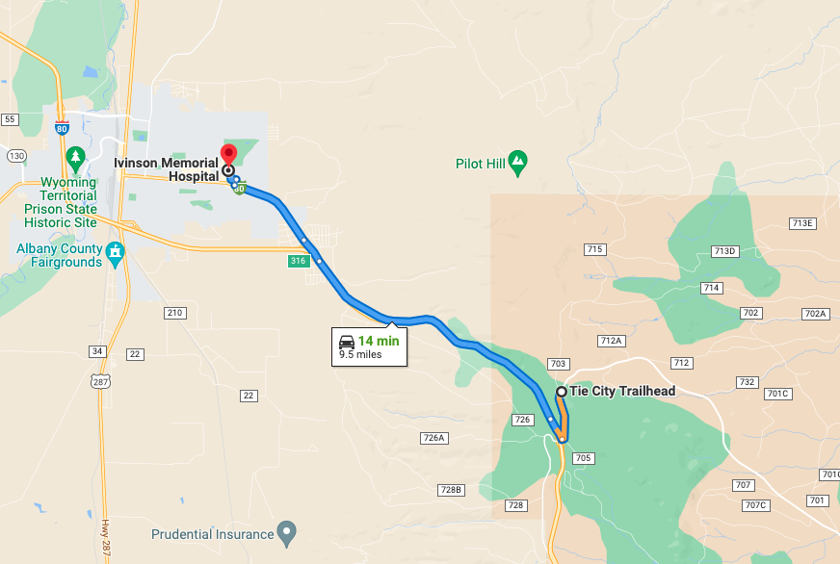

Directions to Ivinson Memorial Hospital (255 N 30th St, Laramie, WY 82072) from the Tie City Trailhead
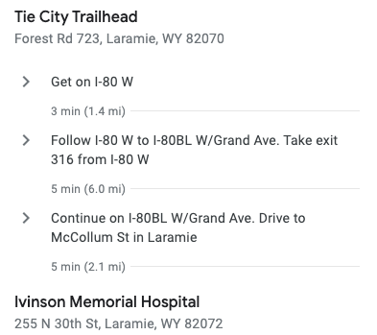

Include any additional resources: route/location maps, photos of general terrain and areas requiring extra caution, etc.

Safety Check-In Planning
Those working solo should establish a structured and rigid check-in procedure with their safety contact. A procedure similar to below is critical to safety. This same plan is also advised for any size group.

- State a “WORRY TIME” that your contact should expect to hear from you. This time should provide you a substantial buffer to account for unexpected weather, a slow day, etc. Consider the time it will take you to get to reliable communication when you return. If your contact does not hear from you before the “worry time” then they should be closely monitoring for your return and should attempt to contact you by text or phone.
- State a “CALL SEARCH AND RESCUE (SAR) TIME” when your contact will commit to making the following calls.
  - First attempt to contact the missing person via text and phone.
  - Second, call the Research Station to inquire if they know if the missing person has returned.
    - Field Station mainline/Station Manager – phone number, Field Station secondary – phone number, Field Station Director – phone number
  - Third, if you cannot reach the missing person and the Field Station cannot confirm their location or cannot be reached then call the County Sheriff (phone number) OR 911 to report the missing person.
    - Provide the authorities the “worry time” and “call SAR time” as well as the researcher’s specific field location provided on this safety plan.
    - Station address report
- Here is an example plan to leave (in writing) with your contact every time you are in the field AND provide them a copy of this safety plan.

“Worry if you don’t hear from me by 5pm and try to contact me to make sure I’m OK. If you can’t reach me then call the MRS contacts to see if they have any information on my current location. If you haven’t received any information by 7 pm then call the Sheriff or 911. You have a copy of my field plan, location, and phone numbers to call if you don’t hear from me. My approximate location in the field will be xxxxxxx.”

RESPONSES TO A MISSED CHECK-IN

Check-in Steps | Contact
Worry Time: XX:XX | - Researcher cell: XXX-XXX-XXXX
CALL SEARCH AND RESCUE(SAR) TIME: XX: XX | - Researcher cell: XXX-XXX-XXXX
If researcher not located… | - Field station manager (see ‘Contacts’ above)  - Field station director
If researcher not located… | - County Sherriff (phone number)  - 911 to report the missing person
Information for reporting missing person(s).

Station address:
Your planned approximate location that can be communicated to authorities: [When you leave your plan with your check-in person, restate your approximate work location for the day such that it will provide a good starting point for SAR to look.]

