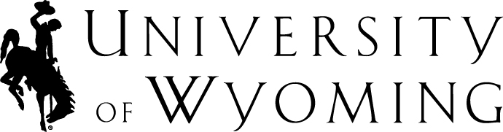

Interview Team Member
Confidentiality Agreement

It is critical that strict confidentiality be maintained before, during and after all phases of the interview process. Please do not discuss the process with anyone outside of your interview committee. By signing this you are also agreeing that you can be a fair and impartial member without bias to any interviewee.

If requested, the Human Resources Department is responsible for providing information to applicants regarding their status and reason for non-selection. This information will come directly from your screening and interview evaluations and it is public record.

Our signatures below signify that we understand and will uphold the confidentiality of the interview and selection process. We also understand that failure to comply with these standards may result in disciplinary actions.

Print Names Signature/Date

Please return to the Hiring Manager with any interview materials/documentation.
**Use of a cell phone should be prohibited during interviews**

