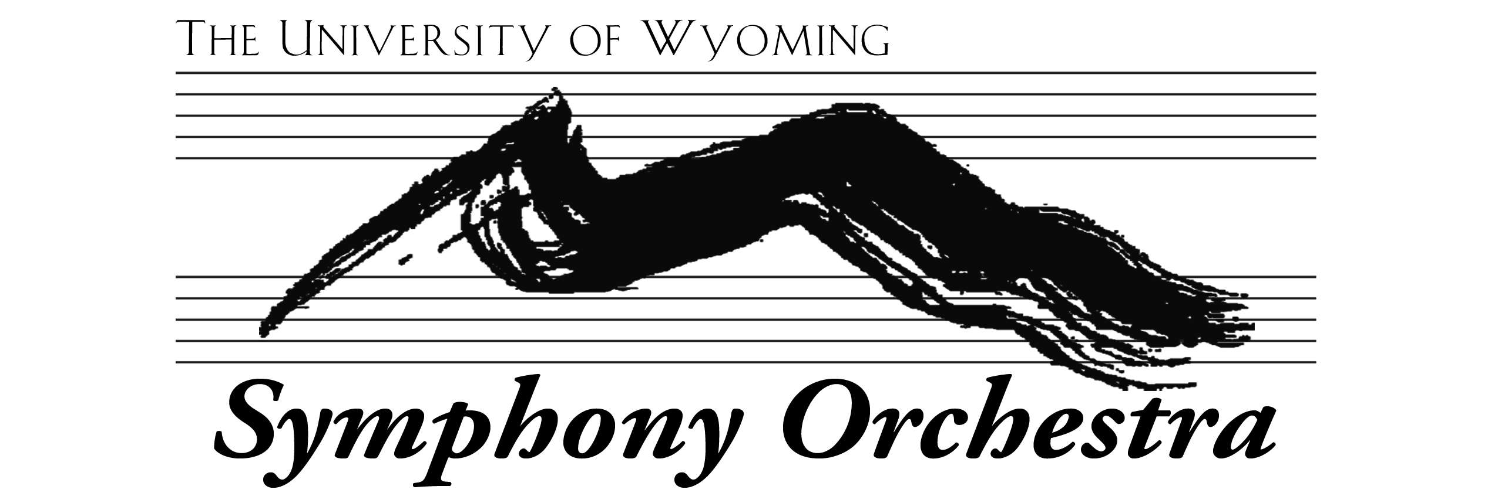
AUDITIONS 2022

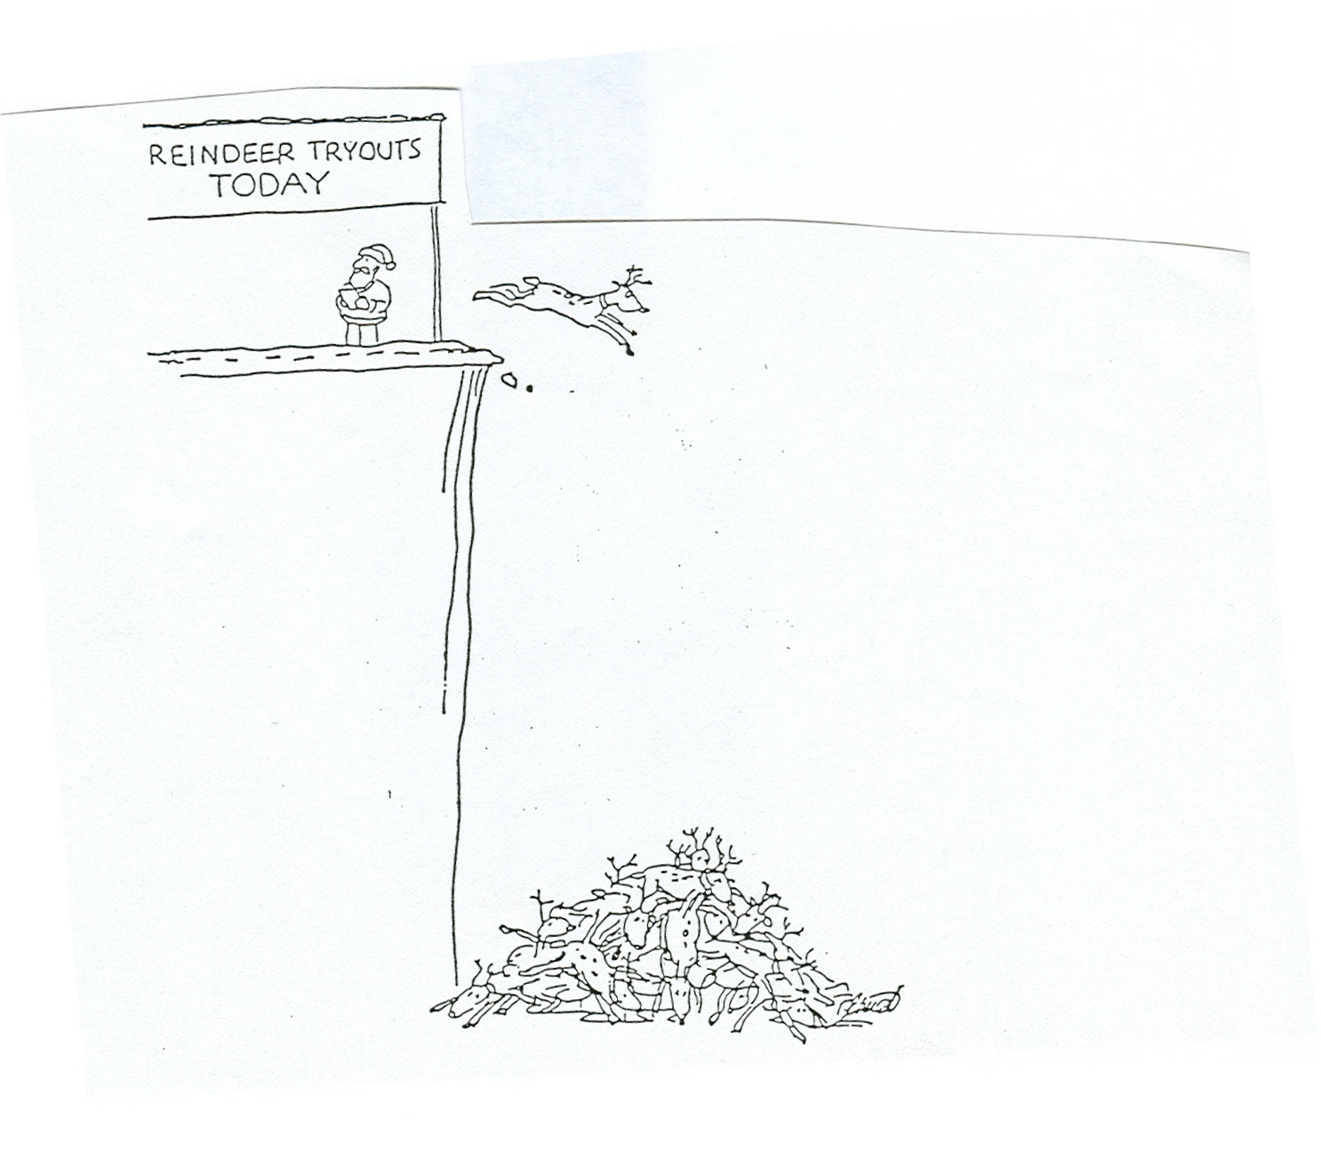

Auditions may be either in person or online. The choice is yours.

If you choose virtual, please upload something to YouTube. Chinese students may use YouKu. Then send me the link. Deadline is 4:00 p.m. Tuesday August 23.

In-person auditions (except percussion) will be Friday August 19th, Monday August 22nd, and Tuesday, August 23rd. Sign up for a time on the sheet on my office door (301). Don’t wait until the last minute! Times will fill up quickly. If you can audition on the first date, please do so. Winds, choose the same time for me and Dr. Belser.

NEW STRINGS – you must audition, even if you auditioned for a scholarship in spring. For most of you, this is for seating.

RETURNING STRINGS – I can use your spring jury, or the last time I heard you, to make my decision. If you think a new audition will show improvement, you’re more than welcome to play again.

WOODWINDS AND BRASSES – Dr. Belser and I will do auditions together if you audition live.

Everyone, please prepare two selections that show your ability. One must be slow, so I hear your tone and musicality. The other, fast, for technique and articulation. They may be two different works, or two movements of the same piece. They don’t need to be extraordinarily long. I’d rather hear 100 well-prepared measures than an entire movement you didn’t have time to learn. For strings, something that shows your ability to shift is always informative, especially for violins who wish to be considered for first violin. Scales are not required, but I’m happy to hear one or two if you like.

PERCUSSION – auditions will be Monday evening, August 22, in room 1016. Dr. Wheelock will have a sign-up sheet and details.

